**Electromagnetic Undulator with switchable period for soft X-ray application in the SKIF project**

Denis Gurova), Konstantin Zolotarevb), Anatoly Utkinc)

*Budker Institute of Nuclear Physics SB RAS, Novosibirsk 630090, Russia*

*a)* [*d.s.gurov@inp.nsk.su*](mailto:d.s.gurov@inp.nsk.su)

*b)* [*K.V.Zolotarev@inp.nsk.su*](mailto:K.V.Zolotarev@inp.nsk.su)

*c)* [*a.v.utkin@inp.nsk.su*](mailto:a.v.utkin@inp.nsk.su)

**Abstract.** The “Electronic structure” beamline is dedicated for realization different photoelectron spectroscopy application in the SKIF project, requires intense photon flux in the soft X-ray and VUV ranges (10 - 2000 eV). The generation of the undulator radiation in this range is very problematic for electron beams with 3 GeV energy. For keeping the opportunity to cover whole range, the special undulator design with possibility doubling of the period was proposed. The commutation of the coils groups provides change the undulator period from 10 to 20 cm with keeping the amplitude magnetic field (0.5 T). The undulator mode (5 cm period) gives a big flux for high energy edge of the range and the wiggler mode (with period 20 cm) provides the sufficient number of the photons for soft region (down to 10 eV). Some details of the undulator design are presented in the report.

**Introduction**

The “Electronic structure” beamline is dedicated for realization different photoelectron spectroscopy application in the SKIF project [1], requires intense photon flux in the soft X-ray and VUV ranges (10 - 2000 eV). The generation of the undulator radiation in this range is very problematic for electron beams with 3 GeV energy.

Spectral range of radiation from undulator with period λu and maximal magnitude of magnetic field is described by formula:

$λ_{k}=\frac{λ_{u}}{2γ^{2}k}\left(1+\frac{K^{2}}{2}\right)$, where

$K=\frac{e}{2πm_{e}c^{2}}λ_{u}B$.

It is seen, that it is impossible to cover the whole range of energies by only changing the magnitude of magnetic field in undulator.

It is possible to se undulator with variable period, where length of period is varied mechanically, by changing the distances between permanent magnets [2]. But order to obtain soft radiation, maximal period in undulator is should be about 1 meters and as result, available number of periods will be 3-4 units because of size restrictions in straight areas for insertion devices in SKIF facility.

Of greatest interest is the method of switching from undulator mode to the wiggler mode by means of doubling of period length in electromagnetic undulator by commutating of current coils [3]. As result the soft range of radiation obtained in wiggler mode.

In current construction discussed construction of normal conducting electromagnetic undulator wit iron yoke, where doubling of period length is obtained by means of commutation of current coils.

**Undulator construction**

Undulator-wiggler have the C- type construction (fig. 1, 2). Such construction of undulator significantly simplifies the simplicity of its installation at synchrotron.

 **

**Fig.1.**Longitudinal cross section of undulator-wiggler. **Fig.2.**Transversal cross section of undulator-wiggler.

The length of undulator L=2900 mm. was chosen taking into account the possibility of manufacturing it on precision mechanics (treatment of parts less than 3m in size)

Gap between poles was selected h=12 mm, width of pole S=90mm, height of pole d=84 mm, length of poles l=20 mm, except 2-nd ad 55-th poles, where l2,55=36mm.

Device can be operated in undulator mode with period λ=100mm (number of regular periods is 26, overall amount of periods s 56) and magnitude of magnetic field up to the B=5 kGs (Fig. 1,2). Wiggler mode with period λ=200mm (number of regular periods is 13) and magnitude of magnetic field up to the B=5 kGs, is achieved as result of commutation of coils such way that one period in wiggler mode is formed by 4 poles. While switching from undulator to the wiggler mode is changed direction of magnetic field in poles: 4+3n and 5+3n, where n is integer and changes from 0 to 16.

Magnetic field in undulator-wiggler obtained by using current coils. Water cooled current coils have 10x1 = 10 turns (copper bus 6x6mm and a hole Ø3mm) are installed on the iron poles. Water cooled current coils with 10x2 = 20 turns are installed on poles 2 and 55. All current coils, except those installed at 1, 2, 55 and 56 poles, are connected in series. It is supposed to use 4 current sources. To obtain the magnetic field B = 5 kGs in the regular part of the device in undulator mode, the current in the bus I = 270 A is necessary, in the wiggler mode I = 250 A.

**Simulation of undulator**

The undulator – wiggler simulation was carried out using the “Mermaid” program for magneto-static calculations and software to calculate optical characteristics of radiation from SR sources “SPECTRA”.

At fig. 3 presented the calculated 3D model ¼ of the edge of undulator - wiggler.

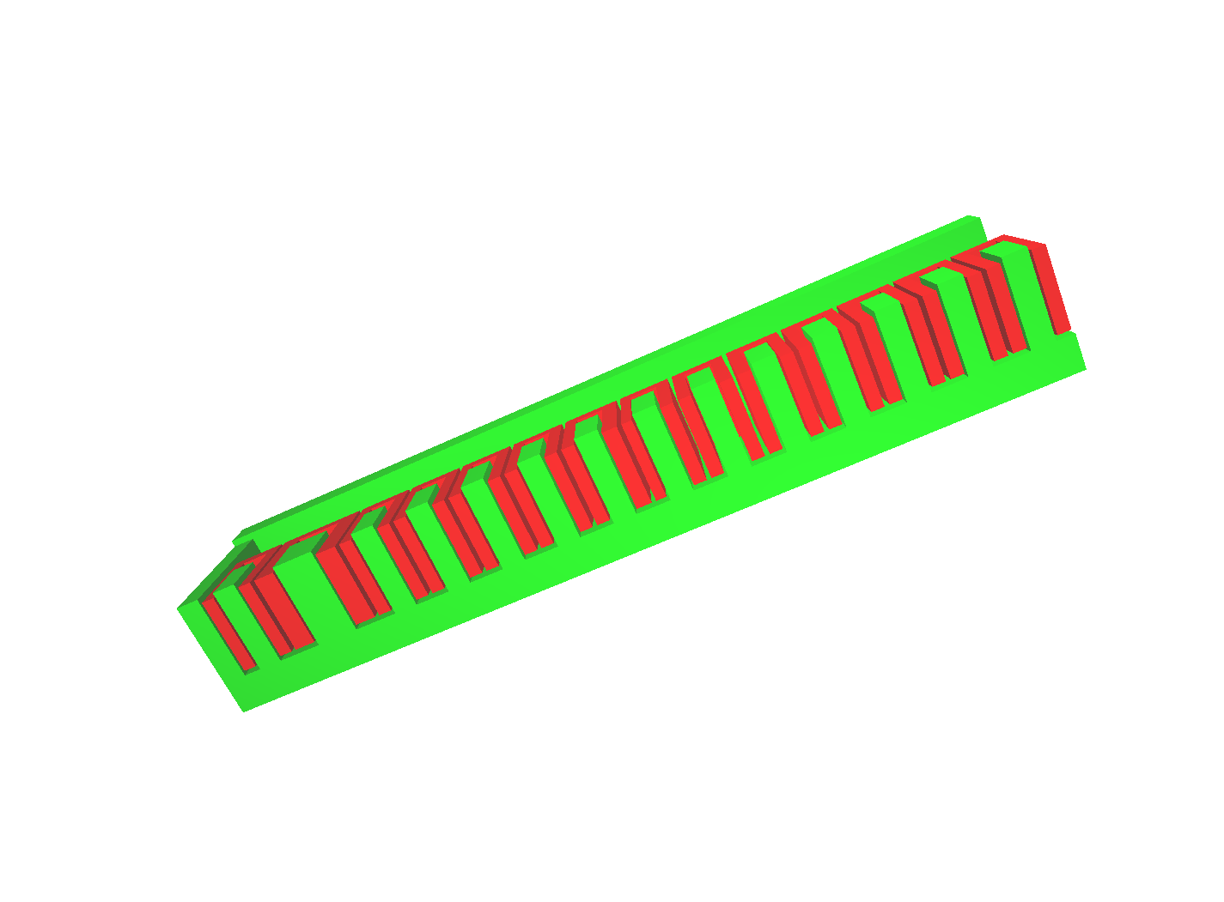 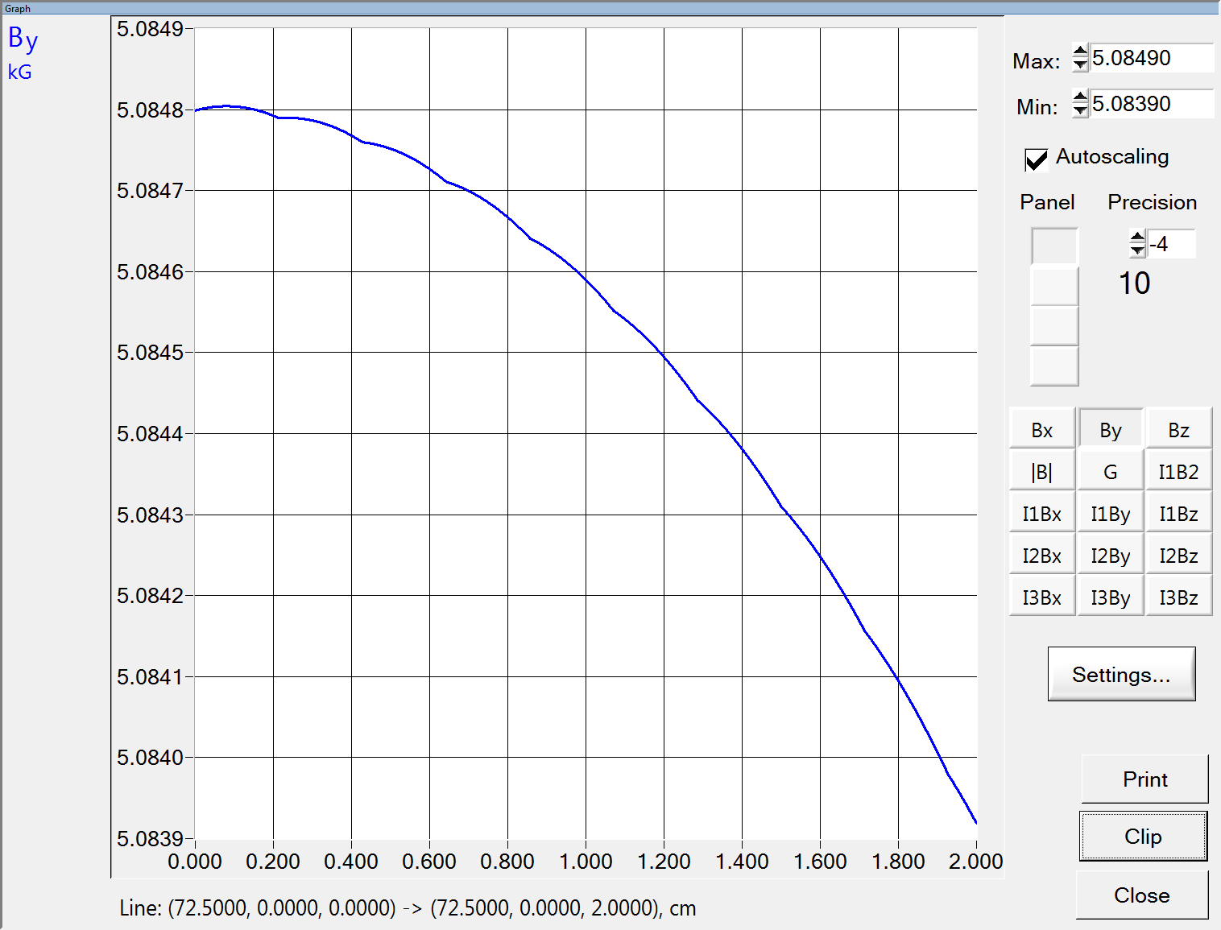

**Fig.3.** 3D Model of ¼ of the edge of undulator-wiggler. **Fig.4.**Distribution of the magnetic field in the median plane

in the transverse direction relative to the electron beam.

At fig. 4 shown the magnitude of the magnetic field from the center of the electron beam along the width of the pole in the range from 0 to 2 cm.

At figures 5 and 6 shown the distribution of the magnetic field along the undulator in the undulator and wiggler modes.

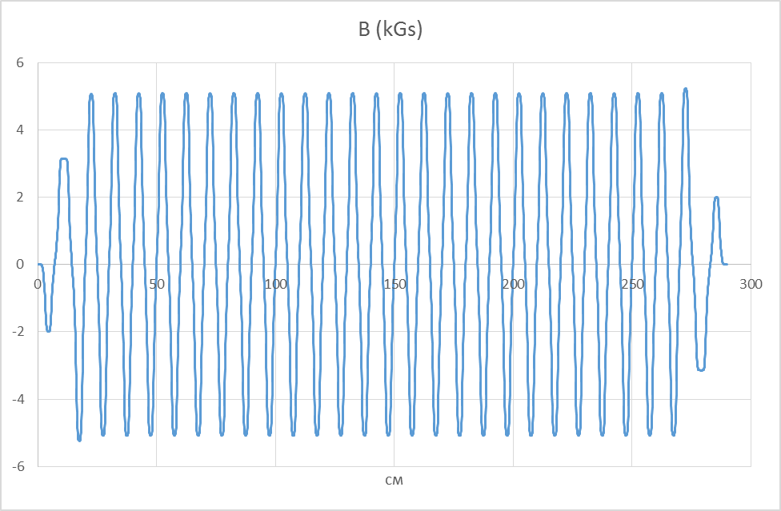 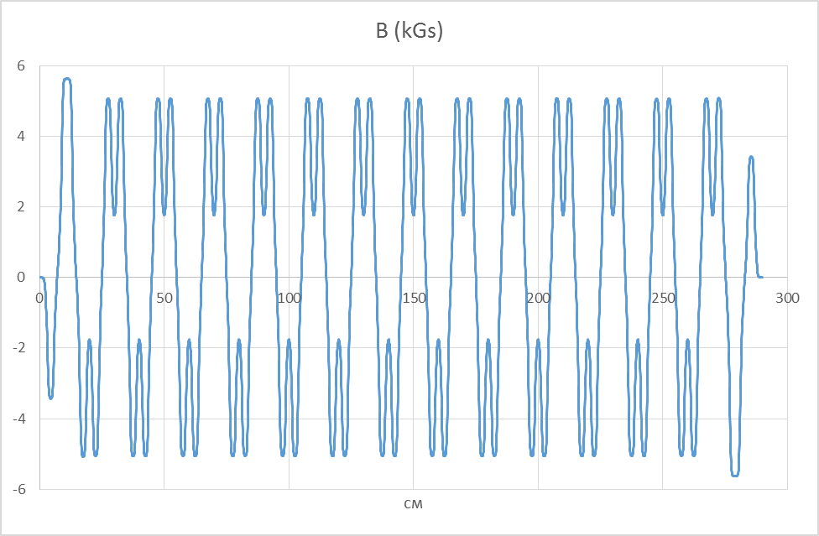

**Fig.5.**Magnitude of magnetic field along undulator-wiggler at λ=10cm. **Fig.6.**Magnitude of magnetic field along undulator-wiggler

at λ=20cm.

At figure 7 shown the angles of the electron beam trajectory in the undulator and wiggler modes.

At figure 8 shown the electron beam trajectories in the undulator and wiggler modes.

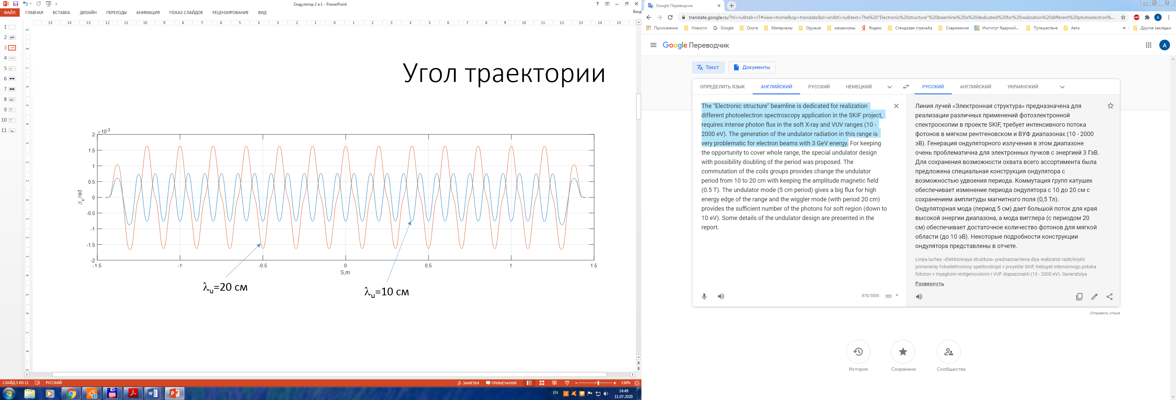

**Fig.7.** Angle of trajectory of electron beam in undulator and wiggler modes.

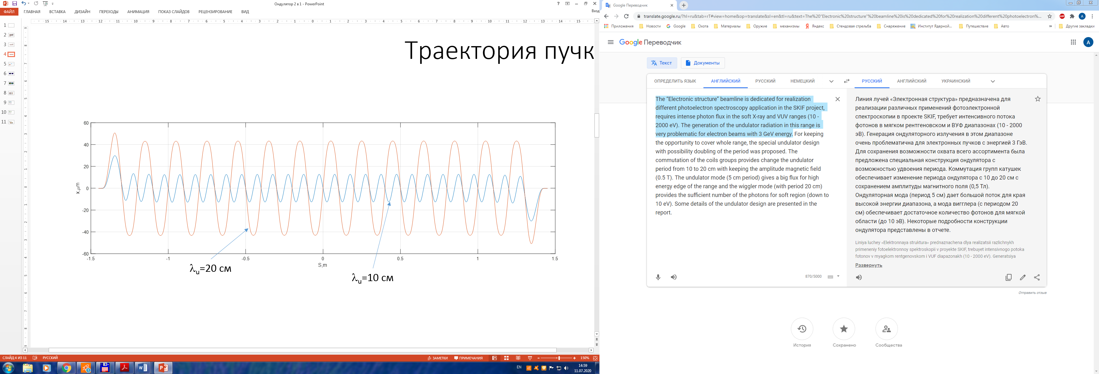

**Fig.8.** Trajectories of electron beam in undulator-wiggler.

Fig. 9 shows the spectral distribution of radiation in undulator and wiggler modes at a maximal magnetic field B = 0.5 T in an undulator.

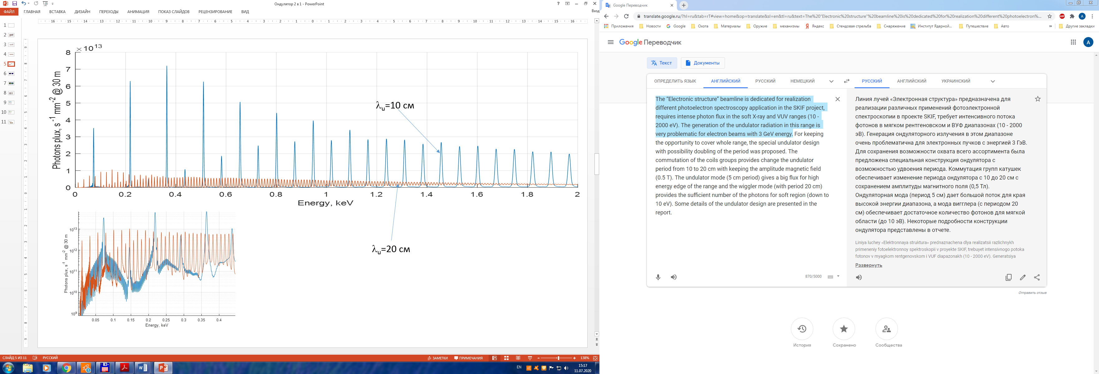

**Fig.9.** Spectral distribution of radiation at B=0,5T in undulator.

Fig. 10, 11 show the spectral distribution of radiation in the undulator mode, depending on the magnitude of the maximal magnetic field in the undulator.

Fig. 12 shows the distribution of the radiation power density at the distance of 12 m from the insertion device in the wiggler and undulator modes.

In the wiggler mode of operation, two maxima of the radiation power density are observed. This is due to the fact that in each half period of the wiggler there are 2 peaks of the maximum value of the magnetic field (Fig. 6). However, the angle of the electron beam trajectory at these peaks is different.

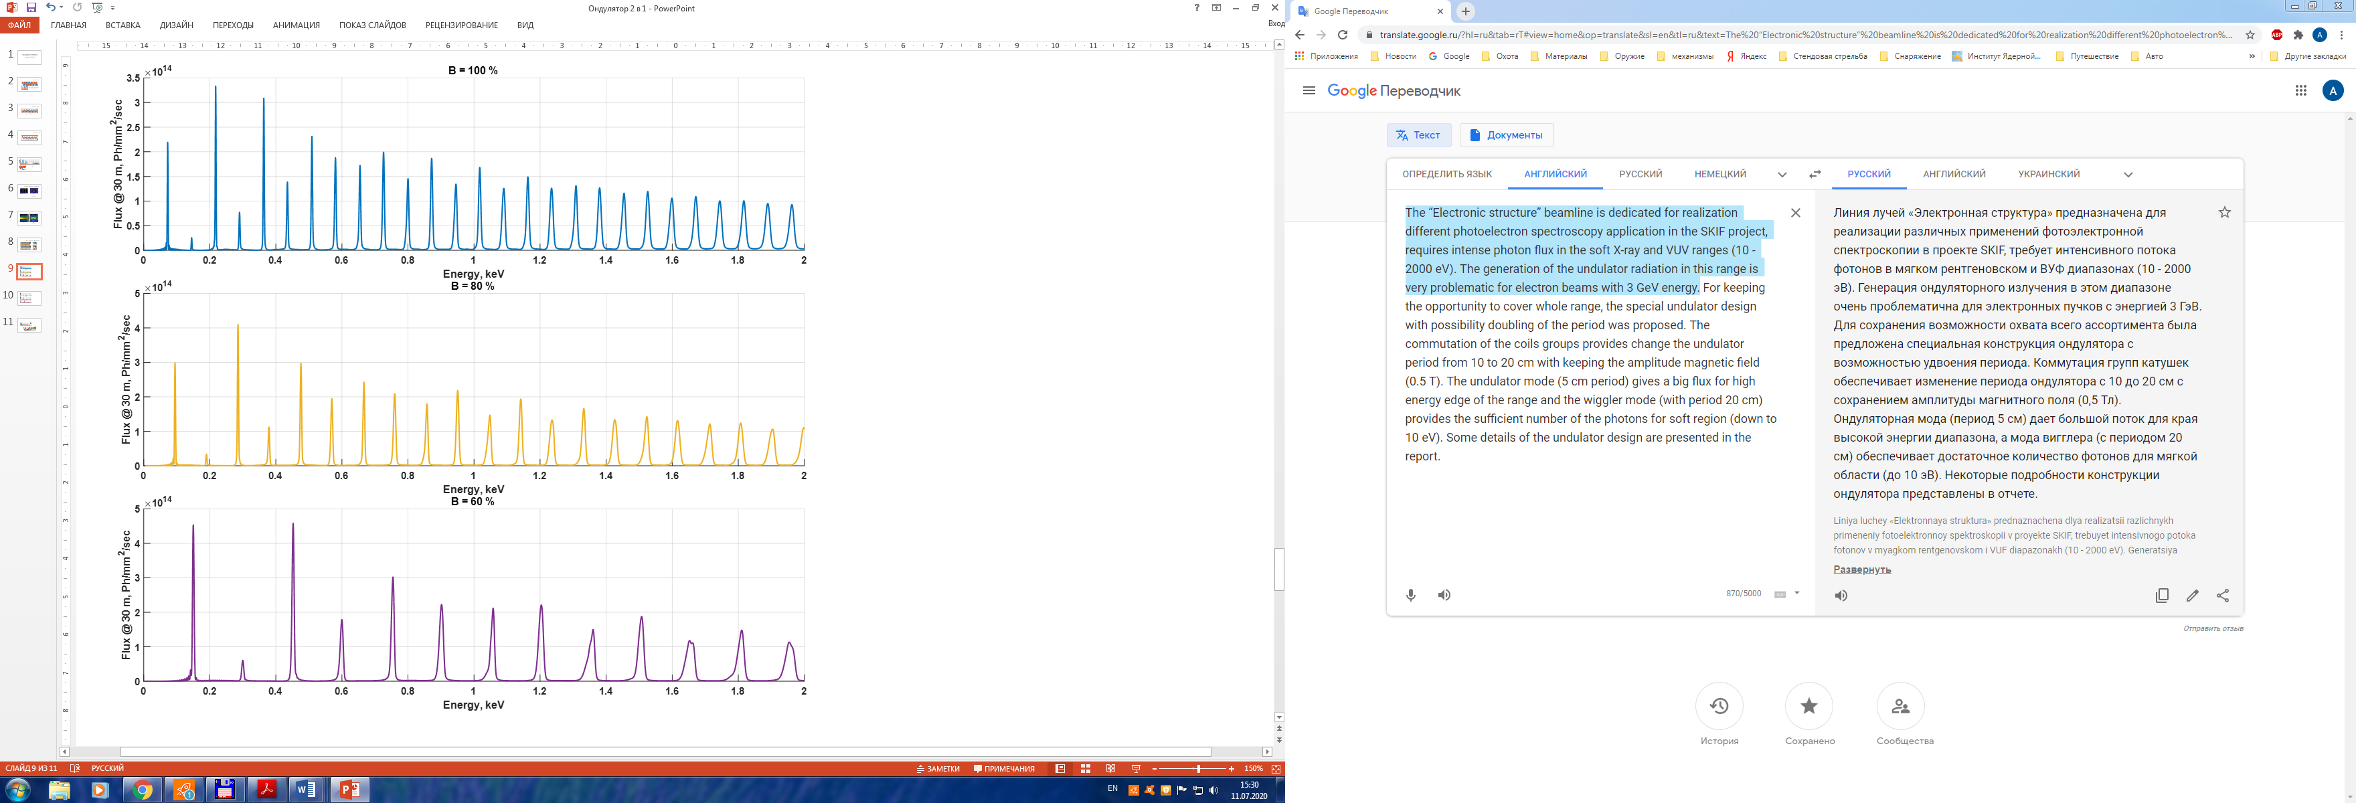

**Fig.10.** Spectral distribution of radiation at different values of field in undulator.



**Fig.11.** Spectral distribution of radiation at different values of field in undulator.

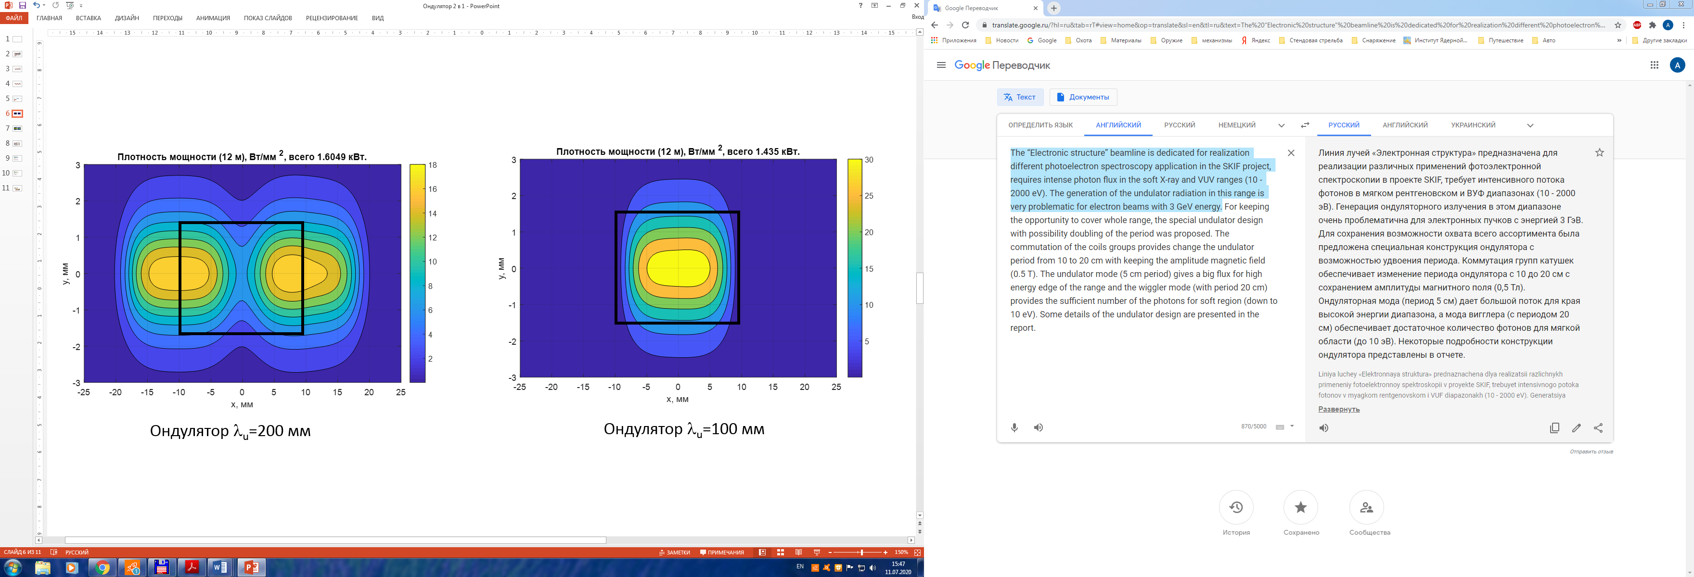

**Fig.12.** Power density of radiation at distance 12 from undulator.

**Conclusion**

It can be seen from the presented calculations that the described undulator design allows covering a wide spectrum of radiation in the undulator or wiggler mode from one insertion device, which extends the capabilities of the beamline. A device of this type is proposed to be installed on “ELECTRONIC STRUCTURE BEAMLINE 1-6” at SKIF SYNCHROTRON FACILITY.

Man parameters of the insertion device:

|  |  |  |
| --- | --- | --- |
|  | undulator | wiggler |
| Period | 100mm | 200mm |
| Number of regular periods | 26 | 13 |
| Overall amount of poles | 56 | 56 |
| Length of insertion device | 2900mm | 2900mm |
| Gap between poles | 12mm | 12mm |
| Width of pole | 90mm | 90mm |
| Maximal magnitude of magnetic field | 0.5T | 0.5T |
| Maximal magnitude of current | 270A | 250A |
| Maximal power consumption | 20kW | 17kW |

**References**

1. Andrey Bukhtiyarov, Anton Nikolenko, Igor Prosvirin, Oleg Tereshchenko, Ren Kvon, *“ELECTRONIC STRUCTURE” BEAMLINE 1-6 at SKIF SYNCHROTRON FACILITY*, Synchrotron and Free electron laser Radiation: generation and application (SFR-2020)/ July 13 – 16, 2020/ Book of Abstracts
2. I. Davidyuk, O.A. Shevchenko, V.G. Tcheskidov, N.A. Vinokurov, *Magnetic and mechanical design of large-aperture variable-period permanent magnet undulator*, Nuclear Inst. and Methods in Physics Research, A 915 (2019) 36–39
3. Axel Bernhard, Peter Peiffer, Daniel Wollmann, and Tilo Baumbach, University of Karlsruhe Robert Rossmanith, Forschungszentrum Karlsruhe*, SUPERCONDUCTIVE INSERTION DEVICES WITH VARIABLE PERIOD LENGTH*, Proceedings of EPAC08, Genoa, Italy/ WEPC100