Stationary Diagnostics Of Magnetized Plasmas
Ivan Sorokin^{a)}, Igor Vizgalov and Dobrynya Kolodko
National Research Nuclear University MEPhI 115409, Russia, Moscow, Kashirskoe highway, 31
^{a)}Corresponding author: sorokin@plasma.mephi.ru
Abstract. A combined module for in-situ diagnostics of local plasma parameters and ion mass spectrum in the linear plasma device PR-2 is presented. The module consists of a stationary mass-spectrometer and a probe system containing several Langmuir probes. The mass-spectrometer is based on a classical scheme of static magnetic ion separator with 180° deflection using the background magnetic field of the plasma device, which allows us to measure both positive and negative relative ion fluxes simultaneously during the experiment. An example of a mass spectrum obtained with the device for a plasma of mixed hydrogen and air is presented.

INTRODUCTION
Stationary plasma diagnostics of local parameters and ion mass-spectrum are necessary to control discharge regimes and a plasma composition during the experiments. Corpuscular diagnostics of a plasma ion flux can provide information about a plasma-chemical kinetic of the discharge. Usually optical spectroscopy is used for determination of the plasma composition [1, 2], but often it cannot deliver the reliable information. The work gas analysis, for example by quadrupole mass-spectrometer, can provide information of the neutral species in vacuum chamber, but not of the ion composition of plasma. In-situ mass-spectrometry systems based on the mass separation and detection of plasma ions are usually complicate, for example the omegatron mass-spectrometer [3] requires an additional RF source of the electrical field and ultra-high-vacuum differential pumping. The plasma ions mass-spectrometer (PIMS) [4] is based on the cycloidal focusing in the perpendicular electrical and strong magnetic field, which is not always used on linear plasma devices. A simpler ion separation method of magnetized plasmas is using the background magnetic field of the plasma device as a separating factor. The idea of stationary mass-spectrometer using the background magnetic field is widely used [5, 6], but usually its construction prevents to measure both positive and negative ions during one experiment. Combined diagnostics module (CDM) for in-situ analysis of both the local parameters and ion mass spectrum of magnetized plasmas developed for the linear plasma device PR-2 [7] is presented.

EXPERIMENTAL SETUP
Scheme of CDM developed for linear plasma device PR-2 (NRNU MEPhI) is shown in Fig. 1. It consists of the static mass-spectrometer (MS) and the probe system containing twelve single Langmuir probes. MS is based on classical scheme of static magnetic ion separator with 180° deflection of the accelerated plasma ions between entrance slit and body of MS. Symmetrical MS allows to measure relative fluxes of both positive and negative ions from plasma column. The probe system is intended for measurement of local plasma parameters near mass-analysis area. It is important to monitor local plasma potential because the extraction voltage for plasma ions should be constant during the mass-analysis process. So we have placed twelve single Langmuir probes at different distance from the plasma center. It permits us to know both local plasma parameters including a plasma potential in the mass-analysis area and an averaged profile of a plasma column.
Ions reaching the entrance slit (1 mm) are accelerated by the electrical field applied in the accelerating gap (1 mm). Then they are deflected by the local magnetic field of plasma device and as a result separated by M/Z ratio. Mass-spectrum of plasma ions is obtained by changing the accelerating voltage, and registered by four ion collectors placed at different radii of ion trajectories. The collector at the lower radius (r = 3.5 cm) is used for a rough mass-analysis of typical light working gases (M/Z < 10 a.e.m.). The second collector (r = 7 cm) has a better mass resolution and is used for more accurate measurements in a heavier mass range.
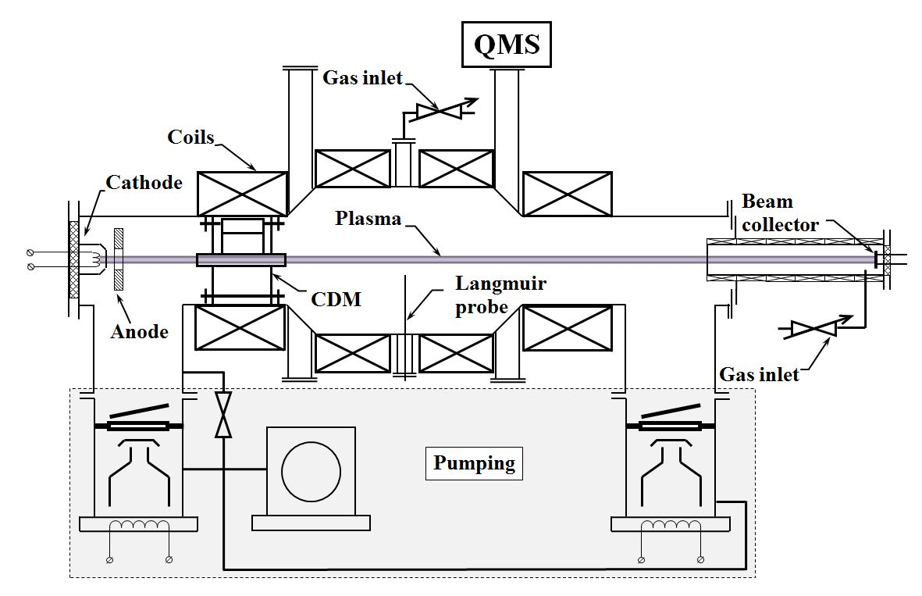 | 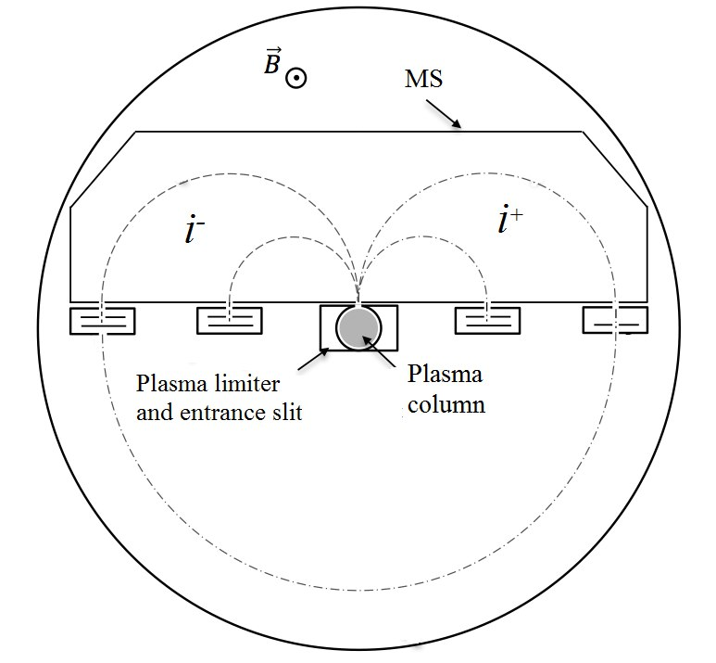
(a) | (b)
Figure 1. Scheme of the linear plasma device PR-2 (a) and CDM (b)

General scheme of a static mass-spectrometer has a good mass resolution (cf. Fig. 2) for ions of usual working gases and light admixtures (M < 10 a.m.u.). For hydrocarbons, residual gas components and heavy ions it works only in detector regime. The mass resolution of MS depends on different parameters and can be improved, for example, by increasing the radius of ion trajectories or the magnetic field in the plasma device. Often these parameters are fixed for each plasma device. For PR-2 the radius of ion trajectory is limited by the inner diameter of the main vacuum vessel (d = 37 cm, r_{i} ≤ 9 cm), but it is possible to double r_{i} by additional acceleration of ions after first focusing at 180°. Often the value of the magnetic field is limited by parameters of the applied power supply. For PR-2 it is about 0.16 T, so only one possibility for us to increase the value of the magnetic field in analyzed area in this way was to mount the CDM to one of the magnetic mirror.

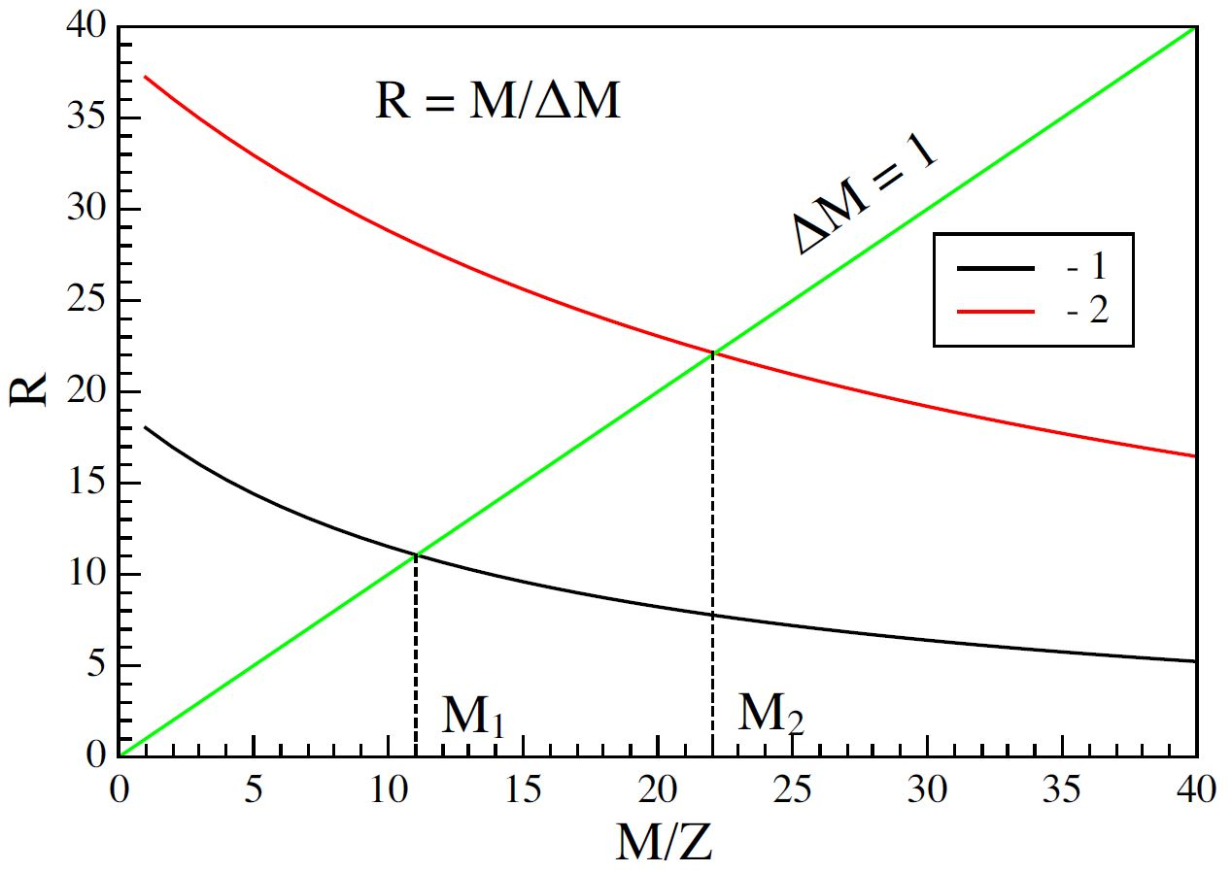 | 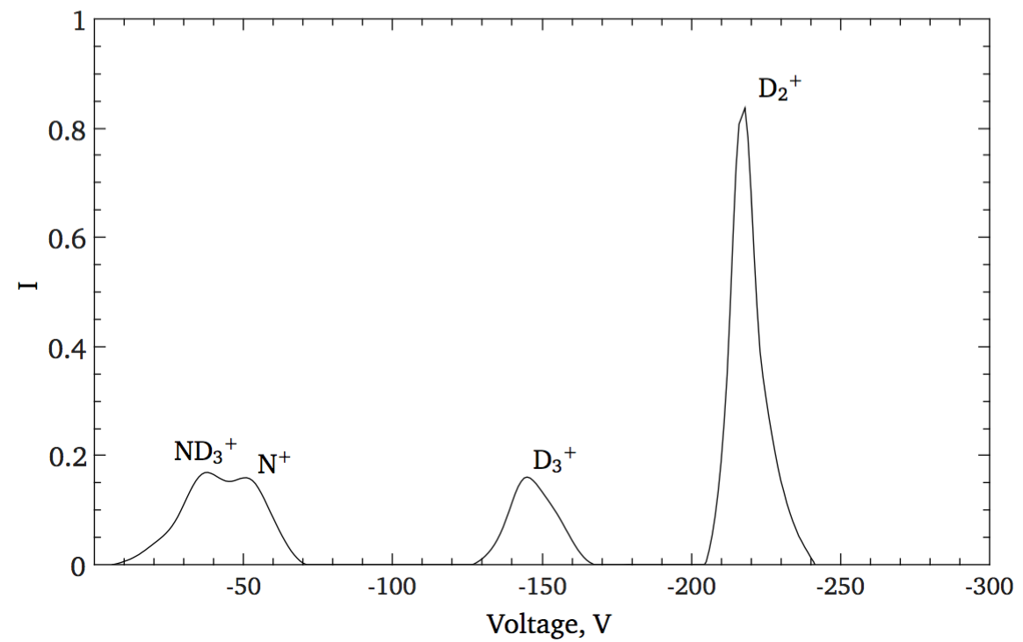
(a) | (b)
Figure 2. Theoretical resolution of MS and minimal resolved masses for two collectors:
1 – r = 3.5 cm and 2 – r = 7 cm (a); Example of mass-spectrum for nitrogen and deuterium (b)

Also CDM is used as a vacuum diaphragm in PR-2 between the electron gun and the main chamber. It provides pressure gradient about two orders for different regimes of the e-gun from vacuum beam transport to arc regime. High distortions in the ion current signal are observed when the gas pressure is above 10⁻¹ Pa. This is caused by the particle scattering and charge exchange processes inside MS. The body of CDM has differential pumping allowing to expand the working pressure range of MS up to vacuum arc regimes of the plasma device at higher pressure (> 10⁻¹ Pa).

RESULTS
CDM was mounted to the magnetic mirror of the plasma device (0.12 T). The functionality of CDM was tested on usual for PR-2 the beam-plasma discharge (BPD). Working gas was the mixture of hydrogen and air, pressure – 5.0×10⁻² Pa in the main vacuum vessel, 10⁻⁴ Pa – in the gun (MS body). The power of the electron gun was 100 W (the accelerating voltage – 1 kV, the emission current – 100 mA). In the selected regime both positive and negative ions were observed. Mass-spectra obtained by CDM are shown in Fig. 3 – 4. Measurement system of the module allows to obtain mass-spectrum for all M/Z ratio range, including negative one, in one experiment.
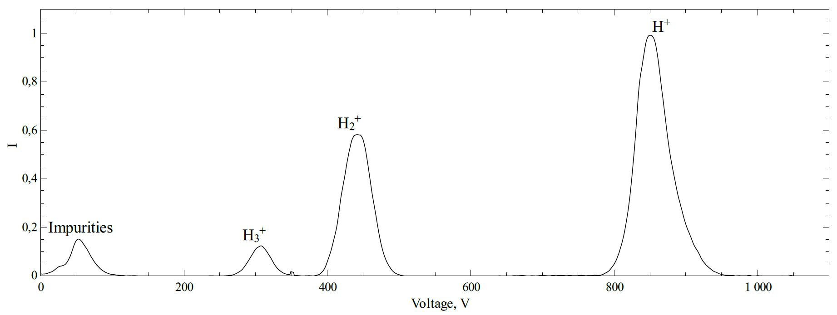
Figure 3. Mass-spectrum of BPD on hydrogen with air admixture measured by the collector at r = 3.5 cm

The rough mass-analysis (cf. Fig. 3) can give brief information about main ion composition of the plasma column for usual light working gases (hydrogen, deuterium, helium). It helps to choose right regimes of the discharge for each plasma-surface interaction experiments and lead to a better interpretation and understanding plasma-chemical kinetics of the discharge. Also there is unresolved mass peak of air admixtures in Fig. 3. The design of CDM permits to mount several detectors at different distance to the center of the entrance slit for each of the M/Z ration range to optimize the mass-resolution.

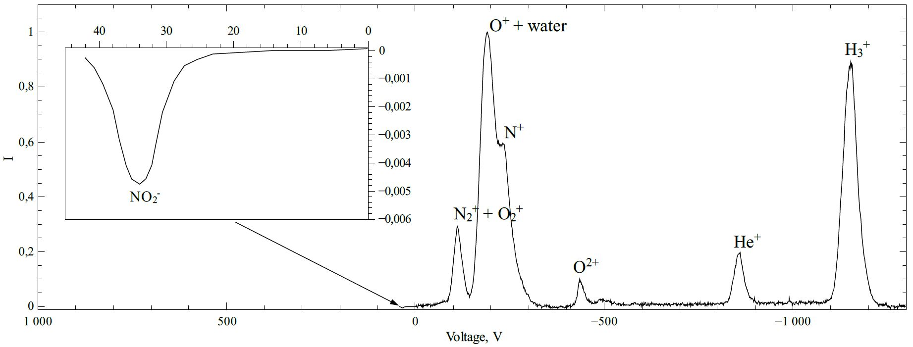
Figure 4. Mass-spectrum of both positive and negative plasma ions of BPD on hydrogen with air admixture measured in one experiment by the collectors at the lower radius (r = 3.5 cm).

Figure 4 shows MS measured by ion detectors at higher radii of ion (positive and negative). In this case it is possible to resolve several main peaks of air admixtures and one of the negative ions (NO₂⁻). Detector at higher radius has better resolution in heavier mass range, but it is also not enough for M/Z > 14 to resolve ions with small ΔM (cf. Fig. 2a). Next modification of CDM will have additional accelerating step improving the mass-resolution of MS by increasing of the radius of the ion trajectories.

CONCLUSION
CDM for in-situ analysis of both the local parameters and ion mass spectrum of magnetized plasmas developed for the linear plasma device PR-2 is presented. It allows to in-situ measure mass-spectrum of both positive and negative ions from plasma column simultaneously during the experiment.
The functionality of CDM was tested on usual for PR-2 the beam-plasma discharge (BPD) at the regime presenting whole ion mass range including negative ones. The insufficient value of MS resolution in M/Z > 14 can be improved by additional accelerating step planned in next modification of the CDM.

ACknowledgments
The work was partly supported by the Competitiveness Growth Program of National Research Nuclear University MEPhI.

References
- D. Nishijima et al., Phys. Plasmas, 14, 103509 (2007)
- A. Kreter et al., J. Nucl. Mater., 417, 651 (2011)
- E.M. Hollman et al., Rev. of Sci. Instr., 72/1, 623 - 626 (2001)
- G.F. Matthews, Plasma Phys. Control. Fusion, 31, 841 - 863 (1989)
- H. Kojima et al., JNM, 128&129, 965-968 (1984)
- O. Waldmann et al., 34th EPS Conf. On Plasma Phys. Warsaw, 31F, 5.108 (2007)
- K.M. Gutorov, V.A. Kurnaev, I.V. Vizgalov, 28th Conf. On Phen. in Ion. Gases (ICPIG) P. 378(2007)

