Development of New Mirror Antenna for Generation of High Intermittent Heat Flux in GAMMA 10 Tandem Mirror
R. Minami^{1, a)}, T. Imai¹, T. Kariya¹, T. Numakura¹, K. Tsumura¹, Y. Ebashi¹,
S. Kajino¹, Y. Endo¹ and Y. Nakashima¹
¹ Plasma Research Center (PRC), University of Tsukuba, Tsukuba, Ibaraki, 305-8577, Japan
^{a)} Corresponding author: minami@prc.tsukuba.ac.jp
Abstract. Electron cyclotron heating (ECH) power modulation experiments in GAMMA 10 tandem mirror have been carried out in order to generate and control the high heat flux and to make the ELM (edge localized mode) like intermittent heat load pattern for divertor simulation studies. The maximum energy density obtained by the use of present mirror antenna systems is about 0.08 MJ/m² and is still far lower than that of ITER ELM. To achieve the generation of higher heat flux, the development of a new mirror antenna has carried out in order to concentrate the heating power on the axis. The calculated e-folding radius of power density has been improved from 63 mm for the present mirror to 40 mm for the new mirror antenna.

INTRODUCTION
The divertor plasma control and plasma wall interaction are urgent issues for ITER and the fusion research because the boundary plasma physics is the key to sustain the steady-state fusion reactor plasma. GAMMA 10/PDX project is aimed to the development of the mirror devices for the fusion-reactor relevant research including: the potential control and the end losses, the transport of particles and heat fluxes, physics of divertor plasma and Plasma Wall Interaction. The divertor plasma simulator which makes use of high heat flux generated at the open end of the GAMMA 10 is called E-Divertor [1].
In GAMMA 10, it is essential to achieve high confining potential with ECH. Fundamental ECH at the plug region (P-ECH) generates the axial ion confining potential φ_{c}. Experimental observation shows that φ_{c} increases with the P-ECH power, and no saturation has been observed as long as the electron density is kept at a certain level. The P-ECH drives a portion of the heated electrons into the loss cone and induces an intense axial flow of warm electrons. Each electron is perpendicularly accelerated or decelerated depending on its motion on a gyro circle. Perpendicularly accelerated electrons gain magnetic moment and these electrons will be exhausted from the resonance surface because of the μ∇B force. A portion of the axially flowing electrons is observed as end losses of electrons.
Recently, over 1 MW, a few seconds, 28 GHz gyrotron for GAMMA 10 and other low B field device ECH source has been developed. Multi-MW and multi-frequency technologies are major issues to challenge for robust and cost effective reactor heating system. The development of the high power 28 GHz gyrotron is major hardware efforts in GAMMA 10/PDX project. In the 28 GHz gyrotron development, the output power has been achieved 1.38 MW in the short pulse test, which is new record in this frequency range.
In plug region, an antenna system composed of an open-ended corrugated waveguide and two mirrors is installed. This system is intended to deliver the microwave power radiation into resonance layer. By usage our electromagnetic (EM) code, the mirrors are designed so as to make the circular cross-section of the beam on the resonance layer. In this code, EM fields are obtained by direct calculation of the Huygens-Fresnel formula, precisely derived from Maxwell’s equations without any approximation. The EM fields radiated from an arbitrary surface can be calculated as long as the source fields are given on it. We represent the shapes of the two mirrors by using analytic functions that include several parameters.
In this paper, experimental results in ECH power modulation and design study of an ECH antenna for control of high intermittent heat flux in GAMMA 10 tandem mirror for the future divertor simulation studies are reported.

EXPERIMENTAL APPARATUS
The GAMMA 10 is the world largest tandem mirror device (full length of 27 m), which is a minimum-B anchored tandem mirror with outboard axisymmetric plug and barrier cells. The plasma confinement is achieved by a magnetic mirror configuration as well as positive and negative potentials at the plug/barrier region formed by ECH. The main plasma confined in the central cell of GAMMA 10 is produced by the wave of the ion cyclotron resonance frequency (ICRF) range. ECH systems (28 GHz, 200 kW at barrier cells and 500 kW at plug and central cells) are prepared for producing plasma-confining potentials in the plug and barrier regions, and also for direct electron heating in the central cell [2]. Neutral beam injections (NBI, 25 kV, 20 A) are prepared for producing hot ions in the central cell and anchor regions.
Figure 1 shows the P-ECH system and locations of the diagnostic systems used in the preliminary P-ECH modulation experiment to generate the high and ELM-like heat flux.
A gyrotron radiates a quasi-Gaussian beam from an output window. The radiated beam is transformed into HE₁₁ mode in the corrugated waveguide of 2.5 inch diameter through the Matching Optics Unit (MOU). The transmission line has two miter bends and it is connected to the GAMMA 10 vacuum vessel. In the vessel, a launcher composed of an open ended corrugated waveguide and two mirrors (M1 and M2) is installed. It radiated the microwave power to the resonance layer as shown in Fig. 1. The microwave beam is obliquely injected into the resonance surface at an angle of 54˚. Power density profile on the resonance surface is well fitted to a Gaussian distribution with an e-folded radius (w) of 63 mm. The mirror M2 can be rotated around the horizontal axis and can change the beam direction [3].
The heat flux is measured by the movable calorimeter. This diagnostics instrument is located at 30 cm downstream from the end-mirror coil (z_{EXIT}=30 cm) and can be inserted from the bottom of the vacuum vessel up to the center axis of GAMMA 10. It is possible to obtain the radial profile of heat flux at z_{EXIT}=30 cm by changing the radial position [4].
The flux and the energy spectrum of the end loss of electrons are measured by a multi-grid energy analyzer (diagnostics of electron loss, LED). End losses enter the analyzer through a small hole on an electrically floating end plate that is located in front of the end wall. The collector current of the analyzer corresponds to the electron current flowing into the end plate [5].
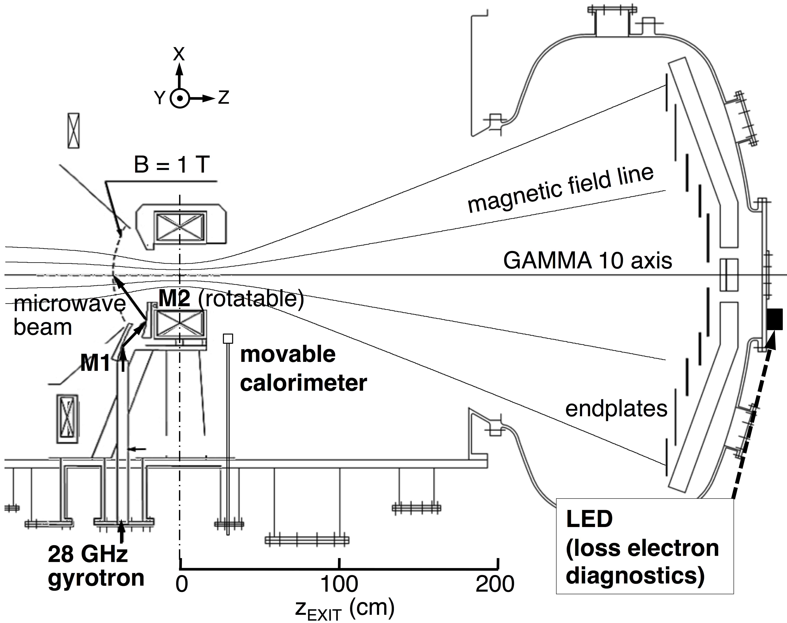
Figure 1. Cross-section of plug and end regions. The powerful microwave beam is propagated from the antenna to the resonance surface with magnetic field of 1.0 T.

EXPERIMENTAL RESULTS AND DISCUSSION
The investigation of plasma flow from the end-mirror exit of GAMMA 10 is carried out to examine its performance relevant to the divertor simulation studies. Typically, the radial profile of the heat flux density measured with the calorimeter had the peak on axis [6]. The peak heat-flux of 17 MW/m² on the axis was obtained by using a movable calorimeter during the P-ECH injection. The heat-flux continues to increase with ECH power. This value almost corresponds to the heat load of the divertor plate of ITER. These data indicate that the P-ECH is able to control the end losses of the ion and electron fluxes by the use of power modulation, which can also produce the arbitrary heat load pattern like the various type of the ELM. The maximum value of the one pulse energy density is about 0.08 MJ/m² with the power of 380 kW for 5 ms. The one pulse energy density is still far lower than ITER level [7,8].
A major goal of ELM simulation experiments in GAMMA 10/PDX project has been to study how the ELM like pattern of intermittent heat load has an effect on divertor plate. It is not able to simulate the energy distribution or charged species of ELM. It is only able to simulate the heat load produced by high energy electrons in GAMMA 10. However, it is able to obtain the experimental data on modification of target materials under the pulse heat load equivalent to ELM, which is produced by not electron beam but thermalized electrons. The target of ELM simulation experiments in GAMMA 10/PDX project is to clarify the physical mechanism of effects on irradiated material under the pulse heat load equivalent to ELM, which are including the plasma wall interaction (PWI) studies. Besides, the combined irradiation with high energy ion beam using NBI is under consideration.
For the ELM simulation experiments in the future, we have started development of over-1.5 MW gyrotron at 28 GHz. The first tube of 28 GHz gyrotron with 1 MW and a few seconds pulse duration has been already fabricated and tested [9] as an ECH source for GAMMA 10 and other low B field devices. The obtained maximum output of this source is 1.38 MW. Thus, if new gyrotron is applied to ECH system, three-time progress in ECH power sources is expected.
To achieve the generation of higher heat flux, it is necessary to design a high efficiency mirror antenna. The design of the mirrors has determined the surface of M1 and M2. We have represented the shapes of the two mirrors M1 and M2 using analytic functions that include several parameters. We have chosen an ellipsoid for M1 so that it converges the beam on M2. The two focal points of the ellipsoid are taken as the center of M2 and a point on the waveguide axis, respectively. The microwave beam is sufficiently converged on M2 and more than 99% of the power radiated from the waveguide is, as a result, transmitted to M2. The shape of M2 is assumed to be a quadratic with some higher-order corrections added to extend the degree of freedom as

(1)

The calculation parameters of new M2 are optimized so that it converges the beam on resonance layer.
Figure 2(a) and 2(b) show the calculated power density profiles on the resonance layer obtained in case of usage of present mirror and new mirror (M2) design. In new design, it is achieved that the e-folding radius w of the power density of the radiation distribution on the resonance surface is 40 mm and only M2 surface is arranged without change of another mirror (M1). The power density on the axis is inversely proportional to the square of w. Thus, if new mirror (M2) is applied to ECH system, more than two-times progress in the power density on the axis is expected.
Preliminary experiment has been carried out to clarify the effect of the new mirror antenna with the narrower power density profile. In this preliminary experiment, the new mirror antenna has been applied to one side of the P-ECH system only (west side of GAMMA 10). Another side (east side of GAMMA 10) antenna is same as the present mirror. Figure 2(c) shows the power P_{e} of the electron end loss as a function of the P-ECH power P_{P-ECH}. The axial heat flow is estimated from the product of effective electron temperature T_{eff} and electron current Ie measured by the LED. As can be seen from Fig. 2(c), the significant increment of T_{eff} ⋅ I_{e} has been observed although the improvement of only one side antenna has been applied.
As a result, it seems reasonable to conclude that the effectiveness of concentrated power density has been confirmed for the generation of higher heat flux on the axis of GAMMA 10. Thus, if new mirrors are applied to both sides of GAMMA 10, once more higher electron heat flux can be generated.

Figure 2. Power density profiles on the resonance surface radiated from (a) present and (b) new mirror antennas, respectively. Each origin indicates the GAMMA 10 axis. The contours are linearly plotted and the outermost contour indicates 1/10 of the peak power density. (c) The end loss electron power is plotted value of the product of effective electron as a function of P-ECH power P_{P-ECH}. These data are obtained by the use of present (closed circle) and new (open circle) mirror antennas.
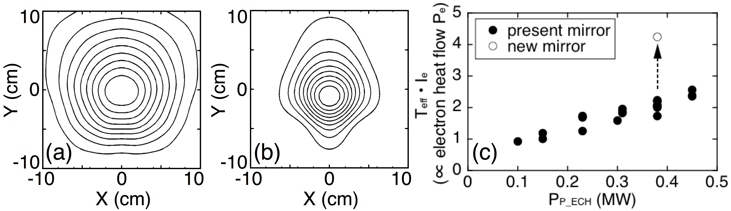

SUMMARY
ECH power modulation experiments in GAMMA 10 have been carried out in order to generate and control the ELM-like high heat flux for divertor simulation studies. The maximum absolute value of the one pulse energy density on the GAMMA 10 axis is about 0.08 MJ/m² with the power of 380 kW for 5 ms. The design study of new mirror antenna and MW gyrotrons have been started and narrower power density profile on the resonance surface have been achieved in calculation. The significant increase in the end loss electron power has been observed although the improvement of only one side antenna has been applied. The effectiveness of concentrated power density has been confirmed for the generation of higher heat flux on the axis of GAMMA 10. It remains a challenge for future research to approach the ITER level ELM energy density by the upgrade and the combination of the multi-MW gyrotron and the new mirror antenna on both sides of GAMMA 10.

Acknowledgments
The authors thank the members of the GAMMA 10 group of the University of Tsukuba for their collaboration and valuable discussion during this study. This work is partially supported by the grant-in-aid for Scientific Research from Ministry of Education, Science, Sports and Culture of Japan (Grant No. 25249141) and National Institute for Fusion Science (NIFS) Collaborative Program (No. NIFS14KUGM090).

References
[1] T. Imai et al., Trans. Fusion Sci. Technol. 59, 1T, 1 (2011).
[2] T. Kariya et al., Trans. Fusion Sci. Technol. 51, 2T, 397 (2007).
[3] Y. Tatematsu et al., Jpn. J. Appl. Phys. 44, No. 9A, 6791 (2005).
[4] Y. Nakashima et al., “Generation and Characterization of High Heat-Flux Plasma-Flow for Divertor Simulation Studies using a Large Tandem Mirror Device,” 23rd IAEA Fusion Energy Conf., FTP/P1-33 (2010).
[5] T. Saito et al., Fusion Eng. Des. 26, 241 (1995).
[6] Y. Nakashima et al., J. Nucl. Mater. 415, S996 (2011).
[7] G. Janeschitz et al., J. Nucl. Mater. 290-293, 1-11 (2001).
[8] G. Federici et al., J. Nucl. Mater. 290-293, 260-265 (2001).
[9] T. Kariya et al., Nucl. Fusion 55, 093009 (2015).

