H+ and D+ High Current Ion Beams Formation from ECR Discharge Sustained by 75 GHz Gyrotron Radiation
V. Skalyga^{1,2, a)}, I. Izotov^{1,2}, S. Golubev¹, S. Razin¹, A. Sidorov^{1,2}
¹ Institute of Applied Physics, Russian Academy of Sciences.
46 Ulyanova st., Nizhniy Novgorod, Russian Federation
² Lobachevsky State University of Nizhni Novgorod (UNN)
23 Prospekt Gagarina, Nizhniy Novgorod, Russian Federation
^{a)}Corresponding author: skalyga@ipfran.ru
Abstract. Operation of modern high power accelerators often requires production of intense beams of hydrogen ions. H⁺ and D⁺ beams are utilized or envisioned for use in linear accelerators. Requirements for the brightness of such beams grow together with the demand of accelerator development and arising experimental needs. New facilities aiming at outperforming the previous generation accelerators are usually designed for higher beam currents. Enhancing the hydrogen beam intensity and maintaining low transverse emittance at the same time is, however, becoming increasingly difficult. The most modern accelerators require hydrogen ion beams with currents up to hundreds of mA (pulsed or CW), and normalized emittance less than 0.2-0-3 π·mm·mrad to keep the beam losses at high energy sections of the linac below commonly imposed 1 W/m limit. The latest results of high current H+ and D+ beams formation from plasma of ECR discharge sustained by 75 GHz / 200 kW gyrotron radiation in open magnetic trap of simple mirror configuration at the Institute of Applied Physics (IAP RAS) are presented. High microwave power and frequency allow sustaining higher density hydrogen plasma (n_{e} up to 7·10¹³ cm⁻³) in comparison to conventional ECRIS’s or microwave sources. The low ion temperature, on the order of a few eV, is beneficial to produce light ion beams with low emittance. Results on ion beam extraction and emittance measurements are presented.

Introduction
Recently generation of high current proton and deuteron beams was investigated at SMIS 37 facility [1,2,3] at the Institute of Applied Physics (IAP RAS). SMIS 37 has been constructed for production of high current beams of multicharged ions. However, due to the substantial potential exhibited by the setup, we found it reasonable to test its capabilities for proton beam production. At this experimental setup plasma is created and electrons are heated by 37.5 GHz gyrotron radiation with power up to 100 kW in a simple mirror trap under ECR condition. Using of such high frequency of microwave (in comparison with conventional ECRIS’s) allows to create and sustain plasma with significantly higher density (up to 2·10¹³ cm⁻³) [2] and at the same time to maintain the main advantages of conventional ECRIS such as high ionization degree and low ion energy (on the order of a few eV). Reaching such high plasma density relies on the fact that the critical density for the microwave radiation grows with the frequency squared. Using high microwave power allows to keep the average electron energy on a high enough level (50-300 eV) for efficient hydrogen ionization even in the case of so-called quasi gasdynamic regime of plasma confinement [3] at neutral gas pressure range of 1∙10⁻⁴ - 1∙10⁻³ Torr.
The quasi gasdynamic confinement regime is characterized with low ion trapping time. Plasma losses from the magnetic trap are determined by ejection of charged particles through the plugs with ion sound velocity. Typical value of plasma lifetime in such regime at SMIS 37 is on the order of 10 µs. Such low lifetime together with extremely high plasma density allows to produce unprecedented plasma fluxes in any types of ion sources. The peak density of the plasma flux at the magnetic plug (mirror) at SMIS 37 is about 10 A/cm². The quasi gasdynamic confinement of ECR plasma and parameters of the source in this regime have been described previously in a number of publications, e.g. in [2,3].
The experimental results described in [4,5] demonstrate the feasibility of high power millimeter wave quasi-gasdynamic ECR ion sources for the production of high brightness proton beams with favorable species fraction. For the next experimental step on H+ and D+ ion beams production SMIS 37 facility was upgraded up to SMIS 75 by replacing of the old gyrotron with the new one with 75 GHz radiation frequency and 200 kW peak power. Present paper is devoted to the latest results on ion beam formation using modified facility.

SMIS 75 experimental facility
The experimental research presented in this work was carried out on the SMIS 75 shown schematically in Fig. 1.
FIGURE 1. SMIS 75 experimental setup.

A gyrotron generating a Gaussian beam of linearly polarized radiation at the frequency of 75 GHz, with the power up to 200 kW, and pulse duration up to 1.5 ms was used as a source of pulsed microwave radiation. The microwave radiation is launched into the plasma chamber through a quasi-optical system consisting of 2 mirrors, quartz (vacuum) window and a special microwave coupling system shown on the left in Fig. 1. The setup has been designed for efficient transport of the radiation avoiding parasitic resonances and plasma flux impinging the quartz window. A simple mirror trap was used for plasma confinement. The magnetic field in the trap was produced by means of pulsed solenoids, spaced 15 cm apart. The current pulse with the shape close to half period of a sinusoid had the duration of 11 ms with the magnetic field variation during the microwave pulse being less than 3%. Magnetic field in the plug was varied from 2.7 to 4 T (ECR for 75 GHz is 2.7 T). Ratio of the maximum and minimum magnetic fields of the trap was equal to 5 (i.e. Bmax/Bmin). The hydrogen inlet into the source was realized through an opening incorporated with the microwave coupling system. The delay between hydrogen injection and subsequent microwave pulse (300-3000 µs) as well as gas pulse duration (about 5 ms) were adjusted for each experimental condition in order to maximize the beam current and optimize the temporal shape of the extracted current pulse. Ion extraction and beam formation were realized by two-electrode, i.e. single gap plasma electrode - puller electrode, system. A few sets of the electrodes were tested in experiments. A Faraday cup was placed just behind the end of puller electrode to measure the total beam current passing through the extractor. For measuring of the transverse ion beam space distribution a small moveable Faraday cap with 3 mm diameter was used. Emittance of the extracted beam (all species together) was measured with “pepper-pot” method, which has been successfully tested earlier at SMIS 37.“Pepper-pot” plate was placed 1 mm downstream from the puller with another 55 mm gap before a CsI scintillator for beam imaging.

Experimental results
Results on beam hydrogen beams formation with different extraction system configuration are presented. At first extractor with 5 mm plasma electrode aperture and 10 mm puller aperture with 11 mm gap was used. In figure 2 examples of Faraday cup and puller currents oscillograms together with averaged current dependence on extraction voltage are shown.
FIGURE 2. Faraday cup and puller currents oscillograms in case of 55 kV extraction voltage (on the left). Averaged current dependence on extraction voltage (on the right).

As the next step the ion beam space distribution was studied using the small moveable Faraday cup. Current distribution was measured in the transverse plane to the beam direction at a few distances downstream the puller: 21, 30 and 40 mm. Result are shown in figure 3 together with beam diameter dependence on the distance from the extraction system.
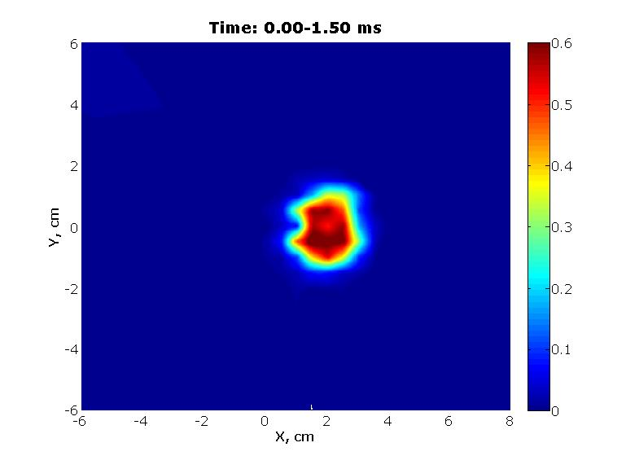 | 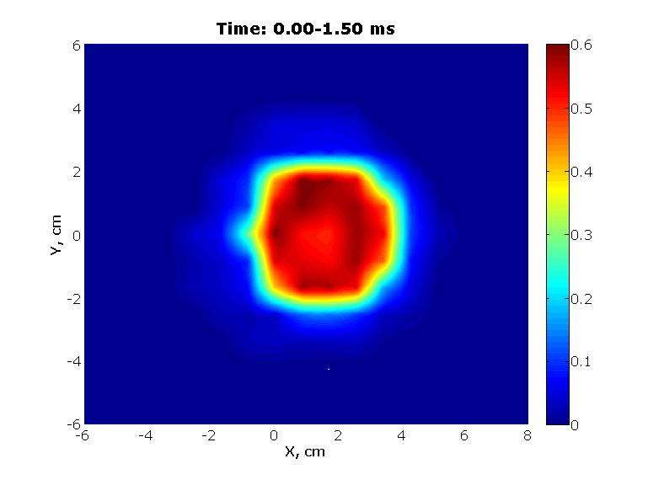
a) | b)
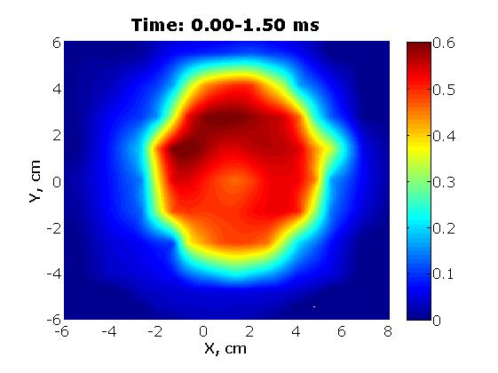 | 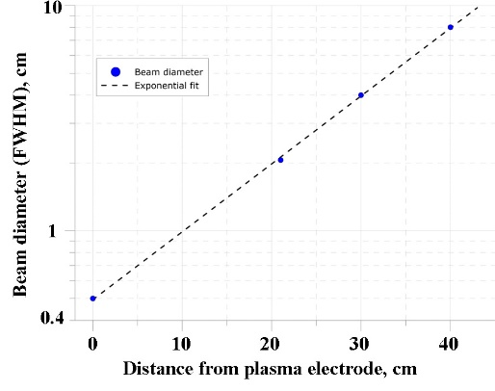
c) | d)
FIGURE 3. Beam current distribution in the transverse plane to the beam direction at 21 mm – a), 30 mm – b) and 40 mm – c) downstream the puller and ion beam diameter dependence on the distance from the extraction system – d).
Data in figure 3 - d) shows that beam divergence grows with the distance from extraction system. It happens due to not compensated space charge in the beam and that means that for future applications it would be necessary to use 3-electrode extraction system to avoid electron drain from the beam back to plasma. Then extractor with 7 mm plasma electrode aperture and 22 mm puller aperture with 11 mm gap was used. The maximum achieved ion beam current at 55 kV of acceleration voltage was 380 mA. And as the last step extractor with 10 mm plasma electrode aperture and 22 mm puller aperture with 11 mm gap was used. The maximum achieved ion beam current at 55 kV of acceleration voltage was 500 mA. Ion beam emittance study was performed using “pepper-pot” method. Paper-pot plate was placed in 1 cm behind puller end. In case of all extraction system configurations measurements gave the same result. Example of the reconstructed emittance diagram is shown in figure 4. The rms normalized emittance appeared to be 0.03 π∙mm∙mrad. As it was mentioned above beam quality on the longer distance from the puller suffers from the not compensated space charge and in future development must be corrected with the third electrode in extraction system. Equivalence of emittance for different extraction apertures means that experimental value is determined by measuring precision and the real emittance value must be lower.Also experimental results with hydrogen and deuterium were also similar, signal difference was not observed in case of pulse to pulse stability about 10 %. In frames of performed experimental studies hydrogen ion beams with current up to 500 mA and rms normalized emittance 0.03 π·mm·mrad were produced. In comparison with results previously obtained at SMIS 37 facility in case of 75 GHz gyrotron radiation frequency it is possible to produce ion beams with much higher brightness.
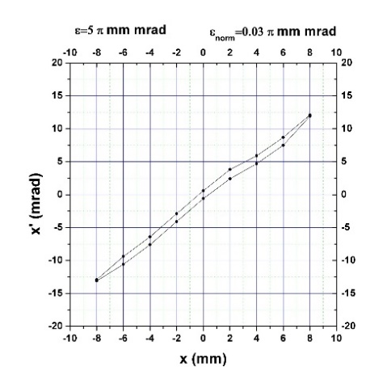
FIGURE 4. Ion beam emittance diagram. Extractor: 5 mm plasma electrode aperture and 10 mm puller aperture with 11 mm gap. rms normalized emittance is be 0.03 π∙mm∙mrad.

Acknowledgments
Work was performed in frame of realization of federal targeted program “R&D in Priority Fields of the S&T Complex of Russia (2014-2020)” contract #14.604.21.0065 (unique identification number RFMEFI60414X0065).

References
[1]. S. Golubev, I. Izotov, S. Razin, A. Sidorov, V. Skalyga, A. Vodopyanov, V. Zorin, A. Bokhanov.. Nuclear Instruments and Methods in Physics Research B, v. 256, p. 537 – 542 (2007).
[2] V. Skalyga, V. Zorin, I. Izotov, S. Razin, A. Sidorov, A. Bohanov.. Plasma Sources Science and Technology v.15, p. 727-734 (2006).
[3] V.Skalyga, I.Izotov, S.Golubev, A.Sidorov, S.Razin, A.Vodopyanov, O.Tarvainen, H.Koivisto, T.Kalvas. Review of Scientific Instruments. 87, 02A716 (2016)
[4] V. Skalyga, I. Izotov, A. Sidorov, S. Razin, V. Zorin, O. Tarvainen, H. Koivisto, T. Kalvas.. JINST, v.7, P10010 (2012).
[5] V. Skalyga, I. Izotov, S. Razin, A. Sidorov, S. Golubev, T. Kalvas, H. Koivisto, and O. Tarvainen. Review of Scientific Instruments, v. 85, no. 2, 2014, p. 02A702-1 – 02A702-3.

