Studies of Plasma Production in a Linear Device with Plane LaB₆ Cathode and Hollow Anode
T. D. Akhmetov^{1, 2, a)}, V. I. Davydenko^{1, 2}, A. A. Ivanov^{1, 2}, G. I. Shulzhenko¹,
A. Kreter³, and B. Unterberg³
¹Budker Institute of Nuclear Physics SB RAS, 11 Lavrentieva prospect, 630090, Novosibirsk, Russia
²Novosibirsk State University, 2 Pirogova str., 630090, Novosibirsk, Russia
³Forschungszentrum Jülich GmbH, Institut für Energie- und Klimaforschung – Plasmaphysik,
52425 Jülich, Germany
^{a)}Corresponding author: t.d.akhmetov@inp.nsk.su
Abstract. A plane circular LaB₆ cathode and a hollow anode are used for the arc discharge plasma production in a newly developed linear plasma device with the axially symmetric magnetic field. The cathode is heated by radiation from a graphite foil flat spiral. A separately powered magnetic coil located around the plasma source is used to vary the radial distance between the outermost magnetic field line from the cathode and the inner anode surface. The discharge geometry defines distinct operational modes: partially direct discharge and magnetic insulation. The magnetic field in the source can be varied from 0 to 2.4 kG while preserving the chosen field geometry, with the discharge voltage and current depending on the particular mode. A hydrogen plasma stream with a density of up to 1⋅10¹³ cm⁻³ and a diameter of about 4 cm is produced. The discharge characteristics and the plasma parameters do not change significantly between the two modes and in a relatively broad range of magnetic fields.

INTRODUCTION
Plasma-material interaction studies usually require a steady-state uniform plasma flow at a sample of several centimeters in size, and a density of about 10¹³ cm⁻³ in a magnetic field of several kilogauss [1]. Such plasmas can be produced using large-area LaB₆ (lanthanum hexaboride) hot cathodes [1–3]. The PISCES plasma generator with a LaB₆ disk cathode demonstrated good performance and capability of continuous operation [2]. An alternative configuration is used at the linear plasma device PSI-2, where the steady-state plasma is produced by an arc discharge between a cylindrical LaB₆ cathode and a hollow anode [1,4]. The front surface of this cathode is mapped on to the inner surface of the anode along the magnetic field lines, and the plasma density is peaked off-axis.
Here we report the experimental results from an upgraded version of the linear device [3] with a plane disk cathode, a new conical anode, and increased magnetic field. Unlike the previous design, now the geometry of the magnetic field is preserved as the magnetic field strength is varied. The discharge is operated in two main modes which are different in terms of the projection of the outer edge of the cathode toward the inner surface of the anode along the magnetic field lines. The first mode is characterized by a finite radial gap between the edge field line and the inner anode surface and will be referred to as the magnetically insulated discharge. In the second mode the field lines from a ring at the cathode edge intersect the conical anode surface. This mode will be referred to as the partially direct discharge or quasi-PSI mode, because its geometry has been intentionally made very similar to the arc discharge at PSI-2 [1,4] in order to compare the electrical parameters of discharges and the plasma density radial distributions. To make this similarity close, our stand was equipped with a conical anode an the magnetic field in the anode was made approximately two times larger than at the cathode with the maximum field in the anode up to 2.05 kG in this mode compared with 1.7 kG in PSI-2. The remaining substantial difference is that we use the disk cathode which provides the electron emission over the whole area including the near-axis region, whereas at PSI-2 the cylindrical cathode emits electrons only at the circular periphery.

PLASMA SOURCE AND LINEAR DEVICE
The plasma source is located inside a linear device [3] with three main magnetic coils and a vacuum chamber 14 cm in diameter and 75 cm in length. Two discharge mode configurations are shown in Fig.1. The linear device is attached to a larger vacuum chamber which serves as a pump for neutral gas and as a plasma stream neutralizer.

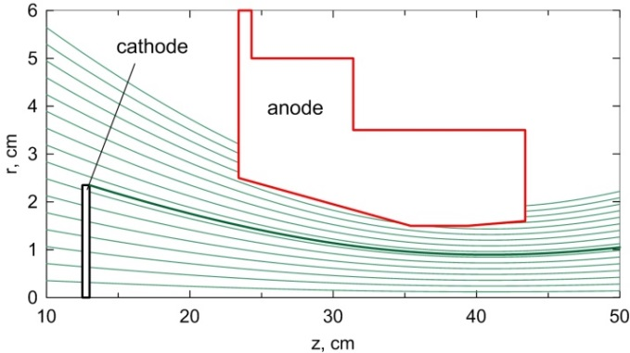 | 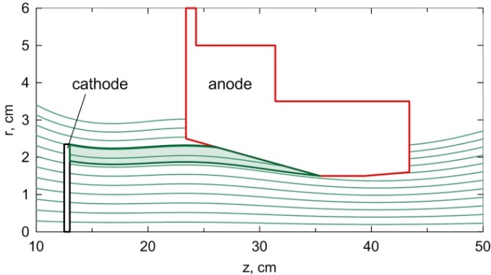
(a) | (b)
Figure 1. Discharge geometry: (a) magnetically insulated mode, (b) partially direct discharge mode.
Probe is located at z=52 cm.

Therefore, this is a pulse device, with duration limited either by excessive growth of neutral gas pressure or by the arc power supply. The working gas (hydrogen in our case) is injected through the cathode flange by a valve. In a long-pulse regime (up to 2 s) the results occurred to be controversial, because steady-state arc current and voltage could not be achieved when the arc current exceeded several tens of amps. This is most likely associated with the gradual increase of the base pressure in the large chamber and with the excessive additional cathode heating by the ion flow from the plasma. Therefore, in order to operate at high arc currents, we switched over to a short-pulse mode using a new capacitor power supply. The discharge current can be adjusted by changing a ballast resistor in the power supply and/or by varying the charging voltage of the capacitor bank.
Experimental settings:
Cathode heater: 0.8–1.0 kW (I ≈ 60 A, U ≈ 15 V),
Magnetic field in the anode: up to 2.4 kG in the magnetically insulated mode, Fig.1(a),
and up to 2.05 kG in the partially direct mode, Fig.1(b),
Base vacuum: 6⋅10⁻⁵ Torr, vacuum vessel volume ≈ 0.17 m³,
Gas feed (H₂): 25–150 sccm, gas pressure in the vessel by the end of a 0.2 s pulse < 2.5 mTorr,
Arc discharge: I_{max} = 300 A, U_{max} = 800 V, pulse duration 20 ms using the new power supply.

The LaB₆ disk cathode with the open emitting surface 47 mm in diameter is heated by radiation from a flat spiral cut from a 0.5 mm thick flexible graphite sheet. The heater shape is stable at operating temperatures necessary to achieve the temperature of the cathode near 1600 °C required for the initial thermal emission current of several A/cm². The cathode and the heater are surrounded by heat shields made of 8 layers of tantalum foil and graphite foil. After about 30 minutes of gradual heater current ramp-up the cathode is ready for operation. Let us estimate the cathode temperature and the electron emission current. It is reasonable to neglect radiation and conduction heat losses from the rear side of the cathode. In steady-state conditions the heater power is equal to the sum of the power radiated from the open cathode surface and the power required for electron emission from the surface
where ε is the cathode emissivity, σ is the Stefan–Boltzmann constant, T is the cathode temperature, S is the cathode area, j_{e} is the electron emission current density determined by the Richardson-Dushman equation, and ϕ_{wf} is the work function. This equation determines the cathode temperature as a function of the heater power. Taking W_{heater}=0.9 kW, S=17.3 cm², ε=0.8, and ϕ_{wf}=2.9 eV [5], the cathode temperature is T=1507 °C, the radiated power is 0.8 kW, the electron current density is j_{e} =2.2 A/cm² which gives the total electron current I_{e}=38 A. Since we neglected other heat losses, this is the estimate of the cathode temperature and of the emission current from above. When the discharge begins, the cathode is additionally heated by the impact of the plasma ions accelerated in the cathode sheath. As a result, the electron emission increases until the final steady state is achieved. Depending on the heater power and on the arc voltage, the current ranges from 30 to 180 A. The total current is the sum of the electron emission current and of the much smaller ion current from the plasma to the cathode.

EXperimental performance
Voltage-current characteristics of both discharge modes are shown in Fig.2. In the magnetically insulated mode the arc voltage tends to decrease as the gas flowrate grows, and at high magnetic field (2.4 kG in the anode) the discharge voltage is ~20 V higher than in weak field (0.8 kG). Most of the further experiments were conducted at 50 sccm hydrogen flowrate.

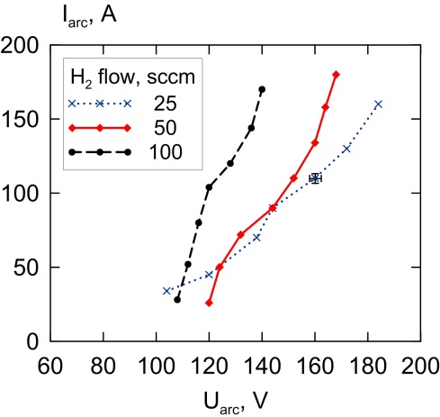 | 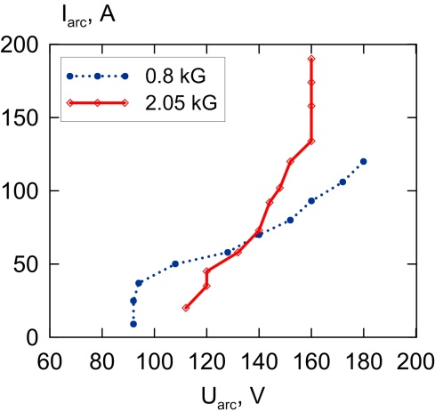
(a) | (b)
Figure 2. Voltage-current characteristics of the discharge: (a) magnetically insulated mode at several gas flowrates
(2.40 kG in the anode), (b) partially direct mode (50 sccm gas flowrate).

Voltage-current characteristics of the discharge in the magnetically insulated mode and in the partially direct mode can be compared respectively with the I(U) data from the magnetically insulated discharge at PISCES [2] and with the measured and theoretical I(U) dependence from PSI-1 where the zone of the direct discharge was considered [4]. These I(U) plots have similar growth of the arc current with the arc voltage. However, in our case the discharge voltage is larger than ~100 V compared with ~70 V in PSI-2 (70 sccm of D₂ gas, 7 kW arc power, cylindrical cathode, B = 1.6 kG at the anode) and ~70 V in PISCES.
The discharge resistance weakly decreases with the discharge power in both discharge modes. At high magnetic field and at the arc power above 20 kW sufficient for dense plasma production, the resistance of both discharges is 1–1.5 Ohm. The ion saturation current at the axis in the partially direct discharge mode is proportional to the arc power and within the measurement accuracy is the same for 0.8 and 2.05 kG field in the anode.
Better knowledge of potential distribution is beneficial for understanding of the discharge physics in the two modes. We used a double probe to measure the radial profiles of the ion saturation current, electron temperature, and floating potential. Variation of the electron temperature with radius is substantial, so we used T_{e} data to estimate the plasma density profiles. Figures 3–4 show the floating potential profiles, and plasma density and electron temperature in both modes. The floating potential is measured relative to the ground. Also the “anode shadow” is shown, which corresponds to the radius of the anode hole at the rear end of the anode. The electron temperature was measured at three radial positions: at r=0, 15, 25 mm. The cathode potential is typically –80–100 V relative to the ground. In larger magnetic field the on-axis plasma density is slightly higher. However, the width of the density profile is the same. Plasma densities in both modes are comparable, and it is remarkable that in both modes the plasma density is peaked at the axis.
The experimental results obtained in the two modes apparently contradict the intuitive expectation that the discharge in the magnetically insulated mode should be the one with higher voltage and relatively smaller current, because the cathode is separated from the anode by a substantial gap across magnetic field. The dependence of the arc current and voltage as well as the plasma density on the magnetic field turned out to be very weak. There is also little difference between the modes in the arc current, voltage, and in the plasma density profiles.
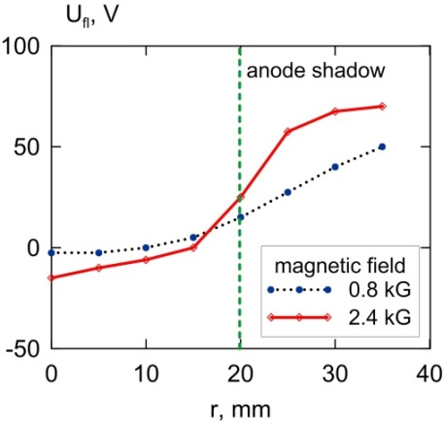 | 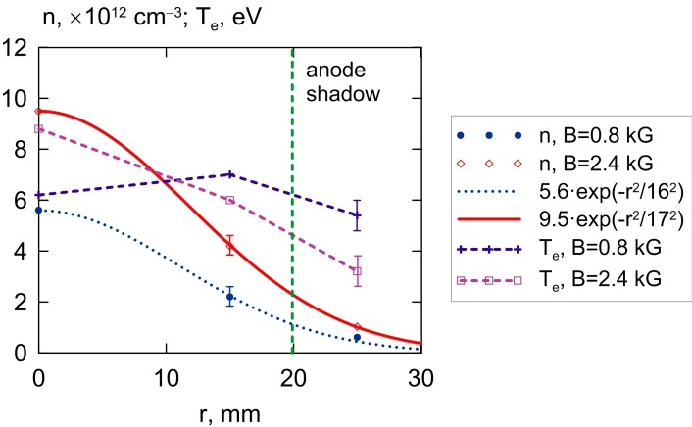
(a) | (b)
Figure 3. Magnetically insulated mode: (a) floating potential profiles, (b) plasma density: experimental points and gaussian fit, and electron temperature.

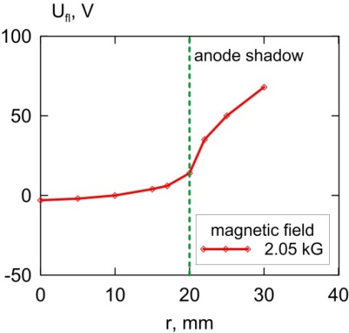 | 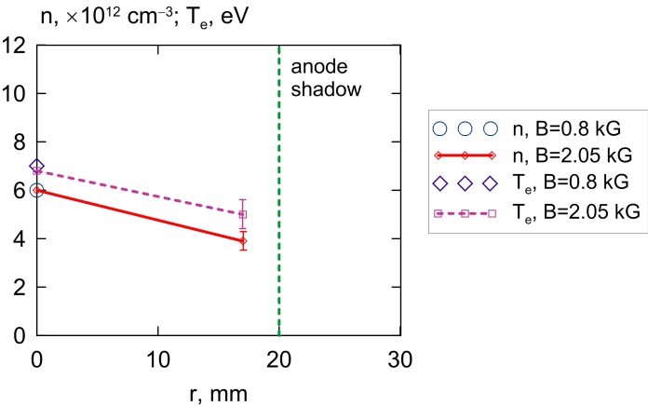
(a) | (b)
Figure 4. Partially direct discharge mode: (a) floating potential, (b) plasma density and electron temperature.

In summary, the plasma source produces the plasma stream in magnetic field up to 2.4 kG with the density about 10¹³ cm⁻³, the core electron temperature of 6–10 eV, and the diameter of 4 cm, which makes this plasma suitable for linear devices for plasma-material interaction studies.

Acknowledgments
This work has been supported by Russian Science Foundation (project N 14-50-00080).

References
- A. Kreter, C. Brandt, A. Huber, S. Kraus, S. Möller, M. Reinhart, B. Schweer, G. Sergienko, and B. Unterberg, Fusion Sci. Technol. 68, 8–14 (2015).
- D. M. Goebel, Y. Hirooka, and T. A. Sketchley, Rev. Sci. Instrum. 56, 1717–1722 (1985).
- T. D. Akhmetov, V. I. Davydenko, A. A. Ivanov, A. Kreter, V. V. Mishagin, V. Ya. Savkin, G. I. Shulzhenko, and B. Unterberg, Rev. Sci. Instrum. 87, 056106 (2016).
- D. Naujoks, G. Fussmann, and H. Meyer, Contrib Plasma Phys. 38, S1, 127–133 (1998).
- E. Chu and D. M. Goebel, IEEE Trans. Plasma Sci., 40, 2133–2144 (2012).

