Observation of Dust Particles Ejected from Tungsten Surface under Impact of Intense Transient Heat Load

A.A. Kasatov1, 2, a), A.S. Arakcheev1, 2, 3, A.V. Burdakov1, 3, I.V. Kandaurov1, V.V. Kurkuchekov1, 2, V.A. Popov1, 2, A.A. Shoshin1, 2, D.I. Skovorodin1, 2, Yu.A. Trunev1, 2, A.A. Vasilyev1, 2 and L.N. Vyacheslavov1, 2

1Budker Institute of Nuclear Physic SB RAS, Novosibirsk, 630090, Russia

2Novosibirsk State University, Novosibirsk, 630090, Russia

3Novosibirsk State Technical University, Novosibirsk, 630092, Russia

a) Corresponding author: [a.a.kasatov@gmail.com](mailto:a.a.kasatov@gmail.com)

**Abstract.** A test facility for experimental simulation of transient heat load expected for ELMs type I events in ITER is developed at BINP SB RAS. Dynamics of tungsten particles in the ablation plume is investigated by small-angle light scattering technique and using fast CCD and ICCD cameras. The threshold of intense particle generation, sizes and velocities of particles ejected from the surface are estimated.

# Introduction

Tungsten erosion is highly increasing under impact of intense transient heat loads corresponding to ITER-relevant ELMs type I events and major disruptions. Such heat loads can reach energy density of 5-80 MJm-2, power density of 5 - 25 GWm-2 and the heating time of 0.3 – 3 ms [1, 2]. The heightened erosion is associated with creation of melt layer and ejection of dust particles. The dust particles might penetrate to the hot plasma, which leads to strong radiation and degrades plasma performance. In addition, dust particles are accumulated inside the vacuum vessel and absorb tritium.

High power electron beam (up to 10 MW, up to 0.3 ms) [3, 4] is employed for experimental simulation of the impact of intense transient heat loads at the level expected in the ITER divertor. The impact produced by the electron beam on the metal target is characterized by small direct pressure and low effect of vapor shielding. These peculiarities permit simulation of impacts of intense transients on tungsten under different conditions compared with plasma guns and lasers. High power density with low attendant background light give new capabilities for experimental simulation of transient heat loads corresponding to ITER-relevant ELMs type I.

# Experimental setup

## Beam Source

High power long pulse electron beam (70 - 120 kV, 10 - 100 A) with almost rectangular pulse shape having duration of 0.1 - 0.3 ms is employed for experimental simulation. Electron beam is generated in a guiding magnetic field of 0.01 T then it is compressed passing to the target in converging magnetic field, which reaches 0.2 - 0.3 T at the tungsten target. In the typical operation modes the beam cross-section is compressed more than 20-fold. Calorimetric measurements showed that 51 % of ejected electron beam energy is absorbed by the target. Power density on the target (area of about 1 cm2) is up to 15 GW/m2. The heat flux parameter exceeds value of FHF =250 MJm-2s-0.5.

## Diagnostic System

In the experiments carried out on the GOL-3 device, several techniques for in situ diagnostic of ablated material are employed [5, 6]. Targets from rolled tungsten with size of 25 х 25 mm2 and thickness of 3 - 4 mm were used in these experiments. The technique of small-angle scattering of continuous-wave laser light and fast visualization of droplets are used to observe the dynamics of dust particles emitted from the target during and after the pulsed heating.

The laser has the following characteristics λ = 532 nm, output power P = 0.7 W. The probe laser beam is parallel to the target surface at distance of 5 - 7 mm from it. The light scattered by dust particles is collected by lenses into inputs of 1 mm-diameter silica fibers and directed to the three recording channels based on PMT. The scattered light is recorded in three different angular ranges relative to the incident laser beam (0.01 - 0.03 rad, 0.07 - 0.09 rad, 0.1 - 0.12 rad).

Fast CCD and ICCD cameras (SDU-285 and image intensifier EPM44G) are used for observation of dust particles. Imaging of hot particles without laser illumination with 2-500 μs exposure enables measurement of particle velocities after heating pulse.

# Experimental results and discussion

The waveforms of the scattering signal are shown in Fig. 1. The curves corresponding to signals in different channels are labeled in the Fig. 1 by characteristic sizes of particles. The duration of scattering signal is variable and is typically a few milliseconds. Waveform analysis shows that relatively small particles (1 - 4 μm) reach the laser beam before the larger particles (6+ μm), and consequently small particles have greater velocity (100+ m/s) than the larger one.

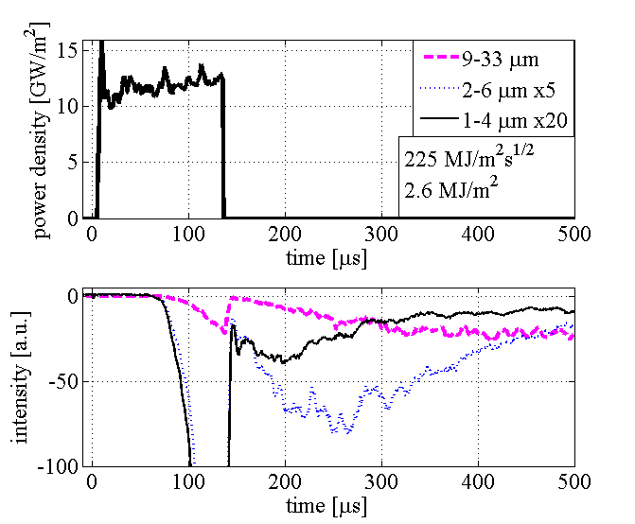

**Figure 1.** Waveforms of heat load (top) and scattering signals (bottom) (magenta - 0.02 rad; blue - 0.08 rad; black - 0.11 rad).

Fast imaging with CCD and ICCD cameras detect particles with velocities of several hundred m/s for particles near the front of the ablation plume (Fig. 2a). At larger delays of 0.5 ms (Fig. 2b) and 1.5 ms velocities are lower 5 - 20 m/s and 1 - 15 m/s respectively under the heat load 2.1 - 2.6 MJ/m2. Noticeably, that these delays particle follow a sort of “Hubble’s law” when particle velocity is proportional to the particle distance from the target surface (Fig. 3a). The start time of the ejection of dust particles approximately corresponds to the end the beam (Fig. 3b). Analysis of fast imaging of tungsten particles obtained simultaneously with laser scattering show that particles are generated during the time interval are much shorter than characteristic duration of laser scattering signal.

|  |  |
| --- | --- |
|  |  |
| (a)  ICCD, Tstart = 170 µs, Texp = 2 µs, Tbeam = 125 µs. | (b)  CCD, Tstart = 500 µs, Texp = 20 µs, Tbeam = 131 µs. |

**Figure 2.** Image of tungsten dust particles.

|  |  |
| --- | --- |
|  |  |
| (a) | (b) |

**Figure 3.** Particle velocities (a) and the start time of particle ejection (b) versus distance from the surface (0 µs corresponds to the beginning of the beam injection, the electron beam duration Tbeam = 131 µs).

The variation in time of size of particles can be estimated from dynamics of the ratio of signal intensity in channels associated with different scattering angles. An additional assumption that at each moment the probe laser beam is intersected by particles of similar diameter is made here. The result is presented in Fig. 4, where diameter of particles crossing the laser beam increases from 2 μm to 7 μm during the main part of the scattering signal.

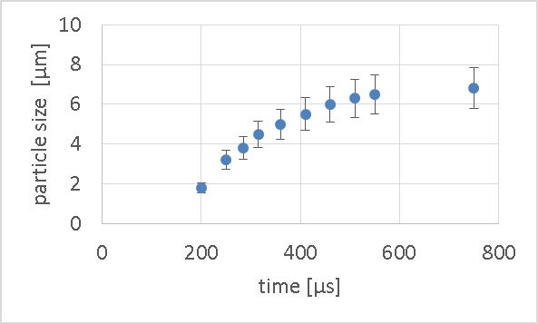

**Figure 4.** Particle size passing the laser beam versus time (the electron beam duration Tbeam = 131 µs).

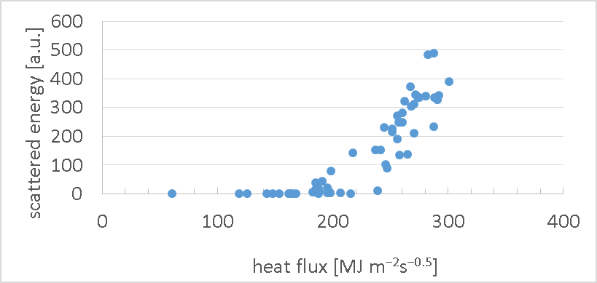

**Figure 5.** The energy scattered by dust particles versus heat flux.

Scattering of continuous wave 532 nm laser light shows different dynamics of tungsten particles ejection depending on absorbed heat load in the range 100 - 300 MJ m-2s-0.5. Figure 5 shows the dependence of the energy scattered by dust particles in the first millisecond after the end of the beam from the heat load. The generation of dust particles starts with 170±15 MJ m-2s-0.5 and grows rapidly with an increase in the heat load.

# Summary

A test facility with high-power wide-area long-pulse electron beam source is developed at the BINP and allows simulation of the ITER-relevant transient heat loads like ELMs type I. Unique features (low direct pressure on the melt layer and relative low plasma radiation, sufficient irradiation area) of the heating device has led to conduct research on target surface erosion soon after exposure.

Fast imaging with ICCD camera permits detection of particles with velocities of several hundred m/s near the front of the ablation plume. At larger delays of 0.5 and 1.5 ms velocities are lower 5 - 20 m/s and 1 - 15 m/s respectively at heat load 2.1 - 2.6 MJ/m2. It is significant, that at these delays particle suite sort of “Hubble law” when particle velocity is proportional to the particle distance from the target surface. The generation of dust particles starts with 170±15 MJ m-2s-0.5 and grows rapidly with an increase in the heat load. The dust particles with a size of 2-7 µm are observed.

# Acknowledgements

The work at the electron beam facility was supported by Russian Science Foundation (project N 14-50-00080). The development of small-angle scattering of 532 nm laser light technique was partially supported by RFBR, research project No. 15-32- 20669.

# References

1. R.A. Pitts et al., J. Nucl. Mater. 438 (2013) S48.
2. M. Shimada et al., J. Nucl. Mater. 438 (2013) S996.
3. V.V. Kurkuchekov, et al., Fusion Sci. and Technol. V63 (2013) No.1T, 292–294.
4. Yu.A. Trunev, et al., “Heating of tungsten target by intense pulse electron beam”, AIP Conf. Proc. (these proceedings).
5. A.A. Vasilyev et al, “Observation of the tungsten surface damage under ITER-relevant transient heat loads during and after electron beam pulse”, AIP Conf. Proc. (these proceedings).
6. L.N. Vyacheslavov, et al., “Novel electron beam based test facility for observation of dynamics of tungsten erosion under intense ELM-like heat loads”, AIP Conf. Proc. (these proceedings).