Multi-Second Neutral Beam Injector (60kV, 6A) for Plasma Diagnostics in the Upgraded T-15 Device
N.V.Stupishin^{1,2,a)}, P.P.Deichuli¹, A.A.Ivanov^{1,2}, A.G.Abdrashitov¹, G.F.Abdrashitov¹, V.V.Rashenko^{1,2}, P.V.Zubarev¹, A.I.Gorbovsky¹, V.V.Mishagin¹, V.A.Kapitonov¹, V.A.Krupin³, G.N.Tilinin³
¹Budker Institute of Nuclear Physics of Siberian Branch Russian Academy of Sciences, Novosibirsk, Russia
²Novosibirsk State University, Novosibirsk, Russia
³National Research Center “Kurchatov Institute”, Moscow, Russia
^{a)} e-mail: N.V.Stupishin@inp.nsk.su
Abstract. A diagnostic neutral beam injector DINA-KI60 has been developed and produced for upgraded T-15 tokamak (Kurchatov Institute, Moscow). The system will be primarily used for measurement of the ion temperature by charge-exchange recombination spectroscopy (CXRS), for magnetic field measurements via motional Stark effect (MSE) and investigation of plasma turbulence by Beam emission spectroscopy (BES). The ion source provides 60 keV, 6 A hydrogen beam with low angular divergence less than 10 mrad. Ions are extracted from a plasma created by an arc-discharge source with cold cathode and, after accelerating and focusing, are neutralized in a gas target. The extracted beam has about 86% of full energy specie. The grids of ion optical system are spherically curved providing geometric focusing of the beam at a distance 4 m. Diagnostic neutral beam has been successfully tested at Budker Institute of Nuclear Physics at 2 seconds pulse duration with modulation of the beam (duty ratio from 1:1 to 1:3).

Introduction
The neutral beams are widely used in magnetic fusion machines [1] for diagnostic as well as plasma heating [2]. Fast neutral beams provide a wide range of plasma diagnostics in modern plasma physics experiment and give unique information about local plasma and magnetic field parameters. Charge exchange recombination spectroscopy (CXRS), Motional Stark effect (MSE) and Beam emission spectroscopy (BES) diagnostics in large plasma devices require a hydrogen beam with an energy about 60 keV. The equivalent neutral beam current should be a few amperes or higher to provide reasonable signals in the detection system. In addition, important higher full energy fraction in a hydrogen beam enables the higher signals in the detection system. In the Budker Institute of Nuclear Physics (Novosibirsk) a number of different diagnostic neutral beam injectors based on arc-discharge plasma source with cold cathode have been developed since 1975 [3, 4]. Arc-discharge plasma box provides highly ionized plasma, so that the extracted beam has up to 90% of full energy specie. The beams had an ion current up to 3-4 A, particle energy up to 50 keV, angular divergence ~0.5° and full pulse duration up to 2 seconds (active - 0.7 s) [5]. The diagnostic injector based on arc-discharge plasma source with longer active beam pulse and higher energy was developed recently for upgraded T-15 tokamak, Kurchatov Institute, Moscow. This paper contains the injector description and results of the beam parameters measurements.
Nominal parameters of the neutral beam DINA-KI60:
particle energy - 60 keV, beam current (in ions) – 6 A, neutral beam current trough exit port – 2.2 A, arc discharge current 450 A, focal length - 4 m, beam divergence – less than10 mrad, duty ratio – from 1:1 to 1:10, active pulse duration – 1 second, full pulse duration – up to 10 seconds, cryopumping rate - 45 m³/s each, working species of ion – hydrogen, deuterium and another species also are possible.

injector beamline
The developed injector is based on an arc-discharge plasma source. The neutral beam is provided by extraction of ions from the plasma emitter, accelerating to the desired energy and subsequent neutralization by charge exchange in a gas target (~44% efficiency for 60 keV and hydrogen target) in the neutralizer tube. Remaining ions are deflected by a bending magnet and aimed on to a residual ion dump. A retractable calorimeter for beam profile and position measurements is installed at the exit of the injector tank. In Fig. 1 the general layout of the diagnostic neutral beam injector is shown. The focal point of the diagnostic beam is at 4 m distance from the ion source and close to the plasma center. The vacuum system comprises two liquid–helium cryogenic pumps and one turbo pump with 200-500 l/s pumping speed, which used for initial pump down of the injector vessel and during regeneration of the cryogenic pumps. Two identical cryopumps placed along the beam and separated with an aperture inside the vacuum tank provide the differential pumping. Each cryopump has a designed hydrogen pumping speed of 45 000 l/s. The vacuum tank and beam duct (neutralizer tube, bending magnet, residual ion dump retractable calorimeter, and aimed) are similar to those used in the diagnostic injector for Alcator C-mod devise (Boston) [6].

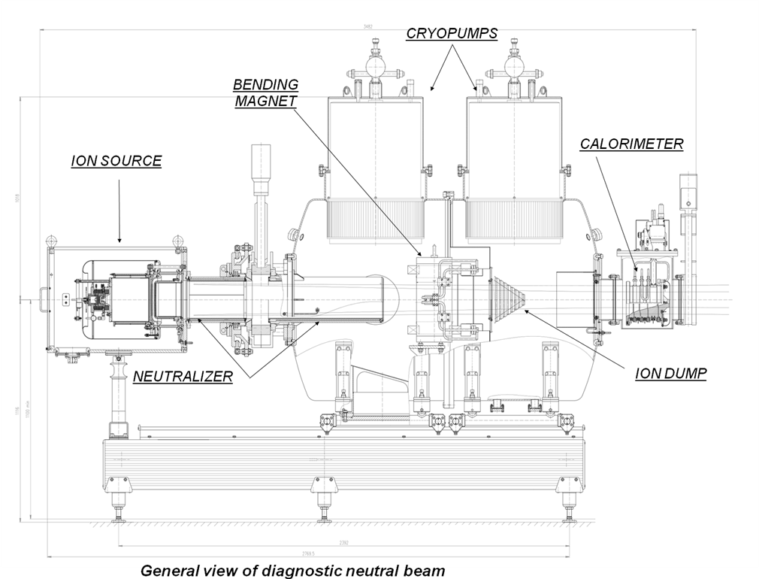
Figure 1. General view of diagnostic injector

ion source
The ion source consists of an arc-discharge plasma source and a four-grid electrostatic accelerator. A cold cathode arc-discharge plasma generator produces a highly ionized plasma jet. As a result of its collisionless expansion, the ion current density falls down to that required for optimal beam extraction. At the same time, the transverse ion temperature in the diverging plasma decreases, which results in a small beam divergence. The gas is introduced into the plasma box using two pulsed gas valves. The first gas valve is located near the cathode. It puffs the gas during quite small period of time. To initiate the arc discharge, a short high voltage pulse (~10 µs) is applied between special trigger electrode and cathode body. During the arc discharge, the gas is supplied by second gas valve located near anode. The plasma generator is shown in Fig. 2a. The plasma stream expands from the anode orifice into a cylindrical volume. To obtain homogeneous ion current density at the plasma grid, the outer surface of it is covered by an array of Nd–Fe–B permanent magnets. The magnetic field strength at the inner wall of the expander is 0.2 T and falls down radially to less than 0.01 T at 2 cm distance from the wall. The plasma emitter for extraction of a 6 A ion beam has been obtained at discharge current 420-450 A.

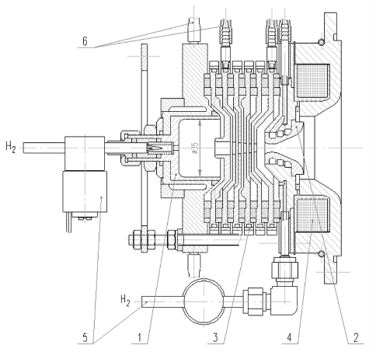 | 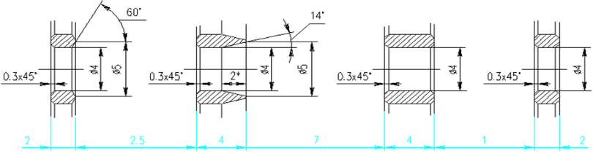
(a) | (b)
Figure 2. a) Multi-second plasma source based on arc discharge with cold cathode:
1-cathode, 2-anode, 3-water cooling washers, 4-magnetic coil, 5-gas valves, 6- water cooling tubes
b) Elementary cell geometry of NB ion-optical system (working gapes 1-2: 2.6 mm, 2-3: 7.7 mm, 3-4: 1 mm)

One of the main advantages of cold cathode type of arc plasma source is a high proton fraction 80%–90%. However, the lifetime of the plasma source is limited due to intensive electrode’s erosion, especially at the cathode region. An optimized design of the cathode and the nearest electrodes is found which reduces the erosion and allows us to increase the pulse length. Compared with the prototype designed for TCV tokamak [3] significantly improved characteristics of the generator. The plasma source produces the extracted ion current up to 7 A at a low angular divergence. Arc plasma generator has been tested with pulse duration up to 4 second.
The ion-optical system consists of four grids with 745 circular apertures diameter 4 mm each. The holes of grids configured in a hexagonal pattern. The grids are mounted on the water-cooled flanges, making possible full heat removal between the pulses. In order to focus the beam on to the desired point inside the plasma, the grids have the shape of the spherical segments with the 4 m curvature radius. The focal length of the IOS is ~4 m. The geometry of the elementary cell is shown in Fig. 2b. The diameter of plasma emitter at first grid is about 160 mm.

Data acquisition and control system
The control program for DINA-KI60 was developed in LabVIEW environment. It allows specifying required neutral beam input settings: acceleration voltage level, suppression grid voltage, arc discharge current, magnetic insulation current as well as to generate timing gates by the FPGA module (NI PCIe-7842R). The accuracy of timing gates is 1 µs. In addition, the FPGA allows to preset the rising input settings, so the rising discharge current and rising magnetic isolation current during the working pulse is possible for correction of the beam current (Fig. 3b, 4th trace). NI PCIe-6363 control module is used for measuring of the neutral beam parameters (ACD function, Fig. 3). It also realizes the gate valve control and retractable calorimeter control with indication of its current status (on/off). To measure a temperatures of calorimeter and ion dump we use a set of thermocouples and two Ethernet modules ET-7000. A set of interlocks provides the pulse shot prohibition in case of bad vacuum, gate valve close, low cooling water etc.

eXERIMENTAL RESULTS
According the project requirement the main regime of the injector operation is modulated beam. It is realized by the modulation of the accelerating voltage. The typical waveforms of the extracted current, accelerating voltage and other parameters shown in Fig. 3a, 3b. Note that arc current of plasma source is also modulated: during the beam-off interval it is automatically reduced to the low level to avoid the breakdown at voltage renewal and to reduce the arc generator erosion – Fig. 3b, 4th picture.
The beam profiles were measured by an array of the secondary emission detectors (SEDs) near retractable calorimeter z=2.9 m from IOS (Fig. 4). The measured beam radius corresponds to ~0.5° angular divergence.
The ion beam species mix has been measured for 50 keV beam by using H_{α} Doppler shift spectroscopy [7]. The best composition of the beam current at the IOS: Н ⁺= 86%, Н ₂⁺=4,5%, Н ₃⁺=6%, Н ₂О ⁺ =3,5%.
The injector is capable of providing a deuterium beam of correspondingly reduced current compared to the hydrogen beam. The maximal frequency of the beam modulation required is 100 Hz.

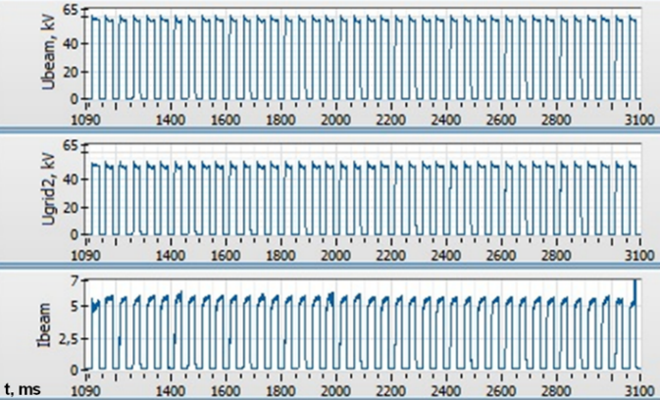 | 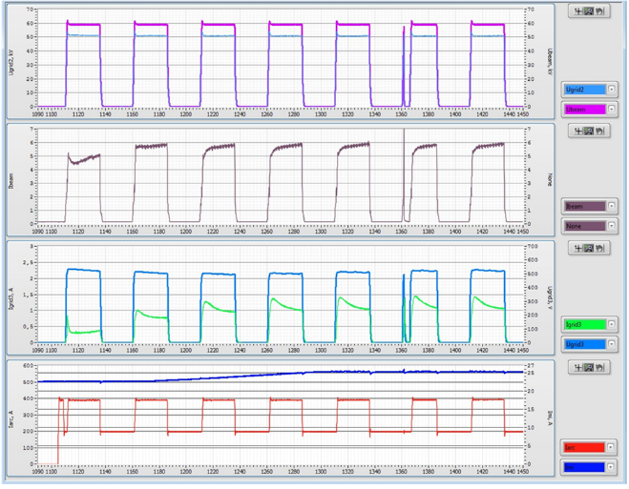
(a) | (b)
Figure 3. a) Modulated 60 keV beam pulse at 2 s duration (short #1084):
accelerating voltage (upper trace), extraction voltage (middle trace), beam current (lower trace)
b) The initial part (0.33 s) of the 60 keV beam pulse (short #1070):
1st picture: extraction voltage (blue) & accelerating voltage (purple)
2nd picture: beam current (brown)
3d picture: suppression grid current (green) & suppression grid voltage (blue)
4th picture: arc current (red) & magnetic insulation current (dark blue)

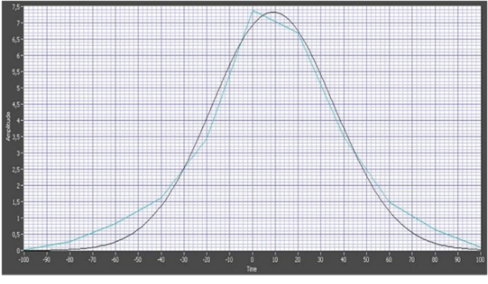
Figure 4. Typical beam profile near calorimeter z=2.9 m, beam e-folding radius R_{e}=32 mm

References

- V. Davydenko, P. Deichuli, A. Ivanov, N. Stupishin, V. Kapitonov, A. Kolmogorov, I. Ivanov, A. Sorokin, I. Shikhovtsev, “Recent Progress in Development of Neutral Beams for Fusion Studies”, AIP Conf. Proc. (these proceedings).
- P. Deichuli, V. Davydenko, A. Ivanov, S. Korepanov, V. Mishagin, A. Smirnov, A. Sorokin, and N. Stupishin, Rev. Sci. Instrum. 86, 113509 (2015).
- V. I. Davidenko, I. I. Morozov, and G. V. Roslyakov, PTE, 1986, N6, c. 39–42 (in Russian).
- G. F. Abdrashitov, V. I. Davydenko, P. P. Deichuli, D. J. Den Hartrog, G. Fiksel, A. A. Ivanov, S. A. Korepanov, S. V. Murakhtin, and G. I. Shulzhenko, Rev. Sci. Instrum. 72, 594 (2001).
- P. P. Deichuli, A. A. Ivanov, and N. V. Stupishin. Rev. Sci. Instrum. 79, 02C106 2008.
- P. P. Deichuli, G. F. Abdrashitov, A. A. Ivanov, V. V. Kolmogorov, V. V. Mishagin, G. I. Shul’zhenko, N. V. Stupishin, D. Beals, and R. Granetz. Rev. Sci. Instrum. 77, 03B514 (2006).
- A. A. Ivanov et al., preprint Budker INP 2002-41, Novosibirsk, 2002, 15p.

