Observation of the Tungsten Surface Damage under ITER-relevant Transient Heat Loads during and after Electron Beam Pulse
A.A. Vasilyev^{1, 2, a)}, A.S. Arakcheev^{1, 2, 3}, I.A. Bataev³, V.A. Bataev³, A.V. Burdakov^{1, 3}, I.V. Kandaurov¹, A.A. Kasatov^{1, 2}, V.V. Kurkuchekov^{1, 2}, K.I. Mekler¹, V.A. Popov^{1, 2}, A.A. Shoshin^{1, 2}, D.I. Skovorodin^{1, 2}, Yu.A. Trunev^{1, 2}, L.N. Vyacheslavov^{1, 2}.
¹ Budker Institute of Nuclear Physic SB RAS, Novosibirsk, 630090, Russia
² Novosibirsk State University, Novosibirsk, 630090, Russia.
³ Novosibirsk State Technical University, Novosibirsk, 630092, Russia.
^{a)}Corresponding author: Alex.Alex.Vasilyev@gmail.com
Abstract. Wide-area (2 cm²) high-power (up to 7 MW) submillisecond electron beam source was applied for generation of intense pulsed heat loads on tungsten sample. Various diagnostics sets were used for in-situ research of the surface damage: IR imaging of the front view of the target, capturing of the reflection pattern of continuous wave laser radiation, recording of intensity of thermal radiation from several spots of the surface. Sample was exposed to a various heat loads near and above melting threshold. Formation of the crack network on the surface and its development with successive pulses was observed. Two-dimensional temperature distribution was obtained after heating at the cooling stage. Melting and spalling of material were shown on severe damaged target. Propagation of the cracks along the surface at a depth of 0.1 – 0.2 mm was revealed with transverse microsections. Circular motion of the molten layer was found with subsequent exposures.

INTRODUCTION
Tungsten is considered as a material for divertor area in the future reactor-size tokamaks. It will undergo impact of the intense continuous and pulsed heat loads [1]. Different mechanisms of the surface damage can occur at such severe conditions [2, 3]. Cracking, melting, dust generation may affect plasma confinement. Theoretical models for cracking were developed [4]. Currently, there is a lack of the in-situ experimental data of tungsten behavior under ITER-relevant heat transients. The following paper is dedicated to investigation on tungsten erosion under impact of intense electron beam.

DESCRIPTION of TEST FACILITY

Parameters of Electron Beam Source
Targets were exposed to transient heat loads at a novel specialized test facility developed at the Budker Institute SB RAS [5]. It is equipped with a high-power submillisecond electron beam injector with a plasma emitter [6]. Total power of the device is up to 7 MW with a typical pulse duration of 0.1 – 0.3 ms. Target is placed in magnetic field of ~0.2 T, which is used to compress the electron beam to deliver an intense energy load on an area of about 2 cm². Temporal shape of the heating has rectangular profile with sharp edges. The cross-sectional distribution of the energy load has a dome-like form with a full width at half maximum of 9 – 12 mm depending on magnetic field. The machine is able to provide up to 15 GW/m² in maximum at high-power operating mode.

Diagnostics Layout
The facility is fitted with a set of optical diagnostics for in-situ observation of the surface erosion [7]. Front view of the tungsten plate is captured by a fast CCD camera with 1.4 MP resolution supplied with an infrared filter. The final spectral sensitivity of the system allows to obtain a picture of thermal radiation of surface in near infrared range (880 – 1020 nm) without interference from the light of ablation plume. Optical magnification is equal to 1/2.7. It determines the maximal spatial resolution of the images, which is about 20 μm. 2D distribution of the target surface temperature is reconstructed using absolute calibration with tungsten ribbon lamp. Also, sample surface is imaged by the same CCD camera applying same optical layout using a continuous light of laser (λ=532 nm). A narrowband optical filter provides rejection of plasma and thermal radiation. Diameter of the laser spot is about 8 mm and it cover half of the exposure area. Formation of the molten layer on crack edges and cracks intersections can be detected by this diagnostics. Surface image is transferred on an array of fiber optics equipped with IR-filter. Thermal radiation from four spots (~2.7 mm in diameter) on the surface is gathered and recorded with photodiodes followed by high-frequency ADC [8]. This diagnostic allows to investigate temperature dynamics of the surface temperature during heat load. The test facility has capabilities for investigation of dust ejection, which is discussed in [9].

EXPERIMENTAL RESULTS AND DISCUSSION

Cracks Formation and Propagation on Tungsten Sample
Samples of rolled tungsten with thickness 3-4 mm were used in experiments on high heat loads. IR-imaging revealed formation of non-uniformity in thermal radiation of the surface. Average energy load of 0.6 MJ/m² near melting threshold caused cracking of the tungsten sample. Cracks edges were clearly detected during electron beam impact because of their increased thermal radiation (Fig. 1). It was found that slight cracks net is formed after the first heat load. It becomes denser and more distinguishable with subsequent exposures. Propagation of this structure becomes slower after fourth pulse.

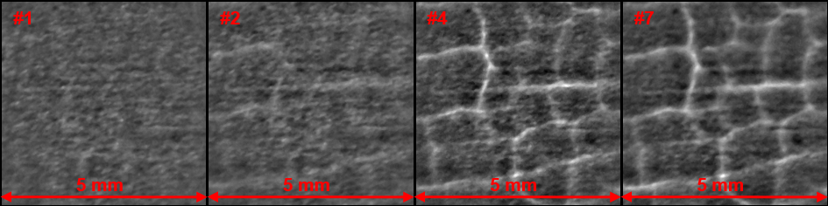
FIGURE 1. Images of the central area of the target soon after heat load. Dome-like background light profile was subtracted to emphasize inhomogeneities of thermal radiation.

Further irradiation leads to increase of the sample erosion. The initially damaged tungsten target with the crack network was imaged after beam impact with average energy load ~1 MJ/m² and F_{hf}~ 70 MJm⁻²s^{-0.5} (heat flux factor). 2D temperature distribution was obtained from IR-image captured 20 µs after the end of heating (Fig. 2(a)). It indicated material melting on the crack edges in the center of the target. Subsequent SEM survey showed intense melting of the surface layer near these areas (Fig. 2(b)). Transverse microsection of the target revealed propagation of the cracks along the surface at a depth 0.1 – 0.2 mm (Fig. 2(c)). Such cracks start from perpendicular ruptures and develop into the bulk of material. This target damage is responsible for suppression of the heat transport from the surface. It can lead to appearance of overheated areas and pieces which are partially detached from the bulk of the sample.
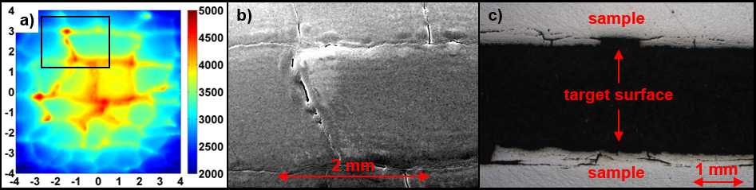
FIGURE 2. a) picture of temperature distribution on the surface 20 μs after beam impact; b) SEM image of the area marked with black rectangular on (a); c) transverse microsection of the sample

Imaging of Target in Laser Light
Tungsten surface was imaged during heat load and after its cooling at room temperature with illumination of continuous-wave laser light. Figure 3 shows these pictures superimposed with thermal image of the sample during the heating. Reflection pattern of the laser spot has fine-grained structure at room temperature. It becomes smoother during beam impact. SEM survey showed that areas of intense laser light reflection match with edges and intersections of the cracks. This effect can be associated with formation of the molten layer in these places.

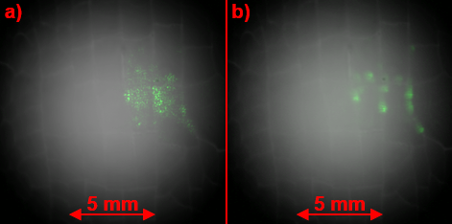
FIGURE 3. Images of the laser reflection pattern overlaid on thermal radiation picture. a) image captured without heating at room temperature; b) reflection pattern during beam impact.

Appearance of Detached Parts and Overheated Areas
Investigation of the target surface irradiated to more than 100 exposures with heat loads of ~1 MJ/m² and F_{hf}~90 MJm⁻²s^{-0.5} showed existence of the local hot areas. These overheated regions remained on the sample more than 5 ms after beam termination. Temperature excess over surrounding space was about 500K. Following SEM survey revealed the tungsten layers were severe detached from the bulk of the material.

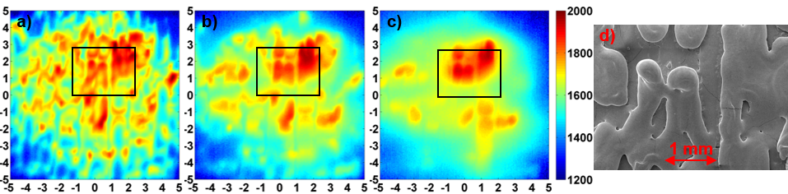
FIGURE 4. Temperature distribution after electron beam termination in different times: a) 350µs, b) 1850 µs, c) 7850 µs. d) SEM picture of the area marked with black rectangular on previous images.

Motion of Molten Layer
Multiple exposures with average heat load above the melting threshold (F_{HF}>100 MJm⁻²s^{-0.5}) caused formation of helical structure in the picture of thermal radiation of the target surface. The structure was located near the border of irradiation area. Comparison of the successive NIR images 100 μs after beam ending revealed a circular motion of this structure (Fig. 5(a,b)). Electron current flows from edge to centre of the target and magnetic field is directed perpendicularly from the surface, so direction of this motion correlates with J×B force. A set of five subsequent pictures showed that helical structure on a radius of 5 mm moved on a distance of ~0.1 mm per one heating pulse.

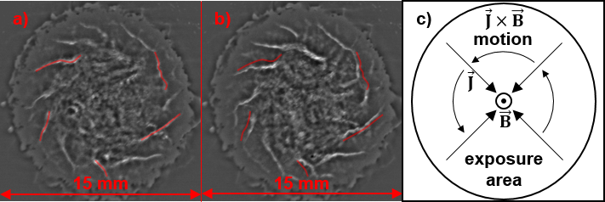
FIGURE 5. Picture of molten layer motion. a) the reference IR image obtained after heat load end; b) IR image captured after 4 successive exposures; c) directions of the magnetic field, current and J×B motion. Red curves on (b) mark inhomogeneities on (a)

CONCLUSION
A high-power wide-area long-pulse electron beam source was applied to create intense transient heat loads on tungsten samples. Unique set of in-situ diagnostics was used in this research: IR-imaging of the surface, imaging with laser light illumination, fast recording of dynamics of thermal radiation emission. Post-mortem analysis included SEM-survey and transverse microsection cutting.
Crack net formation and development was observed with serial heat loads. Melting of the crack edges was found using imaging with laser light illumination and by analysis 2D temperature distribution. Propagation of the crack along the surface was revealed after cross-section cutting. Detached parts of the target with excessive temperature of ~500 K over surrounding sample were found after more than 100 pulses. Circular motion of the molten layer was detected by comparison of IR-images taken after heat load ending with a set of successive pulses.

Acknowledgments
The work at the electron beam facility was supported by Russian Science Foundation (project N 14-50-00080). Study of the target surface erosion was partially supported by RFBR, research project No. 15-32-20669.

References
- A. Loarte, et al., Phys. Scr. T128 (2007) 222–228
- A. Huber, et al., Phys. Scr. T159 (2014) 014005 (5pp)
- A.V. Burdakov, et al., J. Nucl. Mater. V438 (2013) 677-680
- A.S. Arakcheev, et al., J. Nucl. Mater. V467 (2015) 165-171
- Yu.A. Trunev, et al., “Heating of tungsten target by intense pulse electron beam”, AIP Conf. Proc. (these proceedings)
- V.V. Kurkuchekov, et al., Fusion Sci. and Technol. V63 (2013) No.1T, 292–294
- L.N. Vyacheslavov, et al., “Novel electron beam based test facility for observation of dynamics of tungsten erosion under intense ELM-like heat loads”, AIP Conf. Proc. (these proceedings)
- A.A. Ivanova, et al., Instruments and Experimental Techniques, V59 (2016) No. 3, pp. 344–350.
- A.A. Kasatov, et al., “Observation of dust particles ejected from tungsten surface under impact of intense transient heat load”, AIP Conf. Proc. (these proceedings)

