Development of 28/35 GHz Dual-frequency Gyrotron for ECH Study
T. Kariya^{1,a)}, T. Imai¹, R. Minami¹, K. Tsumura¹, Y. Ebashi¹, H. Idei², K. Hanada², M. Ono³, K. Komurasaki⁴, T. Numakura¹, Y. Endo¹, Y. Nakashima¹
¹Plasma Research Center (PRC), University of Tsukuba, Tsukuba, Ibaraki, 305-8577, Japan
²Research Institute for Applied Mechanics, Kyusyu University, Fukuoka, 816-8580, Japan
³Princeton University Plasma Physics Laboratory, N.J. 08543-0451 USA
⁴Department of Advanced Energy, University of Tokyo, Kashiwa, Chiba, 277-8561, Japan
^{a)}kariya@prc.tsukuba.ac.jp

Abstract. The high power and long pulse operation of the gyrotron as well as efficient transmission of its output are quite important for achieving improved plasma performances. A 28 GHz 1 MW gyrotron developed for GAMMA 10/PDX achieved an output power of 1.38 MW in 2015 experiment after the power supply was improved. Furthermore, a new 28/35 GHz dual-frequency gyrotron (2 MW 3 s and 0.4 MW CW) for QUEST, NSTX-U, Heliotron J and GAMMA 10/PDX has been fabricated, after the preliminary test of a double-disk sapphire window installed in the gyrotron was performed. In the first experimental test, the oscillation of the main mode was confirmed at a frequency of 28.036 GHz with a Gaussian-like beam and an output power of 1.22 MW.

1. introduction
Electron cyclotron heating (ECH) and electron cyclotron current drive (ECCD) are attractive and promising techniques for achieving heating, current drive, and plasma control in fusion magnetic confinement systems, especially for dense, large-core plasma control applications in the future. ECH is essential for achieving potential confinement and high electron temperature, also high heat flux production for the recent ITER diverter simulator, with tandem mirror GAMMA10/PDX [1-3]. A gyrotron is an essential and powerful tool for ECH and ECCD. Some gyrotrons for fusion research are being developed at the Plasma Research Center (PRC) of the University of Tsukuba [4-10].
At present, ECH physics experiments in some plasma devices require gyrotrons with a relatively lower frequency (14–35 GHz). Gyrotrons in this frequency range are also used in the recent electron Bernstein wave (EBW) experiment [11]. For example, the Q-shoo University Experiments with Steady-State Spherical Tokomak (QUEST) of Kyushu University require 28 GHz 0.4 MW CW gyration. The collaboration between the University of Tsukuba and Kyushu University adapted Tsukuba University’s 28 GHz 1 MW gyrotron, which achieved the output power of 1.38 MW in 2015, to the QUEST ECH system and demonstrated plasma heating and current drive effects. Successful results were obtained in the first QUEST plasma experiment using a 28 GHz gyrotron. Overdense plasma with a density in excess of 1×10¹⁸ m⁻³ (higher than the cut-off density of 8.2 GHz) was produced. An EC-driven plasma current of 66 kA was achieved non-inductively with 28 GHz injection [12]. The ECH experiments of GAMMA 10/PDX and National Spherical Torus Experiment (NSTX-U) at the Princeton Plasma Physics Laboratory (PPPL) require a 28 GHz gyrotron with a 1.5–2 MW output over several seconds [13]. Further, a 35 GHz gyrotron having an output power greater than 1 MW for a pulse duration of several seconds is required for the Helical-Axis Heliotron (Heliotron J) at Kyoto University. Achieving 35 GHz oscillations in the 28 GHz gyrotron would be very useful for collaborative research. Hence, we have started with the development of the 28/35 GHz dual-frequency gyrotron [14-16].

2. design of 28/35 ghz dUal-frequency gyrotron [10]
The design targets for the 28/35 GHz dual-frequency gyrotron are listed in Table 1 and the structural cross-section is shown in Fig. 1(a). The targets for operation at 28 GHz are 2 MW for a 3 s pulse and 0.4 MW CW, whereas the power target at 35 GHz is 1 MW for pulse duration of 3 s. The MIG is a triode gun that can be used to control the electron beam parameters by varying the anode voltage. The combination of cavity oscillation modes for the two frequencies must be able to oscillate in the same cavity structure. And the difference in the radiation angle between the f₁ = 28 GHz and f₂ = 35 GHz cavity modes must nearly equal 0° to achieve a high RF beam transmission efficiency for both modes with the same internal mirrors. In addition, the MIG is required to inject an electron beam at the first peak of cavity electric field for both oscillation modes with pitch factor α = 1.0–1.2 under the magnetic field distribution produced by a super conducting magnet (SCM). We have selected such a combination of cavity oscillation modes: TE_{8,5} with f₁ = 28 GHz and TE_{10,6} with f₂ = 34.77 GHz.
TABLE 1. Design parameters of 28/35 GHz dual-frequency gyrotron
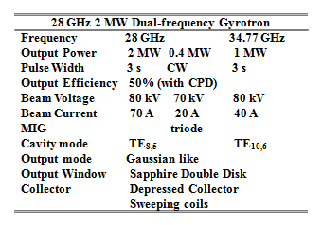
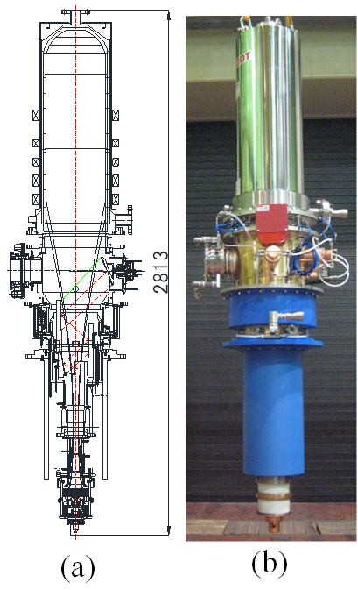
Figure 1. (a) structural cross-section and (b) picture of 28/35 GHz dual-frequency gyrotron.

The calculated beam current dependence of the cavity oscillation power at 28 GHz and 34.77 GHz are shown in Fig. 2(a) and 2(b), respectively. For I_{k} = 70 A with α > 1, 28 GHz oscillations with a power greater than 2 MW are expected. In the same cavity structure, 34.77 GHz oscillations with a power greater than 1MW were obtained for I_{k} = 40 A with α > 1. The results show that the target output power for the 28/35 GHz dual-frequency gyrotron was achieved in these designs. The RF wave is converted to a Gaussian-like beam by a built-in quasi-optical mode converter, and then transmitted to the outside of the tube, through an output window, by a system of four mirrors. The total transmission efficiency from the mode converter to the output window is 97.4% at 28 GHz and 97.0% at 34.77 GHz. The profile and phase of the output RF beam are adjusted using a matching optics unit (MOU), and the beam is coupled to a corrugated waveguide in HE₁₁ mode. The total transmission efficiency from the mode converter to the corrugated waveguide is 96.2% at 28 GHz and 96.4% at 34.77 GHz. The output window is a sapphire double-disk window cooled with a fluorocarbon coolant (FC-3283). The calculation results for the output window indicate that both 2 MW 3 s and 0.4 MW CW operations are possible at 28 GHz, and that 1 MW 3 s operation is possible at 34.77 GHz. The collector adopts collector potential depression (CPD) for enhanced efficiency and has sweep coils to reduce its heat load. The peak average deposition power density of the collector is less than 0.6 kW/cm², with a spent beam having a power of 2.8 MW. These results imply that the collector can operate at 0.4 MW CW. The gyrotron has a DC-break section to allow it sustain the high voltage between the body section and (grounded) collector. Likewise, the gyrotron has a body insulation jacket to sustain the high voltage between the body section and (grounded) SCM.

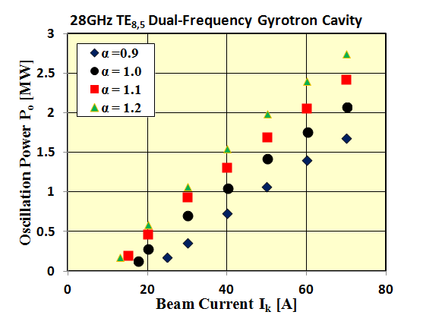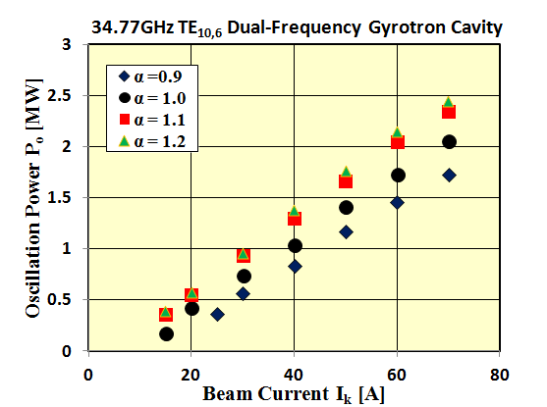
(a) (b)
Figure 2. Calculated beam current dependence of the cavity oscillation power at (a) 28 GHz and (b) 34.8 GHz.

3. preliminary test of dual-frequency gyrotron output window
This dual-frequency gyrotron has a sapphire double-disk window to enable CW operation. The structural cross-section of double-disk window is shown in Fig. 3. The frequency characteristics of a double-disk window depend on the thickness (depends on manufacturing error) and permittivity (depends on frequency) of the sapphire disk and fluorocarbon coolant (FC-3283). FC-3283 is a substitute for FC-75. The frequency characteristics of the double-disk window can be adjusted by varying the thickness of the fluorocarbon coolant. Before installing a double-disk window in the dual-frequency gyrotron, we confirmed the dependence of its reflective power on coolant thickness through a cold test using gunn diode oscillator power = 1 mW and a hot test using gyrotron output power = 600 kW, as shown in Fig. 4(a) and 4(b), respectively. The solid line and the dashed line show the calculated reflectance with which the dielectric constant of sapphire is 9.4 and 9.3, respectively. The differences in the absolute value of reflectance in the cold test are due to interference caused by the diverging incident waves or reflection waves. In the hot test, the reflective power was less than 2% at a coolant thickness of about 4 mm. The calculated absorbed power of the double-disk window was less than 1%. The best adjustment of coolant thickness can be performed after installing it in the dual-frequency gyrotron. In addition, uniform flow of the coolant on the sapphire surface, which is important for achieving a high cooling efficiency, was confirmed. For the inlet and outlet structure of the coolant, a 6×50 mm² rectangular structure was better than a φ 6 mm pipe structure for obtaining uniform flow and a lower pressure loss. Until the CW operation test of dual-frequency gyrotron, the pressure loss of the cooling system will be reduced further. During the CW operation test, the window temperature will be measured with an IR camera.
Figure 3. Structural cross-section of the double-disk window of the new 28/35 GHz dual-frequency gyrotron.
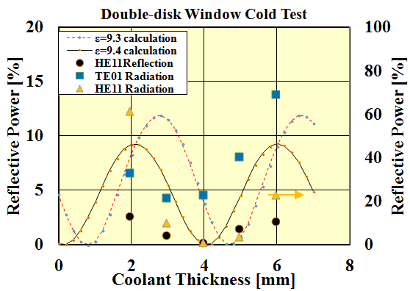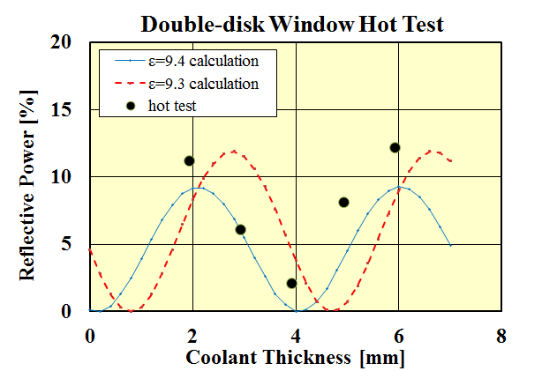
(a) (b)
Figure 4. Reflective power dependences of double disk window on coolant thickness using (a) gunn diode oscillator power (1 mW) and (b) gyrotron power (600 kW).

4. first experimental results of dual-frequency gyrotron
The picture of the 28/35 GHz dual-frequency gyrotron after fabrication is shown in Fig. 1(b). New gyrotron was installed to the test stand of the University of Tsukuba in June 2016. A one-week testing was performed until now, because some troubles of the power supply happened unfortunately. The oscillations of the main mode were confirmed at frequencies of 28.032 ~ 28.045 GHz with Gaussian-like beam. The output RF profile was measured by the burn patterns at the output window. The oscillation frequencies were measured by the cavity frequency meter. Beam current I_{k} dependences of the output power P_{o} and the output efficiency η with the beam voltage V_{k} of 80 kV are shown in Fig.5. The P_{o} is measured calorimetrically by the SiC water load at output window. The magnetic field and the anode voltage were optimized corresponding to each beam current value. The output power of 1.22 MW was obtained at I_{k} = 51 A with η = 30.0%. The further adjustment of the gyrotron and experiment are now in progress.

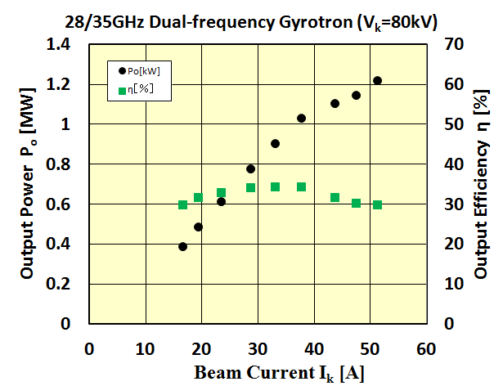
Figure 5. Beam current dependences of the output power and efficiency at 28 GHz oscillation test.

5. SuMMAry
At the PRC of the University of Tsukuba, mega-watt gyrotrons are being developed for plasma and fusion research. A 28 GHz 1 MW gyrotron developed for GAMMA 10/PDX achieved an output power of 1.38 MW in a 2015 experiment. A new 28/35 GHz dual-frequency gyrotron (2 MW 3 s and 0.4 MW CW) is being developed for QUEST, NSTX-U, Heliotron J and GAMMA 10/PDX. In 2015, all design-related work for the gyrotron was completed and the gyrotron was fabricated. The preliminary test of a double-disk sapphire window was performed before installation of it in the gyrotron. The frequency characteristics of the double-disk window were optimized and the flow of the coolant was confirmed. In the first experimental testing of the new gyrotron, the oscillation of the main mode was confirmed at a frequency of 28.036 GHz with Gaussian-like beam and an output power of 1.22 MW.

Acknowledgments
The authors would like to thank T. Eguchi, Y. Kawakami and Y. Mitsunaka of Toshiba Electron Tubes and Devices Co., Ltd (TETD) for help to gyrotron development. This work was partially supported by the NIFS Collaborative program (NIFS11KUGM050 and COD27077) and Grants-in-Aid for Scientific Research from the Ministry of Education, Culture, Sports, Science and Technology of Japan (26249141 and 15H05770A).

References
[1] T. Saito, et al., J. Plasma Fusion Res. 81, 288 (2005).
[2] A. Mase, et al., Nucl. Fusion 31, 1725 (1991).
[3] Y. Nakashima, et al., Trans. of Fusion Science and Tech. 68, 28 (2015).
[4] T. Kariya, et al., Trans. of Fusion Science and Tech. 51, 417 (2007).
[5] T. Imai, et al., Trans. of Fusion Science and Tech. 51, 208 (2007).
[6] T. Imai, et al., Trans. of Fusion Science and Technology 63, 8 (2013).
[7] R. Minami, et al., Plasma Fusion Research 8, 2402081 (2013).
[8] T. Kariya, et al., Fusion Sci. Tech. 55, 91 (2009).
[9] T. Kariya, et al., J. Infrared, Millim. Terahertz Waves 32, 295 (2011).
[10] T. Kariya, et al., Nucl. Fusion 55, 093009 (2015).
[11] H. Idei, et al., Plasma Fusion Res. 7, 2402112 (2012).
[12] H. Idei, et al., in Proceedings of the 25th IAEA Fusion Energy Conf., (2014).
[13] G. Taylor, et al., Proc. 17th Joint Workshop on ECE and ECRH (EC-17) EPJ Web 32, 02014 (2012).
[14] T. Eguchi, et al., Trans. of Fusion Science and Tech. 63, 280 (2013).
[15] T. Kariya, et al., Plasma Fusion Res. 8, 1205107 (2013).
[16] H. Nakabayashi, et al., Trans. of Fusion Science and Tech. 63, 283 (2013).

