Design of Permanent Magnet Trap for High Current Gasdynamic ECR Ion Sources With Plasma Heating by Gyrotron Radiation With Frequency up to 45 GHz
V.A.Skalyga^{1,2, a)} , I.V.Izotov¹, E.A.Mironov¹, A.V.Voitovich¹, O.V.Palashov¹
¹ Institute of Applied Physics, Russian Academy of Sciences.
46 Ulyanova st., Nizhniy Novgorod, Russian Federation
² Lobachevsky State University of Nizhni Novgorod (UNN)
23 Prospekt Gagarina, Nizhniy Novgorod, Russian Federation
^{a)}skalyga@ipfran.ru
Abstract. During recent research in the IAP RAS a new type of ECR ​​ion sources with plasma heating by powerful gyrotron millimeter wave radiation was developed. Due to the high frequency and power of heating microwaves plasma with unique parameters (density of about 10¹³ cm⁻³, the electron temperature of 100 eV and a temperature of the order of 1 eV ions) could be created in a magnetic trap of the ion source. Under such conditions a so-called quasi-gasdynamic plasma confinement regime, characterized by a short lifetime (about 10 microseconds), is realized in the source trap. Such short lifetime in combination with high plasma density allows to create ion beams of light or heavy multiply charged ions with current density up to 800 mA / cm2. The possibility of such hydrogen and deuterium ion beams formation has been demonstrated at pulsed experimental facility SMIS 37 in case of plasma heating with gyrotron microwave radiation at frequency of 37.5 GHz and a power of 100 kW and using of a simple mirror magnetic trap created by a pair of pulsed solenoids. Further research on the development of high current ECR ion sources demands higher pulse repetition rate or transition to a CW regime of the ion beam generation. In this case, the use of pulsed magnetic systems becomes impossible. In this paper we propose a design of a magnetic trap with mirror field configuration produced with permanent magnets for plasma confinement in the ion source of the type described. The magnetic field of the trap at its mirrors is 1.5 T, i.e. it allows to realize ECR plasma heating by radiation with frequencies up to 45 GHz. The use of a permanent magnet trap has a number of significant advantages over a "warm" or superconducting coils: it allows to operate both in pulsed and continuous mode; it eliminates the need for high-voltage insulation of solenoids from the discharge chamber placed under high potential; it does not require constant cooling; it doesn’t require power supply and consequently it has a compact size and provides higher reliability of the entire device.

Introduction
Development of ECR ion sources has been ongoing for decades in a large number of laboratories around the world. This resulted in a huge number of results; sources of this type are widely used as injectors in accelerators, for materials and surface treatment, medicine, etc. Methods of multiply charged ion beams formation as well as proton and deuteron beams are well-developed. The most advanced ECR ion sources are using 24 GHz and 28 GHz gyrotron microwave radiation for plasma heating (LBNL, Berkley, USA; LPSC, Grenoble, France; MSU USA, IMP, Lanzhou, China; RIKEN, Japan). However traditional ECR sources are not able to form ion beams with current more than 100-150 mA [1,2] and couldn't fulfill the requirements of modern accelerating facilities. Pulsed high-current ECR ion sources with quasi-gasdynamic regime of plasma confinement and its heating by gyrotrons have been developed at IAP RAS by the authors [3,4]. Such sources are unique in the world by combining the ion current (up to 500 mA) and emittance (normalized RMS emittance < 0.2 pi∙mm∙mrad) [5-9]. It is suggested to apply the experience and developments gathered in the pulsed mode for developing a CW machine. Successful completion of the project would allow creation of a basis for development of CW high-current ECR sources with previously inaccessible parameters of the ion beam.
Present paper is devoted to general overview of the future ion source and detailed description of the permanent magnet trap which will be used for plasma confinement.

ION SOURCE PROTOTYPE GENERAL DESIGN
In frames of a running project at IAP RAS the new CW high current ECR ion source with gyrotron plasma heating called SMIS 28 is under construction. This facility is aimed to produce continuous high-current (>200 mA) ion beams with low emittance (<0.2 pi∙mm∙mrad). The scheme of the future experimental facility is show in figure 1. The key element of the setup is a 28 GHz, 10 kW CW gyrotron manufactured by Gycom [10]. This microwave generator will be equipped with power supplies which allow CW and pulsed operation. Gyrotron radiation will be transferred to a plasma part through a special transmission line consists of mode filter, mode convertor TE_{0,2} to TE_{0,1}, arc detector, 100 kV DC break, polarizer, 2 microwave windows and dummy load for power control. Before plasma chamber radiation will pass through a microwave-plasma coupling system which will optimize microwave absorption by plasma and prevent plasma flux to the microwave transmission line. In plasma chamber microwaves will be absorbed under ECR conditions by plasma confined in a mirror magnetic trap. This trap was specially designed and manufactured from permanent magnets. Its detailed description is presented below. Plasma chamber and microwave-plasma coupling system will have water cooling for operation at high microwave power levels. Ion beam will be formed by two or three electrode extraction system which could be equipped with single or multiaperture electrodes. Maximum planed beam acceleration voltage will be 100 kV. Then an ion beam will pass through a diagnostic chamber where it would be analyzed and used for different purpose. Experimental facility will be equipped with necessary vacuum pumping, radiation protection and control and diagnostic systems.
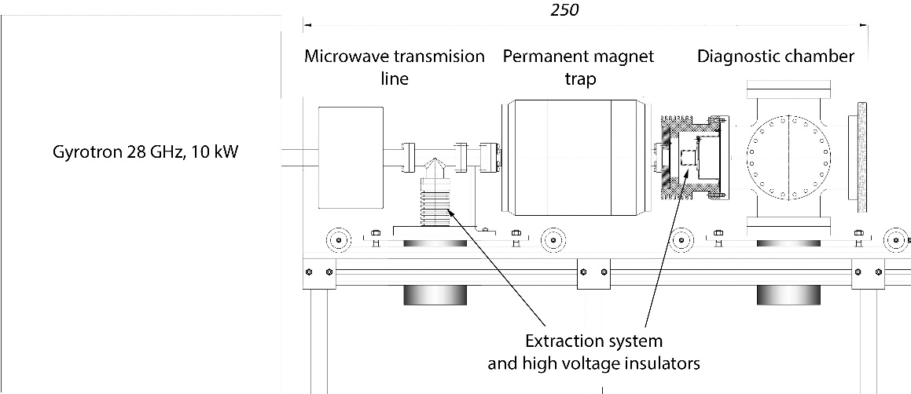
FIGURE 1. Scheme of the future SMIS 28 CW high current ion source.

permanent magnet trap for Ecr plasma heating
The use of a permanent magnet trap has a number of significant advantages over a "warm" or superconducting coils: it allows to operate both in pulsed and continuous mode; it eliminates the need for high-voltage insulation of solenoids from the discharge chamber placed under high potential; it does not require constant cooling; it doesn’t require power supply and consequently it has a compact size and provides higher reliability of the entire device.
During design process of the magnetic trap a number of technical problems were solved and original solutions were applied to create the system with configuration that provides the possibility of ECR discharge ignition and sustentation under conditions of microwave radiation heating at frequencies up to 45 GHz.One of the main differences of magnetic systems based on permanent magnets from the solenoid system is the zero magnetic field circulation on any closed loop or circuit passing through infinity. The consequence is an inevitable change in the sign of the magnetic field on the axis of the system. This difference has brought a number of features into the design of the magnetic system for plasma for ECR ion source.
For effective plasma confinement and heating a set of requirements were applied to the system. Field must be of "mirror trap configuration" with field strength at magnetic mirrors not less than 1.4 T and not less 0.2 T at the trap center. Distance between magnetic mirrors should be about 12-15 cm. The mirror the ratio should be in the range 3 ≤ Bmax / Bmin ≤ 7. The inside diameter shall not be less than 5 cm in order to allow an isolated location of a plasma chamber with minimum diameter of 4 cm. Furthermore, it was necessary to allow the extraction of ions from the trap at the region before the change of magnetic field sign at the longitudinal axis. This condition in this case was difficult to implement, due to the change of the sign of the field strength inside the system. To solve this problem it was proposed to place ion extraction system also inside the magnetic system. Since extractor parts will have a larger diameter (to allow operation at high voltages) than the plasma chamber, the design of the magnetic system has been decided to make asymmetrical with bigger inner diameter from one side.
To create the trap rings with coaxial and radial directions of magnetization were used, allowing quite simple technology of system assembling together with high accordance accuracy to desired configuration. In order to ensure optimum distribution of the magnetization in the system rings of different diameters were used. With high accuracy it can be assumed that the field at each of the magnetic mirrors is mainly produced only by appropriate / proximal half of the magnetic system that allows to simplify the design task. Similar problems have been solved earlier by the authors in the same geometry with the development of laser devices (apodising screens [11], Faraday isolators [12,13]), so the design of each of the halves of the magnetic system is similar to the previously proposed scheme. However, a significant complication appeared to provide the necessary magnitude of the field at the minimum (trap center) for the given ratio of the magnetic system inner diameter and the distance between the magnetic mirrors again due to the change of the sign of the field, which must be for each of the system halves. This problem was solved only by the use of a massive central coaxial magnetized rings.
The problem of magnetic system design optimization has been solved with a method, which can be called the modified method of gradient descent/ascent. The magnetic field strength at the mirror was chosen as maximized function, and geometric dimensions of the magnetized rings were used as variable parameters under condition of fixed mass of the structure (or roughly approximate material price). Method modification was in control of the optimization to provide the necessary field strength at the trap center at each step. Optimization was performed for each of the halves separately, due to the asymmetry of the system. There was a number of optimizations for different fixed weight values of the system, whereby the optimal design of the system was found capable to meet all the requirements for the magnetic field configuration.
The choice of the ferromagnetic alloys types used in the system was made according to residual magnetization, coercive properties and their price. Thus, in the center of the magnetic system more expensive magnets with high coercivity were used because they are placed in a relatively strong demagnetizing fields [12] and have to hold thermal effects due to probable plasma chamber heating. The system bulk is made of cheaper magnets located on the periphery, which do not have high requirements. Also soft magnetic materials [11-13] were used in the design of the magnetic system, able to ensure the optimal distribution of magnetic field flux and additionally reduce the system weight.
Final design of the magnetic trap together with calculated magnetic field distribution is shown in figure 2. Figure 3 represents magnetic field distribution along the longitudinal axis twice measured experimentally and compared to the theoretical calculation.
FIGURE 2. Magnetic trap with calculated field distribution.
FIGURE 3. Measured magnetic field distribution at longitudinal axis of the trap compared to theoretical calculation.

Futures of permanent magnets connected with zero field circulation gives some advantages from MHD plasma stabilization point of view. It could be seen from the fig. 2 that field configuration has 2 diverter points near the wall and that makes curvature of magnetic field lines less unstable to MHD perturbations close to plasma chamber wall. Figure 4 shows radial dependence of dl/B value integrated from the first magnetic mirror to the position of the extraction system (plane with the change of inner diameter of the magnets). It could be seen that even dependence gradient changes its sign near the wall.
FIGURE 4. ∫dl/B (R) integrated from the first magnetic mirror to the position of the extraction system.

Acknowledgments
This work was supported by the grant of Russian Science Foundation # 16-12-10343. Development of magnetic systems construction methods used for the trap manufacturing was supported by the mega-grant of the Government of the Russian Federation No. 14.B25.31.0024 executed at the Institute of Applied Physics RAS

References
- R. Gobin et al. Rev. Sci. Instrum., 73, 2, (2002), p. 922.
- J.D. Sherman et al. Rev. Sci. Instrum., 73, 2, (2002), p. 917.
- S. Golubev et al. Proc. of the 15th International Workshop on ECR Ion Sources (ECRIS’02). Jyväskylä , Finland, June 12 – 14, 2002, p. 21-24.
- Golubev S.V. et al. Rev. Sci. Instrum., v. 71, N. 2, pt. 2, p. 669 – 671, 2000.
- A. Sidorov et al. Review of Scientific Instruments, 79, 02A317 (2008).
- V. Skalyga et al. JINST, v.7, P10010 (2012)
- V. Skalyga et al. Review of Scientific Instruments, v. 85, no. 2, 2014, p. 02A702-1 – 02A702-3.
- V.Skalyga et al. Nuclear Instruments and Methods in Physics Research A, v. 768, p. 146–150, 2014
- S. Razin et al. Review of Scientific Instruments, v. 85, Issue 2, p. 023307-1 – 023307-4, 2014.
- http://gycom.ru/
- Mironov Е.А. et al. Optics Communication v.295, p.170-175 (2013).
- E.A. Mironov et al. Quantum Electron., 43(8), 740-743 (2013).
- E.A. Mironov et al. Applied Optics. 53, 3486-3491 (2014).

