Development of High-Power Gas Discharge and Electronic Vacuum Devices for Pulsed Electrophysic.
Current Status and Prospects
V.D.Bochkov, D.V.Bochkov, V.M.Dyagilev, P.V.Panov, V.I.Teryoshin, I.V.Vasiliev and V.G.Ushich
Pulsed Technologies Ltd., 5, Yablochkova Str., 390023 Ryazan, Russia
Abstract. In the paper the most recent research and development efforts made by Pulsed Technologies ltd. are presented. Design and essential characteristics of power high-voltage TDI and TPI-thyratrons (Pseudospark Switches), spark gaps, as well as X-ray tubes of the new generation are described. The report cites examples of emerging applications in leading world institutions, including high-power pulsed Electro-Physics (EP).

Current Status of Investigations and Developments
High power pulse switches have always been the key elements of Pulsed Power systems [1-5]. Recently, the significance of Pulsed Power applications has become even more conspicuous due to expanding utilization of particle accelerators, advances in research and commercialization of hydro-pulse and electro-magnet pulse technologies, plasma fusion electrical generators (FRC - Field Reversed Configuration and MTF - Magnetized Target Fusion approach) [6, 7], plasma focus machines [8], non-thermal treatment of materials and food stuff in ultra-power electrical fields [9, 10] etc.
Widely known pulse hydrogen thyratrons, if compared to other switches, feature the longest lifetime, maximal efficiency (up to 99%) and switching power, best rate of anode current rise (up to 10¹¹ A/s) and timing stability (jitter), ability to operate in various climatic conditions and in conditions of substantial electrical, radiation and mechanical overloads. However thermionic cathode has always been the most critical factor, limiting lifetime in the conditions to some hundreds of hours.
The analysis of pulse thyratrons capabilities has shown that these switches are the most perspective and adequate for further improvements, which has evoked a task to develop principally new fast plasma switches for Pulsed Power applications with perfected operating parameters, especially lifetime and hence, competitive abilities. One of possible solutions of the problem would be a development of thyratron switch, based on a phenomenon of pseudospark discharge.
A few references to history. Attempts to create a plasma switch, free of shortcomings associated with classical thyratrons and at the same time featuring best capabilities of spark gaps and ignitrons, were made long before, in early 1950s. One of the first work in this direction was a research of superdense glow discharge by a team of B.N. Klyarfeld [11]. In Russia the investigations were conducted by several scientific groups in Moscow, Sarov, Kiev, Kharkov and Ryazan. They included research of superdense glow discharge, electrode material erosion, effect of magnetic field. Finally some prototypes of cold cathode thyratrons were devised and built. However no serious result was achieved. And only after extensive investigations of low-pressure discharge in 1980s in Germany, US, France, Russia and other countries started [12] with assistance from new methods and instruments for plasma diagnostics, engineers succeeded to present a series of thyratrons with unheated cathode. A significant contribution to the understanding of plasma phisics in the switches, known also as pseudospark switches (PSS), was made a research teams managed by J.Christiansen, K.Frank, W.Hartmann (Germany), M.A.Gundersen (USA), G.A. Mesyats and Yu.D. Korolev (Russia).
In Russia practical investigations and engineering were conducted by a private company Pulsed Technologies ltd. (Ryazan) in close cooperation with physicists from High Current Electronics Institute, Joint Institute for High Temperature, Budker Insitute of Nuclear Physics. The very first prototypes of Russian pseudospark switches had some fundamental distinctions in comparison with analogues, designed in Germany, France and USA [13, 14], providing improved timing parameters and some orders of magnitude longer lifetime (http;//www.pulsetech.ru).
There are two basics types of Pulsetech pseudospark switches, marked as TPI and TDI (Fig.1a-1b), which span a vast variety of applications with operating voltages up to 150 kV and peak currents up to 300 kA :
- TPI-type or Hollow Cathode Thyratrons [18-20] operate mainly with superdense glow, which propagates by sub-light ionization waves at non-local processes in gases. They are used for pulse switching of charge up to tenth of Coulomb in pulse power supplies at pulse repetition rate up to 100 kHz and pulse width from some nanoseconds to tens microseconds. In applications similar to classical hot cathode thyratrons the TPI switches can handle peak currents up to 20 kA within less than 2-10 ns with time jitter less than 200 picoseconds. They can also handle current reversals up to 100% of a forward peak current, hold off high inverse voltages, feature exclusively low for plasma and semiconductor switches recovery time and significantly longer life, having low cost, light weight and relatively small dimensions.
- TDI-type – power and ultra high power thyratrons [22-24] with electrode material vapor arc are intended for switching charges up to hundreds of Coulomb per pulse. TDI-switches with self-inductance less than 5 nH can handle peak currents up to 300 kA at voltage drop 25-50V, record rate of rise of current up to 5×10¹² A/s and time jitter less than 5 ns.
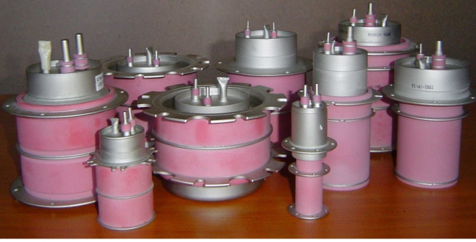  a) | 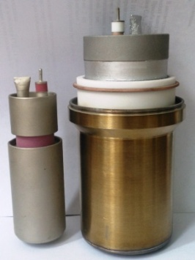  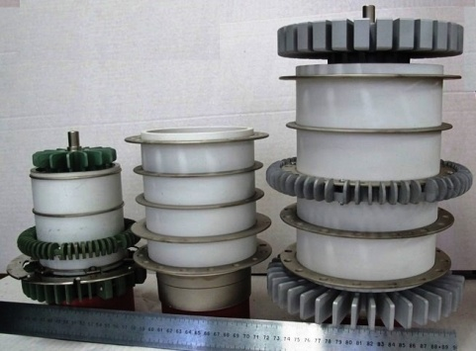  b)  c)
Figure 1. Production Devices of Pulsed Technologies Ltd.
1a) Family of pseudospark switches TDI- and TPI-types.
1b) TGI-thyratrons operating at anode voltages 50 and 75 kV and average current 3 and 10 A.
1c) The compact sealed-off hollow cathode gas-discharge tubes were used to get signals with pulse width of 100–800 ns, power up to 2000 kW, frequency up to 800 MHz with a repetition rate of 100 Hz. Maximal dimensions ∅37×25 mm, weight 250 gram [17].

The basics advantages of TDI-switches over spark and vacuum gaps are longer life (2-3 orders of magnitude), substantially wider operating voltage range, high stability of electrical and timing characteristics in a wide range of temperatures, ability of parallel operation onto a common load in overdamped and underdamped modes.
For different operating modes are made thyratrons (pseudospark switches) in two basic types, labeled as TPI and TDI for operating voltages up to 150 kV, the pulse currents up to 200 kA
- In addition to thyratrons with unheated cathode the company fabricates thermionic cathode TGI-thyratrons (Fig.2) with peak output power up to 250 MW pulsed and average power up to 0.5 MW, comprising combined hollow and heater dispenser cathode with average currents up to 70A , as well as spark gaps with charge transfer per shot up to 200 Coulombs, rugged surge arresters LA for lightning protection of telecommunication installations with high stability and without used of any radioactive substances and “peaking” spark gaps for voltages up to 350 kV. Another production - compact repetitive pulse generators of high-power high-frequency pulses (Fig.1c).

TPI-switches Applications (Fig.2-5)
- Laser systems power supplies;
- Charged particles accelerators(Fig.2), including Free Electron Lasers (FEL), Radiographic systems, plasma sources and so long;
- Non-thermal effects of high-energy electrical fields on biological objects for debacterization of drinking and waste water, food stuff pasteurization, tumor treatment.
- on-thermal effects of high-energy electrical fields on geological objects with a purpose to increase precious and rare metals extraction efficiency.
- Oil and ore production – gamma-neutron logging, georadars.
- Proton accelerators and Neutron-boron capture therapy of tumors, kidney stones treatment lithotripters.
- Nature-conservative apparatuses and plasma-chemistry - electro-filters for cleaning-up of gaseous waste in industry and energy, in pulse power supplies for ozone production and so on.

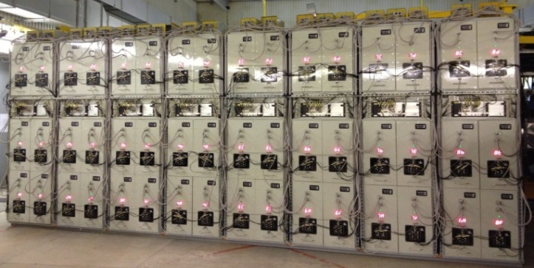 | 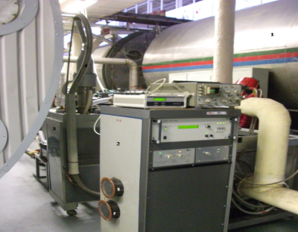  a) | b)  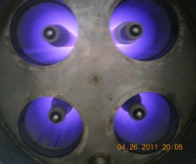  b)
FIGURE 2. Pulse generators of linear accelerator LIU-2 is an assembly of 48 modulators withTPI2-10k/50 thyratrons | Figure 3. Air cleaning in corona streamer discharge.  a) Facility; b) The corona glow in the reactor

- Air cleaning (Fig.3). In the Europe largest waste water cleaning structures Kuryanobskiye and Luberetskiye in Moscow for air cleaning from hydrogen sulfide, ammonia and other toxic gases by means of electrostatic precipitator in corona streamer discharge. More than 40 electrostatic precipitator systems “Corona” with output up to 15 000 cubic meteres per hour use our thyratrons TGI2-5k/50H.
- Mobile gas cleaning system with TPI1-10k/50 thyratrons based on streamer corona in experimental works “Mars-500” conducted by FGUP Salute supported by Roscosmos and Russian Academy of Science in 2011.

In the recent years development of high voltage pulse generators (pulse currents and pulse voltages) has been gaining momentum for applications in pulse power.

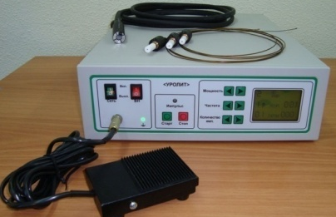  a) | 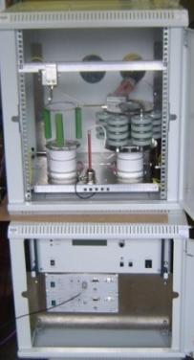 | 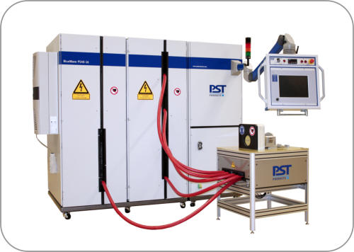  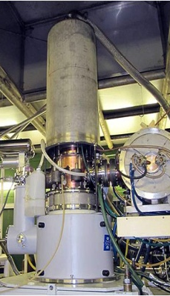  b)  a)
FIGURE 4. Devices with TPI-thyratrons.  a) Nanosecond pulse generator for Synchrotron radiation source in Scientific Center Kurchatov Institute.  b) Tomsk Pulse Lithotripter UROLIT with TPI1-1k/20 switches. |  | Figure 5. Devices with TDI-thyratrons.  a) Gyrotron for ITER utilizing crowbar thyratron TDI1-100k/75D.  b) Metal forming and welding with high electro-magnetic fields machines (commisioned and used by Germany automobile industry plants) based on TDI1-200k/25H thyratrons.
- Duke Free Electron Laser Laboratory, Texas Tech University, Brookhaven National Laboratory, Baker Instrument Company, ONERA, China Academy of Engineering Physics.
- Thyratron drivers for TDI, TPI and TGI-switches.
- MedLine, Tomsk Pulse Lithotripter UROLIT with TPI1-1k/20 switches.
- DC and Pulsed X-Ray tubes.

TDI-switches applications (Fig. 5-10)
- Environmentally-friendly, energy-saving robotic industries – electro-magnet pulsed technologies, electron beam, laser and electro-hydraulic pulsed machining and treatment of materials.
- Oil production – seismic exploration, electric drilling, installations for cleaning-up of oil production instruments and improvement of oil well efficiency.
- Crowbar protection circuits for TV and Radio-equipment, other high-power radio engineering equipment, including gyrotrons.
- Electro-physics - Dense Plasma Focus, Charged Particles Accelerators, Nuclear Fusion, Plasma Lens; High Power Lasers, etc;
- Health Care - Urology (Shock Wave Lithotripsy for Kidney Stone Treatment), Orthopedic, Ophthalmology etc.
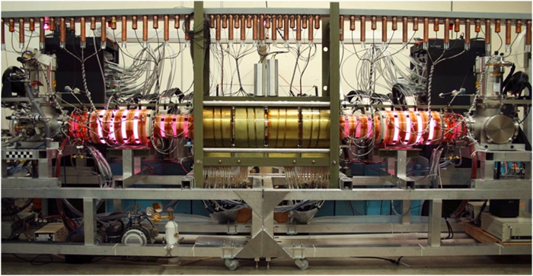 | 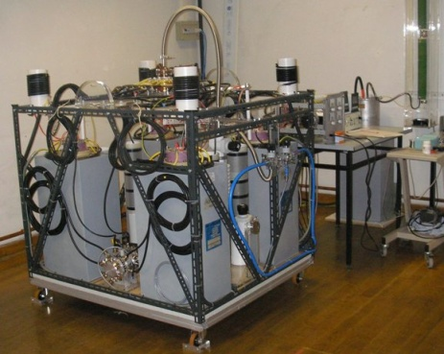
FIGURE 6. Nuclear fusion research installations, built on pulse power supplies with TDI4-100k/45H thyratrons by Pulsetech. (US, Canada). | Figure 7. Dense Plasma Focus with TDI1-200k/25H thyratrons. (Nanyang Technological University, Singapore).

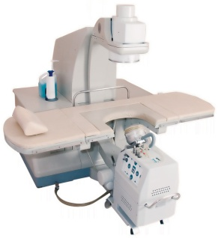  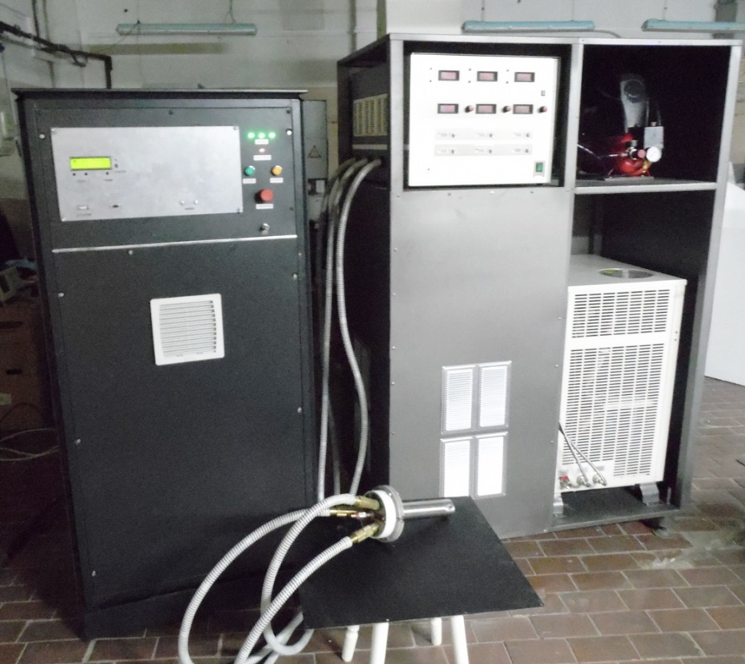  b)  a)  a)  b) | 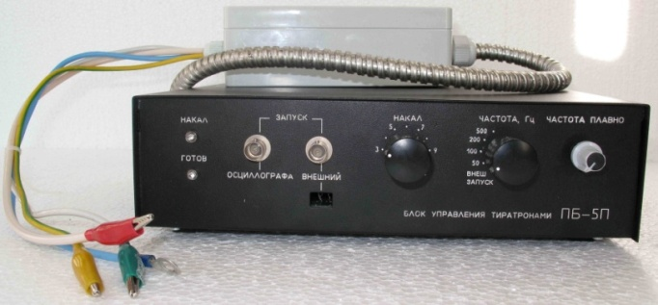
FIGURE 8. Systems with TDI-thyratrons.  a) Pulsed repetitive atmospheric pressure plasmatron with a power supply based on TDI1-200k/25HW thyratron for robotic part hardening lines.  b) TDI1-50k/16H switches in Medical lithotripter “Medolit”. | Figure 9. Thyratron drivers for TDI, TPI and TGI-switches
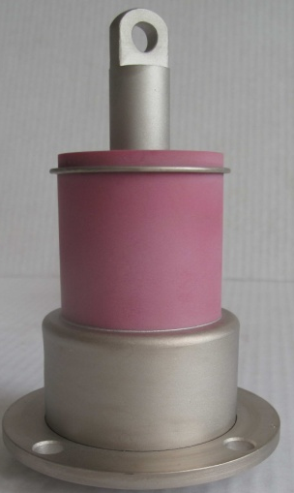  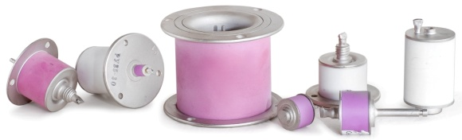 | 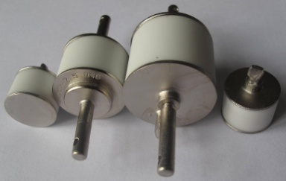  c)
FIGURE 10. Two- and three-electrode spark gaps
a) LA86 surge arrester for protection of electronics equipment from direct lightning strike with switching charge up to 250 C (Canada, USA). b) RU-series of 3-electrode spark gaps. c) Patented design of 2-electrode spark gaps for operating voltage 0.5-5 kV not containing radioactive isotopes.

Competitive advantages of TDI and TDI-switches
The main limitations for application of the existing switches are unavoidable power losses on internal resistance in on-state and low lifetime of the switches (spark gaps, thyratrons and modulator tubes). In terms of total cumulative charge the lifetime of spark gaps reaches 100 – 10 000 C, thyratrons and modulator tubes with thermionic cathode up to 5⋅10⁵ C, mercury ignitrons – up to 10⁵ C. The limits in spark gaps are defined by severe electrode erosion, in thyratrons and modulator tubes by loss of thermionic cathode emission, increase of grid thermo-currents, reduction of hold-off voltage, in ignitrons – by critical damage of anode electrode, contamination of mercury by electrode metal vapors and death of igniter. For wider application in industrial systems in contrast to military applications another important requirement is a cost of the device. Hydrogen thyratrons with thermionic cathode are rather expensive, for example CX2708 thyratron (e2v technologies, UK) with maximum anode voltage of 40 kV costs more 20000US$.
The lifetime of semiconductor switches (SOS-diodes, IGBT, PCSS, MOSFET, FID-switches) reaches 20000 hours, which in 1990s determined a decline in sales of vacuum and plasma counterparts. In the meantime the solid state switches are able to reliably replace vacuum and plasma switches in low power devices, switching relatively low voltages and currents. There is a number of technologies, including emerging applications, in which plasma switches have no alternative. Thus it was generally accepted that the most significant advantages of sold-state switches over plasma tubes were higher lifetimes, better energy efficiency (p-n junction voltage drop is 1.5-3 V only, the voltage drop in plasma switches is 20-200 V), no need for cathode heating, small dimensions, light weight and low price for the same set of output parameters. However for output currents over 1 kV and voltages over 5 kV at current rise rate exceeding 10⁹ A/s the only benefit of solid state devices was a lifetime expectancy, as dimension and weight were critically increased due to series connection of elements, application of magnetic compression, fluid cooling, high-voltage isolation between separate switches, overvoltage protection etc, which reduced efficiency down to 18-30% and made the cost of assemblies unreasonably high. At the same time just a single thyratron is able to switch high energy and peak currents with a high rate of rise and efficiency of 90-99%, which makes them practically indispensable.
Pseudospark switches by Pulsetech are internationally patented with priority since 1990. There are only 2 manufacturers of switches similar to TDI-type thyratrons for anode currents up to 150 kA: the world-renown English company e2v technologies (HX3020) and a company Alstom Vakuumschalttechnik GmbH (Germany), which in 2000 started production of pseudospark switches FS2000 and FS3000. At the moment no data on market availability is available. TPI-type switches absolutely have no commercially available analogues.
In 2000-2015 Pulsed technologies ltd. have carried out research work aimed to improve operation and competitive strength of the switches. Thus, provided technical margin of 20-30% of output parameters ratings, which is also characteristic for solid-state devices, TPI-switches have lifetime expectancy not less than that for semiconductors’. A standard endurance testing of TPI1-0.2k/12 thyratron has revealed lifetimes not less than 20 000 hours. For high power TPI-thyratrons in modes with sub-microsecond pulse width and peak currents up to 10 kA the expected lifetime is not less than 10 million Coulombs in terms of total cumulative charge transfer. The values are at least 10 000 higher than for spark gaps and 10 times higher than for classical thyratrons (e.g. TGI). TDI- and TPI-switches can be operated either from cathode and anode parts.
Investigations, carried out in Budker’s Institute of Nuclear Physics SB RAS, have shown that TPI-switches are remarkable for exquisite parameters, for example, TPI5-10k/50 thyratron hold-off voltage recovery time is a fraction microseconds after conduction of forward anode current up to 10 kA [17]. TPI1-0.2k/12 has a time of transition into on-state of less than 3 ns at peak currents up to 1 kA [18].
TDI-switches in terms of reliability, high timing stability and value for money surpass all known power switches, including rail-gap.
Circuit schematic simplicity. In is important to note another interesting property of the new thyratrons. All preceding cold cathode thyratrons, including pseudospark switches, were not completely “cold”. Operating without heating of cathode they cannot be operated without permanently heater hydrogen reservoir (2-90 W).
TDI- and TPI-thyratrons, equipped with a patented built-in device “SNRV” (Fig.11) are capable of operating in absolutely “cold state”, that is without heating of reservoir [21]. As a result we have principally novel switches, combining very best properties of thyratrons, vacuum and spark gaps, solid-state switches. This solution allows to substantially improve performance of our switches, makes it easier to operate in circuits with cathode under high potential (both cathode and anode), offers almost instant readiness.
The Pulsetech pseudospark switches are capable of operating with voltage reversals up to 100% [9]. We have an extensive experience of TDI1-50k/50 switches operation in sources of low-energy (20-40 keV), high current (30 kA), small aperture (S > 10 cm²) electron beams.
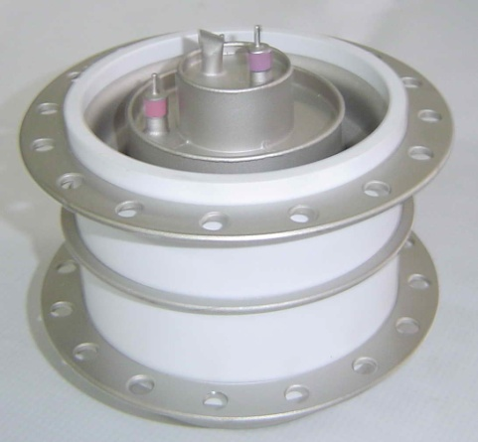

Figure 11. TDI1-100k/45SN - thyratrons, are capable of operating without heating of reservoir

TDI1-200k/25H thyratron lifetime in EMPT forming and welding machines in automotive industry reaches more than 2 million Coulomb of total cumulative charge transfer at 4 C per shot.
Specifically designed thyratron drivers series PB-5P and PB-3D are used to trigger, control and support TPI and TDI-thyratrons, including operation under high potential on cathode and via a fiber optic channel.
The international expansion of the TPI- and TDI-switches could only be made thanks to scientific marketing efforts and, first of all, thanks to a vast expertise, accumulated by Russian scientists and engineers, utilizing the switches, and their valuable recommendations. Gradually came a recognition by global users.
High quality and competitive strength of the switches is approved by a considerable portion of total sales in USA, Canada, Japan, Germany, China, Israel etc. In 2007-2015 export sales constituted more than 70% of total production.
Time reveals that TDI and TPI thyratrons maintain a number of advantages over known switches. Including soild state devices. That is clearly borne out by a fact of sales to institutions occupied in design and development of cutting-the-edge solid state high voltage switches (Ioffe Institute, Institute of Electro-Physics etc). Another fact proving that is contract with leading international companies. In particular we manufacture and ship 5 different types of switches with voltage ratings 25, 45 and 75 kV, peak current 200 kA, energy per shot 14 kJ to customers in Seattle, California, Kansas, Canada etc for main switches and crowbar protection. And we keep on improving our products, in particular lifetime and reliability.
All devices are patented in Russia and the US.

REFERENCES

- Yutkin L.A. The electrohydraulic effect and its application in industry. - Leningrad: Engineering, 1986 (in Russian).
- J.C.Martin, "On Pulsed Power" in Advances in Pulsed Power Technology, v.3, Edited by T.N.Martin, A.N.Guenther, and M. Kristiansen, Plenum Press, New York and London, 1996, 546 p.
- Sinch M., Podlesak T.et al., Proc. 20th Power Modulator Symposium, USA, 1992, P.1-4.
- Levy S., Nikolich M. et al., Proc. 20th Power Modulator Symposium, USA, 1992, P.8-14.
- Mesiats G.A., Pulsed Power and Electronics, Moscow: Nauka, 2004.
- Slough J., Pihl Ch., Bochkov V.D., Bochkov D.V., et al, 17th IEEE International PPC, 2009, Washington DC, P. 255-259.
- M. W. Binderbauer, T. Tajima, L. C. Steinhauer, E. Garate, et al, Physics of Plasmas 22, 056110 (2015) 056110-2 - 056110-16.
- Bogolyubov E.P., Bochkov V.D., Veretennikov V.A., Vekhoreva L.T., et al. Physica Scripta, 1998, Vol.57, P.488-494.
- Bochkov V.D., Djagilev V.M., Harris G., Kryutchkov S.P., Ponizovskiy A.Z., et al, Proc. BEAMS '98, Haifa, Israel, 1998, Vol.2, P.1031-1034.
- Zykov A.M., Kolchin K.I., Bochkov V.D., Gnedin I.N., et al, Proc. 7th Intern. Conf. on Electrostatic Precipit. (ICESP), Korea, 1998, P.465-470.
- Abramovich L.Yu, Klyarfel'd B.N., Nastich Yu.N., Technical Physics, 1966, v.36, №4, p.714.
- Special issue IEEE Trans. on Plasma Sci., 1995, Vol.23, N.3.
- V.D.Bochkov, V.M.Dyagilev, Yu.D.Korolev, and V.G.Ushich, Instruments and Experimental Techniques, Vol.41, No.5, 1998, pp.676-680.
- V.D.Bochkov, Yu.D.Korolev, "Pulsed gas-discharge switching devices" in "Encyclopedia of Low Temperature Plasma". Edited by V.E. Fortov, book 4, No. XI.6, Nauka Publishing, Moscow, Russia, 2000, pp. 446-459.
- Bochkov V.D.and Pogorel'skii M.M., Instruments and Experimental Techniques, 1998, Vol.41, N.2, P.210-215.
- V.Bochkov, D.Bochkov, V.Nicolaev, V.Teryoshin, P.Panov, A.Batrakov, K.Karlik, G.Ozur, D.Proskurovsky, 2012 IEEE International Power Modulator and High Voltage Conference, San Diego, CA, USA, 2012, pp. 664-667.
- Dubinov A.E., Kornilova I.Y., L’vov I.L., Sadovoy S.A., Selemir V.D., et al, IEEE Trans. on Plasma Sci., 2010, Vol.38, N.11, P. 3105-3108.
- Akimov A.V., Logachev P.V., Bochkov V.D., Dyagilev V.M. et al, IEEE Transactions on Dielectrics and Electrical Insulation, 2010, Vol. 17, Issue 3, P. 718-722,.
- Anchugov O.V., Matveev Yu.G., Shvedov D.A., Bochkov V.D., et al, 2007 PPPC, Albuquerque, NM, USA, 2007, P.1335-1338.
- Bokhan P.A., Zakrevsky D.E., Lavrukhin M.A., et al, 17th IEEE PPC, Washington DC, P. 1303-1308.
- Bochkov V.D., Bochkov D.V., Dyagilev V.M., Ushich V.G., ACTA PHYSICA POLONICA A, 2009, N.6, Vol.115, P.980-982.
- Bochkov V.D., Vlasov P.N., Djagilev V.M., Seeteekh D.S., Ushich V.G., 12th IEEE Intern. Pulsed Power Conference, Monterey, CA, USA, 1999, P.1272-1274.
- Zharova N.V., Ratakhin N.A., Saushkin A.V., Fedushchak V.F., and Erfort A.A, Instruments and Experimental Techniques, 2006, Vol. 49, N. 3, P. 384–387. © Pleiades Publishing, Inc., 2006.
- Bochkov V.D., Drozdovskii A.A., Golubev A.A., Novozhilov Yu.B., et al, ICOPS/SOFE, 2011, Chicago, USA.

