Code Development for the Calculations of Time-dependent Multimode Oscillations in the Cavity of the Future High-power Gyrotrons
T. Numakura¹, T. Imai, T. Kariya, R. Minami, K. Tsumura, Y. Ebashi, S. Kajino
Plasma Research Center, University of Tsukuba
¹numakura@prc.tsukuba.ac.jp
Abstract. A computational code for the electromagnetic field in the cavity of high-power gyrotrons is developed. The gyrotron mechanism is described by a self-consistent set of equations taking into account the dependence of the axial structure of microwave oscillations on the relativistic electron beam in the cavity. The parameters of the electron beam are calculated using the EGUN electron trajectory code, and the effects of the space charge and the velocity spread of the electron beams are considered. The computational code includes a time-dependent description of the electromagnetic field and a self-consistent analysis of the electron beams. The equations are solved using a second-order predictor-corrector scheme. The calculations of the present study are carried out for a 1-MW gyrotron developed for the GAMMA10/PDX tandem mirror (80 kV, operating mode: TE₉₄ mode, 35.45 GHz). The calculations reveal that, using a triode-type electron gun, stable excitation of the desired mode can be realized in standard startup scenarios.

1. Introduction
High-power millimeter-wave gyrotrons for fusion plasma applications are designed for continuous-wave or long-pulse operation. These gyrotrons have become an indispensable tool for controlled fusion ECH and ECCD experiments. Recently, a number of studies [1-4] have investigated high-power and long-pulse gyrotrons, and multi-frequency gyrotrons are required for experimental flexibility and research collaborations. Two of the important issues in the development of these gyrotrons are increasing the radiated power and providing stable operation in a single desired mode. Mode competition during gyrotron startup is also an important problem because the cyclotron resonance condition can be fulfilled for a large number of modes during the voltage increase from zero to its nominal value. Several studies [5,6] have shown that the excitation of one or two parasitic modes is practically unavoidable. Therefore, optimum design of the resonant cavity for gyrotron oscillators requires analysis of the startup scenario. The time evolution of beam parameters during startup is computed using the electron trajectory code [7]. For future high-power gyrotrons, which will require large currents, the effects of space charge and velocity spreads on the beam-interaction in the resonator are considered herein.
The method of calculating the time evolution of the power of the gyrotrons during startup is presented in Section 2. This code was tested at the Plasma Research Center of the University of Tsukuba [3,8] and the calculation results of the gyrotron configuration for GAMMA 10/PDX are presented in Section 3. Experimental investigation revealed that the maximum power of the gyrotron exceeded 1 MW.

2. INTERACTION MODEL
We herein consider the open resonator of a gyrotron formed by a section of a cylindrical waveguide, the cross-section of which can vary slightly along its axis. The input cross-section has a cutoff narrowing that prevents penetration of RF fields into the electron gun, and interaction between the electrons, and the RF field ceases in the output cross-section.
The RF field E in the cavity is expressed in cylindrical coordinates (r,θ,z) as a superposition of TE cavity modes:

$\text{E}=\sum_{nm}{V_{nm}\left(z,t\right){\text{E}}_{nm}}exp\left(iω_{nm}t\right)$ (1)

where V_{nm}(z,t) is the field amplitude, which slightly varies in time t and along the axis position z, and ω_{nm} is the frequency of the mode. The function E_{nm} characterizes the eigenvector of the corresponding TE mode with indices n and m and is determined by the Helmholtz equation, as follows:

$Δ_{⊥}\text{E}\text{+}k_{nm}^{2}\text{E}=0$ (2)

with the complex transverse wave number k_{nm}, which is determined by the boundary condition of the cavity. Taking into account Eqs. (1) and (2) and the condition of weak dependence of the field amplitude on time, the complex function V_{nm} obeys the following parabolic equation:

$\frac{∂^{2}}{∂z^{2}}V_{nm}\text{+}\left[\frac{ω_{nm}^{2}}{c^{2}}-k_{nm}^{2}+I_{c}\right]V_{nm}-2i\frac{ω_{nm}}{c^{2}}\frac{∂}{∂t}V_{nm}=-\frac{4π}{c^{2}}\frac{∂}{∂t}J$ (3)

which describes the evolution of the field amplitude in time and along the axis of the cavity under the interaction of the electron beam. Moreover, I_{c} is the small correction term in Ref. 8. The source term J depends on the electron momentum with the correction term from the non-uniform magnetic field B in the z-direction:

$-\frac{4π}{c^{2}}\frac{∂}{∂t}J=-Z_{0}I_{b}G_{e}C_{nm}\frac{k_{nm}Ω}{u_{z}c}〈\left(1+\frac{c^{3}u_{zj}}{V_{0}Ω}\frac{dB}{dz}\right)\frac{P_{j}}{γ_{j}}e^{iϕ_{j}}〉$ (4)

where Z₀ = μ₀c, I_{b} is the beam current, C_{nm} is a normalization constant [1] for the TE_{nm} mode, γ is the relativistic factor, the index j refers to the j-th electron, and P is the transverse component of the electron momentum including the slowly varying part of the gyrophase with the phase factor e^{iφ}. The brackets <> denote averaging over the initial gyrophase and the initial azimuthal angle of the electrons. The coefficient G_{e}, which accounts for the coupling between the mode and the electron, depends on the electrons guiding-center coordinates in the cavity, and the radius of the annular beam was chosen so as to maximize the corresponding G_{e}. In the absence of the electric field, the electrons gyrate about the guiding center at the cyclotron frequency, Ω/γ, and u_{z} is the velocity component along the external magnetic field in the cavity. Moreover, V₀ is equal to 1,022 kV [1]. The boundary conditions for Eq. (3) are radiation boundary conditions [9,10] with zero reflection at the frequency ω_{nm}:

${\left\{\frac{∂}{∂z}V_{nm}\text{∓}{\left[\frac{ω_{nm}^{2}}{c^{2}}-k_{nm}^{2}\right]}^{1/2}V_{nm}\right\}}_{\begin{matrix}z=z_{in} \\ z=z_{out}\end{matrix}}=0$ (5)

where z_{in} and z_{out} are the z-coordinates at the input and output of the resonator, respectively. The boundary condition at z_{in} was used to determine the starting value of the derivative of V_{nm} for the integration of the equations. As discussed in Ref. 9, these conditions assume that the cavity cross section is far from critical and is weakly varying in the end. In the present study, we used the electron motion in terms of the adiabatic approximation and the nonlinear equations of motion for an electron in a thin annular beam satisfied by P and u_{z} [1]. Included in the calculation are the effects of the space charge of the electron beam [1]. We investigate the effect on J of having a velocity spread in the electron beam. In order to avoid a detailed analysis of the electron trajectories, we assume that all of the electrons are emitted with the same energy and that the perpendicular velocity dispersion can be approximated as a Gaussian distribution with Δα. For stationary oscillations, the time-derivative term of the field equation is negligible.
For the numerical integration of the set of equations, we assume that V_{nm} is constant during electron transit. This assumption is based on the ordering of time-scales such that the characteristic time of evolution of the RF field profile and the value of the beam parameters are much larger than the transit time of the electron through the cavity. The equations of motion are solved using a second-order Predictor-Corrector scheme and the field equation is solved using the finite difference Crank-Nicolson scheme. Parallel algorithms [11] are used based on the required calculation accuracy and in order to reduce the computation time.
In general, gyrotron operations can be controlled by the beam energy, the pitch factor α, I_{b}, and the radius of the annular electron beam in the cavity. These beam parameters are related to the electron gun parameters of the gyrotrons. In the regimes of pulsed operation, not all of these parameters can be varied during one pulse. In these gyrotrons, the coil is used to adjust the radius of the annular beam. Since these coils have a large inductance, it is not feasible to vary the magnetic field during the pulse. The Richardson-Dushman equation [5] for electron emission from a hot cathode in the presence of an electric field in the electron gun is used to estimate the value of the beam current. The time required to vary the temperature of the emitter of the gun is also much greater than the time of the pulse, which indicates that the emission temperature is maintained constant during the pulse. These limitations limit the methods that can be used to control the startup scenario in pulse gyrotron. In the case of a triode-type gyrotron gun, there are only two independent parameters, i.e., the accelerating voltage and the anode voltage, which allows for better adjustment of the beam energy and the pitch factor. The evolution of the energy and the pitch factor of the beam during startup can be calculated using the EGUN electron trajectory code [12].

3. RESULTS
Numerical investigation of the set of self-consistent equations was carried out for the 1-MW gyrotron developed for the GAMMA10/PDX tandem mirror [13,14]. The operation mode is the TE₉₄ mode at 35.45 GHz at the cavity, and the device operates at the fundamental cyclotron resonance. The calculations were performed using a typical set of operating parameters [1]. (An 80-kV, 40-A electron beam was produced by an electron gun in the absence of the effects of current neutralization.) The operating anode voltage is 40 kV and the corresponding pitch factor α was 1.1. The geometry of the cavity and the magnetic field profile were chosen according to the gyrotron design [13,14].
Figure 1(a) shows the field profiles for the parasitic TE₉₃ mode in the presence of the TE₉₄ operating mode of the above-described gyrotron from the stationary calculation. The electron beam parameters are I_{b} = 40 A and α = 1.1. The parasitic TE₉₃ mode oscillates with a very small amplitude, and the presence of the operating mode clearly suppresses the parasite mode. Figure 1(b) plots the calculated efficiency of the gyrotron operated in single mode with respect to the beam current with the effects of the space charge and pitch factor spread. The space charge and velocity spread of the beam results in a moderate reduction in efficiency when the current I_{b} increases. The calculation results indicate that beam optimizations are important for the development of high-power mega-watt gyrotrons.
The dense mode spectrum of high-order modes requires consideration of the temporal evolution of the beam parameters during the startup phase. The mode with the lowest power threshold will be excited first. As the beam parameters approach their final values, a different mode can be excited. However, its threshold is determined in the presence of the oscillating mode. Thus, the calculation of a single mode starting current [5] is not helpful in determining whether the mode remains stable when a large-amplitude regime is reached. Analysis of the changing beam parameters during startup is necessary in order to solve the problem of mode competition in the cavity.
The results of the calculations of the evolution of the output power at the output cross-section at which the calculation were ended in the operating mode and the competing modes are shown in Fig. 2.

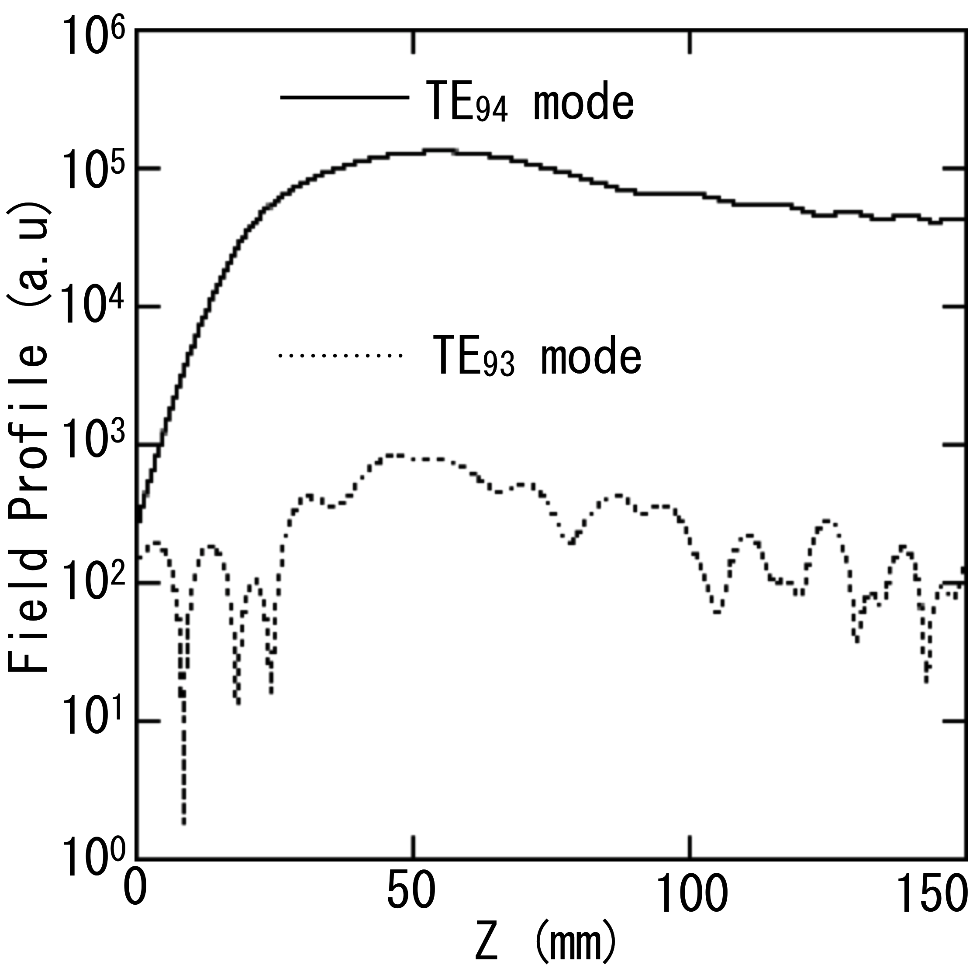 | 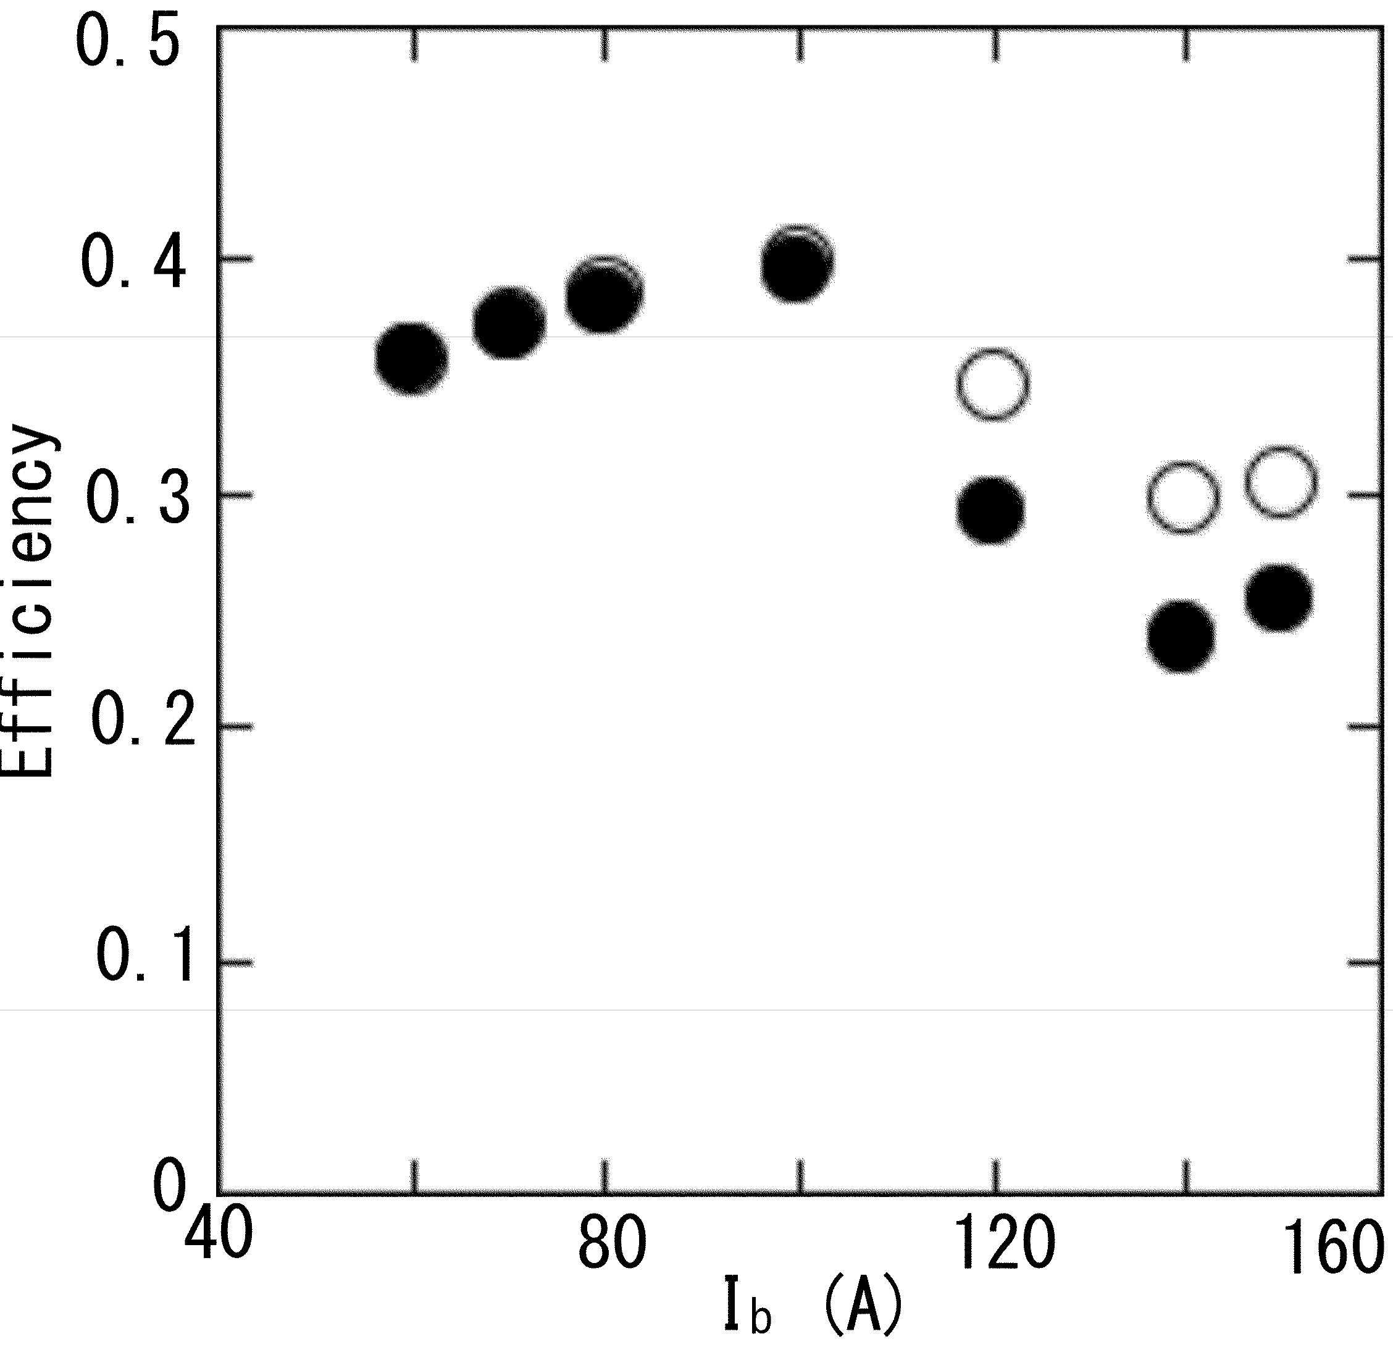
(a) | (b)
Figure 1. (a) Axial structures of the amplitude of the operating mode (solid curve) and the parasitic mode (dotted curve) in the cavity obtained from the stationary analysis with I_{b} = 40 A, α = 1.1, and an 8% spread in the pitch factor. (b) Effects of velocity spread and the space charge on the efficiency of the gyrotron operated in single mode. Filled circles represent the efficiencies with space charge and velocity spread, and open circles represent the efficiencies without space charge and velocity spread.
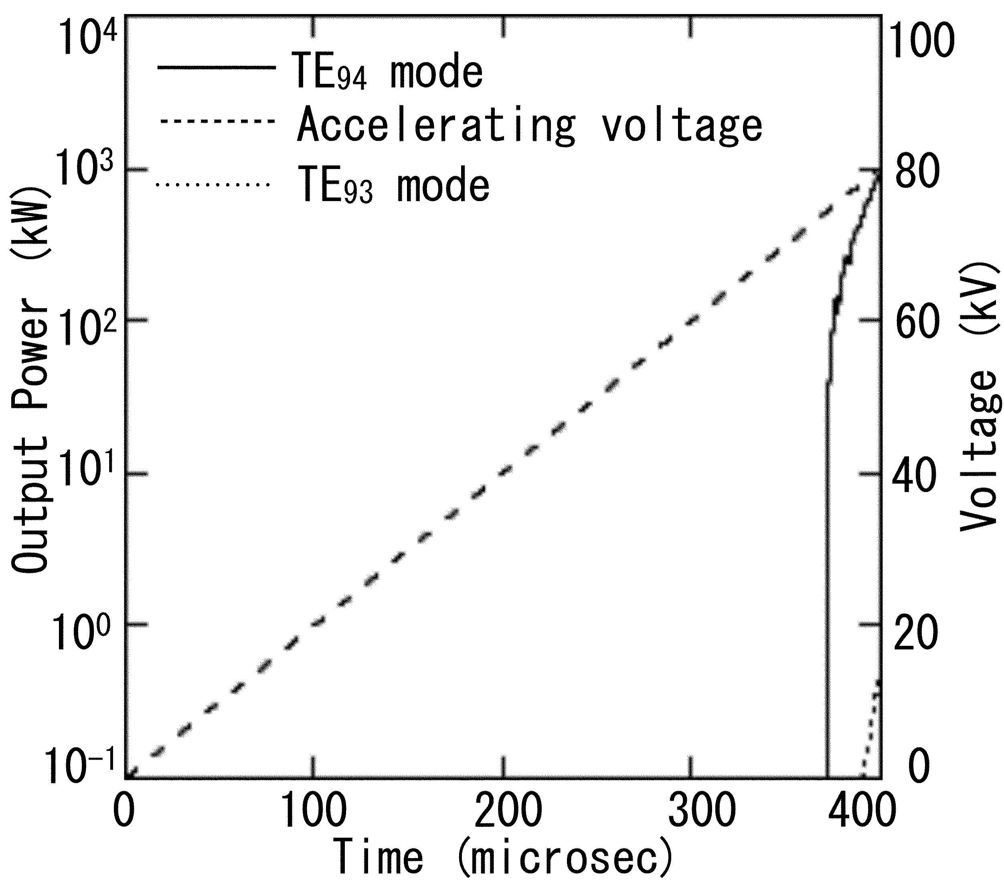 | 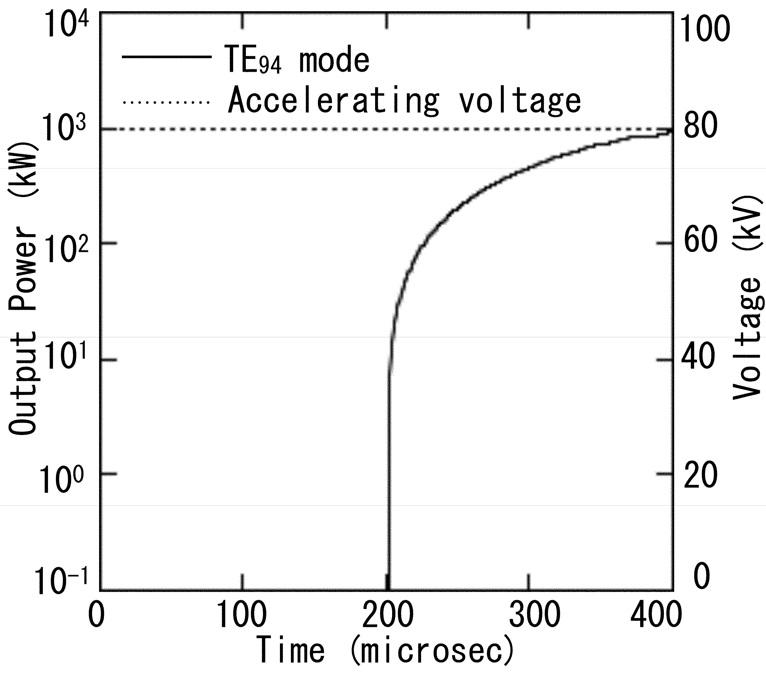
(a) | (b)
Figure 2. Time evolution of the output power and the accelerating voltage of the gyrotron in the startup scenario for the final beam properties (beam current: 40 A, beam energy: 80 kV, pitch factor: α = 1.1). Solid curve: TE₉₄ mode (desired operating mode); dashed curve: TE₉₃ mode (parasitic mode). The pitch factor α increases linearly with time for two startup scenarios. (a) Diode-type startup: the beam energy increases linearly with time. (b) Triode-type startup: the beam energy is constant (80 keV).

A triode-type electron gun of the gyrotron provides separate control over the anode and cathode voltages, allowing for different startup scenarios for achieving the design operating voltages. In case (a), we assumed that the body voltage [12] for accelerating the electrons and the anode voltage for increasing the pitch factor are coupled by a voltage divider, so that both the beam energy and the pitch factor are proportional to the time. This scenario is a typical diode startup scenario. In case (b), the standard triode startup is simulated. In this scenario, the full accelerating voltage is established before “turning on” the beam by increasing the anode voltage. In both startup scenarios, the TE₉₄ mode (the desired mode) achieves an output power of approximately 900 kW, and the currents when the TE₉₄ mode begins oscillating in this calculation are higher than the starting currents of a single mode. In triode startup, the operating mode is present in the cavity and the parasitic mode is not visible. In diode-like startup, the TE₉₃ mode is suppressed when the TE₉₄ mode is stable.
In consideration of the requirement for collaborative research in gyrotron development, experimental and design studies of high-power multi-frequency gyrotron have begun, and the computational code described herein for designing the resonant cavity of the gyrotron has been established for gyrotron development in the future GAMMA 10/PDX plan.

Acknowledgments
The present study was supported in part by a Grant-in-Aid for Scientific Research from the Ministry of Education, Culture, Sports, Science and Technology of Japan (26249141).

References
- M. V Kartikeyan, E Borie and M. V. A. Thumm, Gyrotrons (Springer-Verlag, Berlin, 2004).
- G. S. Nusinovich, Introduction to the Physics of Gyrotrons (John Hopkins University, Baltimore, 2004).
- T. Imai et al., Trans. Fusion. Sci. Tech. 63, 8 (2013).
- C. J. Edgcombe, Ed., Gyrotron Oscillators, London: Taylor and Francis (1993)
- D. R. Whaley, M. Q. Tran, T. M. Tran, and T. M. Antonsen Jr, IEEE. Trans. Plasma. Science. 22, 850 (1994).
- G. S. Nusinovich et al., Trans. Plasma. Science. 32, 841 (2004).
- W. B. Herrmannsfeldt, SLAC-331-UC28, Stanford Linear Accelerator Center, (1988).
- Y. Nakashima, et al., Fusion Eng. Design 85 issue 6, (2010) 956.
- S. N. Vlasov et al ., Radio Engng and Electron. Phys., 21, 96 (1976).
- S. N. Vlasov et al ., Radiophys. Quantum Elec. 12, 972-978 (1969).
- T. Numakura et al., Trans. Fusion. Sci. Tech. 63, 295 (2013).
- T. Eguchi et al., Trans. Fusion. Sci. Tech. 63, 280 (2013).
- T. Kariya et al., J Infrared Milli Terahz Waves. 32, 295 (2011).
- T. Kariya et al., J. Plasma Fusion Res. 8, 000 (2013).

