The Research of Photoneutralization of Negative Hydrogen and Deuterium Ion Beams in Non-resonance Photon
Open Trap
M.G. Atlukhanov^{1, a)}, A.V. Burdakov^{1, 2}, A.A. Ivanov^{1, 3}, A.A. Kasatov^{1, 3}, A.V. Kolmogorov¹, S.S. Popov^{1, 3, b)} , M.Yu. Ushkova³, R.V. Vakhrushev¹
¹Budker Institute of Nuclear Physic SB RAS, Novosibirsk, 630090, Russia
²Novosibirsk Technical University, Novosibirsk, 630092, Russia
³Novosibirsk State University, Novosibirsk, 630090, Russia

- Corresponding author: atluhanov.m@gmail.com
- s.s.popov@inp.nsk.su
Abstract. The paper presents the results of experiments on quasi-stationary photoneutralization H⁻ and D⁻ beams. Studies were carried out using non-resonance adiabatic photons accumulate.

Introduction
For future fusion reactors (such as ITER) it is necessary to use powerful atomic sources with high efficiency. Currently [1], gas charge-exchange targets are widely used due to its simplicity. This approach has a significant limitation, as the efficiency of neutralization of negative ions with the energy of 1 MeV is less than 60%. Furthermore, there are complications associated with the deterioration of the vacuum conditions due to the gas flow and the appearance of impurities in the beam. A possible way to convert a beam of negative ions to the atomic one with a high efficiency and devoid of drawbacks is to use a photon converter [2], based on the process of electron photodetachment from the ion, which makes possible to achieve the effectiveness of this approach close to 100%.
The photon target is based on the adiabatic retention, allowing the photons to stay in the limited space, despite the presence of open areas in the mirror surface. Note, such devices don’t have a number of limitations specific for more traditional resonance accumulators. This are requirements for laser radiation quality (length width, emittance), positioning precision, temperature stability etc., that significantly increases the complexity of resonance system creation.
The energy density in this layout increases proportionally to the lifetime of the photons. Integral lifetime in the photon trap is determined, as in the resonant photon target, mainly by the loss of the photons in the reflections, as well as the time they get outside the system, since the mirror cannot form a closed surface, because it requires a place to input and output the particle beam, as well as the input of the photons. This idea was confirmed experimentally in more simple system of spherical mirrors [3].

Non-resonant photon target
To test the use of non-resonant photon converter [4], an experimental model was designed (Fig.1), which consists of cylindrical shaped parallel mirrors, docked at the ends (upper line) with spherical mirrors. Concave mirrors provide slow decrease of distance between the top and bottom of the mirror when drifting from the center of the trap that can effectively reflect photons back into the system. Confinement of photons in such a trap is based on the adiabatic conserved quantities, which limits the space occupied by the photons, despite the presence of open areas of the mirror surface.
Figure 1. Experimental model non-resonant photon trap
For the experimental use mirrors were implemented on monocrystalline silicon substrates with a multilayer dielectric coating. The length of the reflecting surface of one segment is 50 mm, width is 300 mm of the reflecting surface, the overall size of the mirrors is 250 mm, the retention area is 150 ÷ 200 mm. Calculated reflectance of individual mirrors was 0.999. To enter the photon target one of the cylindrical mirror has an opening with diameter of 300 µm.

The Experimental Scheme
Experiments aimed to measure the coefficient of neutralization in the quasi-stationary photon exchange target, were carried out at experimental stand.
The stand includes a photon target laser input system, as well as the registrar of the passed Н⁻ beam.
Diagnostic injector DINA-4A was used as the ion source for the experiment. At the outlet of the injector a bending magnet is installed, deflecting the negative component of the particle flow. Inside the vacuum chamber at the optical plate with respect to the axis of the injector following elements are installed: photon target; two molybdenum diaphragms 0.5 mm width before and after the target, to collimate a narrow beam corresponding to the target area of neutralization. The distance between the mirrors is 5 cm. In order to register ion particles analyzer is used, which the registers negative components of the beam. Current level of registered negative particles is a fraction of a µA. This current is being affected by the secondary emission and background noise. To eliminate this effect the receiver and signal cable were shielded and biased by -9 V.
Laser radiation is focused by a lens into the inlet of the target. To adjust the position of the laser spot near the hole, a SDU camera is used. With a minimum power of the laser radiation the spot is aimed at the inlet via the translator of the focusing lens.

Measurement of the neutralization ratio in the photon target
The degree of neutralization k of the beam of negative ions in the photonic target is determined by the ratio of the current signal enabled to the signal with the laser turned off.
(1)
The experiments were carried out with particle energy in range 6-12 keV, the working gas hydrogen and deuterium. Laser power was 2 kW and a pulse duration of 50 ÷ 150 ms.
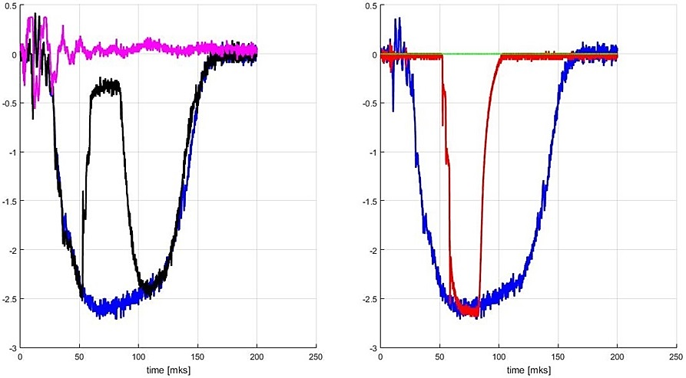
In Fig. 2 oscillograms of the H⁻ beam neutralization at the injection energy of 12 keV is shown, H⁻ without neutralization (blue), neutralized beam (black), laser light (red) and electromagnetic interference (magenta). It can be seen that with the laser ramp-up the current of negative ions drops as long as the radiation does not reach the maximum power. In this case, the ion current when laser-on does not fall to zero (electromagnetic interference), what does not display the 100% neutralization of the beam. Upon turning the laser off, the ion current is increasing till it reaches the reference signal corresponding to a current of negative ions with the laser turned off. In this series of experiments, the maximum neutralization coefficient is k = 89 ± 0.5%.

Figure 2. Oscillograms in experiments on neutralization H⁻ beam
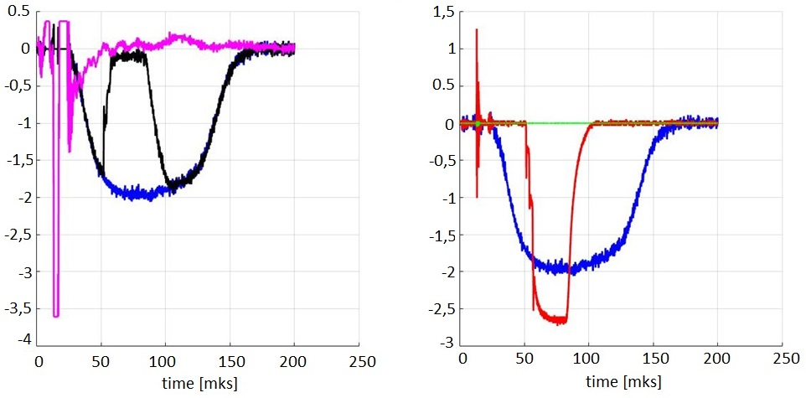
Also, a series of experiments to D⁻ (Fig. 3), the beam energy is 10 keV, the maximum ratio of neutralization of k = 95 ± 1%.
Figure 3. Oscillograms in experiments on neutralization D⁻ beam

Dependence neutralization ratio On the laser power
Comparing the waveforms of the laser radiation to the negative ion current, neutralization degree dependence on the laser power was obtained. Both curves have the same functional relationship,
(2)
where j₀, j₋ correspondently neutrals current and negative ion current on entrance to the target, V_{i} – particles speed, σ – photodetachment cross section, c – the speed of light, P - the radiation power within the neutralization area by width d, which is clearly seen in the logarithmic plots of the negative ion current weakening from the power of the supplied radiation. If compress the abscissa for H⁻ in factor then the curves are in good agreement (see. Fig. 4b) in accord with (2). U_{H}, U_{D-} are corresponding acceleration voltage for H⁻ , D⁻ ; m_{H}, m_{D} are masses.
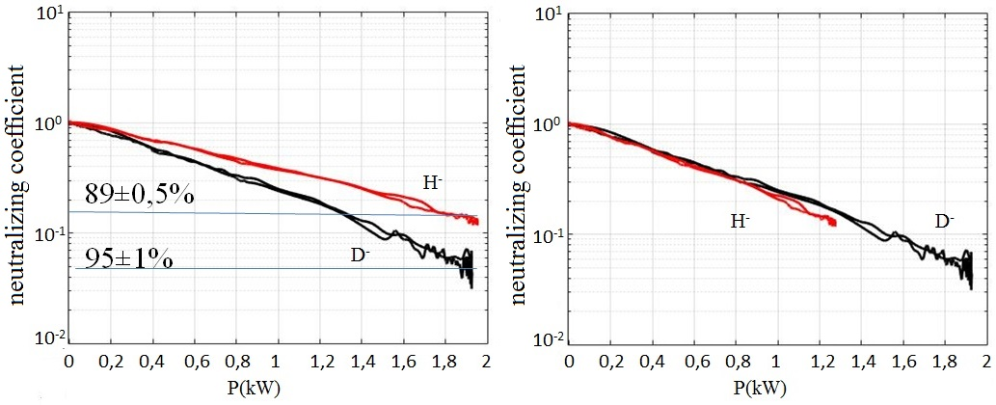
(a) (b)
Figure 4. The dependence of the neutralization degree for H, D from the laser radiation power (a). (b) -- the same at horizontal compression of the curve for hydrogen.

Summary
Experimental results show the possibility of non-resonant radiation accumulation requiring a high density of radiant energy in large compared with the wavelength of the spatial volume. It shows the insensitivity of the pump radiation to the quality and accuracy of positioning and stabilization of optical elements in contrast to systems based on resonator Fabry-Perot type. Neutralization degree of negative ions for hydrogen and deuterium was measured (89% and 95% correspondingly), it allowing the development of highly efficient sources of neutral atoms for heating and plasma diagnostics in such large facilities as ITER [1] or FRC by Tri Alpha Energy Inc. [5]. In addition, the proposed method can be used in spectroscopy and laser isotope separation [6].

Acknowledgements
This work was supported by Russian Science Foundation (project N 14-50-00080).

References
- R. Hemsworth, H. Decamps and J. Graceffa at al. Status of the ITER heating neutral beam system. Nucl. Fusion. V. 49, P. 045006 (2009)
- J.H. Fink, A.M. Frank, Photodetachment of electrons from negative ions in a 200 keV deuterium beam source, Lawrence Livermore Natl. Lab. (1975), UCRL-16844.
- S.S. Popov, M.G. Atlukhanov, A.V. Burdakov, and M.Yu. Ushkova. An Experimental Investigation of Nonresonance Photon Accumulation in a System of Spherical Mirrors, Optics and Spectroscopy, 2016, Vol. 121, No. 1, pp. 160–163.
- S.S. Popov A.V. Burdakov, A.A. Ivanov, I.A. Kotelnikov. Non-resonance photon drive to neutralize the powerful beams of negative ions. // Abstracts of the XXXIX International (Zvenigorod) conference on plasma physics and CF, Zvenigorod, 2012, p.232.
- A. A. Ivanov, G. F. Abdrashitov, V. V. Anashin et al. Review of Scientific Instruments 85, 02B102 (2014); doi: 10.1063/1.4826326
- G.N. Makarov, Low-energy methods of molecular laser isotope separation, Physics – Uspekhi, Vol. 58 (2015), No 7, pp. 670 – 700

