Recent Progress in Development of Neutral Beams for Fusion Studies
V.Davydenko^{1,2,a)}, P.Deichuli¹, A.Ivanov^{1,2}, N.Stupishin¹, V.Kapitonov¹, A.Kolmogorov¹, I.Ivanov¹, A.Sorokin¹, I.Shikhovtsev^{1,2}.
¹ Budker Institute of Nuclear Physics SB RAS, Novosibirsk, Russia
² Novosibirsk State University, Novosibirsk, Russia

^{a)}Corresponding author: V.I.Davydenko@inp.nsk.su
Abstract. A number of neutral beams with ballistic focusing were developed in several recent years for fusion studies in the Budker Insitute. Diagnostic neutral beam injectors for large stellarator W-7X and tokamak T-15 were produced and tested. A high power, relatively low energy neutral beam injector was developed to upgrade the neutral beam system of the gas dynamic trap device and C2-U/W experiments. This injector produces a proton beam with the particle energy of 15 keV, ion current of up to 175 A, and pulse duration up to 30 ms. For tokamaks Globus-M and TCV heating injectors of focused neutral beams with power ~ 1 MW and duration ~1 s were elaborated and produced. Future development of diagnostic and heating neutral beam injectors is discussed in the paper.

INTRODUCTION
Within the last twenty years more than thirty diagnostic and heating neutral beam injectors with ballistic beam focusing have been developed and produced in the Budker Institute. The ballistic beam focusing is provided by spherically shaped multi-aperture electrodes of ion optical system. The injectors are successfully used in different plasma physics experiments. At the Open System Conference 2010 review on development of the injectors was presented [1]. In the paper diagnostic and heating neutral injectors developed after this Conference are presented.

DIAGNOSTIC NEUTRAL BEAMS
Diagnostic neutral beams developed in the Budker Institute [2] have energy ranging from 20 to 60 keV, equivalent beam current of 1–4 A, and pulse duration 10⁻² -10 s. To provide small size of focused diagnostic neutral beam in plasma beam angular divergence should be about or less than 10 mrad. Such small angular divergence is achieved by use of four electrode ion optical systems forming ion beam at relatively small emission ion current density ~110-130 mA/cm².
For active beam emission spectroscopy measurements in large stellarator W-7X [3] the diagnostic neutral beam injector RUDI-X was developed and delivered. The RUDI-X beam has an energy 60 keV, equivalent beam current (for hydrogen) up to 2.5 A, and pulse duration of up to 10 s. In the RUDI-X ion source the plasma emitter is produced by RF-discharge and the ion beam with 20 cm initial diameter is formed by four-electrode multi-aperture ion optical system with beam focusing. Scheme of the RUDI-X injector is shown in Fig.1. Diagnostic neutral beam injector DINA-KI with close beam parameters was also produced and tested for tokamak T-15. In this injector arc plasma generator with cold cathode is used in plasma emitter with peripherical multipole magnetic field. Ion source of the injector forms ion beam with high proton fraction of 80%–90%.

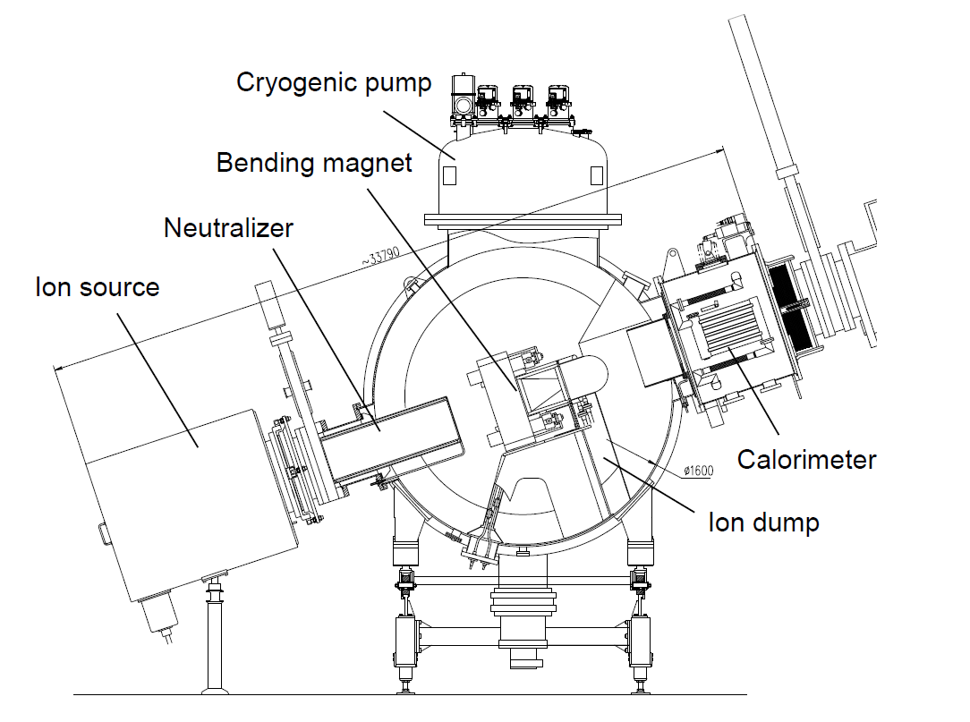
FIGURE 1. Diagnostic neutral beam injector RUDI-X.

Use of slit-like apertures in ion optical system provides lower angular divergence in the direction along the slits because in this direction there are no electric field components that may contribute to the increase of beam angular spread due to aberrations. Diagnostic neutral beam injector RUDI at TEXTOR tokamak was upgraded [4] to increase the beam density at the focal plane in accordance with the requirements of charge-exchange recombination spectroscopy diagnostics. A new focusing ion-optical system with slit beamlets and an enlarged aperture was optimized for 50% higher nominal beam current and reduced angular divergence with respect to the previous ion optical system with round apertures. The upgraded injector produced the ion beam current up to 3 A, the measured beam divergence in the direction along the slits is 6 mrad. The ion source improvements increased the beam density at the focal point, which significantly enhanced active diagnostic signal level and improved measurements of plasma parameters.
At present some specialized diagnostic neutral injectors for advanced diagnostics are developed. For measurement of energy spectrum of fast ions population in plasma by method of artificial target diagnostic injector of intense neutral hydrogen beam with modulation frequency ~10 kHz is developed. Several methods of neutral beam modulation based on modulation of plasma emitter, switching of high voltage power supply, ion beam sweeping by pulse coil, mechanical chopper of neutral beam will be studied. The combined method based on motion Stark effect of with application of laser induced fluorescence, can become the cardinal decision for measurement of magnetic fields up to several gauss. In the diagnostic the combined neutral and laser beams are used. The main difficulty of development of diagnostic neutral beam injector is obtaining of ultra-small dispersion on energy no more than 50 eV. For such small neutral beam energy dispersion not only precise high voltage modulator is required but think target for ion beam neutralization should be used.

NEUTRAL BEAMS FOR PLASMA HEATING
High power focused neutral beams with small divergence are necessary for heating of localized regions inside plasma. Particularly they are useful in the devices with narrow access ports through which only small size, high power density beams can be transported. In heating neutral beam injectors developed in the Budker Institute ion beam is formed by three electrode multi-aperture ion optical systems at ion emission current density of 300-600 mA/cm².
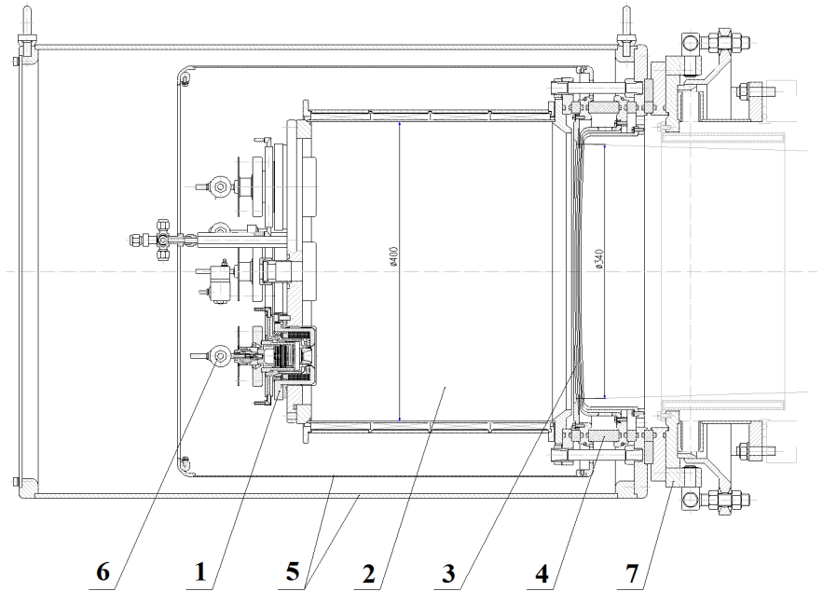
High power, relatively low energy neutral beam injector was developed to upgrade of the neutral beam system of the gas dynamic trap device [5] and C2-U experiment [6]. Shown in Fig. 2 ion source [7] of the injector forms a proton beam with the particle energy of 15 keV, current of up to 175 A, and pulse duration of 30 ms. The plasma emitter of the ion source is produced by superimposing highly ionized plasma jets from four arc-discharge plasma generators. A multipole magnetic field produced with permanent magnets at the periphery of the plasma box is used to increase the efficiency and improve the uniformity of the plasma emitter. The proton beam is formed by three electrode multi-slit ion optical system with 48% transparency, 34 cm initial beam diameter is and 3.5 m focal length. The geometry and potentials of the slit elementary cell [8,9] of the ion optical system were optimized numerically and experimentally to ensure accurate beam formation. The measured angular divergences of the beam are 10 mrad parallel to the slits and 30 mrad in the transverse direction.

FIGURE 2. Ion source of the high power injector : 1 - arc discharge plasma generator, 2 - expander chamber, 3 - grids, 4 - insulator, 5 - shields, 6 - gas valve, 7- aiming unit.

Injector of focused neutral beam with 50 keV beam energy, 1 MW neutral beam power and 0.7 s duration like described in [10] was produced and tested for heating of plasma in spherical tokamak Globus-M. For plasma heating in TCV tokamak, a 35 keV, 1 MW, 1 s deuterium neutral beam [11] is used. The small size of TCV injection port (17 cm x 22 cm) dictated the necessity of having well focused neutral beam for the heating. In ion source of TCV injector plasma emitter is produced by RF plasma box. In multi-slit three-electrode ion optical system 47 mm long slits are placed with a step of 6 mm perpendicularly to the slits inside the 250 mm diameter area. Scheme of heating neutral beam injector for TCV tokamak is presented in Fig.3.
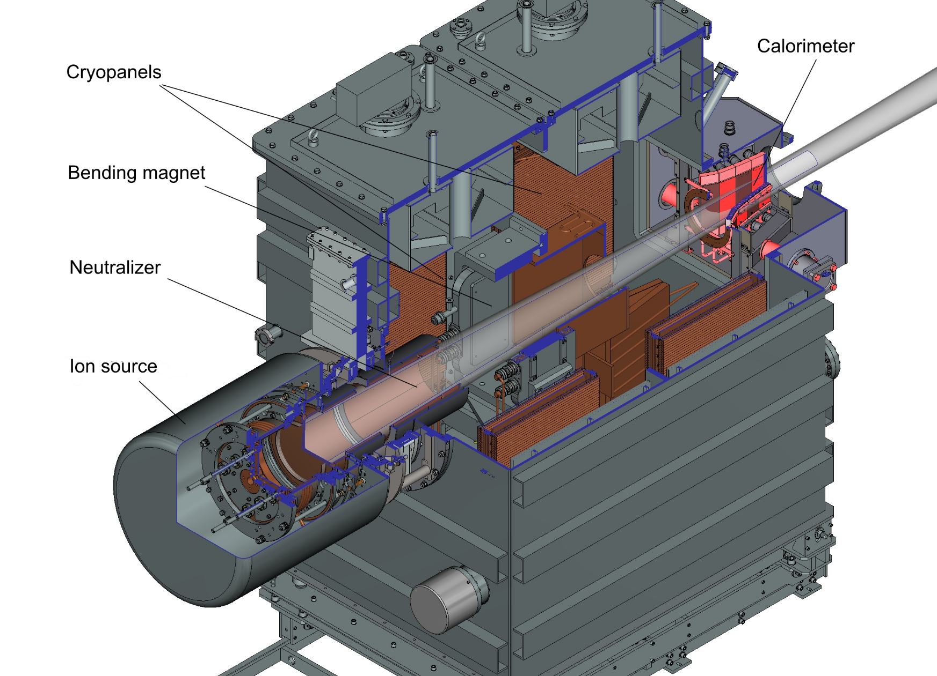
FIGURE 3. Heating neutral beam injector for TCV tokamak.

Future development of the heating neutral beam injectors is a transition to steady-state operation. Elaboration of Faraday screens with intense water cooling is important for steady-state RF-plasma boxes. The versions of the lanthanum hexaboride cathode [12] and washer-stack discharge channel [13] of the arc plasma generator for operation in extended pulse regime are developed. Introduction of the water cooling channels into the grids of ion optical system is necessary for steady state ion beam formation. Due to extremely high beam power density in the focused neutral beam, the calorimeter is also critical element of the steady state injectors. Other components of the injector such as neutralizer, cryo-pumps, bending magnets, beam dumps can be operated in steady state regime without significant problems.
Use of binary mix of hydrogen isotopes in the ratio 1:1 in neutral beam injectors for plasma heating is very attractive for the projects of fusion neutron source. Ion beam composition from the injector ion source operating with binary mix should be experimentally studied in pulsed versions of the heating injectors. For binary mix, the number of beam molecular fractions increases, and energy recovery tasks (that is critical for creation of power effective installations) become complicated. Besides, accumulating of beam particles on internal surfaces of injector elements requires studying during its continuous work. This question is important for safe operation of deuterium-tritium heating injector.

Acknowledgments
This work has been supported by Russian Science Foundation (project N 14-50-00080).

References
- V. I. Davydenko, A. A. Ivanov, P. P. Deichuli, et al., Fusion Sci. and Technology 59, No1T, 128-131 (2011).
- V. I. Davydenko, A. A. Ivanov, Rev. Sci. Instrum. 75, 1809-1812 (2004).
- H. -S. Bosch, R. C. Wolf, J. Baldzuhn, et al., Nucl.Fusion 53, 126001 (2013).
- A. Listopad, J. Coenen, V. Davydenko, et al., Rev. Sci. Instrum. 83, 02B707 (2012).
- А. А. Ivanov, V. V. Prikhodko, Plasma Phys. Control. Fusion 55, 063001 (2013).
- M. Tuszewski, A. Smirnov, M. C. Thompson, et al., Phys. Rev. Lett. 108, 255008 (2012).
- P. Deichuli, V. Davydenko, A. Ivanov, et al., Rev. Sci. Instrum. 86, 113509 (2015).
- V. Davydenko, V. Amirov, A. Gorbovsky, et al., Rev. Sci. Instrum. 87, 02B303 (2016).
- A. V. Sorokin, V. I. Davydenko, P. P. Deichuli, A. A. Ivanov, Technical Physics 61, 1004–1008 (2016).
- A. Sorokin, V. Belov, V. Davydenko, et al., Rev. Sci. Instrum. 81, 02B108 (2010).
- A. N. Karpushov, S. Alberti, R. Chavan, et al., Fusion Eng. Des. 96-97, 493-497 (2015).
- V. I. Davydenko, A. A. Ivanov, and G. I. Shulzhenko, Plasma Phys. Rep. 41, 930-933 (2015).
- A. A. Listopad, Yu. I. Belchenko, V. I. Davydenko, et al., Rev. Sci. Instrum. 85, 02B129 (2014).

