Study of Plasma Electron Thermal Conductivity in the Magnetic Mirror
E.I. Soldatkina^{1, a)}, M.A. Anikeev², P.A. Bagryansky¹, O.A. Korobeinikova², M.S. Korzhavina¹, V.V. Maximov¹, S.V. Murakhtin¹, V.Ya. Savkin¹, D.V. Yakovlev², P. Yushmanov³, and A. Dunaevsky³
¹Budker Institute of Nuclear Physics, Novosibirsk, Lavrentieva prospect, 11, 630090, Russia
²Novosibirsk State University, Novosibirsk, Pirogova street, 2, 630090, Russia
³Tri Alpha Energy, Inc., P.O.Box 7010, Rancho Santa Margarita, California 92688, USA
^{a)}Corresponding author: e.i.soldatkina@inp.nsk.su
Abstract. The paper presents first results of investigations on processes take place in expander of mirror trap where sub-fusion plasma is confined. It is shown that plasma parameters remain constant at magnetic field expansion ratio decreasing down to K = 30. Potential drop in Debye layer near the end plate for expansion ratios K > 30 appeared to be much lower than electron temperature in the center of the mirror as well as characteristic energy of electrons trapped in the expander region.

INTRODUCTION
Problem of axial electron heat loss is an essential challenge for mirror traps and causes rather pessimistic predictions concerning fusion devices based on its principle. However, recent experiments on Gas Dynamic Trap (GDT) in the Budker Institute (Novosibirsk, Russia) demonstrated close to fusion plasma parameters in axially symmetric magnetic configuration [1, 2]. Effective suppression of axial heat flow is being provided by expanding magnetic field between the mirror throat and the end plates. Previous experimental studies dedicated to expander physics role in the overall plasma confinement [3] had been carried out on GDT at much lower plasma parameters than those presently achieved. It is therefore necessary to extend the available set of experimental data to new regimes of interest.
D.D. Ryutov reviewed [4] series of previous works on this matter and analyzed the key issues of expander physics of mirror device theoretically. For the case of secondary emission absence, the electrons flowing from the mirror are confined in expanding magnetic field by ambipolar potential barrier appearing along the field line by virtue of plasma quasi-neutrality.
If there is strong secondary emission from the end plates, main expander problem able to deteriorate core confinement is the presence of “cold” electrons, which can penetrate from expander to the trap and reduce essentially potential difference between end plates and mirror cell. This leads to uncontrollable heat loss from the central plasma. Although secondary electrons could be reflected back from the mirror in case when magnetic field expansion ratio (K=B_{mir}/B_{wall}) is high enough, in particular $K≫\sqrt{m_{i}/m_{e}}$. Qualitative estimations show that in this case the potential distribution in outer part of the end tank (of the vicinity of the plasma collector) flattens, and the most part of “cold” electrons appears to be trapped in a well of effective Yushmanov's potential and has no influence on central plasma confinement.
Note that existing theories are mostly simplified and idealized and should be improved significantly. That we can do to begin this process is to answer the basic questions experimentally in routine GDT regimes. As a first step, we studied the influence of expansion ratio on plasma parameters in the central plane of the trap as well as plasma potential jump in the Debye sheath and electron mean energy in the expander both near the end plate.
Another crucial issue of expander physics is a density of neutral gas accumulating in the expander tank before being pumped out. Reionization of those neutrals could replenish population of “cold” electrons significantly. It is important to know the value of neutrals density, which is critical for plasma confinement.

Experimental Setup
The Gas Dynamic Trap [5] is an axially symmetric linear system with a long central solenoid and high mirror ratio for confinement of two plasma components. One of them is rather dense collisional background plasma (“target plasma”) which is produced in the beginning of experiment by arc-discharge source (plasma gun) and is confined in the gas-dynamic regime. Background plasma could also be produced by microwave breakdown of neutral gas using one of the gyrotrons of ECRH system. During filling stage, that lasts 4.5 ms, temperature of the target plasma is about 3÷5 eV. Deuterium beams with total power of 5 MW are injected in the center of GDT 0.5 ms before plasma gun turning off. They are ionized in the target plasma and form the second plasma component – population of hot (fast) ions, which are confined in the adiabatic regime and gradually are being dragged by target plasma. Target plasma with density of 2x10¹³ cm⁻³ is heated then up to 250 eV. Time of beam operation is 5 ms, during this time a population of hot ions with mean energy about 10 keV and density in the mirror points 5 x 10¹³ cm⁻³ and relative pressure up to 60% appears. Particle balance of background plasma in the stage of beam operation sustained by cold gas fueling. Since 2013 there is also a system of additional ECR heating which allow to gain the temperature of electrons up to 900eV [1, 2]. The ECRH system is built upon two 54.5 GHz gyrotrons with total incident power of up to 0.7 MW, which can be added to the main NBI heating power or used for alternative plasma start-up by ECR breakdown. The schematic layout of the GDT is shown at Fig. 1.
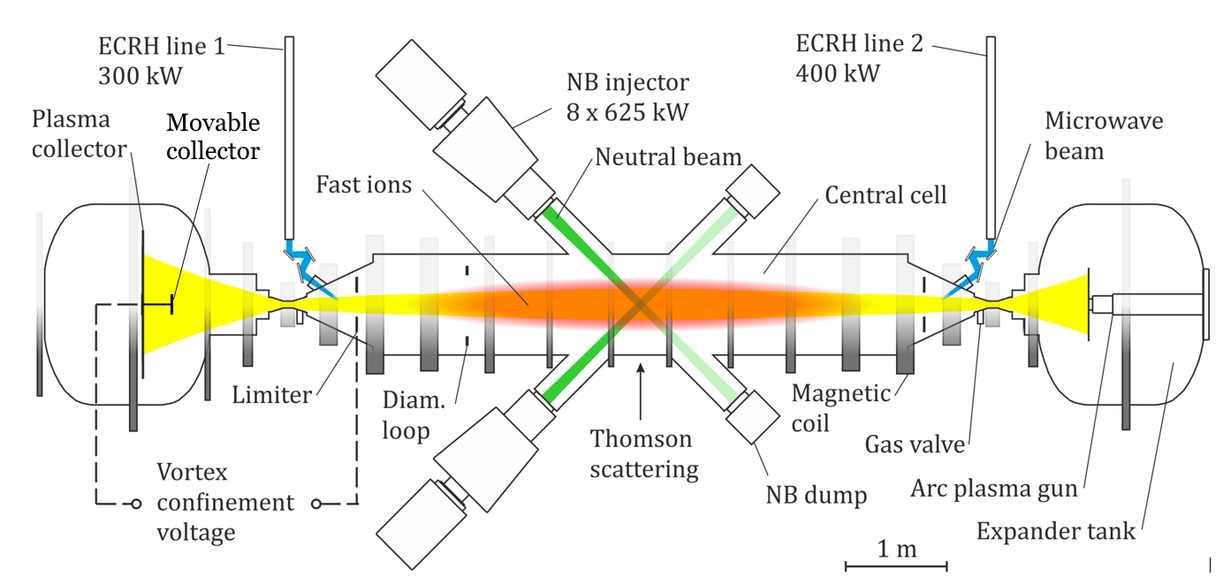
Figure 1. The schematic layout of the GDT

Note that nozzle of plasma gun placed in the position where magnetic field is two order weaker in comparison with magnetic mirror field. It means that essential part of plasma flux is reflected during plasma gun operation. This circumstance causes different vacuum conditions in GDT end tanks during neutral beam operation. Method of generation of target plasma by microwave breakdown of pre-injected neutral gas was developed to eliminate this problem.
The plasma MHD-stabilization in GDT is provided by of so-called vortex confinement method. This method was originally proposed and successfully implemented in experiment on GDT [6]. The vortex confinement is based on initiation of sheared rotation of plasma in a relatively thin peripheral layer.
In the series of experiments devoted to expander physics, on-axis temperature (T_{e}) and density (n_{e}) in GDT central plane were measured by Thomson scattering diagnostics. Energy of fast ions W_{fi} was registered by a diamagnetic loop. The movable plasma collector with a Langmuir probe was installed in the opposite to plasma gun expander. Expansion ratio was adjusted by moving the plasma collector with embedded Langmuir probe. Note that movable plasma collector as well as conventional fixed collectors was grounded. Single Langmuir probe was used for measurements of electric potential drop in Debye sheath on the surface of plasma collector. Langmuir probe is loop with diameter of 7 mm made from a tungsten with a mixture of thorium (wire diameter is 0.12 mm). Distance between probe loop and collector surface was 90 mm. Langmuir probe can work in emissive mode that allow gaining the local plasma potential and in the mode of voltage-current characteristic.

Experimental Results
At figures 2 and 3 results obtained for two different scenarios of background plasma creation (using plasma gun or microwave breakdown) are shown. Apparently, expansion ratio K > 30 shows negligible effect on the plasma temperature and density in the center of the device at different methods of plasma production (Fig. 2, circle and triangle dots). The same measurements were carried out in regime with additional ECR heating with power of 0.7 MW in case of plasma gun start-up. Electron temperature in this regime was about 500 eV. Dependence of temperature on K appears to be similar to the case of moderate temperature (Fig. 2a, square dots).
Emissive probe shows negative space potential of 5÷10V at the vicinity of the plasma collector at the value of the expansion coefficient K > 30 (Fig. 3a, square dots). At lower K, the measured potential goes up while the electron temperature in the center decreases. High voltage drop in the Debye sheath at the plasma collector was not observed. Plasma potential have approximately constant value for K between 30 and 100 at the vicinity of the collector as well as mean energy of electrons (Fig. 3b) which decreases at higher K, and the space potential shows a trend toward zero.

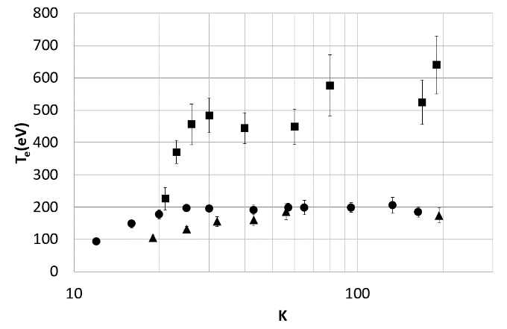 | 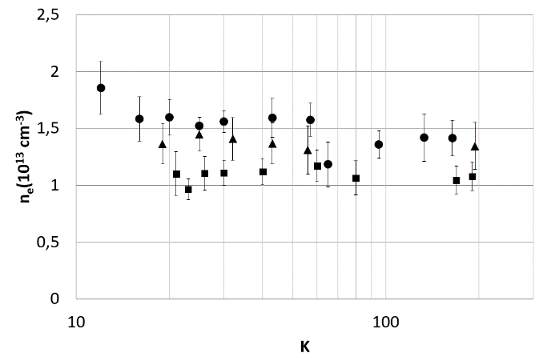
(a) | (b)
FIGURE 2. Dependence of electron temperature (a) and density (b) in the GDT center on the expansion ratio. Circles indicate regime when plasma gun was used for target plasma production, triangles show parameters for ECR breakdown regime, squares demonstrate experiment with additional 0.7 MW ECR heating in case of plasma gun start-up

The most controversial result of this series of experiments is the negative value of the plasma potential relative to the potential of the collector for the expansion ratios in the range from K = 30 to K = 160 (Fig. 3a, square dots). This result apparently caused by different conditions of secondary electron generation due to gas ionization and other processes in different expanders. Penetration of secondary electrons from expander to the trap causes decrease in effective electrical resistance between central cell plasma and collectors. Taking into account electrical current, induced by biasing limiters, one can predict distortion of natural potential profile in the expander.
Based on these concerns the second part of the experiment, in which the ignition of plasma was produced by microwave breakdown, was carried out. Triangle dots on Figure 2 show a similar to regime with plasma gun dependence of the plasma temperature and density in the center of the device on the expansion ratio. In these experiments fast ion diamagnetism remains almost constant in the range of K = 25÷160 of expansion ratio. This indicates low level of anomalous electron heat transport at K > 25÷30. It is important to note, that profile of potential in regime with ECR breakdown (circles on Fig. 3a) is substantially different from the same in experiments with the plasma gun. It became predictably positive and have rather high level for K < 50.
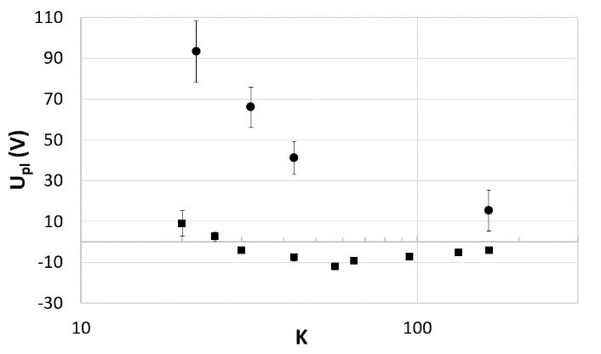 | 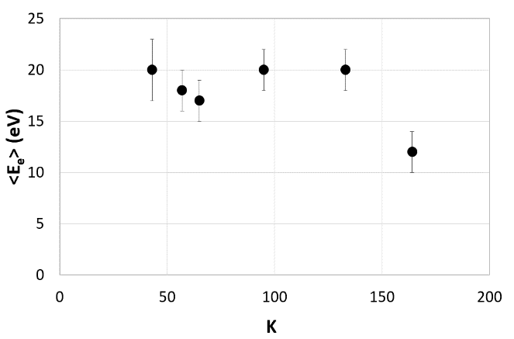
(a) | (b)
FIGURE 3. (a) – plasma potential vs expansion ratio, squares show emissive probe data in plasma gun regime, circles indicate emissive probe data in regime with ECR breakdown. (b) – mean energy of electrons obtained from the current-voltage characteristic of the Langmuir probe in regime with plasma gun

Investigations on influence of neutral gas density in GDT expander on overall plasma confinement are in progress now. Preliminary results of first experiments point out that hydrogen gas densities in the range of n = 0 ÷ 1.5⋅10¹⁴ cm⁻³ affect insignificantly the axial heat losses. This fact could be explained by effect of gas extrusion from plasma stream due to gas heating. Theoretical description of possible mechanism is under construction.

Conclusions
Plasma parameters in the central cell of GDT remain constant in the range of expansion ratio 30 < K < 200. Potential drop in Debye layer near the end plate for expansion ratios K > 30 appeared to be much lower than electron temperature in the center of the trap. Characteristic energy of electrons in the vicinity of end plate at K > 30 is also much lower than electron temperature at corresponding magnetic force line inside the mirror cell. That indicates the presence of electrons population confined in expander by effective Yushmanov’s potential. At present time research of influence of neutral gas in expander on plasma parameters is carrying out.

Acknowledgments
The work was partially supported by grant of President of Russian Federation SP-740.2015.1.

references
- P.A. Bagryansky, A.G. Shalashov, E.D. Gospodchikov, A.A. Lizunov, V.V. Maximov, V.V. Prikhodko, E.I. Soldatkina, A.L. Solomakhin, D.V. Yakovlev, Phys. Rev. Lett. 114, 205001 (2015).
- A.V. Anikeev, P.A. Bagryansky, A.D. Beklemishev, A.A. Ivanov, E.V. Kolesnikov, M.S. Korzhavina, O.A. Korobeinikova, A.A. Lizunov, V.V. Maximov, S.V. Murakhtin, E.I. Pinzhenin, V.V. Prikhodko, E.I. Soldatkina, A.L. Solomakhin, Yu.A. Tsidulko, D.V. Yakovlev, D.V. Yurov, Materials 8, 8452–8459 (2015).
- A.V. Anikeev, P.A. Bagryansky, G.I. Kuznetsov, and N.V. Stupishin, Plasma Phys. Reps. 25 (10), 775-782, (1999).
- D.D. Ryutov, Fus. Sci. Tech. 47, No. 1T, 148-154 (2005).
- A.A. Ivanov, and V.V. Prikhodko, Plasma Phys. Control. Fusion 55 063001 (2013).
- A.D. Beklemishev, P.A. Bagryansky, M.S. Chaschin, E.I. Soldatkina, Fus. Sci. Tech. 57 (4), 351-360 (2010).

