Heating of Tungsten Target by Intense Pulse Electron Beam

Yu. A. Trunev1, 2, a, A.S. Arakcheev1, 2, 3, A.V. Burdakov1, 3, I.V. Kandaurov1, A.A. Kasatov1, 2, V.V. Kurkuchekov1, 2, K.I. Mekler1, V.A. Popov1, 2, A.A. Shoshin1, 2, D.I. Skovorodin1, 2), A.A. Vasilyev1, 2, L.N. Vyacheslavov1, 2.

1 Budker Institute of Nuclear Physic SB RAS, Novosibirsk, 630090, Russia   
2 Novosibirsk State University, Novosibirsk, 630090, Russia.   
3 Novosibirsk State Technical University, Novosibirsk, 630092, Russia.

a)Corresponding author: y.a.trunev@gmail.com

**Abstract.** In Budker Institute of Nuclear Physics are studied the dynamics of tungsten erosion by pulsed electron beam with parameters of heat loads close to the ELM-type events in ITER. This report presents an experimental study of the absorption of the electron beam with energy of 80-95 keV on the tungsten target with an incident heat power flux of 10-50 GW/m2 and duration 0.1-0.3 ms on the area of about 2 cm2. Diagnostics describing beam parameters on the target are briefly discussed. Results of profile measurement of the beam and calorimetry of beam deposited energy on tungsten sample under ELM-like power flow are presented.

# INTRODUCTION

Transient heat loads due to ELM type I or disruptions are considered the main factor responsible for damage of tungsten surface in the ITER divertor. Different techniques are preparing for mitigation of heat load however some number of unmitigated transient events cannot be excluded. In these cases the heat loads can reach energy density Qh=5-80 MJ/m2, power density qh=5-25 GW/m2 over the heating time h=0.3–3 ms for type I ELMs and major disruption. These heat loads correspond to maximal heat flux parameter values FHF=600 - 2000 MJ/m2/s0.5 [1, 2]. Such heat loads are well beyond the condition in the modern tokamaks. In the review [3] summarizes the main approaches to the facilities for simulation of high heat flux loads in the ITER divertor. Electron guns essentially inferior to plasma accelerators on the loaded area, however, they are not particularly limited by vapor shielding effect [3, 4]. Electron beam facility similar to JUDITH [3, 5, 6] used industrial guns based on thermionic cathode with energies of 30-200 keV, the power of up to 0.6 MW and a pulse duration from 1 ms to a continuous mode. On the target, power density of the beam is about several GW/m2 with the diameter that does not exceed 1 mm. Therefore the loaded area is increased due to beam sweeping by the scan magnet of the electron gun. Of course small impact area complicates the in-situ diagnostics of the surface under thermal shock. Moreover required load is generated during more than 1 ms, and thus increases the depth of surface heating and changes temporal dynamics of target heating. In report [7] was suggested the facility with a pulsed electron beam with a power density of 50 GW/m2, and a pulse duration of 60 microseconds, and the typical diameter of loaded area on the target of 1 cm. In Budker Institute is developed technology of pulsed electron guns based on plasma cathode with a pulse duration of up to a few ms, and beam power up to 10 MW with square wave pulse of power [8]. And currently an electron beam test facility were developed based on this technology for in-situ study of tungsten under the thermal shock [9].The purpose of this report is to describe the parameters of the thermal shock loads of pulsed electron beam on a tungsten target for typical conditions of our test facility. Measurements of integral density profile of the beam on the target as well as the energy of the beam deposited in the tungsten sample were carried out. These data allows to define a heat flux parameter, and beam energy flux profile at the target in diagnostic experiments [9, 10, 11] by measuring only a voltage and current of the electron gun.

# Electron Beam Test facility

Test facility for in-situ studying of tungsten under high thermal loads is shown in Figure 1a, it includes a vacuum tank with an external diameter of about 1 m, which houses an electron gun, transport channel with inner diameter 0.1 m, beam collector and target assembly. Facility includes a vacuum tank with an external diameter of about 1 m where is installed an electron gun (1 in Figure 1).Vacuum tank is connected with transport channel of inner diameter of 0.01 m with two diagnostic sections each containing four windows. Beam collector with large conical surface locates at the end of the transport channel and works as Faraday cup for transported electrons. The residual vacuum of about 5 10 - 4 Pa is maintained in facility during operation. The beam is transported in a magnetic field produced by the set of coils 2 in Figure 1a. The movable holder introduces the target assembly (3 in Figure 1) into the diagnostic section. The targets are used in the form of square plate with sides of 40 mm and a thickness of 2.6 mm from rolled tungsten. Calorimetry with L-type thermocouple [12] was used to measure the deposited energy of beam in tungsten target. The electron gun is a multi-aperture diode with a plasma cathode based on the arc plasma discharge. Typical parameters of the electron beam are as follow: energy of 90 keV, a current of 50 A and a pulse duration of up to 1 ms. The diode consists of two grids of about 2 mm thickness with accel gap between them of 10 mm. First one is the cathode (emission) grid and second one is anode (extraction) grid, with 241 adjusted apertures located in a hexagonal order, overall apertures fit in diameter of 80 mm, the diameters of the anode and the cathode apertures are several millimeters, thus the total area of the emission apertures is of 10 cm2.

The beam is formed in a weak magnetic field of about 0.01 T, and is transported to the target in a longitudinal magnetic field with quasiadiabatic compression in the accompanying magnetic field of the order of magnitude of 0.1-0.4 T to a diameter approximately equal to the ratio of fields in the diode and on the target.

By varying the ratio of the fields one can adjust the degree of compression of the beam on the target, and hence the thermal load. The field in transport channel works as magnetic mirror for electrons from the gun, therefore changing ratio of the fields in gun and in drift tube would result in changing of the ratio of current transmitted through channel to the total beam current in the diode. The corresponding dependence of the current versus the mirror ratio is defined in a series of special experiments, when the target assembly was withdraw to the wall of transport channel and beam was received by the Faraday cup.



**FIGURE 1.** Schematic of the facility for generation of transient heat loads.

Registration of the current through the target is insufficient to determine the time variation of power on the target due to plasma processes and thermionic emission on the target, which could significantly distort the signal during the beam pulse [5, 14]. Therefore, additional control over beam power on the target by collimated x-ray detector based on the BGO crystal was made (5 in Figure 1) and installed in front of the window that was orthogonal to the target assembly.

# EXPERIMENTAL RESULTS AND DISCUSSION

Beam dynamics on the target can be illustrated by two traces versus time: power of the beam in e-gun (which is a product of the beam current in the diode on the accelerating voltage) and the X-ray probe signal. Figure 2a shows a typical shot with an average beam power of 3 MW, as seen power remains near constant during total shot.

*a)*

*b)*

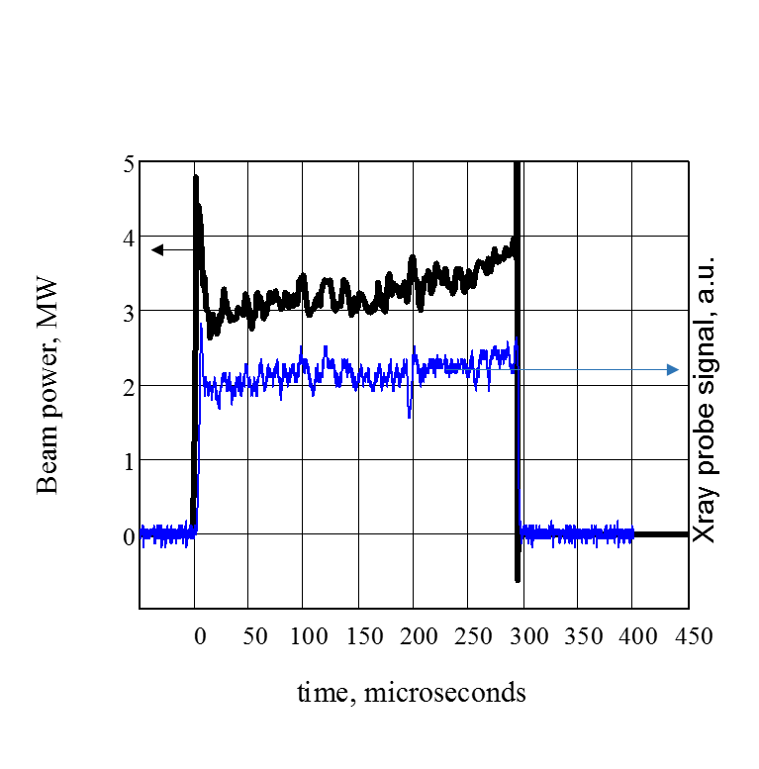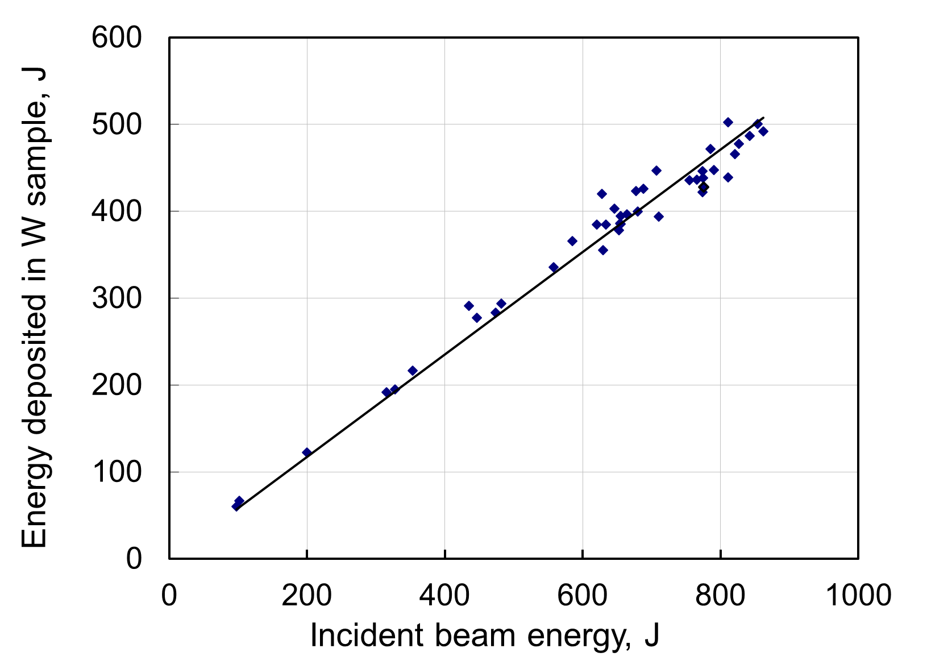

**FIGURE** **2.** a) Trace versus time, upper one is power of the beam in the diode of electron gun, and bottom one is the signal from the X-rays probe that looked at the target, b) The dependence of the energy deposited in the target versus the full energy of incident beam, points - experimental data, straight line - approximation by least-squares method with an curve slope of 0.58.

In a series of shots, we have been changed the power and duration of the beam incident on the target at a fixed magnetic field corresponding to the mirror ratio of 40 and received the dependence of the beam absorbed in the tungsten target from the total energy content of the incident beam. This dependence is shown in Figure 3b. Curve slope could be taken equal to 0.58 with an accuracy of ± 5%. This value is consistent with the calculations [13], but differs in the range of 10% used in works [3, 6], where instead of the energy albedo were taken the value of particles albedo. The maximum achievable energy content of the incident beam on the target during operation was of the order 1kJ. A further increase in energy content is limited by high voltage breakdowns in e-gun diode that seems connected with the formation of plasma on the target [14]. In the absence of target (beam transported to the Faraday cup) energy content of the beam has reached about 2 kJ.

.

***c)***

***b)***

***a)***

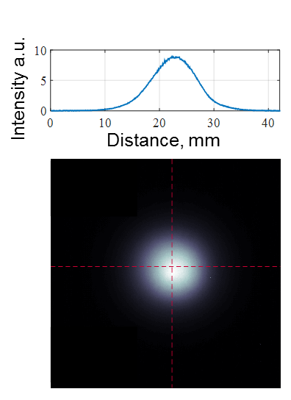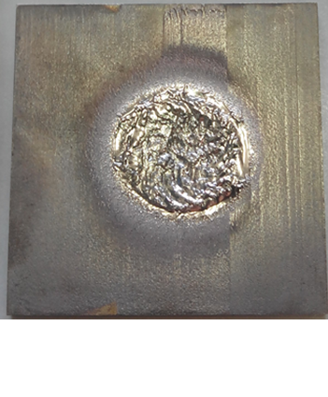

**FIGURE 3.** a) Measurement scheme of the beam energy profile b) Typical snap shoot of glowing screen, on the top showing radial profile of intensity passing through the center of the beam footprint, c) the beam footprint on the tungsten target with side dimension of 40 mm.

To explore an energy profile of the beam on the target were used a measurement scheme shown in Figure 3a.In transport channel was introduced a metal glass on the bottom of which is fixed on one side of phosphor screen 3 and on the other the tantalum converter 4. It glows under the influence of X-rays from the converter. Fast CCD camera shooted this glow. Convertor was placed four centimeters behind the target, at this point longitudinal magnetic field vary from the field to the target by 3% and thus the mean profile and size of the beam was equal to that at target position with good accuracy. The measured profile of the beam on the target is shown in Figure 3b. Radial profile of energy deposition is well described by a Gaussian curve with FWHM of 9.2 mm. It is acceptable with the beam characteristic size calculated according to the law of conservation adiabatic invariant [15] along magnetic field, as well as with a typical beam footprint at the target (Figure 3c) with typical diameter of about 15 mm.

The data allow one to calculate the target load in diagnostic experiments, measuring only voltage and current of electron gun diode. Let us calculate for the above given shot with an average power of 3 MW an typical beam flux parameter on the target, given that 87% of the beam is transported to the target when the mirror ratio between the diode and the transport channel of 40. Averaging the target beam profile along the radius 3 mm obtains flux parameter of 290 MJ/m2/s0.5. As expected from discussion [4], power density was ca. 50 GW/m2 and we did not observe the effect of vapor shielding effect. Note that the total energy content of the beam incident on the target is limited to 1 kJ due to high-voltage breakdowns in the diode, consequently for above showed beam shot when tungsten target loaded by 3 MW power, pulse width of the beam reaches of 0.3 ms and diode breakdown stops operation. The further increasing beam average power for example to up to 5.5 MW will lead to reduction pulse duration due to the breakdown to 0.17 ms with heat flux parameter averaged by profile of the beam over 3 mm radius achieving of 375 MJ/m2/s0.5.

# Acknowledgments

The work at the electron beam facility was supported by Russian Science Foundation (project N 14-50-00080). Study of the target surface erosion was partially supported by RFBR, research project No. 15-32-20669.

# References

1. R.A. Pitts et al., J. Nucl. Mater. 438 (2013) S48
2. M. Shimada et al., J. Nucl. Mater. 438 (2013) S996
3. T.Hirai et al., Materials Transactions, 46(3) (2005), 412-424
4. V. Popov et al., “Theoretical Modeling of Shielding for Plasma Flow and Electron Beam Heating”, AIP Conf. Proc. (these proceedings)
5. D. L. Youchison et al., “High heat flux testing capabilities at Sandia National Laboratories”, New Mexico. (1994) ASME-PUBLICATIONS-HTD, 301, 31-31.
6. O. M. Wirtz, (2012). Thermal shock behaviour of different tungsten grades under varying conditions (Vol. 161). Forschungszentrum Jülich.
7. V.Engelko et al., In High-Power Particle Beams, 1996 11th International Conference on Vol. 2 (1996) 793-796
8. V.V. Kurkuchekov, et al., Fusion Sci. and Technol. **V63** (2013) No.1T, 292–294
9. L.N. Vyacheslavov, et al., “Novel electron beam based test facility for observation of dynamics of tungsten erosion under intense ELM-like heat loads”, AIP Conf. Proc. (these proceedings)
10. A.A. Vasilyev, et al., “Observation of the Tungsten Surface Damage under ITER-relevant Transient Heat Loads during and after Electron Beam Pulse”, AIP Conf. Proc. (these proceedings)
11. A.A. Kasatov, et al., “Observation of dust particles ejected from tungsten surface under impact of intense transient heat load”, AIP Conf. Proc. (these proceedings)
12. I. K. Kikoin, “Tables of physical quantities”. Atomizdat, Moscow, (1976). 1008 (In Russian)
13. Y. G. Li, , et al., Fusion Engineering and Design. 86(12) (2011) 2812-2820.
14. D.Levko, et al., Journal of Applied Physics 113.12 (2013): 123302.
15. V. T. Astrelin et al., “Transportation of Dense Electron Beam through the Input Mirror of the Magnetic Trap GOL-3”, AIP Conf. Proc. (these proceedings)