Valeriy Arkhincheev – Curriculum vitae 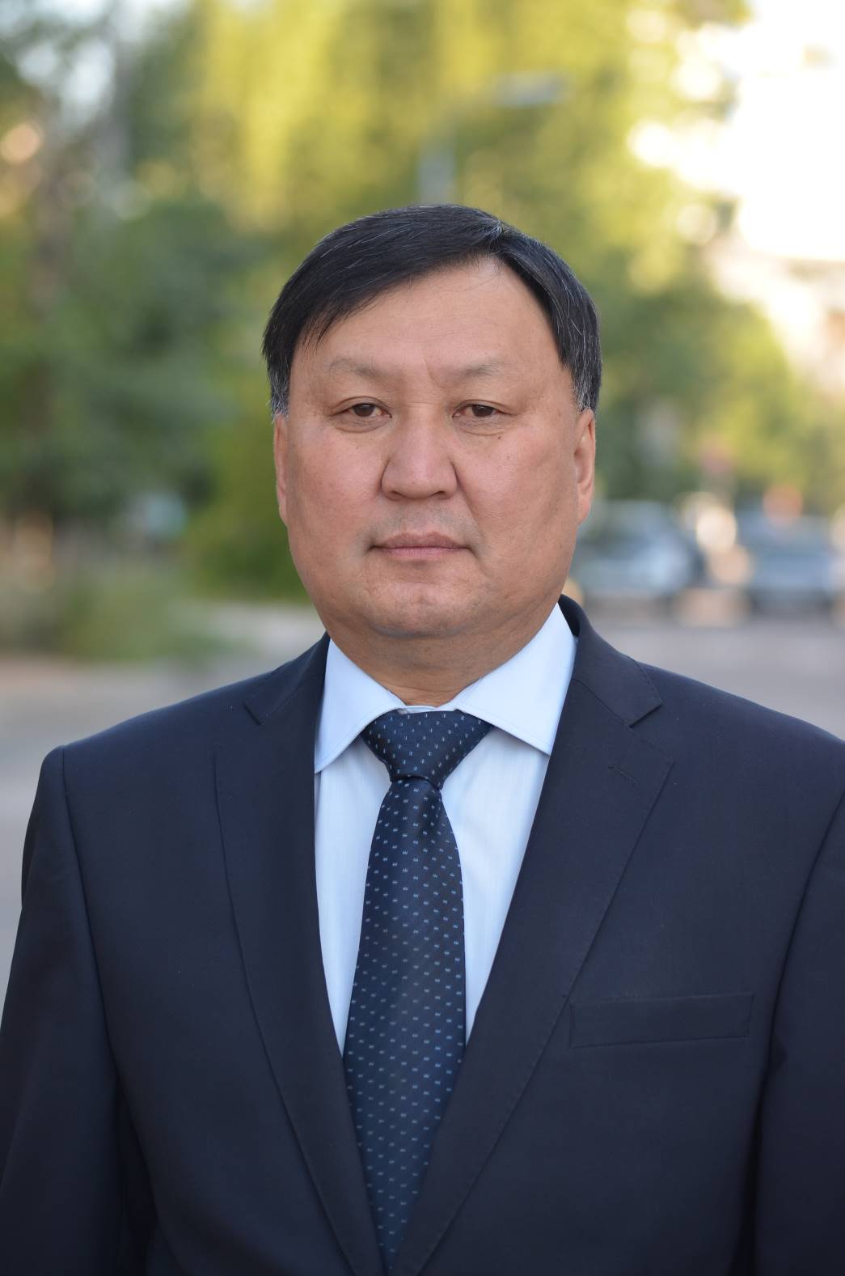

PERSONAL INFORMATION
Family name, First name |  | Arkhincheev,Valeriy
Date of birth |  | April 25 , 1960
Sex |  | Male
Nationality |  | Russian
Family status |  | Married
ORCID |  | http://orcid.org/0000-0003-3468-0414
ResearchGate |  | https://www.researchgate.net/profile/Ve-Arkhincheev
Scopus ID |  | 6602084937
Current address |  | Office  Buryat State University  Center of Information and Quantum technologies,  Institute of mathematics, physics and computer sciences  Str. Smolina 24, Ulan-Ude, 670000, RUSSIA  Tel: +7-3012-213804, Fax: +7-3012-  E-mail: varkhin@mail.ru  Home  Biiskaya 90-30, Ulan-Ude, 670042, RUSSIA
EDUCATION
 | Doctor of sciences  Disputation date: 04.03.2002  Dissertation “Theory of kinetic processes in disordered media”  Ph.D. in condensed matter  Disputation date: 07.03.1998  Dissertation: The exact results in theory of kinetic processes in disordered media |  |  | Irkutsk State University, Irkutsk Russia
1984-1987 | Ph. D courses |  |  | Institute of semiconductors physics, Novosibirsk, Academgorodok Russia
1982-1984 | Training researcher courses |  |  | Institute of semiconductors physics, Novosibirsk, Academgorodok Russia
1977/09 – 1982/06 | Physics  Graduation date: 25.06.1982  Thesis: The theory of shallow impurities in Si:  energy levels, wave functions and transitions between levels. |  |  | Novosibirsk State University . Russia
Professional Career
2024/02- present | Center of information and quantum technologies, Buryat State University,  Ulan-Ude, Russia |  | Director
2016/09- present | Buryat State University,  Ulan-Ude, Russia |  | Professor
2014/04- 2015/01 | Buryat State University, Ulan-Ude, Russia |  | Vice–rector on scientific work
2012 /09- 2016/09 | Center of innovation and educational services Buryat State University, Ulan-Ude, Russia |  | Director
1998/01 – 2014/04 | Institute of Materials Sciences of Siberian Branch Russian Academy of Sciences Ulan-Ude, Russia |  | Leading researcher, senior science researcher, science researcher
1993/09 – 1998/01 | Buryat Branch of Novosibirsk State University, Ulan-Ude, Russia |  | Assistant of professor
1990/01 – 1992/121 | Buryat Science Center, Ulan-Ude, Russia |  | Researcher
1988/11 – 1989/121  __________________________ | Institute of semiconductor physics, Novosibirsk Russia  ____________________________ |  | Engineer  __________
FOREIGN EXPERIENCE 2005/05 – 2008/08  2016/09 - 2021/12 | Federal Urdu University of Arts, Science & Technology, Karachi, Pakistan  Ton Duc Thang University |  | Foreign professor  in frameworks of President Program  researcher professor
Certificates/training
- Diploma of management and economics, Novosibirsk state University, 2015 y
- Diploma of planning project . Moscow institute for increasing qualification, 2021
- Diploma of management of peoples, Krasnodar Institute for requalification, 2021

TRACK RECORDS
Fellowships and awards
1999  2000 | Award Of Siberian Branch Of Academy of Science of USSR  Winner of young scientists competition, diploma  King’s College, London. UK grant of Russian Science Foundation
2000 | Short time visitor (2 monbths), Abdus Salam Center for Theoretical Physics, Trieste, Italy
2001 | Short time visitor, Shrodinger Institute, Vienna, Austria
2001 | Short time visitor (1 month), Abdus Salam Center for Theoretical Physics, Trieste, Italy
2002 | Short time visitor (1 month), Abdus Salam Center for Theoretical Physics, Trieste, Italy
2002 | Short time visitor? Nordita, Copengagen
2004 | Short time visitor (1 month), Abdus Salam Center for Theoretical Physics, Trieste, Italy
Research projects and grants Budget
2024-2025 | Russian Science Foundation, chief 3 000 000 Rus Rubles
2024 | Buryat State University grant, chief 200 000 Rus rubles
2014 - 2015 | Ministry Of Science and High Education of Russian Federation,  chief 600 000 Rus Rub
2011-2013 | Russia – Mongolia , joint Grant of Russian Basic Researcher Foundation,  Chief 600 000 Rus R
2011-2013 | Grant of Russian Science Foundation for prominent scientists (basic researcher)  1 200 000 Rus Rub
2011-2012 7 FTP program on nanoelectonics , leader of researcher group 300 000 Rus Rub

2008-2010 Grant of Russian Science Foundation, regional competition , chief 600 000 RusRub

2005-2007 Grant of Russian Science Foundation, regional competition, chief 400 000 Rus rub
2002-2004 Grant of Russian Science Foundation, chief 400 000 Rus Rub
1998-2000 Grant of Russian Science Foundation, chief 300 000 Rus Rub
2005 Grant of Pakistan Science Foundation, chief 2000 000 Pak Rup
2006-2007 Grant of Pakistan Science Foundation, chief 1000 000 Pak Rup
Papers in peer-reviewed scientific journals
- Arkhincheev V.E., Baskin E.M., Anomalous diffusion and drift on comb model of percolation clusters, Journal of experimental and theoretical physics, 1991. V. 100. P. 292-297

Impact factor IF= 1.00 Q=2 Number of Citations WoS – 112, Google Scholar – 138
- Anomalous diffusion and charge relaxation on comb model exact solutions, Physica A,V. 273. P.204 (2000) Impact factor IF= 3.3, Q=1 Number of Citations WoS – 41 , Google Scholar – 53
- V.E.Arkhincheev, Random walks on comb model and its generalizations, Chaos, V.17, P. 043102 (2007) IF = 3.0 , Number of citations = 36

Google Scholar = 50
- Arkhincheev, VE, Diffusion on random comb structure: effective medium approximation, PHYSICA A-STATISTICAL MECHANICS AND ITS APPLICATIONS, 2002,V.307, P 131-141 IF = 3.3 , Number of citations = 35, Google Scholar = 45
- V.E.Arkhincheev, Acceleration of mass transfer processes in plants due to the geometric structure: a fractional order equation of mass transfer and its application, Scientific Reports, Nature Group, 9, 15269 (2019) DOI : /10.1038/s41598-019-51362-y impact factor IF = 4.525 Q=1

Number of citations = 5, Google Scholar = 7

Publications from 2017
- V.E. Arkhincheev, S/P/Maltsev, B.V. khabituev, Influence of drift on the temporal asymptotic of probability of survival of particles in the medium with traps, Journal of Experimental and Theoretical Physics, 2025. Т. 167. № 5. P. 1-8. IF= 0.95 Q=2
- Md Rasadujjaman, Xuesong Wang, Yanrong Wang, Jing Zhang, Valeriy E. Arkhincheev, Mikhail R. Baklanov, Analytical Study of Porous Organosilicate Glass Films Prepared from Mixtures of 1,3,5- and 1,3-Alkoxysilylbenzenes, Materials 2021, 14(8), 1881; https://doi.org/10.3390/ma14081881 IF= 2.50 Q=2
- V.E. Arkhincheev, The capture of particles on absorbing traps in the medium with anomalous diffusion: The effective fractional order diffusion equation and the slow temporal asymptotic of survival probability, Physica A, V. 550 p. 124487 (2020)
IF= 3.3 Q=1
- V.E. Arkhincheev, Temporal dependency of survival of diffusing particles in many-dimensional media with absorbing traps in an electric field, Journal of Experimental and Theoretical Physics, 2020. Т. 157. № 1. С. 97-100. IF=0.9 Q=2
- V.E. Arkhincheev, Temporal asymptotic of survival probability of particles in effective medium approximation at the capture on traps in the media with anomalous diffusion, Journal of Experimental and Theoretical Physics,. 2020. Т. 158. № 2 (8). С. 309-313. IF=0.9 Q=2
- V.E. Arkhincheev, New temporal asymptotics of survival probability at the capture on traps in media with anomalous diffusion, Journal of Experimental and Theoretical Physics,. 2020. V. 158. № 5 (11). P. 853-857. IF=0.9 Q=2
- V.E.Arkhincheev, Acceleration of mass transfer processes in plants due to the geometric structure: a fractional order equation of mass transfer and its application, Scientific Reports, Nature Group, 9, 15269 (2019) DOI : /10.1038/s41598-019-51362-y impact factor IF = 4.525 Q=1
- V.E. Arkhincheev, Scaling in the problem of capture of diffusing particles on absorbing traps in an electric field, Journal of Experimental and theoretical Physics, V.155 № 1 P 184-188, 2019 DOI: 10.1134/S0044451019010152 IF= 0.95 Q=2
- V.E. Arkhincheev, About influence of magnetic field on the capture of diffusing particles by the absorbing traps , Journal of Experimental and theoretical Physics, V.155 № 3 С 562-566, 2019 DOI: 10.1134/S0044451019030180 IF= 0.95 Q=2
- V.E. Arkhincheev, The calculation of effective three-dimensional diffusion coefficient from survival probability asymptotic at anisotropic diffusion in medium with absorbing traps Physica A, Volume 518, 15 March 2019, Pg 343-348 IF= 3.3 Q=1
- V.E.Arkhincheev, Stability and Dissipation of Many Components’ Systems and Application to Metamaterials, Advances in Condensed Matter, 2017, Volume 2017 (2017), Article ID 8963839, 4 pages, https://doi.org/10.1155/2017/8963839 IF= 0.68 Q=3
- V.E.Arkhincheev, The two-parametric scaling and new temporal asymptotic of survival probability of diffusing particle in the medium with traps, Chaos 27, 033117 (2017); https://doi.org/10.1063/1.4979349 IF = 3.0 Q=1
- V.E.Arkhincheev, Control of quantum particle dynamics by impulses of magnetic field, Nonlinear Dynamics, 2017, Volume 87, Issue 3, pp 1873–1877 DOI https://doi.org/10.1007/s11071-016-3159-5 IF= 3.464 Q=1
- V.E. Arkhincheev, Influence of drift on the temporal asymptotic of probability of survival of particles in the medium with traps, Journal of Experimental and Theoretical Physics, 2017. Т. 151. № 2. С. 322-325. IF= 0.95 Q=2
- V.E. Arkhincheev, Anisotropic diffusion in the medium with traps. Application to Keller-Dykhne theorem, Journal of Experimental and Theoretical Physics, 2017. Т. 152. № 5. С. 970-974 IF= 0.95 Q=2
Awards

- Winner of Young Scientists Competitions of Siberian branch of Academy of sciences, 1999
- Award from Siberian branch, 2010
- Award from Buryat Science Center of Russian academy of Sciences, 2010, 2012
- Awards and Certificates from Ministry of education and science of Buryat Republic, 2015, 2017, 2019
- Awards and Certificate from Ulan-ude City , Department for education , 2017
- Medal of Buryat Republic , “ For Achievements in Buryat republic”, 2019
- Award from Civil Palace of Buryat Republic , 2021, 2022

