High-Intensity Polarized and Un-Polarized sources and Injector Developments at BNL Linac.
- Zelenskiª, G.Atoian, T.Lehn, D. Raparia, J. Ritter
Brookhaven National Laboratory, [11967] Upton, USA
ªCorresponding author: zelenski@bnl.gov
Abstract. The AGS-RHIC pre-injector complex include high-intensity (magnetron type) H⁻ ion source and Optically Pumped Polarized Ion Source (OPPIS); 750 keV RFQ and 200 MeV Linac. In this paper we will focus on the recent Linac pre-injector upgrade with three sources: two magnetron sources and OPPIS. We also present the recent magnetron development to higher duty factor and reliability. Both magnetron sources produce 120-130 mA current (maximum 150 mA, 600-1000 us pulse duration, 7 Hz repetition rate). The LEBT improvement resulted in beam intensity increase (after RFQ at 750 keV) to 80 mA (maximum 90 mA). The polarized beam efficiency transport will be also improved due to shorter LEBT line and electrostatic Einzel lenses replacement with the magnetic quadrupole lenses. The experience of the two sources layout operation (one source in operation the second source in standby) might be useful for facilities with the high downtime cost (like high-energy collider LHC or multi-user facilities like SNS).

INTRODUCTION
There are two types of high-intensity H⁻ ion sources in use at high energy and high average intensity accelerators: Surface Plasma ion Sources (SPS) and volume production H⁻ ion sources. SPS are based on highly efficient H⁻ ion production in collision of ions produced in hydrogen plasma with caesium coated molybdenum surface [1]. The characteristic features of these sources are: the high power efficiency (the 100 mA H- ion beam current is produced with less than ~ 2.0 kW arc-discharge power); high emission current density (in excess of 2.0 A/cm²) and the small arc-discharge chamber volume, which enables the gas pulsing and greatly increases the source gas efficiency. These features make feasible high duty-factor operation. The ISIS Penning type SPS is operated with 5% duty factor (the 50 Hz and 1.0 ms arc-discharge pulse duration) [2]. The pulsed gas operation was implemented at the BINP, Novosibirsk source at 100 Hz repetition rate [3]. The dc Penning source at BINP, Novosibirsk delivered 25 mA beam current [4]. The Mo cathode and anode erosion are moderate at low arc-current and beam formation is not sensitive to cathode dimple erosion, therefore the source lifetime (total integrated current) is in excess of 2 A·h was routinely recorded. The Cs consumption is quite low ~1mg/h, usually one 5 g load would last whole run 6-8 months. Liquid Cs handling in the nitrogen filled glove box is rather routine procedure. In 30 years of magnetron source operation with RFQ, there were no Cs vapor affects observed to the RFQ operation.
Recently, as a result of great efforts the reliable long-term operation (up to 20 weeks) at 6% duty factor and 60 mA H⁻ion current (as measured at injection to the RFQ) was achieved at the SNS volume production ion source with internal RF antenna [5]. This current was obtained with the Cs addition. The gas pulsing in the volume production H⁻ ion sources (with large volume of the plasma chamber) gives some gas flow reduction only at low (~1 Hz) repetition rate. The low emission current density (of about 0.16 A/cm²) requires large (~ 7.0 mm in diameter) extraction system aperture. As a result, in SNS RF-driven H⁻ ion source the gas consumption is high about 30 sccm. This causes large beam losses due to H⁻ ion beam stripping in residual gas and large gas load to the RFQ accelerator section.
The magnetron surface plasma H⁻ ion source has been in use at BNL since 1982 after AGS upgrade with rapid cycling Booster [6]. A multi-turn strip injection of 200 MeV H⁻ ion beam into the Booster increased the AGS beam intensity to 5.0∙10¹³ protons/pulse. In 1989 the Cockroft-Walton injector was replaced by the RFQ pre-injector. The AGS beam was used for experiments with high-intensity secondary mesons and neutrino beams.
The charge-exchange multi-turn injection of polarized H⁻ ion beams to the accelerator rings is essential for feasibility of experiments with polarized proton beams at high-energy accelerators and colliders because of polarized sources intensity is lower than for un-polarized sources. The RHIC complex is the first high-energy accelerator complex where the “Siberian snake” technique was successfully implemented to avoid resonance depolarization during beam acceleration in the AGS and RHIC. The high-intensity polarized H⁻ ion source combined with the charge–exchange injection allowed to achieve maximum possible intensity and luminosity limited by the beam-beam interaction.
The high-intensity Optically Pumped Polarized H⁻ Ion Source (OPPIS) was developed for the RHIC spin-physics program and incorporated in the Linac LEBT system in year 2000 and upgraded with the neutral hydrogen injector for the Run-2013 [7].
Since the first RHIC run in 2000 to the Run-2017 the polarized beam was primary beam for Linac operation. At that time two beams were transported by LEBT. The first beamline was the polarized beamline from the OPPIS and the second beamline the high-intensity un-polarized beam from the magnetron source, which transported to the RFQ after the passage of 45 degree bending magnet. This layout is a compromise in favor of the polarized beam transport efficiency, because of the increased length of the un-polarized beam transport and bending magnet causes some beam losses. The space-charge compensation was improved by the xenon gas injection in the transport line and about 80 mA of H- ion beam was transported to the RFQ input [8]. There was no plan to use polarized beam in Run-2018 in RHIC after polarized the Run -2017. Therefore, we installed the second magnetron source in the straight LEBT section. In this, optimal for the H⁻ beam transport configuration, the beam intensity was increased to 80 mA after the RFQ and fast switching (in about 5 minutes) of the sources was successfully tested.
For the Run-2020 the LEBT was further upgraded to combine beams from two high-intensity magnetron sources and polarized beam from OPPIS (see Figure 1). The results of this LEBT and magnetron sources upgrades are presented in this paper.
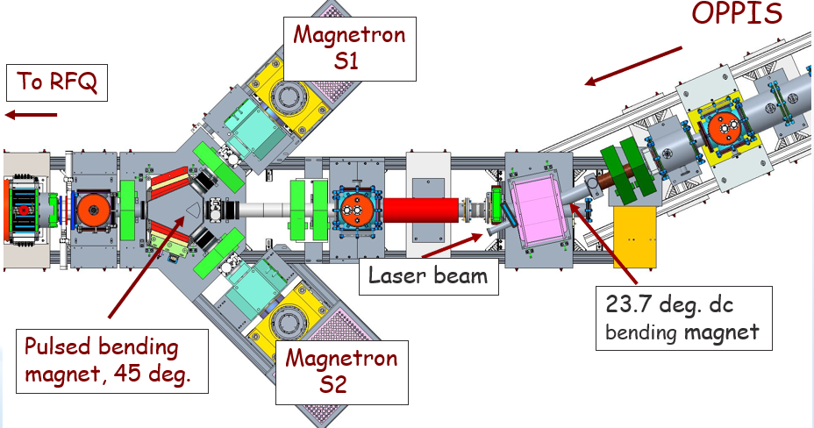

Figure1: New LEBT layout with three sources.

BNL MAGNETRON H⁻ ION SOURCE
As the results of numerous improvements, the BNL magnetron source routinely delivers 110-120 mA H⁻ ion current in 650 µs pulse duration and 7 Hz repetition rate [8-10]. The beam extraction voltage is 35 kV. In the tests of the magnetron source for the possible use at the CERN Linac 4 injector the extraction voltage was increased to 40 kV and the beam intensity increased to 130 mA [11]. A 150 mA H⁻ ion current was produced at arc current 20A.
The arc-discharge current in the magnetron source is only 10-15 A and the arc-discharge voltage is a 140-150 V (see Figure 2). Therefore, the peak power of the arc-discharge is less than 2.0 kW for 100 mA H⁻ ion beam current. This is comparable with the power efficiency of the best proton sources.

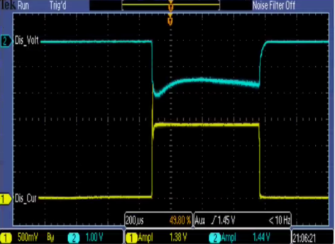

Figure 2: The magnetron arc-discharge operation. The yellow trace is the 14 A discharge current, the blue trace is the 110-150 V arc-discharge voltage.

The average arc-discharge power at 650 us pulse length and 7 Hz repetition rate is only about 10 W. At present, there is no forced cooling in the source, just conductive cooling to the flange. The magnetron source has small discharge volume (of about 1.0 cm³) and the high emission current density. The extraction aperture diameter is only 3.5 mm. Therefore, the gas pulsing by the pulsed valve greatly increases the gas efficiency. At 7 Hz repetition rate and 120 mA H⁻ ion beam current the total hydrogen gas flow was only 0.6 sccm. Simple scaling to 50 Hz repetition rate would imply less than 5.0 sccm gas consumption, which can be further reduced by the valve performance optimization and some reduction of the extraction aperture diameter.

NEW MAGNETRON OPERATION
For the Run-2020 the second magnetron source was introduced into operation. While we use identical (spare) magnetron body, several upgrades were implemented. The gas injection is critical for optimal source operation. The pulsed valve operation is essential for the stable source operation at the best performance and the source gas efficiency. We used the original BINP, Novosibirsk valve as a prototype and made improvements. The main improvement is the replacement of the rubber compression parts with the miniature springs. This change improved valve temperature stability and simplified valve assembly and tuning. The valve outlet hole was reduced to 0.13 mm. As a result, we obtained reliable valve operation and somewhat reduced total gas flow. We also developed a new power supply for the valve (with current stabilization and pulse duration control). This helped to increase pulse duration of the beam to 1000 us. We modified the system of heaters for the Cs supply to magnetron discharge chamber to ensure steady flow with minimal Cs consumption. The new arc-discharge power supply improved beam current stability and reduced the beam current noise. The average arc-discharge power is quite low ~10-15W, therefore we use additional heater for the magnetron body to maintain the magnetron body temperature at 160-180 ºC, which is optimal for the magnetron operation. We built the complete new set of PS for the source.

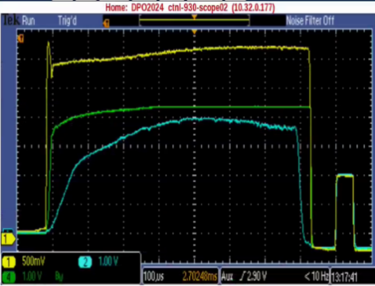

Figure 3: The source operation at 18 A arc-discharge current. The Yellow trace is 130 mA the source current, the green trace is 110 mA the current at injection to the RFQ and the blue trace is 85 mA the current measured after the RFQ.
It is a compact design in standard 60 cm wide rack just about 90 cm toll and placed in the bottom part of the source bench. At 7 Hz repetition rate we use just one turbo-molecular pump of the 1000 l/s pumping speed to operate the source. We modified the source ion optical system with the longer ceramic insulators and larger protection cups to reduce Cs and sputtered tungsten deposition to the insulators. The custom-made Macor insulators were replaced with conventional ceramic insulators. This design eliminated leakages along the ceramic insulators, which developed after extended operation and increased the extraction voltage operational range to at least 40 kV (maximum voltage of the power supply). Electron current is less than 50% of the ion current. It was measured as the difference between the total HV extractor power supply current and the H⁻ ion beam current. The second modified magnetron source produced 120 ma H⁻ ion current at 12 A arc discharge current. At 18 A arc-discharge current and 36 kV extraction voltage the source produced in 130 mA current. About 110 mA current was transported for injection to the RFQ in the LEBT with the two focusing solenoids and 85 mA was accelerated to 750 keV in the RFQ (see Figure 3).
The gas injection into the LEBT line reduced the space-charge neutralization time to less than 50 us and increased total integrated current by about 15 %. We used the pulsed electro-magnetic valve for the xenon gas injection. The best results were obtained at the optimal pressure in the LEBT of about 3∙10⁻⁶ torr.
We tested the feasibility of the source pulse length increase to 1000 µs for the ongoing Linac intensity upgrade with the longer pulse duration. In original design the magnetron body was thermally insulated by the Macor plate and we observed overheating and current degradation at 1000 us pulse duration. We replaced Macor with stainless steel plate which transferred heat to the source flange and added additional forced air cooling to the flange. As a result, a reliable long-term operation was demonstrated at arc-discharge current 12 A and H⁻ ion beam intensity 100 mA (see Figure 4).
The original magnetron arc chamber was designed at FNAL for the slit ion extraction system and has a rectangular shape with many fancy shaped Macor and Molybdenum parts. This design makes difficult development for higher duty factor, which will require cooling line introduction. We are working on complete redesign of the magnetron arc chamber to the circular geometry and provision for an additional cooling line.

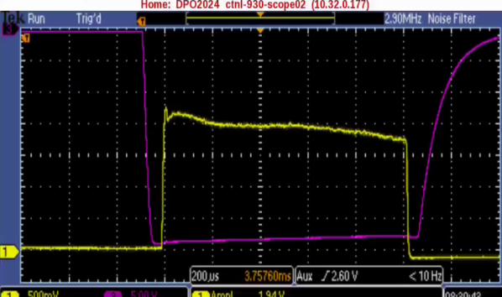

Figure 4: The long pulse operation of the magnetron source. The yellow trace is the 100 mA source current (the time scale is 200 µs/div.). The magenta trace is the extractor voltage pulse-35 keV.

NEW LEBT LAYOUT WITH the THREe SOURCES
In 2019 shutdown period the LEBT was upgraded to combine polarized OPPIS beam and two high-intensity beams from magnetron sources for injection to RFQ (see Figure 1). It was already demonstrated the high-efficiency beam transport with the 45º bend and gas injection for the space-charge compensation. In addition, the 45° bend removes the proton beam produced by stripping of H⁻ ion beam in residual gas. This injector configuration with one source operation and second in stand-by provides enhanced reliability and enabled extended source development program, since we can make changes and improvements in the sources and directly compare results as seen in efficiency of the beam transport efficiency through RFQ to the Linac. A new pulsed three-directional bending magnet with poles shaped for symmetrical horizontal and vertical focussing was manufactured and all beam components (including new chopper box) were rebuilt to minimize the beam-line length from 250 to 200 cm, which reduced beam losses.
The experience of the two magnetron sources layout operation (one source in operation the second source in standby) might be useful for facilities with the high downtime cost (like high-energy collider LHC or multi-user facilities like SNS).

References

[1] Yu. I. Belchenko, G. I. Dimov, and V. G. Dudnikov, Doklady Akademii Nauk SSSR, (Proc. of the Academy of Science of the USSR), 233, p.1283, (1973)
[2] D. Faircloth and S. Lawrie, New J. Phys., 20, 025007, (2018)
[3] G.I. Dimov, G.E. Derevyankin and V. Dudnikov, IEEE Trans. On Nucl. Science, NS-24, p.1545, (1977)
[4] Yu. Belchenko et. al., Rev.Sci.Instrum., 85, 02B108, (2014)
[5] M. P. Stockli et al., AIP Conf. Proc.,1869, 030010, (2017)
[6] J. G. Alessi, AIP Conf. Proc., 642, p.279, (2002)
[7] A.Zelenski et al., Rev.Sci.Instrum., 87,02B705, (2016)
[8] D.Raparia et al., Rev.Sci.Instrum., 87, 02B139, (2015)
[9] A.Zelenski et al., IPAC 2018 Proc., JCOW-IPAC2018-TUPML016, p.1564, (2018)
[10] D. Raparia et al., IPAC 2016, Busan, Korea, p.968, (2016)
[11] J. Lettry et al., AIP Conf. Proc., 1655, 030005, (2015)

