Recent Achievements in Studies of Negative Beam Formation and Acceleration in the Tandem Accelerator at Budker Institute
A. A. Ivanov, A. Sanin ^{a)}, Yu. Belchenko, I. Gusev, I. Emelev, V. Rashchenko,
V. Savkin, I. Shchudlo, I. Sorokin, S. Taskaev, P. Zubarev and A. Gmyrya
Budker Institute of Nuclear Physics, Novosibirsk, Russia
^{a)} Corresponding author: sanin@inp.nsk.su
Abstract. The source for epithermal neutron production, based on vacuum insulated tandem accelerator (VITA) is under operation at the Budker Institute of Nuclear Physics since 2006. The accelerator provides a high current DС proton beam with the energy up to 2 MeV. Numerous improvements to achieve stable tandem work and increase the accelerated proton current were made in more than a decade of experimental operation. These improvements include reduction of the accelerator dark current, modifications for the secondary particles suppression in the tandem gaps, vacuum improvement, upgrades of negative ion source, introduction of additional diagnostics to control and adjust the beam injection and transport. These measures provide the upgraded tandem operation with the accelerated proton current of up 9 mA. Two new schemes of negative ions injection to tandem were designed and tested. New schemes use the upgraded version of Penning surface-plasma negative ion source with DС H⁻ beam current of up 15 mA and beam pre-acceleration before injection to tandem. The recent experimental results and its comparison with numerical modelling are presented and discussed.

BINP Accelerator-Based Neutron Source
Concept of accelerator-based neutron source, using the particle acceleration in the tandem with vacuum insulation (VITA) was proposed in Budker Institute of Nuclear Physics in 1998 [1]. The scheme of vacuum isolation was chosen to provide the reliable high-current DС operation of tandem. The layout of the accelerator-based neutron source with vacuum insulated tandem is shown in Fig. 1. The negative ion source and neutron-producing target are at the ground potential, and the operating voltage is only one half of the full energy gained by accelerated protons. Penning surface-plasma negative ion source is attached to the 15° tilt chamber with the differential pumping. The beam enters 50 mm in diameter transport channel where the solenoidal magnetic lens is placed. The lens focuses the diverging beam and directs it to the tandem entrance. Beam steering is made by two electromagnetic correctors. An electrostatic lens of the first accelerating gap of tandem produces beam focusing, while the applied high acceleration rate minimizes the beam space charge effects. The enlarged tandem entry volume weakens the electric field at the entrance, thus minimizing the effect of beam focusing by the electrostatic tandem lens. The high voltage insulators of the VITA electrodes, embedded one into another, are placed far from the ion beam acceleration zone (see Fig. 1). The negative hydrogen ions are injected from the ion source, transported through the low-energy beam transport line (LEBT) and accelerated to ~1 MeV energy at the high voltage terminal of the tandem, where the stripping target is placed. The protons produced by H⁻ ions stripping in the target are accelerated to the doubled energy at the tandem exit. The protons with energy of 2 MeV are transported through the high-energy beam transport line (HEBT) and directed to the lithium target for neutrons production.
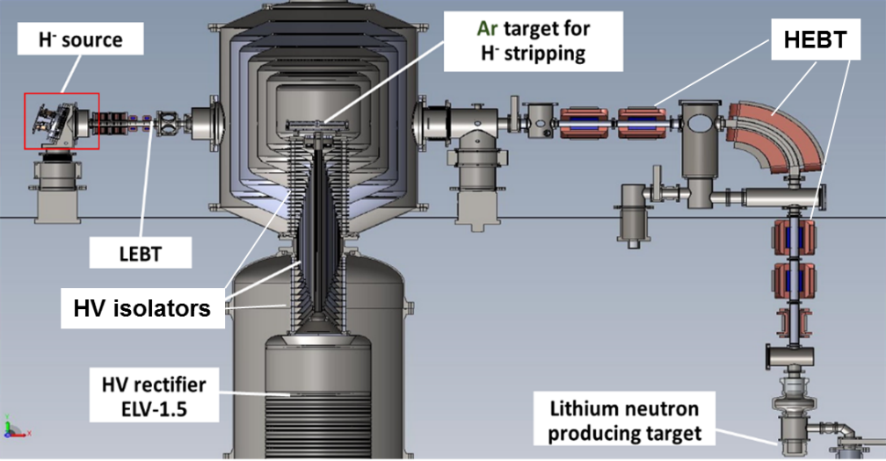
Figure 1. Scheme of accelerator-based neutron source with vacuum insulated tandem (VITA).

TANDEM UPGRADES aNd PROGRESS in OPERATION
The systematic operation and studies of the accelerator-based neutron source began in 2006 [2]. The first accelerated protons were obtained in 2008 [3]. The following step-by-step improvements in the tandem operation and the progress in the accelerated proton current are listed in the Table 1.

TABLE 1. Progress in 2 MeV proton beam production and improvements.
Date | Proton beam, mA | Improvements
2008 | 1 | First experiments on beam acceleration up to 1.8 MeV [3].
05.2014 | 1.6 | Minimization of the high energy x-ray radiation from the tandem; overheated input aperture was eliminated [4].
12.2015 | 5 | Suppression of secondary charged particles: cooled aperture at the tandem entrance; improved pumping of the LEBT and tandem entry box; negatively biased ring in front the input aperture; negatively biased meshes on the input and output apertures [5].
01.2018 | 8 | Beam positioning and focusing using wire scanner; in situ beam position monitoring with the help of CCD cameras [6, 7].
12.2018 | 9 | Negative ion source boosting to higher output current (>10 mA).

Tandem Improvements
Proton beam current with intensity of 1 mA and energy 1.8 MeV was produced at the initial stage of tandem operation [3]. The decrease of the accelerator dark current, optimization of the input to the accelerator and stripping of hydrogen ions in the duct resulted in extension of the stable operation to more than 1 hour with proton beam current up to about 1.6 mA in 2014 [4].
First major increase in accelerated current to 5 mA was done in 2015 after suppression of secondary electrons, produced by accelerated argon ions, which flow from the gas target and were ionized by the beam [5]. The upgrade improves the accelerator operation stability as well. The details of the accelerator modification are shown in Fig. 2. An additional cryopump was mounted at the tandem entrance box to improve LEBT and tandem pumping. A negatively biased ring was placed behind the transport channel output to block the accompanying electrons entering the tandem. A water-cooled tandem entrance electrode with a 20-mm aperture was installed to reduce the gas flow and UV radiation from the transport channel to the accelerator. The diaphragm was covered from the tandem side by a negatively biased tantalum mesh, which diminishes the secondary electrons production by back streaming argon ions. The similar biased electron suppression grid was installed at the accelerator exit too (not shown in Fig. 2).
In the beginning of 2018 an improved matching of the injected beam with the tandem axis was achieved using the wire scanner diagnostics of beam position [6]. The scanner is located near the tandem entrance and monitors the two perpendicular profiles of beam current density. The scanner signals were transformed into the beam current density profiles by using the BINP developed software. The scanner enables to optimize the beam position and the angle at the tandem entrance.
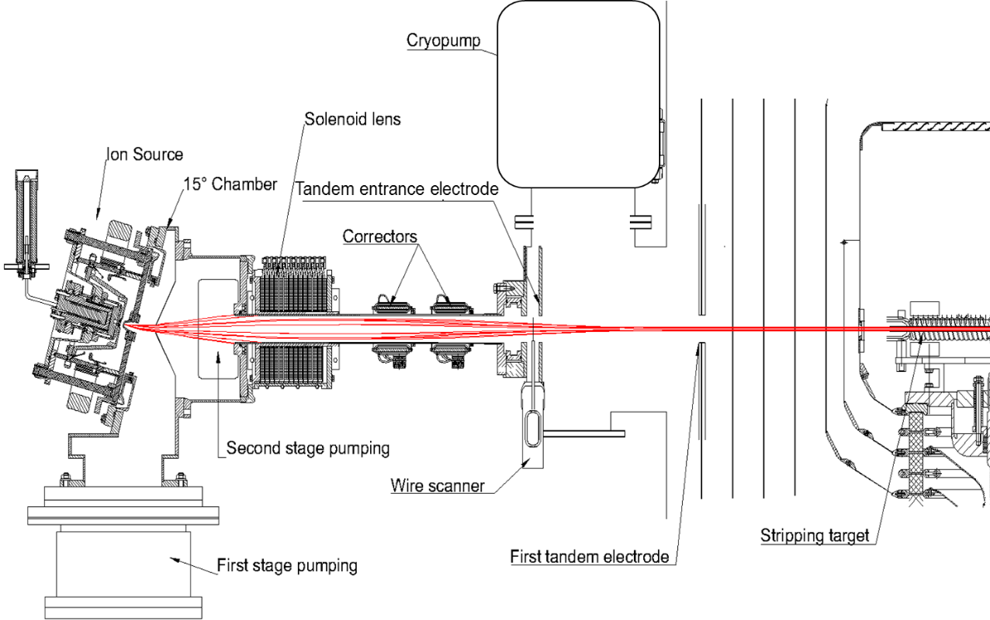
Figure 2. Upgrade of LEBT and tandem elements. H- ions trajectories are shown by red (COMSOL).

Upgrades of Ion Source at Tandem
The first version of DC Penning negative ion source for the tandem was made in 2004 [7]. The source uses high-current Penning hydrogen - cesium discharge with plasma injection from hollow cathodes. The triode source ion-optical system (IOS) with the circular apertures was used for beam extraction and acceleration. The dipole magnetic field in the first source discharge and IOS area was generated by the external electromagnet. H⁻ ions are produced on the cesiated anode surface at constant caesium feed of ~5 mg/h with hydrogen pressure in the discharge chamber of ~4 Pa. The DC H⁻ beam with current up to 8 mA and energy of 25 keV was produced at the source output. The beam regular divergence was ±80 mrad and measured normalized 1 RMS emittance was 0.2 π⋅mm⋅mrad [8]. The picture of H⁻ ions trajectories, calculated by COMSOL are shown in Fig. 2 by red lines (no charge effects were included).
The several upgrades of DC Penning negative ion source to increase output current were made [9]. NdFeB magnet inserts were introduced to increase the magnetic field in the discharge up to 0.1 T. The upgrade of source acceleration power supply allowed to rise the beam energy and to optimize beam transport through the IOS. Several modifications were done to improve the source operation stability, to increase lifetime and to simplify maintenance. The detachable cathode heater, the replaceable high voltage insulators and extraction electrode insert were introduced [9]. The improved differential pumping system was equipped with two high-performance turbomolecular pumps with pumping speed of 2200 l/s. It permits to increase the DC H⁻ beam output to 10 mA.
The source operation statistics at tandem is presented in the Table 2. Both the first and the upgraded source versions have operated for total more than 4281 hours with average daily run ~ 5 hours. An average source start time is about 50 minutes.

TABLE 2. The ion source operation statistics.
Year | Operation days | Source operation hours
2006-2014 | 358 | 1693
2015 | 53 | 265
2016 | 70 | 341
2017 | 121 | 658
2018 | 92 | 516
2019 | 77 | 431
2020* | 40 | 377
Total | 820 | 4281
* now in operation

LEBT Upgrades
The LEBT was equipped with several beam position and current control diagnostics [10]. They simplify beam targeting and focusing at the tandem entrance, and support reliable operation of the tandem accelerator at the increased current level. Four CCD cameras were installed to observe the residual gas glow on the entrance and exit apertures of the first tandem electrode from two perpendicular directions. Special software was written to in situ visualize the beam profile and its position in the input and output apertures during the tandem operation. An example of beam profile visualization is shown in Fig. 3.

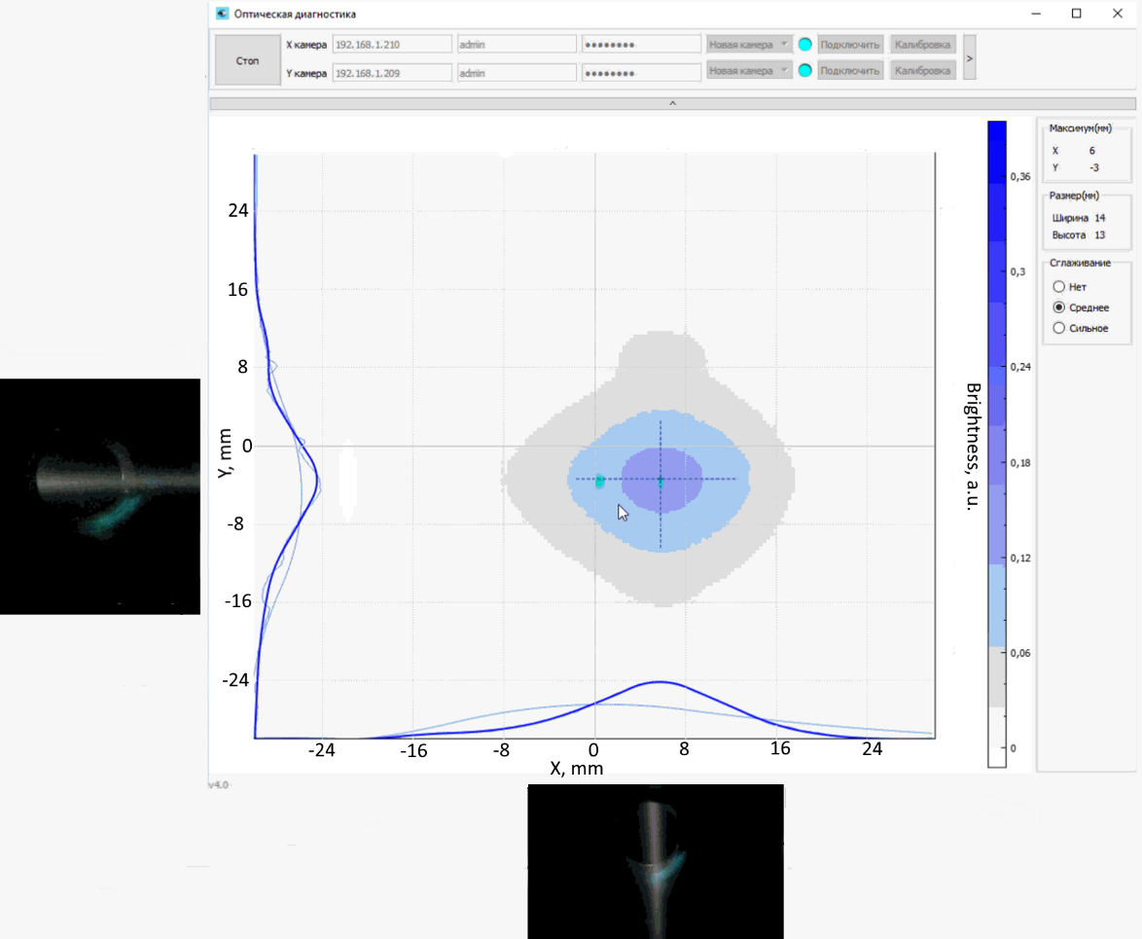
Figure 3. Beam profile visualization at the intput tandem aperture.

The ion source upgrades and optimization of the beam transport allow to achieve the reliable operation with the accelerated 2 MeV proton current of up to 9 mA. The negative ion source was boosted to higher as compare with the regular output current (>10 mA) in the last case.

NEW INJECTORS STUDIES
Several limitations of the existing injection scheme prevent from further increase of tandem operational current. The accelerated current cannot be significantly increased and it was limited by the used ion source arrangement. The magnetic lens and low energy transport channel have small apertures and intercept the beam peripheral parts. The H⁻ ions stripping in the ion source chamber and transport channel can be reduced by improved pumping. The high current beam acceleration could be improved by optimization of the tandem entrance lens. To overcome these problems, two new injectors were designed and studied. Both injectors use upgraded version of Penning surface-plasma source [11] with production of H⁻ current up to 15 mA. The photo of 15 mA source is shown in Fig. 4.
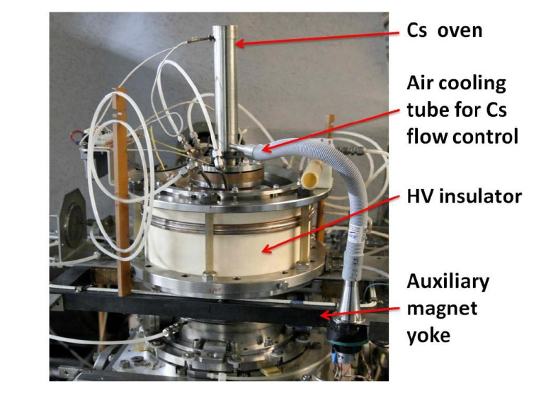
Figure 4. The photo of 15 mA negative ion source.

This source has the enlarged magnetic field and emission aperture Ø 3.5 mm. It produces H⁻ beam with 1 RMS emittance of 0.2 π mm mrad. The data acquisition system for unattended control of the source has been developed [12]. The various scenarios with fine tuning of the source parameters was supported by autopilot. The source start by autopilot is illustrated at the picture of control software application window, shown in Fig. 5.

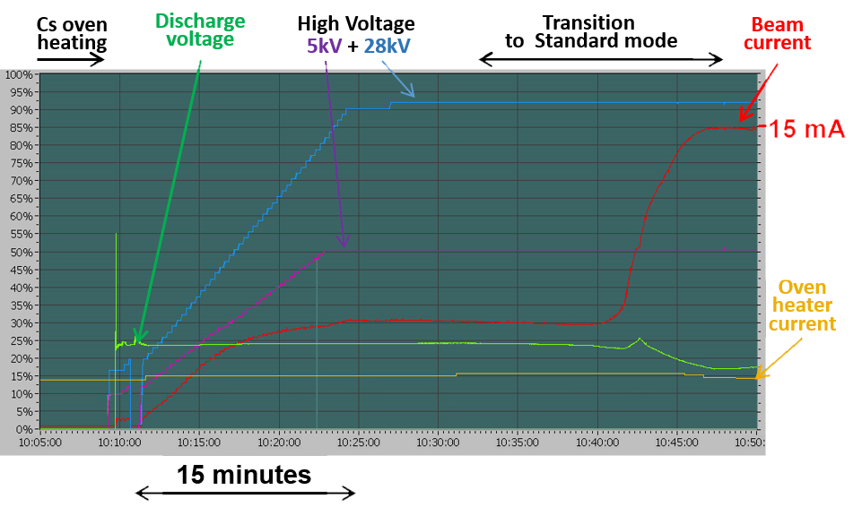
Figure 5. Window of the ion source control program. Source start with discharge ignition, IOS electrodes conditioning and negative ion production activation are shown.

Injector with Additional Lens
The scheme of new negative ion injector design for tandem is shown in Fig. 6. It includes the upgraded version of Penning surface-plasma source, the additional box for improved differential pumping of the ion source chamber and an additional lens for beam focusing to LEBT channel.

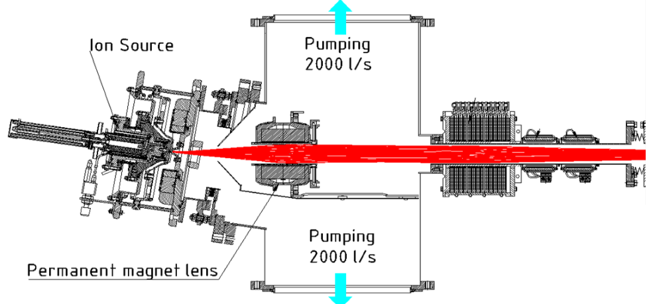
Figure 6. Injector with additional permanent magnet lens. H⁻ trajectories are shown by red (COMSOL).

The calculations of the magnetic field in the ion source, in the permanent magnet lens and in the solenoidal lens of LEBT have been done by the COMSOL software. Figures 6 and 7 show the calculated trajectories of H⁻ beam transmission through the pumping box and LEBT. No beam interception with the lens aperture and LEBT walls were found and 100% transmission of the beam through the LEBT to the tandem entrance was calculated for the beam with emittance 0.2 π mm mrad. The injector is under preparation for installation to the tandem.
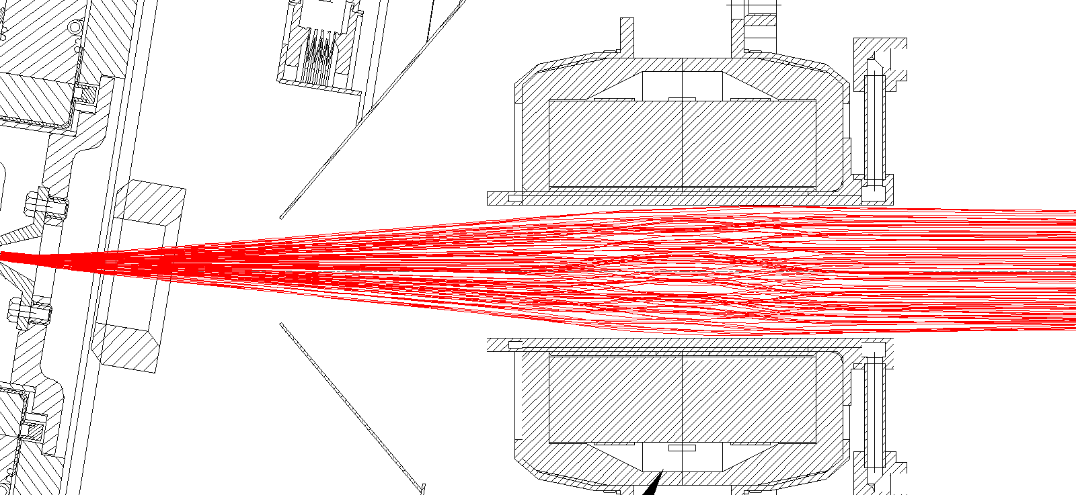
Figure 7. Negative ion trajectories for beam transmission through the permanent magnet lens (modelling by COMSOL).

130 keV Injector with Preliminary 90º Beam Turn
An injector with negative ion beam 90° bend and pre-acceleration to the energy of up to 130 keV was developed [13]. The scheme and photo of 130 keV injector and its diagnostics are shown in Fig. 8 and 9. This injector uses the upgrade version of ion source with 15 mA current yield. The vacuum box with 90° bending magnet is used to separate 33 keV negative ion beam from accompanying particles before entering the acceleration tube. The box was equipped with a high-speed turbomolecular pump protected from particle streams from the source by water-cooled jalousie. The beam acceleration to higher energy of 130 keV before the injection to the tandem reduces the effect of space charge and improves the beam transport through the tandem at wide range of beam parameters and tandem voltages. Beam focusing by the 90° bending magnet and by acceleration tube permits to operate without the additional magnetic lens in the LEBT. High diameter of transport channel (100 mm) and LEBT pumping with additional 200 l/s pump support enhanced vacuum and decrease H⁻ stripping losses during transport.
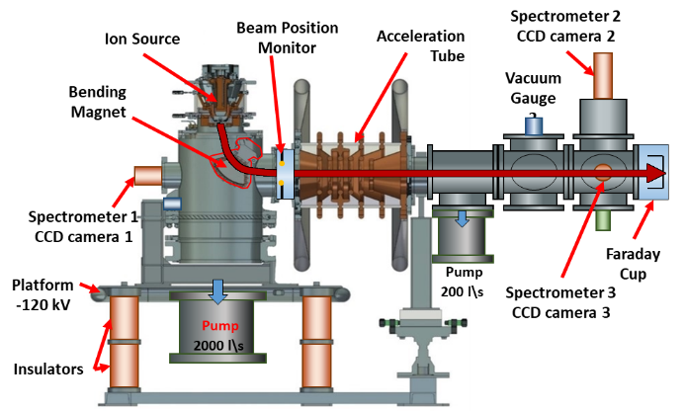
Figure 8. Test stand with 130 keV injector and it diagnostics.

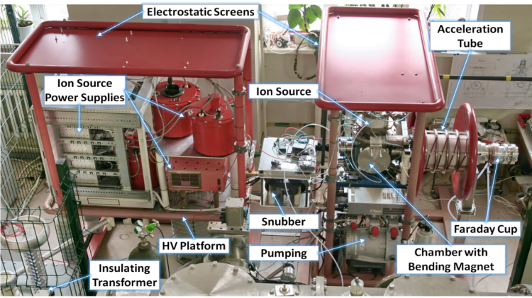
Figure 9. Photo of 130 keV injector with preliminary 90º beam turn.

The studies of H- beam production, acceleration and transport at different vacuum conditions in the transport channel were performed [13]. About 95% beam transmission was achieved. The presence of secondary electrons with a current of ~ 0.4 mA, which were produced in the acceleration tube and co-accelerated with the negative ion beam was recorded. The presumable origin of secondary electrons is H⁻ stripping and secondary emission from the acceleration tube electrodes. The secondary electrons were deflected from the beam by a magnetic filter, installed at the transport tube sides. Reliable operation of the ion injector with ion energy of 133 keV and current of 14.5 mA was achieved.
The effect of Hydrogen, Argon and Xenon gases addition to the 0.8 m long transport tube on the DC 33 keV negative ion beam transverse size and current transported to Faraday cup were studied using optical diagnostics [14]. A drop of the beam size from 9 to 6 mm was recorded with small Xenon addition ~3∙10⁻⁶ Torr. The similar decrease of the beam size was obtained with 10 times larger addition of Argon and with ~40 times larger addition of hydrogen. The coincidence of the measured beam FWHM with the value calculated by COMSOL for the beam with no space charge effect signifies, that the space charge of the beam is fully compensated at the residual hydrogen pressure of
2∙10⁻⁵ Torr in the LEBT. The further gas addition leads to the overcompensation of DC H⁻ beam space charge and to the beam focusing. The Xenon addition is more effective for beam focusing and transport. The H⁻ beam with intensity up to 13 mA was transported and focused to the LEBT exit under a decreased level of the beam losses (<5%).

CONCLUSIONs
The accelerator-based neutron source, using the vacuum insulated tandem is in more than a decade of operation at the Budker Institute of Nuclear Physics. The accelerator provides a DС proton beam with the energy of 2 MeV. Numerous improvements to achieve the stable tandem work and to increase the accelerated proton current were made. The long lasting operation of the tandem accelerator with the proton current of 9 mA was confirmed.
Two new injectors of negative ions for VITA were designed. The injectors use the upgraded version of Penning surface-plasma ion source with DС H⁻ beam current of 15 mA and have the decreased H⁻ stripping losses. Additional elements for enhanced beam focusing, rotation and preliminary acceleration in low energy beam transport channel before injection into the tandem have been implemented. The numerical calculations and experimental tests of the beam production and transport in the new injectors have been made. The injectors are prepared for the installation on the tandem.

References
- B. Bayanov, V. Belov, E. Bender, M. Bokhovko, G. Dimov, V. Kononov, O. Kononov, N. Kuksanov,
V. Palchikov, V. Pivovarov, R. Salimov, G. Silvestrov, A. Skrinsky, and S. Taskaev, Nucl. Instrum. Meth. Phys. Res. A. 413, 397 (1998).
- Yu. Belchenko, A. Burdakov, V. Davydenko, V. Dolgushin, A. Dranichnikov, A. Ivanov, A. Khilchenko,
V. Kobets, S. Konstantinov, A. Krivenko, A. Kudryavtsev, M. Tiunov, A. Sanin, V. Savkin, V. Shirokov,
I. Sorokin and J.P. Farrell, Proceedings of RuPAC 2006, Novosibirsk, Russia (2006).
https://accelconf.web.cern.ch/r06/papers/thlo08.pdf.
- A. Kudryavtsev, Yu. Belchenko, A. Burdakov, V. Davydenko, A.A. Ivanov, A. Khilchenko, S. Konstantinov, A. Krivenko, A. Kuznetsov, K. Mekler, A. Sanin, V. Shirokov, I. Sorokin, Yu. Sulyaev, and M. Tiunov,
Rev. Sci. Instrum. 79, 02C709 (2008). https://doi.org/10.1063/1.2802280.
- D. Kasatov, A. Kuznetsov, A. Makarov, I. Shchudlo, I. Sorokin, and S. Taskaev, JINST 9, 12016 (2014)
DOI: 10.1088/1748-0221/9/12/P12016.
- A.A. Ivanov, D. Kasatov, A. Koshkarev, A. Makarov, Yu. Ostreinov, I. Shchudlo, I. Sorokin, and S. Taskaev, JINST 11, 04018 (2016). https://doi.org/10.1088/1748-0221/11/04/P04018.
- T. Bykov, D. Kasatov, Ia. Kolesnikov, A. Koshkarev, A. Makarov, Yu. Ostreinov, I. Shchudlo, E. Sokolova,
I. Sorokin, and S. Taskaev, AIP Conference Proceedings 2052, 070004 (2018).
https://doi.org/10.1063/1.5083784.
- Yu. Belchenko and V. Savkin, Rev. Sci. Instrum. 75, 1704 (2004). http://dx.doi.org/10.1063/1.1699457.
- Yu. Belchenko, A. Sanin, I. Gusev, A. Khilchenko, A. Kvashnin, V. Rashchenko, V. Savkin, and P. Zubarev, Rev. Sci. Instrum. 79, 02A521 (2008). DOI: 10.1063/1.2816787
- A. Sanin, Yu. Belchenko, I. Gusev, A. Ivanov, V. Rashchenko, V. Savkin, I. Shchudlo, I. Sorokin, and
P. Zubarev, AIP Conference Proceedings 2052, 050012 (2018). https://doi.org/10.1063/1.5083766.
- T. Bykov, D. Kasatov, Ya. Kolesnikov, A. Koshkarev, A. Makarov, Yu. Ostreinov, E. Sokolova, I. Sorokin,
S. Taskaev, and I. Shchudlo, Instrum. Exp. Tech. 61, 713 (2018). https://doi.org/10.1134/S0020441218050159
- Yu. Belchenko, A. Gorbovsky, A. A. Ivanov, A. L. Sanin, V. Y. Savkin et al., AIP Conf. Proc. 1515, 448 (2013). https://doi.org/10.1063/1.4792815.
- P. Zubarev, A. Khilchenko, A. Kvashnin, D. Moiseev, E. Puriga et al., AIP Conf. Proc. 1390, 634 (2011). http://dx.doi.org/10.1063/1.3637435.
- A. Sanin, Yu. Belchenko, A. Ivanov, and A. Gmyrya, Rev. Sci. Instrum. 90, 123314 (2019).
https://doi.org/10.1063/1.5128590.
- A. Sanin, Yu. Belchenko, S. Popov, A. Ivanov, A. Gmyrya, M. Atlukhanov, and S. Abdrakhmanov, Rev. Sci. Instrum. 90, 113323 (2019). https://doi.org/10.1063/1.5128591.

