High-speed Emittance Measurements for Beams Extracted from J-PARC RF Ion Source
T. Shibata^{1, a)}, K. Shinto¹, M. Wada², H. Oguri¹, K. Ikegami¹, K. Ohkoshi¹
and K. Nanmo¹
¹ J-PARC Center, 2-4 Shirakata, Tokai-mura, Naka-gun, Ibaraki 319-1195, Japan.
²Doshisha University, 1-3 Tataramiyakodani, Kyotanabe, Kyoto 610-0321 Japan.
^{a)}Corresponding author: takanori.shibata@kek.jp
Abstract. Oscillation of emittance and Twiss parameters in the negative ion (H⁻) beam from the J-PARC 2MHz RF ion source is measured by applications of a double-slit emittance monitor located at the RFQ entrance. The emittance monitor is equipped with a newly-developed 60 MS/s data acquisition system, so that beam current oscillation in a few MHz can be observed with enough time resolution. From the measurement, it is shown that the beam phase space consists of (1) Direct Current component in the beam core, (2) 2 MHz oscillating component which takes place in the diverging halo and (3) doubled RF frequency (4 MHz) oscillation which slightly exists in the beam halo. The major component is the 2 MHz component, which resultantly decides the beam emittance oscillation frequency. A typical value of the beam emittance in the present experiment is 0.33 π mm-mrad, while the amplitude of the 2 MHz oscillation is around 0.04 π mm-mrad. The results indicate that the high-frequency oscillation component occupying about ten-percent of the beam from the RF source travels a few meters passing through a magnetic lens focusing system.

INTROduction
As a part of linac intensity upgrade, the J-PARC cesiated Radio Frequency (RF) driven negative hydrogen ion (H⁻) source (Fig. 1) operation was initiated in Sep. 2014. No serious troubles which stops the beam operation for long time has occurred in sequences of a few month ion source operations in these 5 years. The continuous operation time of the ion source has been prolonged step by step from 1.5 months in 2014 to 3.5 months in 2020. A trend of the beam operation in 2019 – 2020 is shown in Fig.2 (a). The 2,445-hour operation has been done from January to April 2020 with the H⁻ beam current up to 60 mA for J-PARC user operation. As shown in Fig. 2 (b), this is the first long run with the 60-mA beam operation and without the internal antenna failure. In January and July 2020, operation of 72 mA beam current has been done for around 2 days for accelerator study. Amount of the cesium consumption in the 1,521 hours operation was 0.4 g. In these 5 years, the beam current from the J-PARC ion source has been increased from 33 mA to 60 mA for user operation [1, 2].

While the beam intensity is upgraded, it has been observed that beam oscillation with RF frequency up to 2MHz takes place in the beam accelerated in the linac. In 2018, the beam wave form at the exit of Radio Frequency Quadrupole Linac (RFQ) was measured by a fast current transformer (FCT) at the 3 MeV RFQ test-stand [3]. The ±2 MHz side band was observed around the linac RF frequency 324.5 MHz in spectrum of the FCT signal. From these results, a direct beam current measurement from the RF ion source was measured by Faraday-Cup with a single slit at the ion source test stand (ISTS) [4]. A one-dimensional beam current profile has shown that the strong direct current (DC) component of the beam exists at the center of the H⁻ beam while 2 MHz and 4 MHz components, which
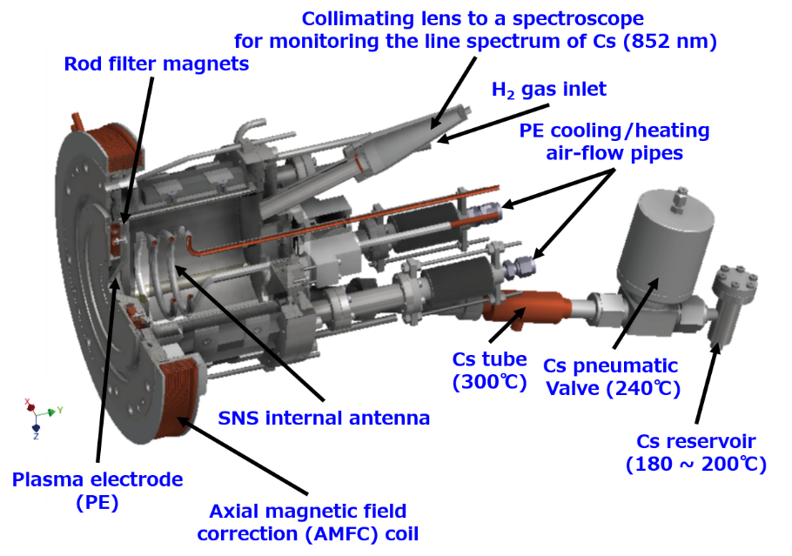
Figure 1. A schematic drawing of the J-PARC cesiated RF negative hydrogen ion source.

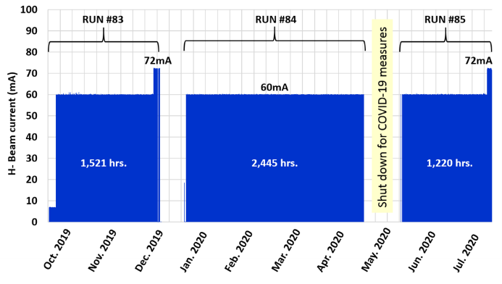 | 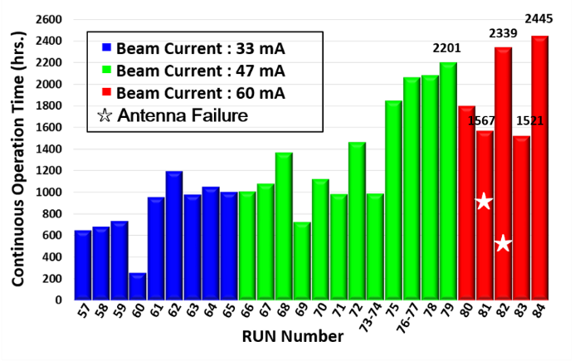
(a) | (b)
FIGURE 2. (a) A trend of beam operation from Oct. 2019 – Jul. 2020. (b) Continuous operation time of the J-PARC RF ion source in each RUN events. Blue, green and red bars show the operation time for the beam current up to 33 mA, 47 mA and 60 mA, respectively.

corresponds to the doubled RF frequency to the ion source, take place at the surrounding part (> 0.8 mm from the beam center), namely at beam halo. However, at this moment, the signal from the Faraday-Cup is not amplified due to the cut-off frequency of the data acquisition system. Also, the next task was to focus on the phase space measurement. At the present time, the fluctuation in the H⁻ beam in a few MHz does not result in serious beam loss or resultant activation of components of the linac. However, the problem may become an issue when we proceed the beam upgrade such as in beam intensity or duty factor. As this point of view, the purpose of this study is to understand the beam fluctuation characteristics from the RF ion source.

In the present study, effect of the RF frequency of the ion source to the beam phase space at the RFQ entrance is measured by an emittance measurement system at ISTS. In the 2nd section, the RF ion source and ISTS configuration are briefly explained. Details of the high-speed double slit emittance monitor, which can observe time variation of beam phase space with high time resolution more than few MHz, are introduced in section 3. In the 4th section, condition of the beam experiment and the main results are shown. Time variation of the beam emittance and the Twiss parameters are investigated from the beam current wave forms (WF) in the phase space. In the 5th section, the relation between the ICP-RF plasma and behavior of the extracted beam is discussed.

Ion Source Test Stand (ISTS)
Figure 3 shows a schematic drawing of the ion source test stand (ISTS) which has the same configuration as the actual J-PARC linac front-end. The RF ion source, as shown in Fig. 1, is equipped with a three-turn internal antenna coil. The plasma chamber is a cylindrical shape and the diameter of100 mm and 120 mm long in axial direction. The chamber is surrounded by 18 poles of cusp permanent magnets for the plasma confinement. A pair of rod filter magnets is inserted just above the taper shaped aperture, which has diameter of 9 mm, of the plasma electrode in order to remove a high-temperature electron flux in the extraction region.

In J-PARC operation, combination of two different RF power input is applied; (1) 30 MHz, 30 W, CW input and (2) 2 MHz pulsed input with repetition rate up to 25 Hz and pulse width up to 800 μs. The forward RF power of the 2MHz input is 26 – 30 kW in the recent operations, while the reflected RF power is reduced to almost zero. A 50-keV electrostatic acceleration part is connected to the RF ion source. At the downstream, two DC solenoids (SOL1 and SOL2) are located for the Twiss parameter matching of the RFQ which follows the SOL2 in the actual linac. The beam transport component equipped with two solenoids is so-called Low Energy Beam Transport (LEBT). At the end part of the test stand, a double slit emittance monitor is installed for the beam phase space measurement instead of the RFQ. The axial position of the emittance monitor is exactly the same as the upstream edge of the RFQ vane (the RFQ entrance).

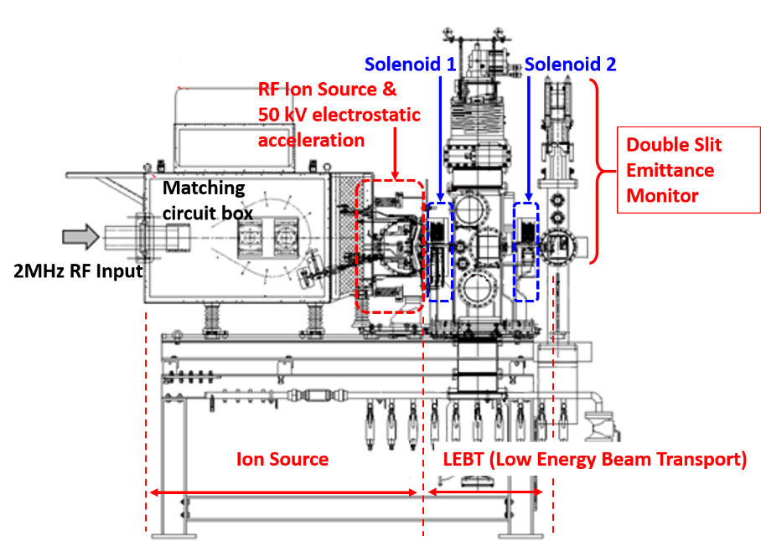
Figure 3. A schematic drawing of the ion source test stand (ISTS).

High Speed Double Slit Emittance Monitor SYSTEM
A basic concept of the double slit emittance monitor is well known [5] and the monitor has been applied to the phase space measurement in J-PARC ion source from the moment of the foundation. Figure 4 shows a photograph of the emittance monitor installed in ISTS. The 1st slit can be moved individually from the 2nd slit which is connected to the Faraday-Cup (FC). Configuration of slits, electron suppression voltage and signal termination of FC are shown in TABLE 1.

Figure 5 shows a drawing of the control and data acquisition system of the emittance monitor. In the data acquisition system, the signal received at the FC is amplified by a preamplifier and collected by a digitizer. A requirement of the data acquisition is to have time resolution higher than few MHz, which is focused in the present study. The data acquisition system consists of a high-speed digitizer and a differential preamplifier. The digitizer is SPECTRUM M2i.4960-exp which enable to vary the sampling rate in the range 1 – 60 MS/s by sampling clock [6].
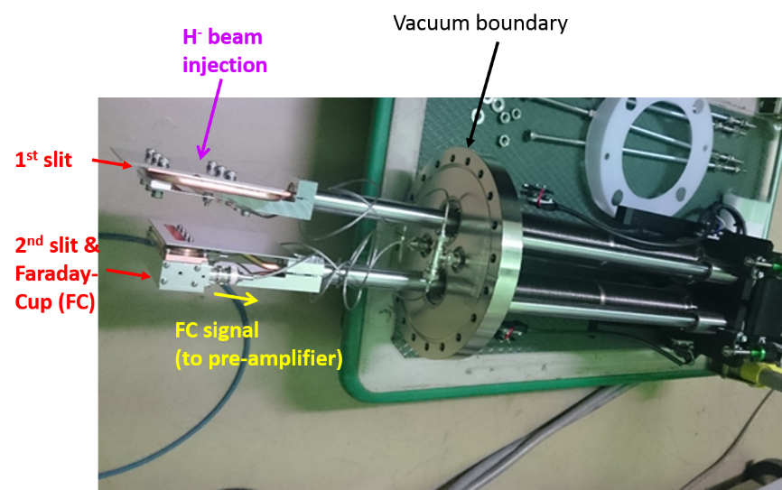
Figure 4. A photograph of the J-PARC double slit emittance monitor installed in ISTS.

TABLE 1. Configuration and applied parameters of the double slit emittance monitor in the present study.
Configuration and applied parameters
Slit width | 0.1 mm
Slit length | 66.7 mm
Distance between 1st and 2nd slits | 61.0 mm
Electron suppression voltage in Faraday-Cup | -500 V
Faraday-Cup signal termination | 100 Ω

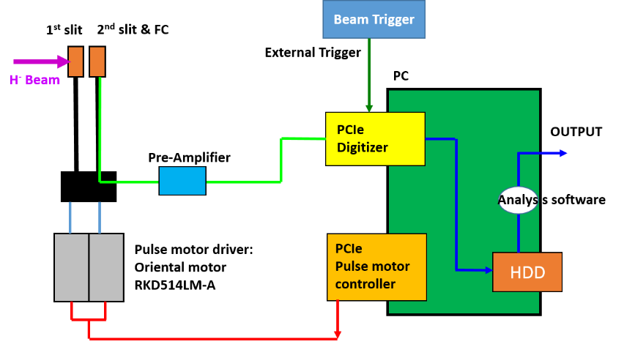
Figure 5. Controlling system of the emittance monitor.

The signal resolution is 16 bits to show time variation of both beam core and halo. As the low noise differential preamplifier, we adopted NF SA-420F5 which has high cut-off frequency 70 MHz and amplifier gain up to 46 dB [7]. The data acquisition is activated by 25 Hz beam ON trigger (which is the same as J-PARC repetition rate) together with pulse motor controller for the two slits. Another requirement of the new emittance monitor is to have phase synchronization between the digitizer and the pulse motor controller in each shot. In order to obtain the high S/N ratio, 6 continuous data points are used for averaging in the analysis software. The sampling number in this measurement is fixed to 1000 for the memory saving. From the double slit emittance monitor, FC current WFs are measured for each position and angle in the phase space. The spatial resolution of the phase space is Δu = 0.2 mm in the position and Δu’ = 2 mrad in the angle. In order to calculate RMS emittance
$$ε_{rms}=4\sqrt{〈u^{2}〉〈{u'}^{2}〉-{〈uu'〉}^{2}}$$
and Twiss parameters, sample particles are generated randomly in the beam phase space according to beam current at each phase space mesh points.

Experimental Results
By using the newly developed high-speed emittance monitor, time variations of the beam parameters at the RFQ entrance were measured. Figure 6 shows the time variations of the 95 %-Gaussian normalized RMS emittance and Twiss parameters (alpha, beta and gamma). The parameters oscillate in the time scale of 500 ns, namely 2 MHz. The averaged value of the beam emittance in 1 cycle is 0.33 π mm mrad and the amplitude of the 2 MHz oscillation is approximately 0.04 π mm mrad. The amplitude is 12.5 % of the averaged value. Time structures of the Twiss parameters also follow the beam emittance. Unlike the variation in the beam emittance, the amplitudes of the oscillation are much less than 10 % of the averaged values of the Twiss parameters in 1 cycle. We simply focus on the time variation of the beam emittance and define the following two time phases. The phase 1 and 2 correspond to the time which the beam emittance is minimum and maximum in 1 RF cycle, respectively.

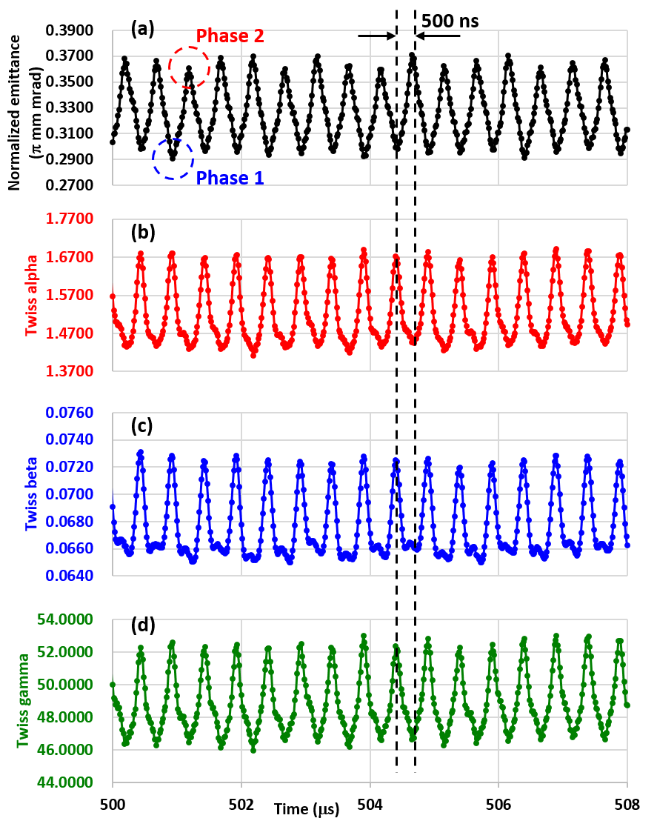
Figure 6. Time variations of (a) beam emittance, (b) Twiss alpha, (c) Twiss beta and (d) Twiss gamma.

A superposition of the beam phase spaces for phase 1 and 2 are shown in Fig. 7. The blue dots are the particle plots at phase 1 and the red dots are the beam orbits at phase2, which is plotted behind the blue dots. As shown in Fig.7, the phase space consists of three components; (1) beam core, (2) diverging halo and (3) converging halo. Also, (4) a small asymmetric halo component takes place at the position around -3.4 mm and the angle 80 mrad in phase 2, while no difference is seen in the opposite position and angle. The difference of the beam phase space in phase 1 and 2 mainly
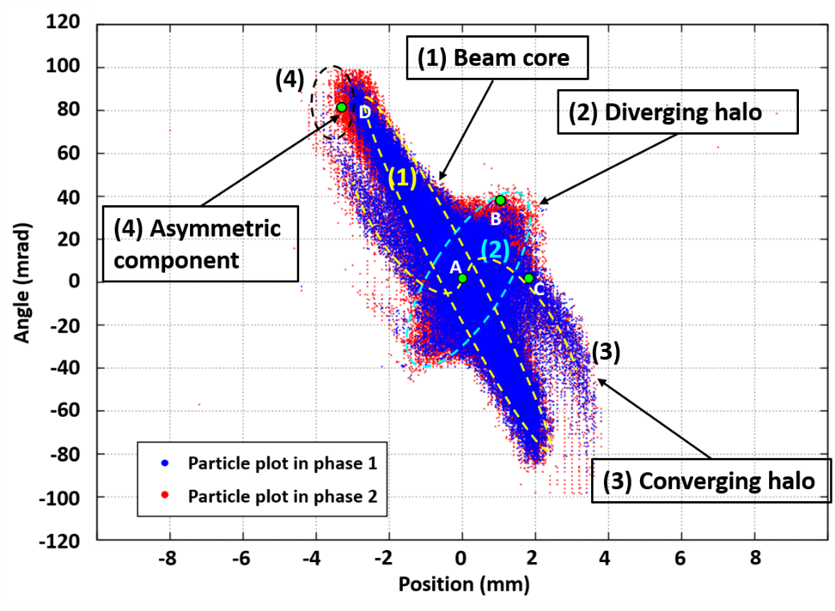
Figure 7. The beam phase space at the phase 1 and 2 in Fig.6 (a). The blue dots are the particle plots for the phase 1 and the red dots are for the phase 2. The beam phase space in the phase 1 is plotted in front of the one in the phase 2. Indicators to show each components of the phase space are shown; (1) beam core: yellow dashed oval, (2) diverging halo: light blue dashed oval, (3) converging halo: yellow S-shaped curve and (4) asymmetric halo: black dashed oval.

lies in the outer part of (2) the diverging halo and (4) in the asymmetric halo component. The beam current wave forms (WF) at several points in these components are compared to understand the dominant beam components and the oscillation frequencies. Together with the components above WFs are plotted also for the beam core and the converging halo.

Figures 8 (a) shows the characteristic beam current WFs measured by the FC in the different beam components. The data point A – D corresponds to the point in the beam phase space (Fig. 7); point A at the beam core: (x, x’) = (0, 0), point B at the diverging beam halo area: (x, x’) = (0, 40), point C at the converging halo area: (x, x’) = (2, 0) and point D at the asymmetric component area: (x, x’) = (3.4, 80), respectively. As the WF signals in point C and D are relatively low, a scaled plot is shown in Fig. 8 (b). The point A is the emittance ellipse centroid (EEC) where the beam core, converging and diverging halos are superposed. Resultantly, 2 and 4MHz oscillating components of the beam current takes place on the DC current component. The DC current components at the angle 0 mrad and in the position

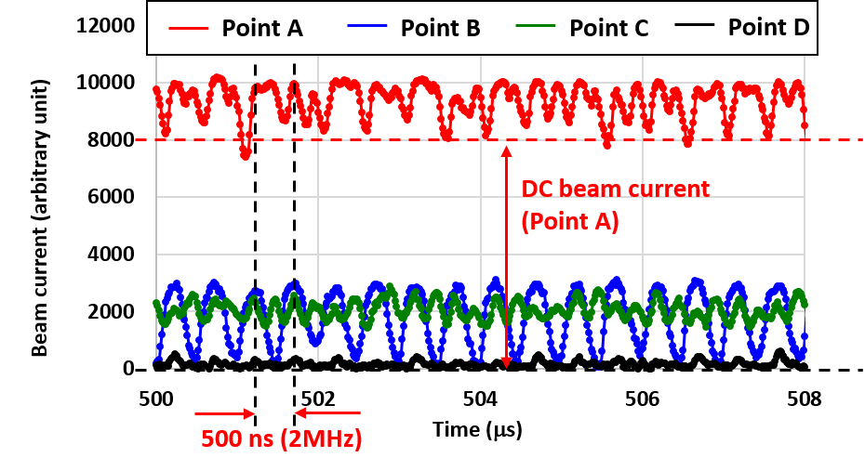 | 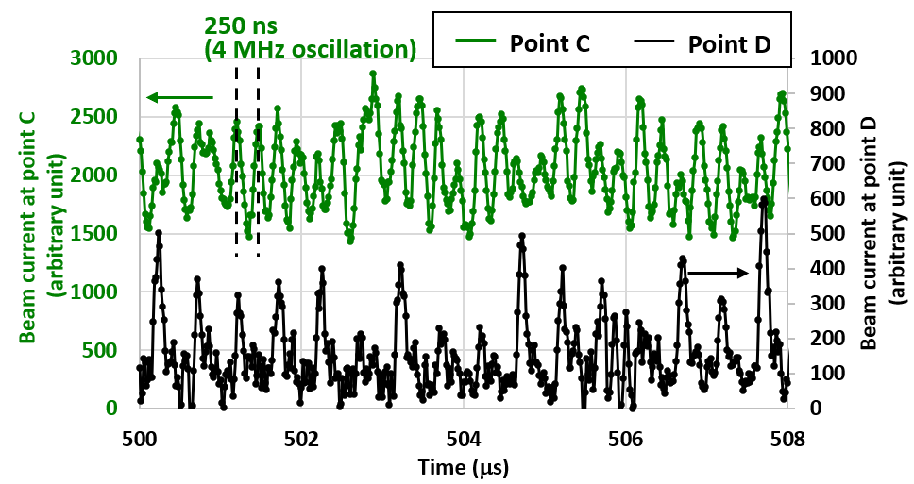
(a) | (b)
Figure 8. (a) Beam current wave forms measured by a Faraday-Cup in the emittance monitor at points A – D in Fig. 7.
(b) a scaled plot of wave forms at point C and D.
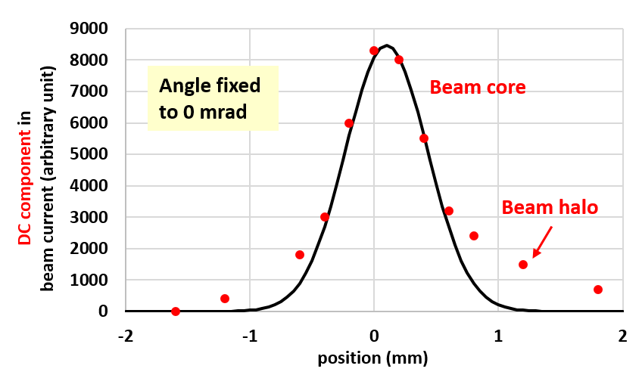 | 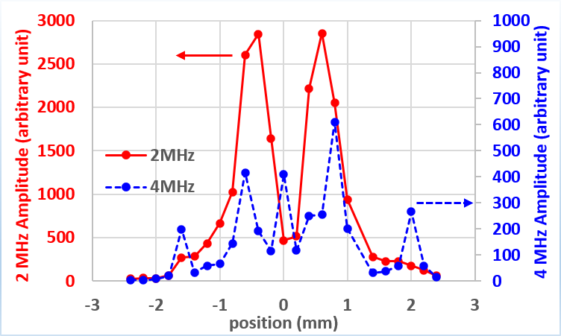
(a) | (b)
Figure 9. (a) Spatial distribution of the DC current component at the angle 0 mrad and the position range -2 to 2 mm in the beam phase space in Fig.7. (b) Spatial distribution of the 2 and 4 MHz components at the angle 0 mrad and the position range -2.5 to 2.5 mm in Fig.7.

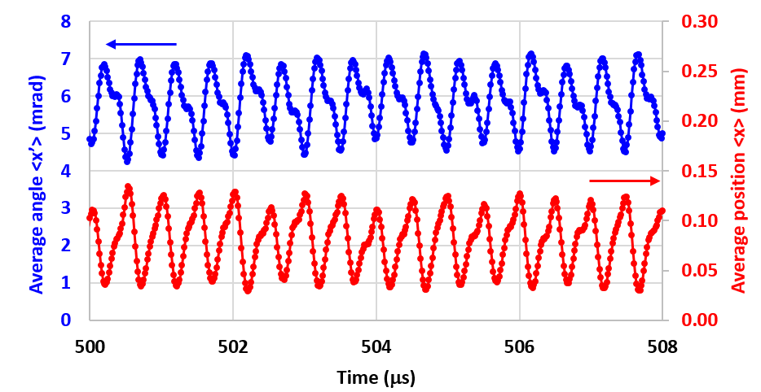
Figure 10. Time variation of the average position and angle in the beam phase space.

range -2 to 2 mm are plotted in Fig. 9 (a). The DC components in the beam current are calculated by averaging the minimum peaks of the WFs at the corresponding phase space positions. The spatial distribution of the DC current shows the Gaussian profile in the area corresponding to the beam halo, namely -0.5 to +0.5 mm in the position. The DC current component also takes place in the outer part of the Gaussian, which corresponds to the beam halo contribution. Figure 9 (b) shows the spatial distributions of the 2 MHz and 4 MHz (doubled RF frequency) components by FFT analysis of the beam current WFs at the angle 0 mrad and the position in the range of -2.5 to 2.5 mm. The amplitudes of the components are square root of the power spectrum density, so that the amplitudes are proper to the original WF signal. At the beam core part (-0.5 to 0.5 mm) where the strong DC component is seen in Fig. 9 (a), amplitude of the 2 MHz component shows low peak. A strong 2 MHz oscillation takes place at the position around ±0.7 mm while the DC component is reduced. This position corresponds to the diverging halo as seen in the point B in Fig. 8 (a). Therefore, origin of the strong 2 MHz oscillation is the diverging halo. On the other hand, the 4 MHz component in Fig. 9 (b) shows several peaks at positions 0, ±0.7, -1.8 and 2.0 mm. The 4 MHz amplitude peaks at ±0.7 mm are the 2nd harmonic of the 2 MHz oscillation due to the diverging halo. As the 2 MHz amplitude is much larger than that of the 4 MHz peaks, the 2nd harmonic is comparative to the other 4 MHz peaks. The width of the two peaks of the 2nd harmonics are 0.4 – 0.6 mm due to the effect of the 2 MHz amplitude peaks while the other peaks have only 0.2 – 0.4 mm width. The other peaks correspond to the ‘S-shaped’ converging halo as shown in Fig.7. Number of the intersections of the converging halo and the x axis is three. Two of the intersections are point A and C in Fig. 7. At these points, the 4 MHz oscillation is seen in the beam current WFs in Fig. 8 (a) and (b). As a result of superposition of (2) the diverging halo and (3) the converging halo on the (1) beam core, the oscillating part of the beam current at point A shows a combination of 2 and 4 MHz. However, as in Fig. 9 (b), amplitude of the 4 MHz oscillation component is much smaller than that of the 2 MHz component. On the other hand, (4) the asymmetric halo shows the beam current WF with smaller amplitude in a magnitude of order than the other beam components. In Fig.10, time variations of the average position and angle of the beam phase space are shown. Amplitudes of the position and angle are around 0.06 mm and 1 mrad, respectively, which are smaller than the spatial resolution of the emittance monitor data acquisition. If the asymmetric component is dominant, oscillation of the averages should not be negligible. We conclude that this asymmetric component is not effective. As a result, contribution of the 2 MHz component in (2) diverging halo is dominant when all the beam current WFs in the phase space points are integrated. This leads to the oscillation of the macro beam parameters with the frequency up to 2 MHz as in Fig. 6.

DIsscussion
In this section, origin of the beam oscillation from the RF plasma is discussed. One hint is given that a part of the beam phase space oscillation is in the frequency up to 4 MHz. This is doubled value of the RF frequency of the ion source power input. The double RF frequency is also seen in the ICP-RF plasma. As shown in Fig. 11 (a), the azimuthal electric field in the ICP-RF ion source shows maximum strength twice in 1 RF cycle. Electrons are accelerated by these field and result in high ionization rate. Therefore, the RF plasma production rate and density oscillate with 4 MHz. These mechanisms are confirmed in the photometry experiments and also in the numerical analysis [8 – 11]. The parents of surface produced H⁻ ions are hydrogen atoms and positive ions in the RF plasma. At the moment of the plasma density ramp up in 4 MHz, the flux to the cesiated surface is also increased and result in high H⁻ production. This mechanism explains the consistency between the photometry results and the extracted H⁻ beam oscillation in 4 MHz.

However, the main oscillation of the H⁻ beam phase space is in the frequency up to 2 MHz. This result indicate that the plasma density oscillation is not the key physics. A conceivable explanation for this reason lies in the transport of the H⁻ ions after production. The transport of the H⁻ is strongly affected by plasma meniscus. On the other hand, shape of the equipotential surface is decided by charge distribution. In the J-PARC RF ion source, the driver region takes place in the closer region to the extraction region than in the ion sources for fusion. Edge of the RF antenna coil is around 20 mm from the plasma electrode surface, namely the top of the extraction region. Although there is a strong

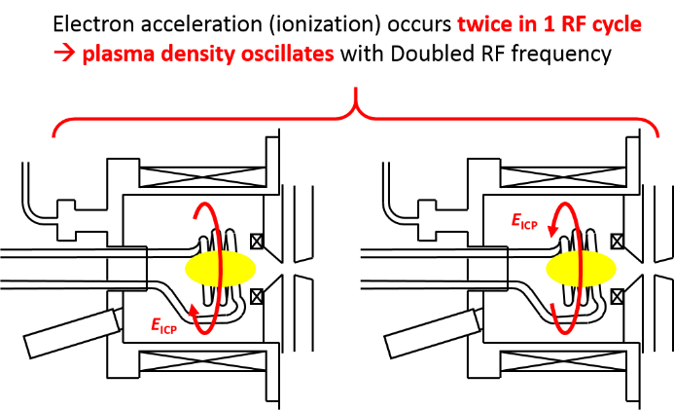 | 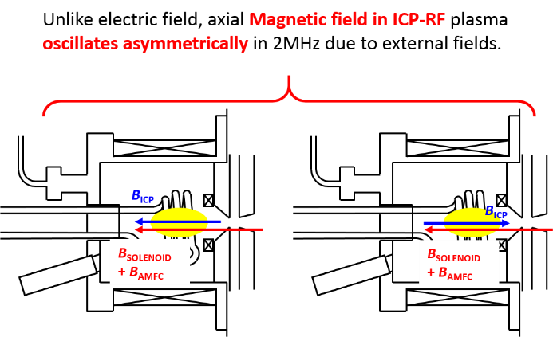
(a) | (b)
Figure 11. (a) Image of ICP-RF electric field and plasma density oscillation in double RF frequency. (b) Image of magnetic field oscillation in an RF frequency due to collapse of symmetric behavior of total field in 1 RF cycle.

magnetic flux density by rod filter magnet up to 400 Gauss exists between the driver and the extraction regions, high electron flux also takes place due to the high plasma density in the driver region around 10¹⁹ m⁻³. From the numerical analysis [9], it is shown that the electron flux to the extraction region varies due to axial magnetic field. If the axial magnetic field is equal to the ICP-RF field, the electron flux and the resultant plasma meniscus also variate in 4 MHz. However, as in Fig. 11 (b), the axial magnetic field is summation of the ICP-RF magnetic field and the external field, which is due to the solenoid in the LEBT and the axial magnetic field correction (AMFC) coil. In such case, magnetic field strength is no more in symmetry at the moments when the ICP-RF field shows maximum intensity. As a result, plasma meniscus shows 2 MHz oscillation.

To understand this effect properly, photometry and Langmuir probe measurement at the extraction region (very close part to the aperture) is necessary to understand whether the particle transport is affected by 2 MHz or 4 MHz oscillation. On the other hand, the effect of the solenoid in the LEBT may generate DC current component in the beam core due to the accumulation of the beam current when the beam is focused. The measurement in the present study is done at the RFQ entrance. For the further understandings, the emittance measurement at the ion source exit is important. These experiments also should be supported by development of the numerical analysis model in the extraction region and in the LEBT.

CONCLUSIONs
Time variation of the beam emittance with RF ion source is investigated by a high-speed emittance measurement system. The new emittance monitor enables to take the beam current WF at each phase space point with time resolution higher than few MHz. From the measurement, oscillation of the beam phase space, namely beam emittance and Twiss parameters, has been observed. Especially, the beam emittance shows oscillation with frequency up to 2 MHz, which is same as the RF input frequency of the ion source, and with amplitude up to 12.5 % of the averaged value.
The beam phase space mainly consists of several components; (1) the beam core, (2) the diverging beam halo and (3) the converging beam halo.

From the comparison of the beam current WFs at each phase space mesh point, it has been clarified that the beam core is fully dominated by the DC current component. However, the results indicate that the high-frequency oscillation component from the RF source travels a few meters passing through a magnetic lens focusing system. The diverging beam halo shows strong 2 MHz oscillation while the small part of the converging halo also shows oscillation with a doubled RF frequency, namely 4 MHz.

One good news is that the beam core shows strong DC component. The results also indicate that the beam oscillation in the linac can be solved by removing the oscillating halo before the beam is entering the linac cavity. A tool has been obtained in this study to confirm the beam oscillations at the moment of the further countermeasures.

Acknowledgments
The authors are fully grateful to Mr. Miyao from KEK, Dr. Hirano, Mr. Hirane, Dr. Moriya from JAEA and Mr. Watanabe from Mitsubishi Electric System & Service Co., Ltd. for their many technical supports on the experiments. The authors are deeply indebted to Prof. Naito and Dr. Kinsho for their continuous encouragement.
This work was supported by JSPS KAKENHI Grant Number JP17K05108.

References
- H. Oguri, “Approaches to High Power Operation of J-PARC Accelerator”, 29th International Linear Accelerator Conference (LINAC18), 16-21 Sep., 2018, Beijing, China.
- K. Shinto, K. Ohkoshi, T. Shibata, K. Nanmo, K. Ikegami, A. Takagi, Y. Namekawa, A. Ueno and H. Oguri, AIP Conf, Proc. 2052, 050002 (2018).
- K. Shinto, T. Shibata, A. Miura, T. Miyao and M. Wada, AIP Conf. Proc. 2011, 080016 (2018).
- M. Wada, K. Shinto, T. Shibata and M. Sasao, Rev. Sci. Instrum. 91, 013330 (2020).
- M. Ikegami, et al., "Emittance Measurement at the ICR 7 MeV Proton Linac", 17th International Linear Accelerator Conference (LINAC94), 21 – 26 Aug. 1994, Tsukuba, Japan.
- Spectrum Instrumentation GmbH; https://spectrum-instrumentation.com/en/m2i4960.
- NF Corporation; http://www.nfcorp.co.jp/pro/mi/lb/preamp/sa/index.html.
- T. Shibata, K. Shinto, A. Takagi, H. Oguri, K. Ikegami, K. Ohkoshi, K. Nanmo and F. Naito, AIP Conf. Proc. 2011, 020008 (2018).
- T. Shibata, H. Asano, K. Ikegami, F. Naito, K. Nanmo, H. Oguri, K. Ohkoshi, K. Shinto, A. Takagi, and A. Ueno, AIP Conf. Proc. 1869, 030017 (2017).
- T. Shibata, S. Mattei. K. Nishida, J. Lettry, and A. Hatayama, AIP Conf. Proc. 1655, 020008 (2015).
- J. Lettry, D. Aguglia, J. Alessi, P. Andersson, S. Bertolo, A. Butterworth, Y. Coutron, A. Dallocchio, N. David, E. Chaudet, D. Fink, J. Gil-Flores, M. Garlasche, A. Grudiev, R. Guida, J. Hansen, M. Haase, A. Hatayama, A. Jones, I. Koszar, T. Lehn, C. Machado, C. Mastrostefano, S. Mathot, S. Mattei, Ø. Midttun, P. Moyret, D. Nisbet, K. Nishida, M. O’Neil, M. Paoluzzi, J. Sanchez Alvarez, R. Scrivens, T. Shibata, D. Steyaert, N. Thaus, and A. Zelenskiet al., AIP Conf. Proc. 1655, 030005 (2015).

