Analysis of plasma characteristics of high-power radio frequency negative ion source based on Langmuir probe
Yongjian Xu ^{1, a}, Xufeng peng^{1, 2}, Ling Yu¹, Wei Liu¹, Yahong Xie¹,
Chundong Hu¹, Yuanlai Xie¹
¹ Institute of Plasma Physics, Chinese Academy of Sciences, Hefei 230031, China
² Institute of Physical Science and Information Technology, Anhui University, Hefei 230601, China
ª Corresponding author: yjxu@ipp.ac.cn
Abstract. The plasma parameters of the radio frequency (RF) negative ion source directly affect the density of negative ion and the uniformity of the plasma in the extraction area. In order to understand the behavioral characteristics of the plasma inside the RF negative ion source, a set of Langmuir probe system (planar probe and cylindrical probe) was developed and tested on the RF ion source test facility at the Institute of Plasma Physics, Chinese Academy of Sciences (ASIPP). The Langmuir probe was used to measure the spatial distribution of the plasma parameters in the extraction area and the axial distribution of the plasma parameters in the expansion area. In the experiment the relationship between the density parameters and the RF power, source pressures are explored. Experimental results show that the plasma parameters present better uniformity and the electron temperature is maintained at a lower level (about 0.8eV) due to the filter magnet field in the extraction area and the electron density can reach up to $6×{10}^{16} m^{-3}$ at the 55kW RF power. Considering the production of negative ions in the extraction area, the Electron Energy Probability Function (EEPF) is also given at different operational parameters. This article helps us to understand the plasma characteristics and provide technical support for experimental study of negative ion production and extraction.
INTRODUCTION
Development of a high power RF negative ion source for neutral beam Injection (NBI) has been ongoing at ASIPP for the past several years^{[1-3]} . Most development efforts are devoted to enhancing the beam current extracted from the source. Its main purpose is to optimize the radio frequency negative ion source and lay the foundation for the design of NBI system of CFETR (China Fusion Engineering Test Reactor). It is meaningful to study the behavior of the plasma in the extracted area since it is closely related to the current density and the uniformity of the extracted beam current. In addition, the parameters of the plasma are extremely valuable for studying the source because it can be used as an input parameter of a theoretical model and can also be used to verify the accuracy of the model ^{[4]}.
The diagnosis methods of the plasma in the extraction area on the RF negative ion source of ASIPP are mainly the optical emission spectroscopy (OES) and the commercial Langmuir probe^{[5]}. However, OES cannot measure the specific plasma parameters at a certain point because its measurement is a linear average, while Langmuir probe can measure it. And through the Langmuir probe, plasma parameters such as the electron temperature, the electron density, the ion density, the plasma potential, the EEPF can be obtained^{[6]}. What’s more, a series of Langmuir probe array can measure the spatial distribution of plasma. For the commercial probe, it is easy to be ablated during high power and long pulse discharge due to its thin probe tips. Therefore, a self-made planar probe is developed. In order to ensure the self-made probe can work at the negative ion source with 1 MHz RF power supply, a probe test platform is established. (Fig. 1).
EXPERIMENTAL SETUP
The Probe Test Platform
The probe test platform is mainly composed of the RF power supply, the matching impedance, the RF coil, the vacuum chamber, the vacuum pump, the water cooling system and so on. The main parameters for probe test platform are listed in Table 1. The purpose of probe test platform is to verify the reliability of the filter circuit, the accuracy of the data acquisition and processing program. What’s more, a microwave interferometer (MWI) is used to verify the accuracy of probe measure results on the test platform.
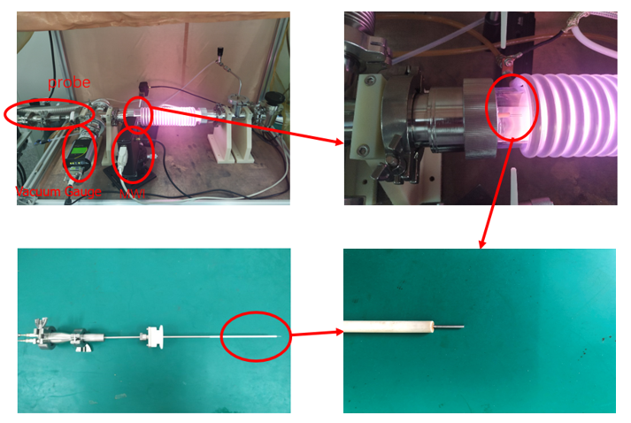

FIGURE 1. Langmuir probe test platform

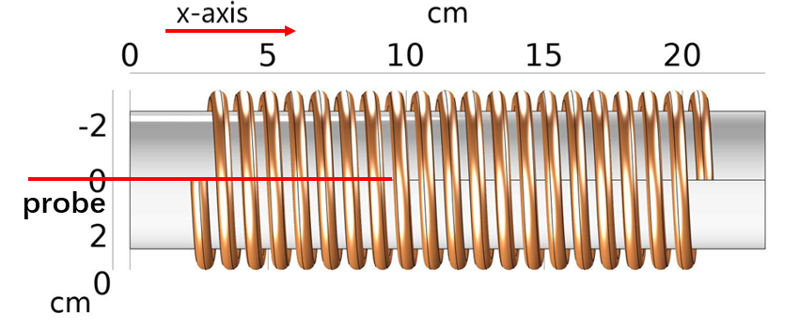
FIGURE 2. The installation position of the Langmuir probe on probe test platform

Table 1 The main parameters of the Langmuir probe test platform
Parameter | Value
RF Power(W) | 100-500
RF Frequency(MHz) | 1
Antenna Radius(cm) | 0.6
Coil turns | 20
Coil Length(cm) | 18
Gas | Ar
Pressure(Pa) | 0.1-50
Tube Length(cm) | 23
Tube Radius(cm) | 4.3

The Langmuir probe system is mainly composed of a bipolar power supply, probe (Fig.1), signal acquisition and processing system which includes sampling resistor, filter circuit, a NI acquisition board and host machine. The self-made tungsten probe tested in test platform is a cylindrical with 0.3mm diameter and 10mm length and the sampling resistance is taken as 100Ω. The probe is movable in the axial direction from 1 to 10 cm (Fig.2).
The RF Negative Ion Source Test Platform
The self-made cylinder and planar probes are also tested on the RF negative ion source test platform in ASIPP. The RF power supply of the ion source can operate from 5 kW to 100 kW with 1 MHz frequency. The RF negative ion source is mainly composed of the driver, the expansion chamber, the accelerator, etc (Fig.3)^{[7]}. The plasma is generated in the RF driver and diffused into the expansion chamber. A filter magnet field produced by two rows of permanent magnets installed at the bottom of the expansion chamber to decrease the electron temperature. Table 2 gives the main parameters for high-power RF negative ion source test platform.
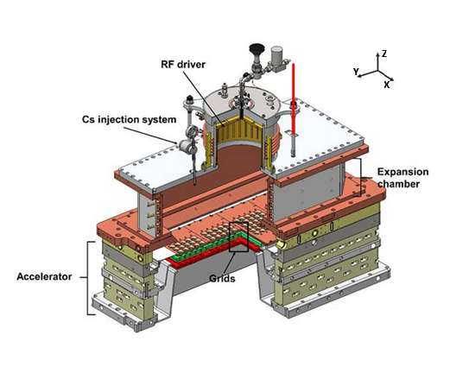
Cylindrical probe
FIGURE 3. The prototype RF negative ion source at ASIPP
The planar probe is installed on the long side of the diagnostic flange and the cylindrical probe is installed on the short side of the diagnostic flange (Fig.4) and the top of the expansion chamber (Fig.3). By moving the probe, the spatial distribution of the plasma from -9 to 9cm along the x axis and from -35 to -10cm along the y axis can be obtained.
Taking the short side direction of the PG as the X axis, the long side direction of the PG as the Y axis, and the vertical upward direction as the Z axis to establish a 3-D spatial coordinate system (Fig.4). The spatial coordinates of the short side probe are (-1.4, Y, 2.87), the spatial coordinates of the long side probe are (X, 0, 2.87), and the spatial coordinates of the top probe are (0, 17.3, Z).
Table 2 The main parameters of the high-power RF negative ion source test platform
Parameter | Value
RF Power(kW) | 5-100
RF Frequency(MHz) | 1
Antenna Radius(mm) | 6.2
Coil turns | 6
Gas | H₂
Pressure(Pa) | 0.3-2
RF driver high(cm) | 12
RF driver diameter (cm) | 20.9
Bucket chamber(cm) | 65(L)×26(W)×19(H)
Diagnostic flange(cm) | 73(L)×34.3(W)

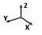
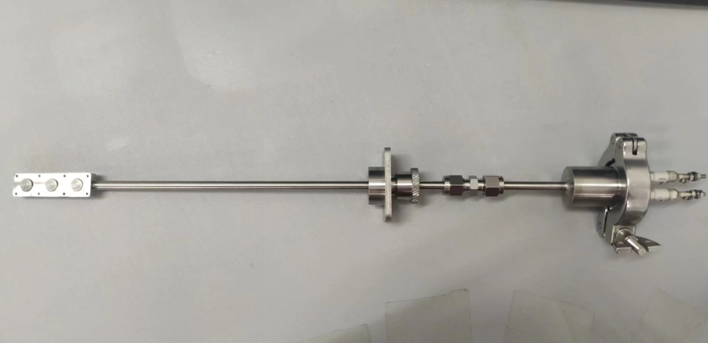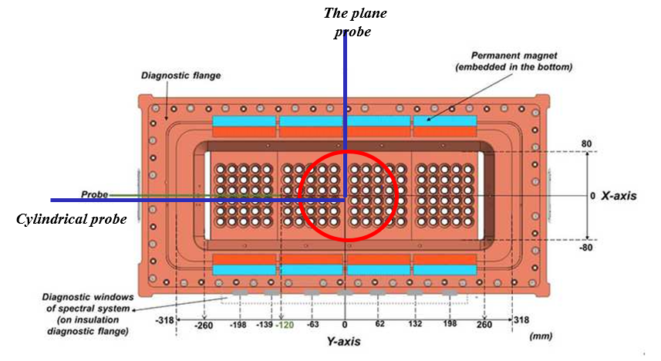
(a) (b)
FIGURE 4. (a) The picture of planar probe; (b) the installation position of the probe at the diagnostic flange.
EXPERIMENT AND RESULTS
Experimental Results of the Probe Test Platform
Firstly, in order to verify the validity of the Langmuir probe, the electron density measured by the probe was compared with that by MWI (Fig.5a). The results show that the electron density presents similar rising trend with the increase of RF power, while the plasma density measured by the probe is slightly higher than that measured by MWI. The reason is that the result measured by MWI is linear average density, while results measured by probe is density of point (the center point of glass tube), so the probe measurement is creditable. Secondly, the changes of plasma parameters with power is studied (Fig.5b). The electron density increases gradually when the RF power changes from 200 W to 550 W and the maximum electron density can reach to $5.8×{10}^{16}m^{-3}$. And the electron temperature gradually decreases in the power range of 200W to 300W, the electron temperature remains approximately constant in the power range of 300W to 500W. The possible reasons are: (1) the discharge is unstable at low power (200- 300W), the error bar at the low power indicates that the error is relatively large; (2) the high energy electrons transfer their energy to the background particles through collisions in the process of plasma diffusion, as the route is long enough to exhaust the energy of high energy electrons after multiple collisions. Third, the axial distribution of electron density and temperature is also explored (Fig.5c). For electron density, an upward tendency is observed as the probe moves from edge to center along the axis of coil, and the electron temperature remain nearly constant (about 5.5 eV). Lastly, the relationships between EEPF and gas pressure is given (Fig.5d). It can illustrate to a certain extent the high-energy electrons decrease and low-energy electrons increase with the increase of the gas pressure, and the measured curve of the EEPF deviates significantly from the classical Maxwell distribution, which is similar to the Druyvesteyn distribution^{[8]}. According to the results of the probe test experimental platform, it shows that the self-made probe measuring system is effective and reliable.
FIGURE 5. The cylindrical probe was utilized on the probe test platform. (a) Comparison of electron density results obtained by MWI and self-made probe; (b) changes in electron temperature and density with RF power; (c) spatial distribution of electron temperature and density along the axial; (d) EEPF under different gas pressures.
Experimental Results of the RF Negative Ion Source Test Platform
In order to verify the reliability of self-made probe further, the self-made cylinder and planar probes are installed on the RF negative ion source test platform and some experiments are carried out (Fig.6). Firstly, the spatial distribution of the plasma in the extraction area is given (Fig.6a and Fig.6b). The electron temperature is about 0.8 eV, and the distribution of the electron density in the extraction area shows good uniformity (about$2\sim 3×{10}^{16}m^{-3}$) due to the filtered magnetic field. Secondly, the plasma parameters in the vertical direction of expansion chamber (z direction) are explored (Fig.6c). The electron temperature (from 6.2eV to 1.8eV) and the electron density (from $9.3×{10}^{16}$ $m^{-3}$ to$1.3×{10}^{16}$ $m^{-3}$) gradually decrease when the probe moves down from the top of expansion chamber. It is consistent with the simulation results in previous research^{[9]}. Third, the variation of plasma parameters with power are studied (Fig.6d). The electron density presents obvious trend of rising with the increase of power and the electron temperature shows slight increase. Finally, the relationships between EEPF and gas pressure is given (Fig.6e and Fig.6f). The change of EEPF is not obvious because of limited range of gas pressure. The electron energy is mainly distributed as lower end (<2eV), it is favorable to production of negative ions.
FIGURE 6. (a) The distribution of electron density and temperature along the x-axis by planar probe measurements; (b) the distribution of electron density and temperature along the y-axis direction by cylindrical probe measurements; (c) the distribution of electron density and temperature along the z-axis by cylindrical probe measurements; (d) changes in electron density and temperature with RF power by planar probe measurements; (e) EEPF under different gas pressures by planar probe measurements; (f) partial enlargement of EEPF corresponding to the peak.
CONCLUSION
The self-made Langmuir probe was tested on probe test platform and RF negative ion source prototype for the first time and got preliminary results. The experimental results show that the self-made probes can be used a diagnostic tool for accurate analysis of plasma parameters and it is helpful for R&D of RF negative ion source. The next step is to make a probe array for plasma diagnostics in the extraction area.
ACKNOWLEDGEMENT
This work was supported by Comprehensive Research Facility for Fusion Technology Program of China under Contract No. 2018-000052-73-01-001228 and Collaborative Innovation Program of Hefei Science Center, CAS (2020HSCCIP016).
References
1. Wei J, Xie Y, Liang L, Gu Y, Yi W, Li J, et al. Plasma Sci. Technol. 18, 954 (2016).
2. Wei J, Hu C, Xie Y, Jiang C, Liang L, Wang Y, et al. IEEE Transactions on Plasma Science. 46, 1149 (2018).
3. Hu C, Xie Y, Xu Y, Jiang C, Wei J, Gu Y, et al. Plasma Sci. Technol. 21, 022001 (2019).
4. McNeely P, Dudin SV, Christ-Koch S, Fantz U. Plasma Sources Sci. Technol. 18, 014011 (2009).
5. Wang Q, Hu C, Xie Y, Liang L, Jiang C. Fusion Engineering and Design. 160, 111826 (2020).
6. Tsumori K, Wada M. New Journal of Physics. 19, 045002 (2017).
7. Xie Y, Hu C, Wei J, Xu Y, Jiang C, Gu Y, et al. Rev. Sci. Instrum. 90, 113319 (2019).
8. Godyak VA, Piejak RB, Alexandrovich BM. Plasma Sources Sci. Technol. 11, 525 (2002).
9. Xu Y, Zhang L, Hu C, Xie Y, Jiang C, Wei J, et al. Plasma Sci. Technol. 22, 025602 (2020).

