CREMLINplus Progress Report First Year

Introduction

This report gives a working-level overview of the state of play of the CREMLINplus project progress after the project´s first year. The progress report provides an update from each work package (10 WP altogether) by addressing the following core questions:

**Achievements**: What are the most important achievements in the WP since the start of the project (M1-M12)?

**Challenges**: What are the main current challenges in the work programme of the WP?

**Outlook**: What are the most important activities planned for the next project year (M12-M24), and how will they be implemented?

WP1 MGT: Management and Dissemination

*Martin Sandhop, DESY; Kaja Scheliga, DESY; Tom Minniberger (DESY)*

Achievements

The project was launched in a Kick-off meeting held on 19-20/02/2020 as a life event at DESY, Hamburg.

Project bodies have been initiated (Task 1.1), and project management (Task 1.2) and administration (Task 1.3) was started:  
The General Assembly (GA) is the decision-making body of the project, with 35 representatives of all project participants, and another 15 nominated deputy representatives. The GA was set up during the kick-off meeting, Jürgen Eschke (FAIR/ GSI) was elected as its chair for the first period.

The Executive Board (EB) is the executive body of the project, its members are the WP-leaders and co-leaders (EU/RUS tandem teams) for each WP. Four EB-meetings were organized during the first year.

The Scientific Advisory Committee (SAC) is the project´s external advisory body, consisting of 9 members, from EU & RUS, plus from Japan.

The Scientific Review Panel (SRP): For both WP8 Access and WP9 TRAIN activities, open calls will be organized, for which external review panels will be needed. For WP9, this SRP TRAIN including “Terms of reference” is set up and currently under approval. For WP8 Access, the respective review panel will be set up in year 2 of the project.

A Management Support Team (MST) was created with 8 members from both coordinator and participants, from EU/ RUS. The MST is convened roughly monthly, as a platform for exchange, support and and brainstorming on current project issues.

Management and dissemination (T1.4):  
A project website was set up ([www.cremlinplus.eu](http://www.cremlinplus.eu)) and is continuously updated; mailing lists for the internal communication were composed.

Challenges   
The COVID-19 pandemic is the one gigantic and lasting challenge and unexpected major risk for the project. With all its related shutdowns of the project participating institutions in EU and RUS and with all pandemic-related restrictions of travelling, it seriously affects all WPs, though the impact and extent for technical and non-technical WPs varies. These variations are taken into account in managing the project.

Against the background of the ongoing COVID-19 crisis, the project management is dealing with constant uncertainties. The project management team and the WP leaders and co-leaders are constantly mitigating the effects of the COVID-19 crisis as best as possible, mainly by translating all meetings and events to a virtual mode via digital communication channels (e.g. Zoom conferences). It has become apparent though that virtual interactions cannot replace face-to-face interactions. It is highly likely that the effects of the COVID-19 crisis will accompany the project throughout its lifetime and will remain its main challenge.

Outlook

The CREMLINplus Annual Meeting 2021 (24-25/03/2021), together with the GA second meeting (26/03/2021), is under preparation, as a virtual event.

The project management, together with the WP leaders and co-leaders, currently develops the general mitigation plan for a coherent reaction to the pandemic challenge. On the basis of this paper, an amendment of the Grant agreement may be started, including several proposed mitigation measures (e.g. sifts of deliverables and milestones; shifting of budget that was not used for traveling). These mitigation measures will facilitate, or even enable, the implementation of the full project working plan (DoA), even under pandemic circumstance.

WP2 NICA: Collaboration with NICA

*Jürgen Eschke, FAIR; Yuri Murin, JINR*

Achievements

Challenges

Outlook

WP3 PIK: Collaboration with PIK*Stefan Mattauch, Juelich; Sergey Grigoriev, NRC KI PNPI*

Achievements

Challenges

Outlook

WP4 USSR: Collaboration with USSR  
*Timur Kulevoy, NRC KI; Harald Reichert, ESRF*

Achievements

Challenges

Outlook

WP5 SCT: Joint technology development around SCT and future lepton colliders *Vitaly Vorobyev, BINP; Lucie Linssen, CERN*

Achievements

Infrastructure for communication and collaboration tools are set up. It includes email lists, wiki and git servers, and software development server. Two co-leaders (one from BINP and one from EU) have been assigned for each task of the WP5. Task leaders are responsible for regular communication within corresponding task. Communication within the entire WP5 is carried out by general meetings. Three general WP5 meetings have been held by the end of February 2021.

Joint efforts on software development for the SCT detector resulted in the 1st release. The release includes all components required for full simulation of the SCT experiment: event generators, detailed detector geometry and materials, Geant4 simulation, basic particle reconstruction algorithms, tools for event analysis.

The following technical designs for the detector prototypes are finalized and allow us to start assembling the prototypes in 2021: time-projection chamber (TPC), cylindrical $μ$ RWELL, focusing aerogel ring Cherenkov (FARICH) detector with reconstruction of the full ring. Some detector components and mockups are already being produced and tested as illustrated on figure 1.

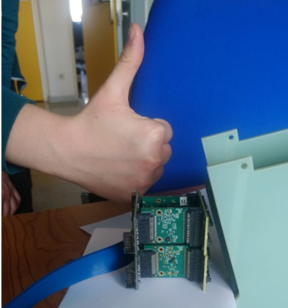 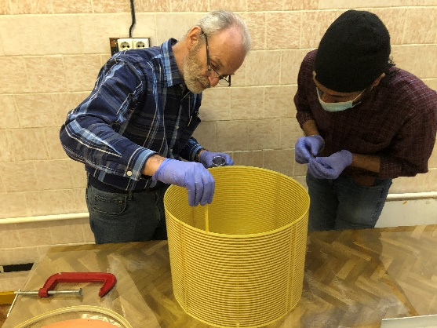 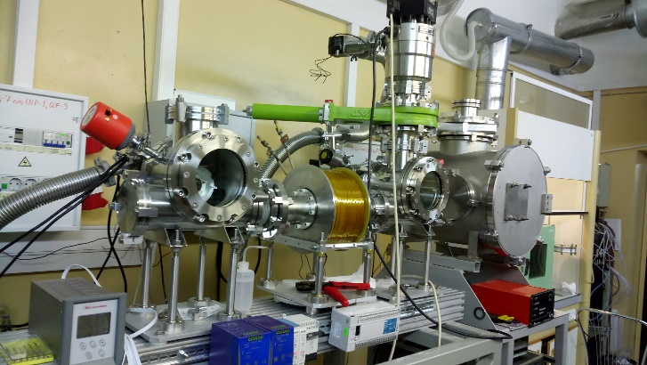

*Fig 1. Photon detector for the FDIRC prototype at JLU (left), gluing cylindrical wall for the TPC prototype at BINP (centre), and wire coating testbench for the drift chamber prototype at BINP (right).*

Challenges

Three challenges should be mentioned. The first one is COVID-19 impact. The average delay on the hardware development due to the pandemic is about 6 months. It is not critical yet since our goals still can be reached with a tighter schedule.

The second challenge is establishing formal collaboration around the SCT experiment (WP5 milestone to be achieved before month 18). It requires communication and decisions at the management level that are even more difficult to make during the pandemic. We estimate delay on reaching this milestone is 6 months.

The last challenge to mention is building the high-current electron-positron collider prototype (WP5 milestone to be achieved before month 42). This goal is inherently risky because it requires much more resources than we have within CREMLINplus. Budker institute supports and funds design and building this machine, so we expect reaching this milestone in time, but it is beyond the WP5 control.

Outlook

The second year of the WP5 implementation should be very productive. The 1st release of the SCT detector software will be presented at the vCHEP21 conference. We aim at signing a preliminary but specific and clear agreement on collaboration around the SCT experiment. The WP5 consortium is expected to constitute the core of this proto collaboration. The full collaboration is only possible after the decision on full funding of the SCT experiment by Russian authorities.

Two prototypes for the SCT inner tracker are expected to be constructed and tested during the 2nd year: TPC at BINP and c $μ$ RWELL at INFN. Technical design for the SCT drift chamber prototype should be finalized by month 24. Development of the frontend electronics and testing the aerogel for the FARICH and FDIRC prototypes will be the in focus for WP5 task 6.

WP6 XCELS: Joint technology development around XCELS*Efim Khazanov, IAP RAS; Catalin Miron, CEA-LIDYL*

Achievements

Challenges

utlook

WP7 DETEC: Joint development of detector technologies*Christian Schmidt, GSI; Otilia Culicov, JINR*

Achievements

A first full reticle-size prototype of the CREMAPS sensor was successfully designed, submitted and produced. After building a suited DAQ and test system, first system tests were carried out. The preliminary and still incomplete results of the tests suggest that all major scientific goals of the submission were reached.

JINR has joint the ALICE ITS3 team with the aim to profit from ITS3 experiences for a future MAPS-based MPD inner tracker integration, key motivation for the CREMAPs MAPS integration initiative of JINR within WP7.

The teams at PIK, FLNP and ESS have decided to create a boron-10 converter based multi-blade detector which should eventually be employed at the PIK instrument SONATA.

This is the deliverable D7.1 that has been submitted with some COVID-19 related delay.

FLNP (JINR) has engaged in evaluating the feasibility of constructing a Boron converter layer-based area sensitive detector though a pilot beam monitoring device based on this technology. This success especially including the sputtering of thin, enriched Boron coatings, indicates that the contributing partners are in principle very well capable of realizing the challenging detector project for SONATA.

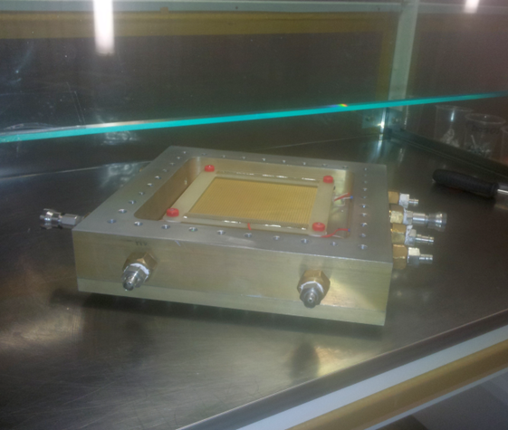 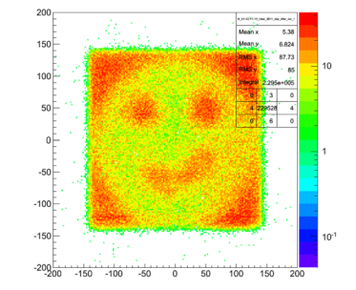

*Fig. 1. PSD prototype with the top cover removed (left). Image generated with the detector (right).*

Challenges

At present, the travel restrictions related to COVID-19 hamper us from performing our work program in close collaboration. This affects the sensor R&D, which remains however successful at reduced speed thanks to the already established team and structures allowing for remote collaboration. It affects to a greater degree the sensor integration efforts as necessary in-person kick-off meetings for the required technology transfers are at present not feasible.

Challenge for the months to come is the full clarification on which party among PIK, ESS and Frank Laboratory JINR exactly will supply which contribution to the SONATA detector system. It was intended is that PIK and FLNP colleagues will be involved in a technology transfer at ESS sites (Lund and Lingkoping) while the visit would be returned for commissioning activities at PIK. The idea being that scientists at PIK can in the future do much of what is done in Lund for future neutron detectors with technology transfer and networking as the two-way benefit for all. With the difficulty of COVID restrictions the distribution of tasks and realization of these goals appears considerably more challenging just now.

Outlook

An intense test program on the CREMAPS prototype including particle beam tests is foreseen. Moreover, a dedicated test program studying the immunity of the sensors to direct heavy ion impacts and to integrated radiation doses is planned. In Feb. 2021, we plan a transfer of the sensor technology to the Goethe University Frankfurt, which will be the starting point of the system integration studies scheduled in this institute. Depending on the Covid-19 situation, we foresee to welcome two PhD students from Kiew (CREMLIN-Plus participant KINR) by Q3/2021 at GSI, who are intended to participate to the design of a DAQ system for the CREMAPS sensor. The availability of this system was identified as a prerequisite for transferring the sensors to our eastern partners, which is again required to start our integration efforts in those laboratories.

Towards MAPS integration know how and technology, JINR will intensively engage in the characterization of high-tech building materials concerning their behaviour in high dose radiation environments. This concerns particularly adhesives and the carbon-fiber foams. Irradiations are planned at the neutron reactor at JINR-FLNP with macro characteristics (thermal, mechanical and

electrical) measured before and after irradiations at LHEP while microstudies (Raman spectroscopy, etc.) are planned to be taken at Flerov Laboratory.

For the neutron detector for SONATA, the full set of specifications now need to be elaborated within the technically feasible and validated against the needs of the instrument. The result of this activity will come out as deliverable D7.4. This is the mayor content of research activities in 2021. At the same time, we aim at starting mutual interchange through extended visits of PIK and FLNP scientists at ESS sites late this year to meet the technology transfer goals within WP7.

WP8 TNA: Access to Russian RI*Anastasia Zadorina, ICISTE; Greta Facile, DESY*

Achievements

Challenges

Outlook

WP9 TRAIN: Staff exchange and training for RI management*Enrico Guarini, UNIMIB; Andrey Polyakov, NUST MISIS*

Achievements

Challenges

Outlook

WP10 LTS *Vladimir Kravchuk, NRC KI; (Ekaterina Kolesnikova, NRC KI); Martin Sandhop, DESY; (Kaja Scheliga, DESY)*

Achievements

Challenges

Outlook