Fusion Yield Registration in the Gas Dynamic Trap
E.I. Pinzhenin^{1, a)} and V.V. Maximov^{1, 2, b)}
¹BINP SB RAS, Novosibirsk Russia
²NSU, Novosibirsk Russia.
^{a)}Corresponding author: e.i.pinzhenin@inp.nsk.su
^{b)}v.v.maximov@inp.nsk.su
Abstract. The diagnostics for a fusion reaction of the product registration at the Gas dynamic trap facility during the deuterium neutral beam injection is described in this review. Both 3.02 MeV protons and 2.45 MeV neutrons registrations are used in GDT experiment. The advantages of the registration of these two products are discussed in the paper Also the fusion reaction intensity and the neutron flux parameters are presented in the article. In addition, the new multichannel diagnostics with the improved parameters are discussed here.

GAS Dynamic trap facility
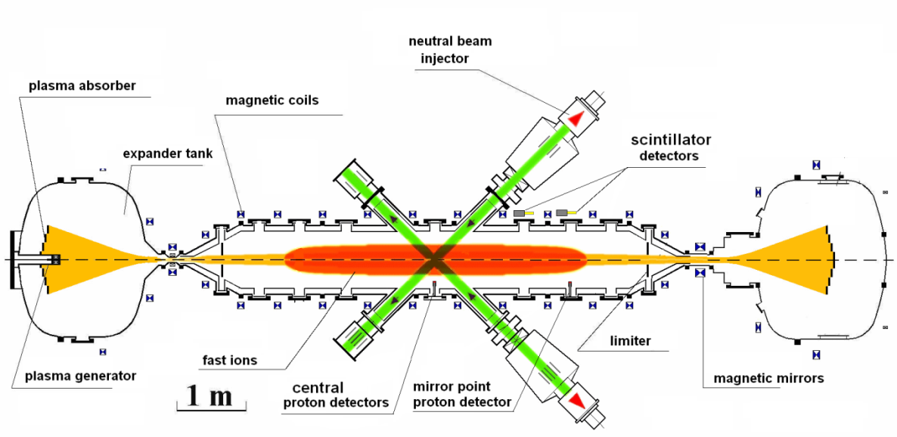
Figure 1. Gas dynamic trap device.

Gas dynamic trap facility (GDT) is an axisymmetric magnetic mirror trap for the fusion plasma confinement Figure 1, [1]. There are two components of the GDT plasma: the first one is a warm plasma component with the electron temperature about 250 eV and density of up to 6 10¹⁹ m⁻³ (warm plasma is confined in a collisional regime that means that the effective ion mean free path of scattering into the loss cone is less than a mirror-to-mirror distance). The second component produced by oblique neutral beam injection is strongly anisotropic fast ions. This component has the mean energy of 10 keV and density up to 10¹⁹ m⁻³. These fast ions are confined in the collisionless regime.
There are fusion reactions in GDT during the deuterium neutral beam heating:
D + D -> ³He (0.82 MeV) + n (2.45 MeV) 50%
D + D -> T (1.01 MeV) + p (3.02 MeV) 50%
Both branches occur with the same probability (for the GDT conditions and for the accuracy of our experimental data). Thus registration of the fusion reaction products is an important contactless plasma diagnostics. Reactions occur both between the fast ions and the fast ions and the ions of the target plasma. The profile of reaction intensity has a maximum near the mirror point, which is caused by the anisotropy of the distribution function of the fast particles. The transverse distribution of the fusion reaction reflects the influence of a large beta effects on the fast particle distribution function. These diagnostics provides information about the fast particle distribution function, influence of microinstabilities and collective effects on the fast particles in the GDT facility. Measurement of neutron flux in GDT can be directly used for theoretical research and numerical simulations of neutron flux in GDT based neutron source.

Fusion Proton diagnostics
Both the proton and neutron registration is used in the GDT experiment [2]. 3.02 MeV protons may be collimated easily to obtain sufficient spatial resolution of diagnostics. Detectors based on semiconductor diodes with thin «dead layer» (less than one micrometer) are used for the 3.02 MeV proton registration. They work in the counting mode and are insensitive to the neutron background. Thus additional flux calibration is not required. The fusion proton diagnostics are used for absolute measurements with spatial resolution to tenth of cm. Moreover diode is insensitive to the magnetic field on GDT conditions, but protons move in circular trajectories in the magnetic field and it should be taken into an account in our experiments (Larmor radii is 38 cm in the mirror point).
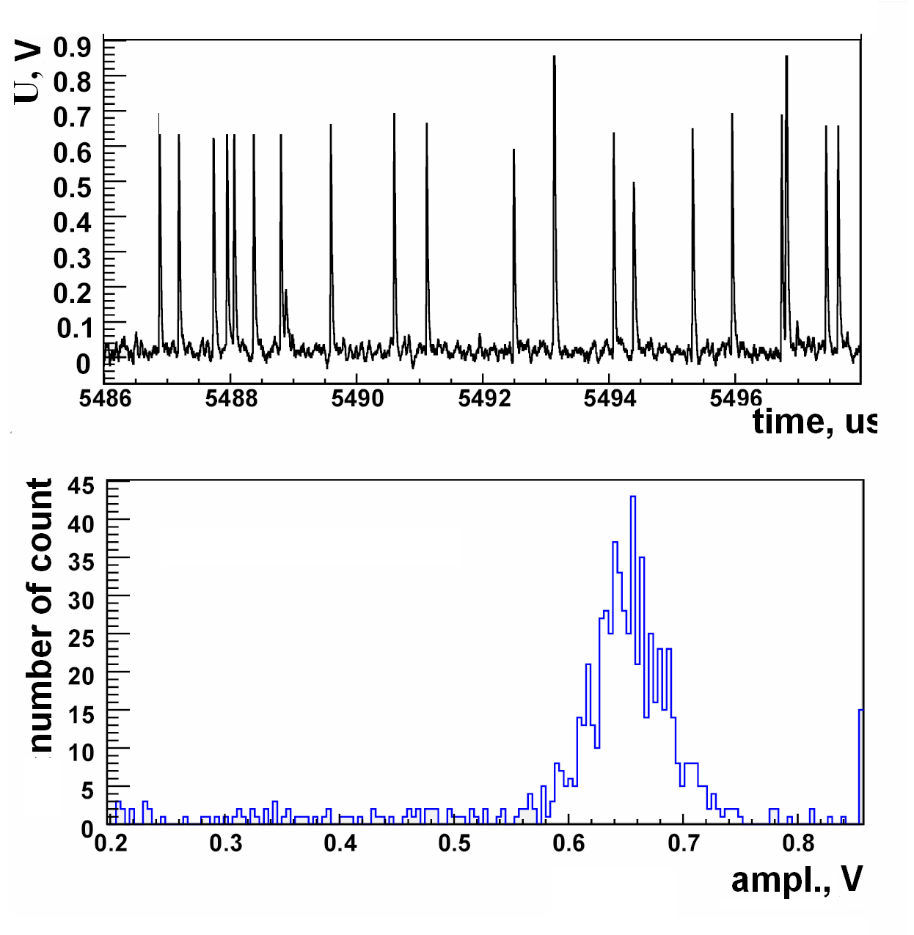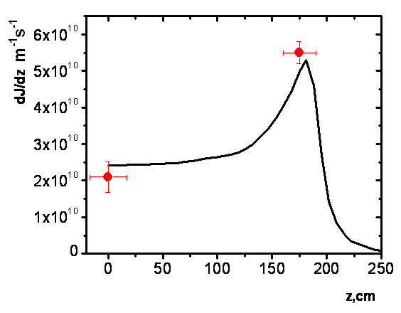
(a) | (b)
Figure 2. (a), Signal of fusion proton detector (addition amplifier with coefficient 2.5 is used). The amplitude spectrum of 3.02 MeV proton. (b), Longitudinal distribution of fusion reaction intensity. Dots are experimental results, solid line is result of numerical simulation by code DOL[7].

All proton detectors based on PIN diodes as a sensitive element. The fast preamplifiers are placed near the diode inside the vacuum. Two-stage current preamplifier with gain 55000 V/A has following parameters: the duration of a single pulse for 3.02 MeV proton is 40-50 ns, amplitude is 0.15-0.3 V, signal to noise ratio better than 10. All parameters are different for the various detectors and depend on specific properties of the PIN diode (capacity, dark current), the preamplifier properties, diode bias voltage etc. The detectors are sensitive to visible irradiation of plasma and to charge-exchange atoms emitted from plasma. Thin aluminum foil (10 mkm) is used for protection of detectors from such irradiation. 3.02 MeV protons pass through the foil without significant change of direction. Proton energy is changed to 0.22 MeV. The collimator designed as stainless still plates is used for the transverse or longitudinal distribution registration (the collimator may not be used in some of the experiments). The record of the oscillogram is produced for the further analysis. Used ADC 824 has following parameters: sampling rate 5 ns, recording time 0.65 ms, 8 bit. So we can’t register all duration of the GDT plasma pulse (5 ms). The diagnostics update will be soon and will include the transition to ADC12500[6] as a registration device. The device have enough memory to record entire plasma discharge of the GDT. The data of the diagnostics collected by the GDT data acquisition system is processed by special program for proton flux measurement and pulse spectrum analysis. This program was created in our laboratory. Time resolution of the diagnostics is determined by the single pulse duration and pulse repetition rate. So the pulses should not overlap too often. Thus time resolution of the diagnostics is 50 mks. Example of the oscillogram is presented on Figure 2 a.
Mirror point proton detector (Fig. 1) is installed near the turning point of fast particles (175 cm from central plane) at a distance of 24 cm from axis of the GDT (and from axis of plasma). The detector has a round shape and area of 0.5 cm². The collimation is not applied. The detector is used for measurement of absolute intensity of fusion reaction and local 3.02 MeV proton flux measurements.
The central proton detector (square shape, area 0.16 cm²) is installed at a distance of 32 cm from the center of the GDT. The collimation is not applied. Ratio of DD reaction intensity near the mirror point and at the central plane of the GDT can be measured by proton detectors in each shot. Measured value is 2.7 (Fig. 2 b) in the experiment with deuterium injection into the deuterium target plasma. The same ratio is 6 for deuterium injection into hydrogen target plasma [8]. For compassion, the results of simulations by code DOL [7] (for GDT conditions) are presented in the Figure 2 b by solid line.
The third detector for the registration transverse distribution of proton emission is based on 0.4cm x 0.16cm PIN photodiode and similar preamplifier. The detector designed for scanning through the chords allows to obtain transverse distribution of fusion reaction intensity with 2 cm spatial resolution. It is necessary to have one pulse of the GDT to obtain one spatial point. The previous generation of detectors based on fast plastic scintillator and PMT also was mount inside the vacuum vessel and was sensitive both to proton and neutron. The paper [2] presents data of that experiment.
The detector based on 3.1 cm² PIN diode was created for the fusion proton registration on the GDT [2]. The collimation used allows us to obtain 10 cm spatial distribution. This detector can be moved to different ports of vacuum system of the GDT for the registration of the longitudinal distribution of the reaction intensity. Conditions of the experiments should be the same during all experimental company for register complete profile. Thus obtaining profile of the longitudinal distribution requires a large amount of experimental shots, so there was a necessity to develop a multichannel system.
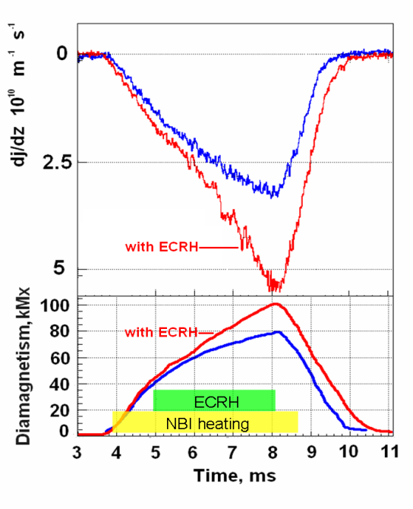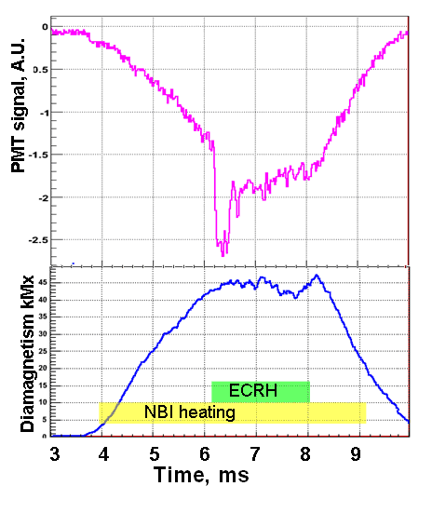
(a) | (b)
Figure 3 (a), Intensity of fusion reaction with and without ECR heating (top). Data from the scintillator based detector with calibration by proton detector. Diamagnetic probe signal (bottom). (b), Signal from neutron detector with gamma flash from 6,2 ms to 8 ms (top), diamagnetic probe signal (bottom).

The multichannel system of the fusion proton registration in the GDT with high spatial (tenth of cm) and timing (300 mus) resolution is developed by authors of the paper. The system will be based on set of photodiode AXUV-100 (sensitive area 1cm2). The diodes will be mounted inside the vacuum chamber, new preamp will be mount near the diode. The transverse distribution of 3.02 MeV proton emission is measured by system based on 5 photodiode. The sensors are placed near the mirror point. The longitude distribution is measured by the system based on 6 photodiode placed along the GDT device (the detectors work in counting mode). Time evolution of the DD reaction spartial profile will be registered by the new diagnostics in every shot.

Scintillator based detectors
The neutrons registration for plasma with magnetic confinement have the following advantages: no influence of magnetic and electric fields, detector may be mounted outside of vacuum vessel, but collimation is problematic, thus it is hard to obtain a high spatial resolution.
Detectors are based on PMT Hamamatsu 2611 and the plastic scintillator (3.5 cm diameter, 10 cm length). The detectors are used for time scan measurements of DD reaction yield. PMT Hamamatsu 2611 was designed by fine-mesh technology [5] and it is suitable for operating in GDT magnetic fields without additional magnetic shield, but it is necessary to mount the detector along the magnetic field. The detector works in current regime. The signal is integrated additionally with the time 25 mks which is a time resolution of diagnostics. Two similar detectors were mounted outside of vacuum chamber (in Fig 1) and worked without collimation. Data from the mirror point proton detector is used for absolute calibration of scintillator based detector in each shot of the GDT.
The detectors based on scintillator and PMT are also sensitive for gamma irradiation. The source of gamma irradiation in the GDT experiment without addition ECR heating is the fission reaction from neutron capture. Thus scintillator detector signal is proportional to intensity of DD reaction. In some experiments the population of electrons with high energy occurs in plasma with additional ECR heating. The evidence of the presence of such electrons is flash on the neutron diagnostics (Fig. 3 b).

Experimental conditions and results
The experiments with the following parameters 4 MW NBI heating additional 0.7 MW ECR heating, magnetic field 0.29 T in the central plane and target plasma density (2 10¹⁹m⁻³) were carried out and the parameters have been optimized for ECR operation. ECR heating increases neutron yield by 80 % (from 3 10¹⁰m⁻¹s⁻¹ without ECR heating to 5.5 10¹⁰m⁻¹s⁻¹ with ECR heating), diamagnetism increased by 25 % (Fig. 3), electron temperature increased by 44 %[3].
Maximum DD reaction intensity is reached during deuterium injection into the deuterium target plasma (without ECRH), with magnetic field in the central plane 0.35 T (maximum for current GDT magnetic system) and with electron temperature 170 eV [2]. The gas dynamic trap facility generates 2 10⁹ neutrons per 5 ms. Measured DD product yield was 2 10¹¹m⁻¹s⁻¹ near the mirror point. Neutron flux was 3 10¹¹ s⁻¹ (in the same place). There is linear growth of neutron flux during experimental shot according to data of temporal distribution of the neutron flux detector, so there is no steady-state plasma confinement regime in the GDT device. Upgrade of magnetic system for ECR heating operation in maximum plasma conditions may allow us to exceed our parameters of neutron flux significantly.
In the experiments with the additional ECR heating scintillator probes observe bursts of gamma irradiation that are associated with the loss of overheated electrons due to contact with vacuum vessel walls. These gamma rays have bremsstrahlung nature and energy more than 100 keV. The flash of gamma radiation can be seen in the Figure 3 b at the start of ECR heating operation.

References
[1] Bagryansky P. A. et al. FUSION SCIENCE AND TECHNOLOGY, Vol. 59, No. 1T, p. 31-35 (2011).
[2] Bagryansky P. A. et al. FUSION SCIENCE AND TECHNOLOGY, Vol. 59, No. 1T, p. 256-258 (2011).
[3] Bagryansky P.A. et al. NUCLEAR FUSION, Vol. 55, Iss. 5, Article number 053009, (2015).
[4] Chistokhin I. B. et al. 10th INTERNATIONAL CONFERENCE AND SEMINAR ON MICRO/NANOTECHNOLOGY AND ELECTRON DEVICES. P. 359-362, (2009).
[5] http://www.hamamatsu.com/
[6] Puryga E.A. et al. IEEE nuclear science symposium conference record. P.1048-1051 (2012)
[7] Yurov D.V. et al. TRANSACTIONS OF FUSION SCIENCE AND TECHNOLOGY, Vol. 63, p.313-315. (2013).
[8] Maximov V.V. et al. NUCLEAR FUSION Vol. 44, p. 542-547 (2004).

