Studies of the Helicon Plasma Source
with Inhomogeneous Magnetic Field
I.V.Shikhvotsev^{1,2, a)}, V.I.Davydenko^{1,2}, A.A.Ivanov^{1,2}, I.A.Kotelnikov^{1,2},
E.I.Kuzmin^{1,2}, A.Kreter³, V.V.Mishagin¹, A.N.Selivanov¹, P.A.Selivanov¹, R.V.Voskoboynikov^{1,2}, B.Unterberg³, V.A.Karelin¹, E.E.Bambutsa¹
¹Budker Institute of Nuclear Physics SB RAS, Novosibirsk, Russia
² Novosibirsk State University, Novosibirsk, Russia
³FZ Juelich, Germany

^{a)}Corresponding author: I.V.Shikhovtsev@inp.nsk.su
Abstract. The development of fusion facilities urges a search for materials resilient to plasma interaction. For simulations of plasma-material interaction a source of steady-state plasma is needed with sufficiently large plasma density at the level of 10¹³ cm⁻³ at least. A helicon plasma source was developed at the Budker Institute of Nuclear Physics SB RAS as a prototype of a powerful plasma source for future use in linear plasma devices for simulation of plasma-material interaction. Using Nagoya-type-III antenna hydrogen plasma is produced at 13.56 MHz frequency and with RF power up to 5 kW inside a quartz discharge chamber of 108 mm outer diameter and 400 mm axial length. Five coils installed outside the discharge chamber produce the magnetic field with two maxima at the ends of the chamber. The efficiency of the plasma production and the plasma density distribution are very sensitive to the geometry and strength of the magnetic field. In this paper, the results of the measurements of radial plasma density profiles and the electron temperature are presented. Their dependence upon the RF power, magnetic field geometry and strength, and gas pressure is discussed.

I. INTRODUCTION
In recent years, attention to electrodeless sources of plasma greatly increased because of high efficiency of gas ionization. One of the most perspective facilities of such type is a helicon plasma source. Helicon discharge has been shown to produce high-density steady-state plasma (n ≥ 10¹² cm⁻³) with relatively low RF power (1-2 kW). In this way, helicon plasma source is most appropriate to simulate fusion reaction conditions and investigate plasma-material interaction (PMI).
Helicons are right-hand polarized electromagnetic waves that propagate in magnetized plasma. An electrodeless discharge can be divided by the RF power intensity: capacitive discharge (E-mode), inductive discharge (H-mode) and helicon discharge (W-mode) [1]. A list of features of the W-mode includes a more efficient RF energy absorption and a high plasma density as compared with the H-mode. Today, a reason of very high ionization efficiency is not fully understood, but many theoretical works suggest Landau dumping as main mechanism of energy absorption.
In this paper geometry and value of magnetic field are investigated to significantly transform temperature and plasma density profiles, magnetic field configurations are simulated and analyzed.

II. EXPERIMENTAL SETUP
Helicon plasma source is shown schematically in Fig. 1a. It represents a quartz tube of 400 mm length surrounded by RF antenna and external coper magnetic coils. The hydrogen plasma is generated in the helicon discharge at the frequency of 13.56 MHz by RF coupling of the Nagoya Type III antenna (Fig 1b).
RF power to the antenna is supplied by COMDELL CB5000 generator up to 5 kW. The external magnetic field is supplied by one mirror coil with (inner diameter 184 mm, cross section 75 mm × 142 mm, 976 turns) and four coils (inner diameter 184 mm, cross section 75 mm × 82 mm, 495 turns). Plasma from the helicon source spreads out along the magnetic force lines; three limiters are installed to avoid strong plasma interaction with the quartz tube. The vacuum system consists of backing and turbomolecular pumps. The base pressure inside the tube is of the order of 10⁻⁷ Torr. A movable triple Langmuir probe was used for measuring radial profiles of the electron temperature and plasma density at the end of plasma discharge camera.

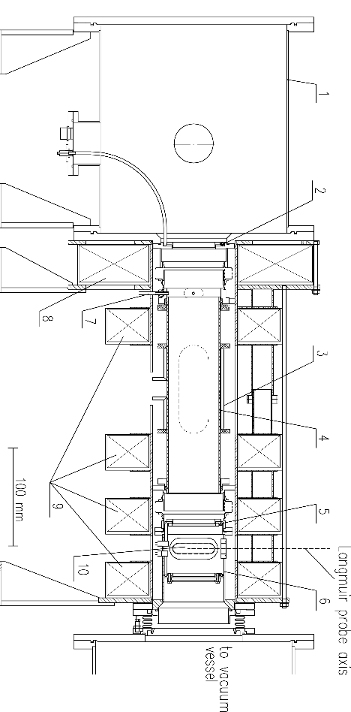 | 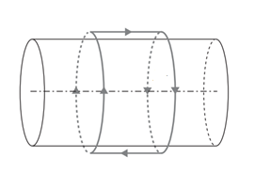
a) b)
Figure 1. a) Scheme of the helicon plasma source: 1 – expansion chamber; 2, 5 – limiters, 3 – RF antenna; 4 – quartz tube; 5, 6 – diagnostic chamber; 7 – gas inlet; 8 – mirror coil; 9 – magnetic coils; 10 – window. b) RF antenna Nagoya Type III (copper tube Ø6×1 mm, inductance – 0.3 µH, diameter – 110 mm, length – 160 mm).

III. EXPERIMENTAL RESULTS AND DISCUSSION
The principal aim of the experiment was to investigate the effect of the magnetic field profile on the plasma characteristics. For these purposes, different magnetic profiles were used (Fig. 2) and the radial profiles of the plasma density and electron temperature were measured.
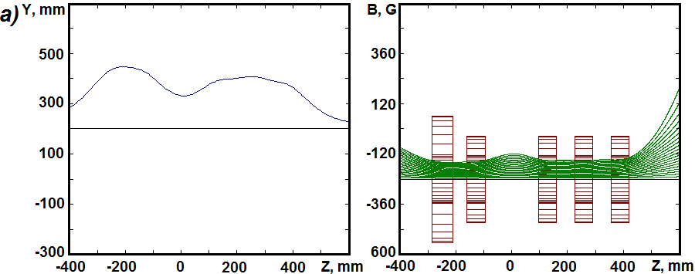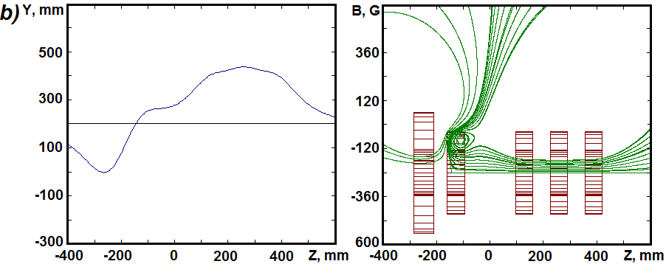

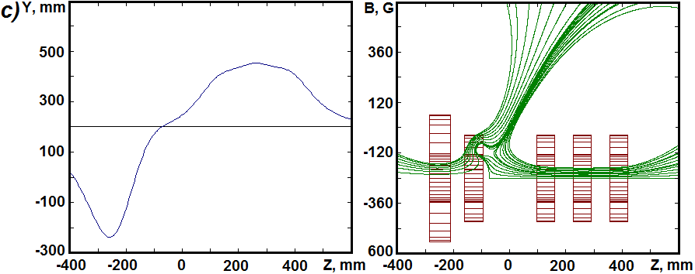
Figure 2. Intensity and force lines of magnetic field:
а) low-diverging field: I_{cc}=4.6 А, I_{mcc}=4.6 А, B_{min}=30 G, B_{max}=300 G;
b) inhomogeneous field: I_{mcc}=-8.4 А, I_{cc}=7.2 А, B_{min}=-240 G, B_{max}=300 G;
c) inhomogeneous field: I_{mcc}=-16.2 А, I_{cc}=7.9 А, B_{min}=-540 G, B_{max}=310 G.

Figure 3. The measured plasma density vs mirror coil current.
Ref. [9] describes the phenomenon of a density peak at low magnetic field, which we also observed. In the current experiment, a density maximum (n=0.4×10¹² cm⁻³) in the low-diverging magnetic field was found at 120 G nearby RF antenna in agreement with the theory of Ref. [2]. Optimal plasma characteristics were found when the magnetic field of the mirror coil was in opposite direction regarding the other coils (Figs. 2b, 2c). Fig. 3 describes a dependence of the plasma density on the mirror coil current I_{mcc} and other coils current I_{cc}. We noted that greater coil current yields greater plasma density.

Figure 4. Radial plasma density profiles for different magnetic configurations.

The profile of the magnetic field at the maximal plasma density is characterized by the mirror ratio of 1.75. Configuration in Fig. 2c is not steady-state because force lines cross plasma quartz camera. We hope to find profiles that don’t cross plasma camera in the future experiments. Plasma density profile is more narrow and the density peak is higher in case of strong mirror current as compared with low-diverging field (Fig.4).
In the experiment, various gas pressure were tested. Corresponding radial profiles of the plasma density and electron temperature are shown in Figs. 6 and 7. We noted that plasma characteristics are more sensitive to the gas pressure change in case of inhomogeneous configuration (Figs. 2b, 2c) than for a low diverging field (Fig. 2a) and plasma density increase from 2×10¹² cm⁻³ up to 4.5×10¹² cm⁻³ for optimal magnetic configuration (Fig. 5). The radial profiles of the plasma density are shown in Fig. 6 and the density has maximum at the pressure of 4 atm at the input side of the gas puffing valve. The temperature profiles have maxima on the edges of the plasma camera and minimum on the axis (Fig. 7).

Figure 5. Plasma density vs gas pressure with different magnetic configuration.

IV. CONCLUSION
Different magnetic field configurations of the plasma source were studied. Plasma parameters were found to be very sensitive to minor changes in the magnetic field geometry. A configuration with the opposite direction of the magnetic field in the mirror coil was found to provide maximal plasma density up to n_{max} = 4.3×10¹² cm⁻³ as compared with unidirectional configuration with n_{max} = 0.5×10¹² cm⁻³. At the same time, a profile with maximum of density is not steady-state as it was discussed in section III. As a result, minor changes in the magnetic coils currents and gas puffing makes it possible to produce plasma with a wide range of parameters. It allows to adopt a decision about farther studies of plasma parameters for different magnetic field geometries.
Application of inhomogeneous magnetic field in a helicon plasma source significantly improves plasma parameters and RF energy absorption. Increasing the electron temperature maxima can be a sequence of the excitation of small-scale Trivelpiece-Gold waves on the edge of plasma column. The waves can directly transport RF power into the center of the plasma column along resonance cones as it was considered in Ref. 10, 11. Intensive heating of the plasma edge increases gas ionization efficiency.

ACKNOWLEDGMENTS
This work has been supported by Russian Science Foundation (project N 14-50-00080).

REFERENCES
- P. Chabert N.Braithwaite, in Physics of Radio-Frequency Plasmas, Cambridge University Press, p. 260-285 (2011).
- I. A. Kotelnikov, Physics of plasmas 21, 122101 (2014).
- Th. Enk and M. Kramer, Phys. Plasmas 7, 4308 (2000).
- David D. Blackwell and Francis F. Chen, Plasma Sources Sci. Technol. 6, 569–576 (1997).
- M. D. Carter, F. W. Baity, Jr. G. C. Barber, and R. H. Goulding, Physics of plasmas 9, 5097 (2002).
- F. F. Chen, Plasma Phys. Control. Fusion 33(4), 339–64, 1991.
- M. Balkey, Optimization of a helicon plasma source for maximum density with minimal ion heating, Ph.D. Thesis, West Virginia University, 2000.
- F. F. Chen, M. J. Hsieh, M. Light, Plasma Sources Sci. Technol. 3, 49–57 (1994).
- T. Lafleur, C. Charles and R. W. Boswell, J. Phys. D: Appl. Phys. 44, 055202 (2011).
- Questions of atomic science and technique. Series: Plasma electronics and new methods of acceleration (3), 4, 241 – 246 (2003).
- D. D. Blackwell, T.G. Madziwa, D. Arnush, F.F. Chen, Phys. Rev. Lett., 88 (14), 145002, 2002.

